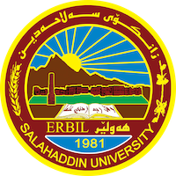
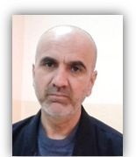
Academic Curriculum Vitae

Personal Information:
Full Name: Abdulrahman Khaleel Suliman
Email: (university email);- abdulrahman.suliman@su.edu.krd
Mobile: 0750 143 82 16

Education:
Higher diploma in medicine, master in Nano-science, Assist Professor.
Employment:
- Radiographer in Erbil teaching hospital, lecture in physics department , college of science, Salahaddin university

Qualifications
- lecturer
- IT qualifications
- English proficiency from the Faculty of Arts, Salahuddin University
Medical radiographic technicians

35 hours of IBRO course
Teaching experience:
- Medical physics, heat and thermodynamics, methodology, medical instrument, electricity in the body.
- Medical physics, heat and thermodynamics, methodology, medical instrument, electricity in the body,
- First aid , method of research, ,
- Thermodynamic lab , medical physics lab, physiology lab. electricity and magnesium lab , properties lab , etc.,

Research and publications
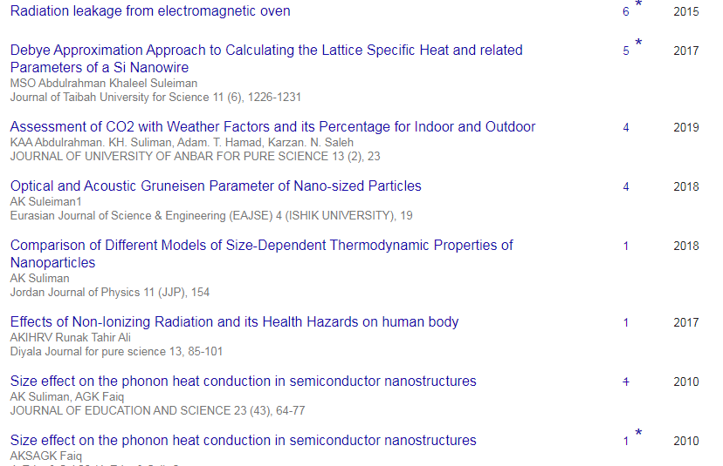
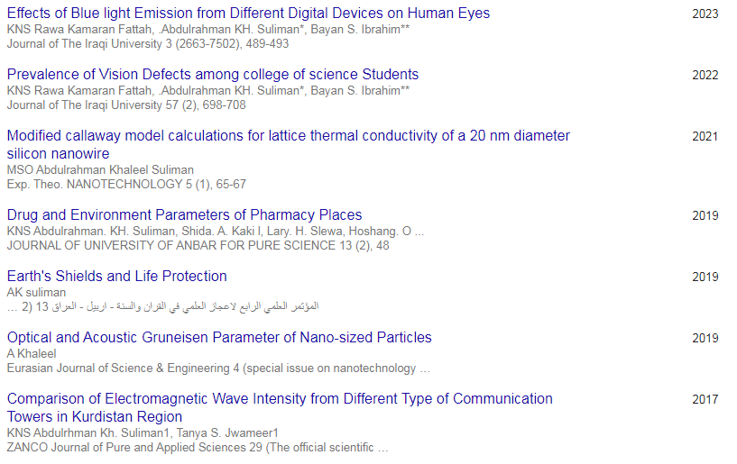
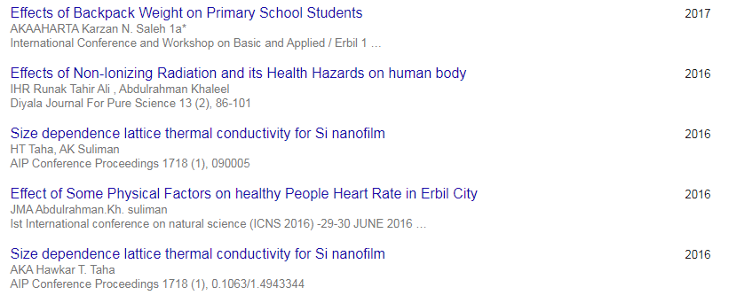
Conferences and courses attended

- مؤتمر المعاهد التكنولوجية- بغداد -1985(presenter)
- First international conference of natural science Erbil-1997 (presenter)
- First international conference for Basic and Applied Sciences-Kirkuk-2010.( presenter)
- مؤتمر الدفاع عن القران- سليمانية-2011(attendance)
- Scientific conference- Erbil -2013 , ( people awareness for the bottled water consumption in terms of the scientific guiltiness) (attendance)
- First international conference of natural science (ICNS2016).CHARMO UV.( poster)
- 5th scientific conference of College of Education University of Garmian-2017 (presenter).
- 5th International Conference and Workshop on Basic and Applied Sciences (ICOWOBAS 2015 (presenter)

- First international conference for Quran - Sunnah and sciences- Sulimania 2017 (presenter.)

- March 18th-19th 2017, Erbil-KRG-IRAQ International Conference and Workshop on Basic and Applied Sciences 2017
(presenter)
- Second International Conference of Mathematics SCIM-Erbil 2018.( presenter)
- المؤتمر العلمي الدولي الرابع-اربيل تحت عنوان (اشارت علمية في القران الكريم والسنة النبوية) 16-10-2019 (presenter)

- International Conference on Nanotechnology and its Applications22-23 January 2020Salahaddin University-Erbil, Iraq
- 6th international conference of applied science, energy and environment ICASEE-2022. (presenter)
15-دووه مين كونفرانسى (به خشينى كرانت بو باشترين بروزه ى ده رجوونى وئايدياى بو قوتابيانى زانكوى سه لا ح الدين هه ولير) (presenter)

Funding and academic awards
Funding source provided by Huawei obtained for research projects

Professional memberships
- Member ship ("modern physics journal"
- Member of the Saudi Society for Medical Physics

Professional Social Network Accounts:

1-https://www.researchgate.net/profile/Abdulrahman-Suliman/stats
2-https://www.facebook.com/abdulrahman.alassafee
3-https://scholar.google.com/citations?user=hELK6oAAAAAJ
4-https://twitter.com/ComAbdulrhman
5-https://accounts.google.com/v3/signin/identifier?dsh=S1695215541%3A1684411282223373&continue=https%3A%2F%2Fdrive.google.com%2Fdrive%2Fmy-drive%3Flfhs%3D2&followup=https%3A%2F%2Fdrive.google.com%2Fdrive%2Fmy-drive%3Flfhs%3D2&ifkv=Af_xneFYj5aREBhSIh-ZTTM01SVKUK8r9fQ-i4zCDeOgjHl_WrCwfFVbf8lDosv4Ycco6yrPkbQn&osid=1&passive=1209600&service=wise&flowName=GlifWebSignIn&flowEntry=ServiceLogin
6-https://orcid.org/0000-0002-3320-2237
7- https://academics.su.edu.krd/profile-admin/ORCID

It is also recommended to create an academic cover letter for your CV, for further information about the cover letter, please visit below link:
https://career-advice.jobs.ac.uk/cv-and-cover-letter-advice/academic-cover-letter/

