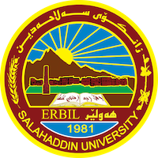
Academic Curriculum Vitae
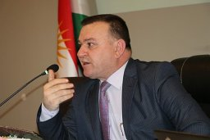
Personal Information:
Full Name: Azad Aziz sleman
Academic Title: Assistance professor
Email: Azad.sleman@su.edu.krd
Mobile:07504542774

Education
MA, PhD
Employment:
1997/10/28
Qualifications
- Teaching in Salaheddin University since 2014
- IT
- Language, IELTS level, 5
- Writer

Teaching experience:
- I had trained in pedagogue course in ministry of Education.
- I was part spat in international conference between Salaheddin University and FAU.

Research and publications
-A contrastive Analysis: The Construction of Interrogative Sentences in English and Kurdish.
-The theoretical bases and foundations for setting up language policy

-(Language policy and its plan in the media Kurdish satellite channels in the Kurdistan region as
a model

Identity and Language of Education in the Kurdistan Region

Conferences and courses attended
I was a member of runner course with my colic about diversity education in 2017.
A Participated in the school management authorization cours.

Funding and academic awards

-6 academic awards from president of University
-2 award from minister of high education.
Professional membership
- A manager of Educational Supervision .

-
Professional Social Network Accounts:

-google scholar
-LinkedIn
-Research gat
-Facebook

