Academic Curriculum Vitae
Personal Information:
Full Name: Ahmed Khaled Ahmed
Academic Title: Assistant Lecturer
Email: Ahmad.ahmed@su.edu.krd
Mobile: +964 (0) 750 4728243

Education:
- I began my undergraduate studies in electrical engineering in 2002 and graduated in 2006.
- In 2010, I began my Master's degree program in Mechatronics and Robotics and graduated in 2012.
- I am currently pursuing a PhD in computer and control engineering.

Employment:
On March 3, 2007 I commenced working in the Engineering College's Electrical Engineering department. At first I started as a lab engineer and extended my experience with computers and programming in the computer laboratory. Upon completion of my master's degree in 2012, I began teaching students several engineering subjects, such as computer programming, mathematics, high voltage engineering, robotics, microcontroller programming, machine learning, computer assisted design, etc. I also supervised several student projects and assisted in the development of revised courses and curricula. I continued working in the Electrical Engineering department until 2020 when I left to pursue a PhD in Computer and Control Science.
Currently, I am pursuing a PhD in computer and control engineering, and I have published three scientific papers in the past two years.

Qualifications
Languages Speaking
Language | Understanding | Speaking | Writing
Kurdish (native Tongue) | Excellent | Excellent | Excellent
English | Very good | Very good | Very good
Arabic | Very good | good | Very good

Courses Attended:
- Leadership & Communication Prepared by USAID & TATWEER (30.03.2010).
- TU BERGAKADEMIE FREIBERG.
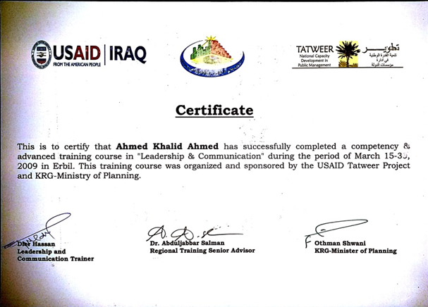
- 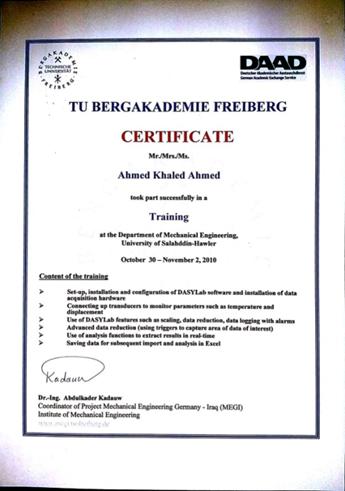

Teaching experience:

Teaching Undergraduate Degrees
# | Subject | Stage
1 | Computer Programming  Electrical Engineering | Second stage
2 | Mathematics II  Electrical Engineering | Second stage
3 | High Voltage Engineering  Electrical Engineering | Fourth stage
4 | Embedded Sys & MCUs  Electrical Engineering | Fourth stage
5 | Object Oriented Programming in C++  Electrical Engineering | Third stage
6 | Fundamentals Of Robotics  Electrical Engineering | Fourth stage
7 | Introduction To MCUs  Mechatronic and Mechanical Engineering | Third stage
8 | Graduation Projects  Electrical Engineering Department | Fourth stage
9 | CIRCUITS II  Electrical Engineering Department | Second stage
10 | Meetings  Electrical Engineering Department | Second stage
11 | Meetings  Electrical Engineering Department | Fourth stage
12 | Meetings  Mechatronic and Mechanical Engineering | Fourth stage
13 | Meetings  Mechatronic and Mechanical Engineering | Third stage
14 | Computer Aided Design and Manufacturing CAD/CAM  Electrical Engineering Department | Fourth stage
15 | Projects Set 1  Mechanical and Mechatronics Engineering Department | Third stage
16 | Projects Set 2  Electrical Engineering Department | Second stage
17 | Projects Set 3  Electrical Engineering Department | Third stage
18 | Projects Set 4  Electrical Engineering Department | Fourth stage
19 | Question Bank In OOP  Electrical Engineering Department | Third stage
20 | Machine Learning (ML)  Electrical Engineering Department | Third stage

Supervising Students
# | Research Title | Degree
1 | Home Automation System Using Arduino  Electrical Engineering Department | Bachelor Degree(Research Project)
2 | Design and Implementation of 3 DOF Robotic Arm  Electrical Engineering Department | Bachelor Degree(Research Project)
3 | Go to Goal Robot  Electrical Engineering Department | Bachelor Degree(Research Project)
4 | IOT liquid level monitoring system  Electrical Engineering Department | Bachelor Degree(Research Project)
5 | Automatic Car Windshield Operation based On Atmega328 MCU  Electrical Engineering Department | Bachelor Degree(Research Project)
6 | Design and Implementation of Senseless Two Wheeled Robot  Electrical Engineering Department | Bachelor Degree(Research Project)

Research and publications

Researches
# | Research Title | Status
1 | REVIEW: THE RE-CONFIGURABLE ROBOTIC GRIPPER DESIGN, DYNAMICS, AND CONTROL  Journal with DOI  International Journal of Robotic Research and Development - IJRRD  2021-09-07 | Published
2 | Simulation of the Dynamic Model of a 3-Axis Stabilized Satellite  Journal with DOI  1st International Conference on Engineering and Innovative Technology  2016-08-16 | Published
3 | Design of a New Modular Reconfigurable Gripper  Impact factor Journal(Thomson Reuters)  TEM Journal  2022-05-29 | Published
4 | Design of a New Modular Reconfigurable Gripper  Scopus  TEM Journal  2022-05-29 | Published
5 | Analyzing the Stress and Modal Behavior of a Reconfigurable Gripper’s Finger with Different Fabrication Materials  Journal with DOI  International Journal of Mechanical Engineering and Robotics Research (IJMERR)  2022-10-25 | Published
6 | Analyzing the Stress and Modal Behavior of a Reconfigurable Gripper’s Finger with Different Fabrication Materials  Scopus  International Journal of Mechanical Engineering and Robotics Research (IJMERR)  2022-10-25 | Published

Conferences and courses attended
Paper Title: Simulation of the Dynamic Model of a 3-Axis Stabilized Satellite
Journal with DOI
1st International Conference on Engineering and Innovative Technology
2016-08-16 Published

Professional Social Network Accounts:
- ResearchGate https://www.researchgate.net/profile/Ahmed-Ahmed-Asinger
- Google Scholar https://scholar.google.com/citations?user=1s-yXJEAAAAJ&hl=en
- Authorea
https://www.authorea.com/users/466100-ahmad-khalid-ahmed
- Academia
https://salahaddin-erbil.academia.edu/AhmedKhaled

