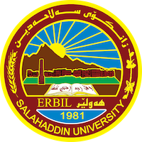
Academic Curriculum Vitae
Personal
Full Name: Ahmed Mohammad Ahmed Aqrawi
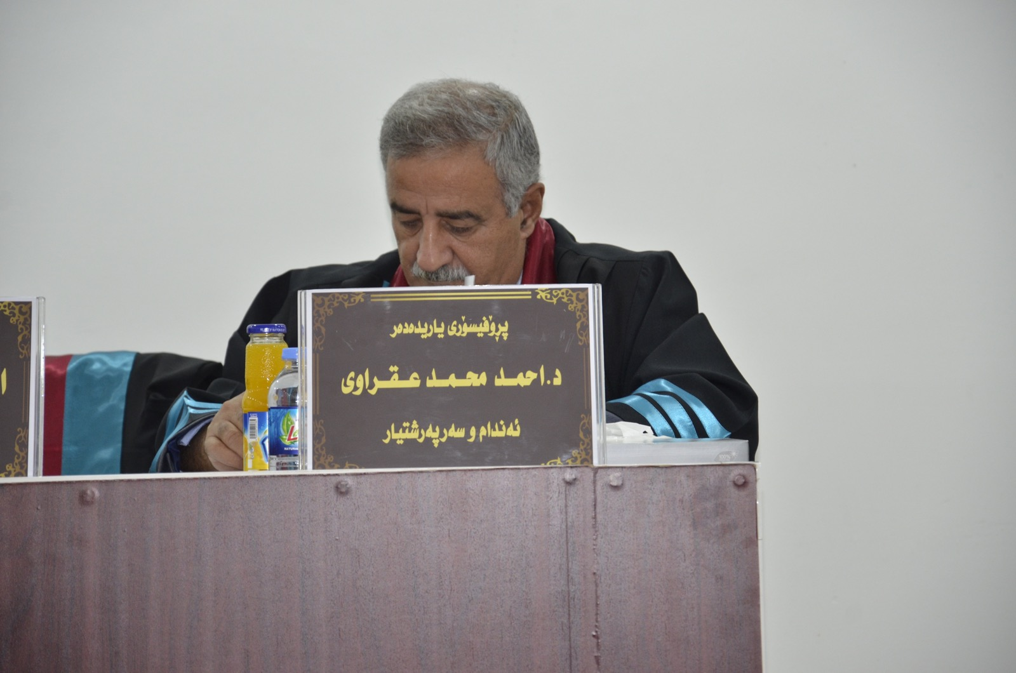
Academic Title: Assistant professor
Email: ahmed.aqrawi@su.edu.krd
Mobile: 07504470939

Education:
2000: Ph.D. in Geology (Industrial and applied mineralogy), University of Baghdad
1990: M.Sc. in Geology (Igneous petrology), University of Mosul
1982: B.Sc. in Geology, University of Mosul
1978: Baccalaureate, Akra secondary school

Employment:
- Salahaddin University-Erbil 22-9-1992

Qualifications
- 2009: Assistant professor of geology, Department of geology, College of Science, Salahaddin University.
- 2001: Lecturer of geology, Department of geology, College of Science, Salahaddin University.
- 1992 Assistant Lecturer of geology, Department of Geology, College of Science, Salahaddin University

- 2008: Training (Geology) at Bangor University - UK within the framework of the "Training of Trainers in Teacher Education for Sustained Quality

Teaching experience:
- Lecturing theoretical and practical subjects of Igneous and metamorphic petrology, optical mineralogy, and industrial mineralogy for B.Sc.
- Lecturing theoretical and practical subjects of Igneous and metamorphic petrology, and industrial. Mineralogy for M.Sc. students.
- Lecturing theoretical and practical subjects of industrial mineralogy, industrial rocks, and rare earth elements

Research and publications
1-Petrochemistry of Mawat ultrabasic rocks around Root Mountain Mawat complex . Mo'ata Scientific Research Journal, V.6, No.1, 1993.
2. Geochemistry of Akra Springs . Jour. Of Duhok Univ. V.1,No. 1, 1998.
3. Petrochemistry and Petrogenesis mafic intrusion o9f Bulfat complex ,
around Hero, Qala Deza area. Iraqi Journal of Earth science, V. 7,
No.1, 2007.
4. Oxygen and Hydrogen Isotope Study of sepentinized Peridotite Rocks, Thrust Zone, North East Iraq. Iraqi Journal of Earth science, V. 7, No.1, 2007.
5- Improvement of the clay utilized by the Dohok Brick factory, Dohok, IRAQI Kurdistan Region. Zanco Vol. 21,No, 1, 2009
- 6. Petrology Of Gabbroic rocks ( central sector) of Mawat Ophiolite complex NE, Iraq, Iraqi Bulletin of geology and mining , V. 8, No.2, 2012.

- 7. Production of insulator bricks for Iraqi Raw materials, Tikrit Journal of pure sciences

- 8. Geochemistry of Rare earth elements in carbonate rocks of the Mirga Mir Formation ( Lower Triassic) Kurdistan Region Iraq. Arabian Journal of Geosciences,V.9 No.4 pp1-13 2016
- 9. Assessment of Suitability of the Beduh Deposits (Lower Triassic)
- for Lightweight Aggregates, North Amadyia, Kurdistan Region – Iraq. Journal of Zankoy Sulaimani – Part A For Pure and Applied Science

- 10. Petrography, geochemistry and provenance of the Chalki rocks in
- Kurdistan region ,North Iraq . Arabian Journal of Geosciences v.ol.9,
- No.8
- 11. New 40Ar/39Ar age constraints on cooling and unroofing history of the metamorphic host rocks (and igneous intrusion associates) from the Bulfat Complex (Bulfat area), NE-Iraq, Arab J Geosci (2018) 11: 234
- 12-"Origin, Depositional Environment, Paleogeography and Paleoclimatology of Early Triassic Regional Marine Oxic Event (Beduh Formation), Kurdistan Region - Northern Iraq" Journal of African Earth Sciences,2020,V163,
- .

Conferences and courses attended
- 1998:First Scientific Conference of Duhok Univ. Duhok
- 2004: 6th International Geochemistry Conference, Alexandria University, Egypt.
- 2006: 7th International Geochemistry Conference, Alexandria University, Egypt.
- 2021: The 1st International Conference (Geo Iraq)

Funding and academic awards
- List any bursaries, scholarships, travel grants or other sources of funding that you were awarded for research projects or to attend meetings or conferences.

Professional memberships
- Member of Kurdistan Geological Society-Erbil

Professional Social Network Accounts:
https://www.researchgate.net/profile/Ahmed-Aqrawi
https://www.linkedin.com/in/ahmed-aqrawi-dr-ahmed-dr-a77b0b36
https://scholar.google.com/citations?hl=ar&user=UylTTCAAAAAJ&view_op=list_works&authuser=1&gmla=AJsN-F4nqwOUXdbVU6AQrsYzi7yDTuakBBJFysq3wZZuCVrKCcZjrsh5ar0lCuFe8TdsFyonwVZGe1vYyc39RBfncKtb6InEwTzHTWtvwC5cK6CCxX1D9IOSFgxnclnaozQusrUSZU5i
https://scholar.google.com/citations?hl=ar&user=UylTTCAAAAAJ&view_op=list_works&authuser=1&gmla=AJsN-F4nqwOUXdbVU6AQrsYzi7yDTuakBBJFysq3wZZuCVrKCcZjrsh5ar0lCuFe8TdsFyonwVZGe1vYyc39RBfncKtb6InEwTzHTWtvwC5cK6CCxX1D9IOSFgxnclnaozQusrUSZU5i

