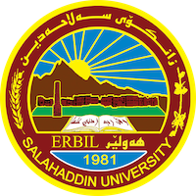
Academic Curriculum Vitae

Personal Information:
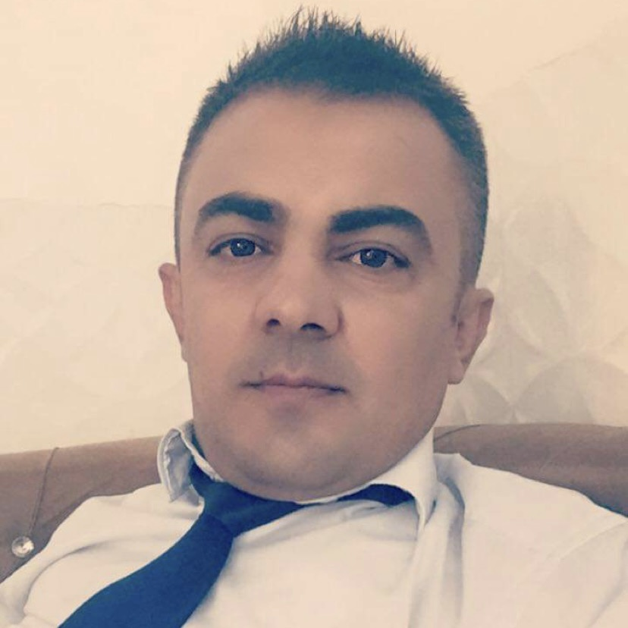
Full Name:Ahmed Aziz Ahmed
Academic Title: assistant lecture
Email: (university email) Ahmed.ahmed3@su.edu.krd
Mobile: 07501194914

Education:
2006-2010
B.Sc. Mechanical Engineering - Salahaddin University- Erbil
2014-2017
M.Sc. Mechanical Engineering (Production) - Salahaddin University- Erbil
Employment:
- 2011-2014 Lab Engineer ( thermodynamic lab , strength of material lab, fluid lab,air condition lab)
- 2017-2018 Teaching Assistant ( mathematics , Cad )
- 2018-2019 Teaching Assistant (differential equation , Eng. drawing)
- 2019-2020 Teaching Assistant (Math I , Math I , workshops)
- 2020-2021 Teaching Assistant (Math I , Math II, Math III, Math IV)
- 2021-2022 Teaching Assistant (Math I , Math II, Math III, Math IV)
- 2022-2023 Teaching Assistant (Math I , Math II, Math III, Math IV)

Qualifications
- IELTS 5.5
- Mechanical Design of building in Grade Engineering Buru
- Lab supervisor and Teaching Assistant, Mechanical Lab, Dept. of ME at SU.
Assistant Lecture, Dept. of ChE at SUH.

Teaching experience:
- Courses, trainings, lab supervision, etc
- Teaching (Math I , Math II, Math III, Math IV , workshops, , Cad , Eng. Drawing)

Research and publications
Three‑dimensional magnetic field and thermal environment,
and parameter uncertainty effects on nonlinear torsional vibration
of an embedded rod composed of two dissimilar rods welded
- by friction welding.

- Torsional vibration of a Rod Composed of Two Dissimilar Frictionally Welded Parts with and without Crack in a Thermal Environment

-Effect of rotational speed on intergranular corrosion
Resistance of friction welded SDSS SAF 2507 joints

Conferences and courses attended
- English language course in salahadding university language center 3 months
- Teaching way in salahadding university pedagogy 3 moths .

Professional memberships
- Kurdistan engineering syndicate.
- Kurdistan teachers union.

Professional Social Network Accounts:

Academic Website: https://academics.su.edu.krd/ahmed.ahmed3
https://scholar.google.com/citations?user=CKVrSioAAAAJ&hl=en
https://www.researchgate.net/profile/Ahmed-Ahmed-534

