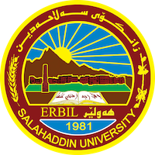
Academic Curriculum Vitae
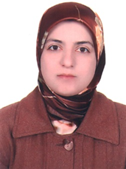
Personal Information:
Full Name: Asma A. Brime
Academic Title: Lecturer
Email: asma.brime@su.edu.krd
Mobile: 4308496

Education:
Bachler degree in 2008
MA in 2013
PhD in 2019
Employment:
- Since 22/9/2002

Teaching experience:
- Local Education consultant for the British Council 2022.
- Since 2002 has been working as a teacher of English language.
- 2008-2012: worked as tutor at department of English college of Education.
- 2012 till now: work as lecturer at Salahaddin University, College of Education.
- 2018 to recent teach at Tishik International University as a part-timer.
- 2011 till now: Work for the British Council/Erbil as an IELTS invigilator and supervisor.
- A UK Education Tour member from 2012 as an interpreter.
- Taught at Dilman International Institute from Jun. to Dec.2014. (a private institute)
Taught English at CIS College.2014-2017. (a private institute).

As a trainer, I have the following training courses:
- “Understanding and Implementing CLT in Teaching Sunrise” for the academic staff and fourth year students at college of Education in the 13/10/2021.
- ''How to Teach Critical Thinking'' workshop in May 2014 and in Dec2014-2015 at Salahaddin University to train teachers how to teach critical thinking skills in academic debate class.
- ''Bribery and Corruption Prevention for IELTS Venue Staff'' workshop in August 2015 to train IELTS invigilators.

- "Child Protection" training course for IELTS invigilators in 2015.

Research and publications
- The Implementation of Communicative Language Teaching by Kurdish EFL Student-Teachers at Colleges of Education 2020.
- EFL Students' Perspective on the Process Writing Approach to Essay Writing 2018
- Incorporating Outside Sources in Kurdish EFL Students’ Academic Writing 2017
- The Effects of the Integrated Approach on EFL Students’ Communication Skills 2015
- Using Summarization as a Strategy to investigate EFL Learners' Difficulties in Reading Comprehension. 2014
- Criteria for Evaluating Students Essay Writing at the Tertiary Level at SalahaddinUniversity, Kurdistan Region, Iraq 2014
- Assessing EFL Learners’ Critical Reading at Salahaddin University-Erbil 2014

Conferences and courses attended
- Give details of any conferences you have attended, and those at which you have presented delivered poster presentations.

Funding and academic awards
Won the Fulbright visiting scholarship in 2016
Professional memberships
TESOL Convention 2021-2022
Professional Social Network Accounts:

- https://scholar.google.com/citations?hl=en&user=VqlKlNAAAAAJ
- https://www.linkedin.com/in/asma-brime-076400123/
- https://orcid.org/my-orcid?orcid=0000-0002-4267-173X

