Salahuddin University-Erbil
College of Basic Education- English Department

Think out of the Box in Innovative Approaches in Teaching Literature
This Project Submitted in Partial Fulfillment of Requirement for the Degree of Bachelors in English at College of Basic Education, Salahaddin University -Erbil
Prepared By:
Hind Hasan Muhammad
Sazan Hashim Abdullah
Supervised by: Bukhari Abdula Rasool
April 11, 2022

Dedication

This study work is dedicated to our family who believed in us, our husbands who tolerated our absence and beloved daughters who have been a constant source of support and encouragement during the challenges of graduate college and life. We are truly thankful for having them in our lives.

Acknowledgement
We would like to thank my supervisor Mr. Bukhary, for his guidance through each step of the process. We express my deep sense of gratitude to every useful feedback he has given in the process.

Table of Content
1.0 Introduction………………………………………………………….. 5
2.0 Literature Review……………………………………………………. 7
2.1 Literature and Its Definition…………………………………. 7
2.2 Types of Literature…………………………………………….. 8
2.3 The purpose of literature……………………………………… 9
2.4 Teaching Literature…………………………………………… 10
2.5 Using Literary Texts in ESL & Foreign
Language Classes……………………………………………………..11
2.6 Innovation in teaching Literature…………………………….14
2.7 Innovative Techniques…………………………………………17
2.8 Challenges of teaching literature………………………………18

3.0 Reflection and Experience ……………………………………………21
4.0 Conclusion……………………………………………………………….24
5.0 Reference……………………………………………………………….25

Section one
Introduction
Literature is a mirror of life and it is a window through which we can see or view the events, challenges, problems, and concerns of each and everyone’s life. However, teaching literature is not as easy as it is thought or what many teachers think about. Teaching literature is a bit challenging itself. It needs sophisticated ideas, great talent, and good skills from both instructors and also from the system and methodologies, through which these materials of literature are given to the students. Moreover, teaching literature needs an atmosphere that would encourage critical thinking and sorts of modern vision for the problems and anxiety of life. In the other hand, English literature is a serious academic discipline. At first hand, the concept is defined in many anthologies and dictionaries in various ways, one could be the definition that is widely held upon is according to Encarta (2009) which says that Literature is the use of well-chosen words to tell a story through narrative, involving characters in conflict, or to express an emotion or idea through artfully arranged images. Literature broadly is any collection of written work, but it is also used more narrowly for writings specifically. considered to be an art form, especially prose fiction, drama, and poetry.” Oxford Learner’s Dictionaries.
Teaching literature could vary from one teacher to another. However, this study is concerned with encouraging the instructor to teach it in an innovative way. Nick Skillicorn defines innovation as “Turning an idea into a solution that adds value from a customer’s perspective” We as researchers are discussing or discovering or establishing different approaches of that are not within traditional box of class teaching, but our concern is with the nontraditional ways such as memorization or quote memorization. What we are concerned is the innovation that is found in teaching literature, by this we mean so many techniques, pedagogical tools, teaching devices, philosophical outlooks or other ways that have not been discovered or talked about yet. We try to talk about in order to benefit it by the instructor in schools or English department in universities.
This study is concerned with encouraging the instructor to teach literature in an innovative way. It is to open teachers’ eyes on new teaching methods in literature. The impact of teaching literature in an innovative approach that can accelerate the learning process in teaching English language and try to search for the latest creative methods – approaches- in teaching literature in primary and secondary schools. How to make literature enjoyable for the majority of students. The challenges that teachers face in how to apply them in practice in the classroom, as the obstacles differ from one environment to another.
In this study we used a combination of reflective method, data collection (literature review) as well as class observation. In addition of that interviews with some experienced teachers. This study aimed to identify the approaches employed by teachers in teaching modern literature to upper primary schools. Also, we focus on the observation of 5 English teachers for different stages, and different schools, private and local.
This study is composed of four sections. Section one which is the one you are reading is the introduction. Section two is a general literature review which is the collection of the writers, researchers, and scholars’ point of view, experience, and information, that have been accumulated about teaching literature and the innovation in teaching literature. Section three which is intitled Reflection and Experience is dedicated to elaborate upon the experiences, reflections, perspectives that we have come across within our project even before we start our observation. Section four is our final conclusion about the results we got.

Section Two Literature Review
2.1 literature and its different definitions.
Literature is a very difficult concept to define from one perspective. This is because the current understanding of literature has departed from the etymological understanding of the term literature.
To begin with, according to Bwalya. L (2006) the term literature is a Latin word ‘litera’ which means Writing. From this background, it is believed that literature is anything that is written. The people that subscribe to this notion believe that any written material qualifies to be called literature, hence mathematical figures are also literature. However, some other scholars disagree with tis definition. Such people extend their argument by saying that this definition is very narrow because it leaves out orature or oral literature. This is to say that literature exists in many forms, therefore saying that literature is any written material is being narrow minded because literature as it is known today exists in many forms which are both in oral and written form.
In addition, literature is literally “an acquaintance with letters” as in the first sense given in the oxford English Dictionary (from the Latin litera meaning ‘an individual character (letter). The term has generally come to identify a collection of texts. The word ‘literature’ as a common noun can refer to any form of writing, such as essays or poetry.
In addition, scylar (1998: 83) defines literature as “any writing on a subject: the body of published work concerned with a particular subject.” A similar definition to this scholar was coined by Pollanen (1997) which says that ‘literature refers to published writings in a particular style on a particular subject. The term is also used to show if the item has been published in a book, catalogue, museum exhibition or newsletter. This definition is quite interesting yet narrow in scope. It holds that literature is any form of writing, of course agreeing with the ones discussed above and the etymological meaning of the word literature. While this view is worth noting, it should be noted that the argument that literature should be a published work is very narrow. It ignores oral literature because orature cannot be published. In addition, to take literature as being any form of writing, then is to say that something becomes literature the time is written whether such a piece of work is published or not. It’s important to distinguish between a book and literature. The definition also argues that literature is concerned with a particular subject, the question that follows is: what subject? This question is valid because there are a lot of literally texts or simply what people call literature yet the publication or the written piece is on several subjects.
In addition to the above, the definition also says that literature has characters. This contradicts with the original meaning of the word literature. For the sake of emphasis, the word literature refers to writing. Originally, this means that any written piece whether it has characters or not, it will still be called literature and there are several pieces of writing that do not have characters.
2.2 Types of literature
Hancock (2006) also defines literature as being written works of fiction and non-fiction in which compositional excellence and advancement in the art of writing are higher priorities than are considerations of profit or commercial appeal. Similar to this definition is the one by Davids (1983) which says that literature is a creative writing of artistic value. These two definitions seem to suggest that literature does not follow the ordinary conventions of writing. Therefore, literature is that which follows a creative writing and has the element of compositional excellence. This leads to the notions of bad and good literature. It appears that good literature is one that uses or has all or many of the creative aspects while bad literature is one that lacks or has few creative aspects.
Kafimbwa (2005) argues that the difficulty in defining literature lies in the fact that literature exists in many forms. Therefore, scholars have failed to come up with one definition that will embrace all the types of literature in their varying forms and degrees. Some types of literature are poetry, short stories, songs, novels, folktales and essays. Within each of these types or forms there are different genres. In poetry these genres include epics (Stephen Vincent Benet’s John Brown’s Body), lyrics (Robert Frost’s “Birches”), and dramatic monologues (T. S. Eliot’s “The Love Song of J. Alfred Prufrock”). Fiction genres include the psychological (Virginia Woolf’s to the Lighthouse), naturalistic (Theodore Dreiser’s Sister Carrie), and proletarian (John Steinbeck’s In Dubious Battle). Some essay genres are the personal and the informative; famous essayists include Ralph Waldo Emerson, who penned “Self-Reliance,” and E. M. Forster, who wrote Two Cheers for Democracy.
The existence of the different types of literature have made it difficult for scholars to come up with one working definitions for literature. Each of the definitions that exist now all have deficiencies. This is so because the body of literature is wide, has many forms.

2.3 The purpose of literature
The purpose of literature is to entertain and instruct (or to delight and enlighten) the reader through the use of the imagination. Literature can also shock, amaze, or provide readers with an escape from reality for a while. This definition is broad although it does not encompass everything. The first point to note is that this definition is slightly different from the tradition notion which holds that literature is anything that is written. It holds that for a piece of work to be called literature, it should not just use words anyhow. This is so because according to the proponents of this view point, literature has its own writing style and words are carefully selected and used in order to fulfill its purpose.
The above definition also means that literature serves many purposes some of which are to entertain and to instruct. In addition, this view holds that people or characters or writers use literature in order to express emotions. While this is true, it does not apply to every piece of literature. This is because there are several texts that are written purely for education or to inform. The other point is that, there is no piece of writing where words are used anyhow, every piece of writing selects words carefully but does not mean that any piece of writing in which the author uses words carefully qualifies to be called literature.

2.4 Teaching Literature
Teaching literature can become motivating and interesting when appropriate teaching strategies are employed by the teacher in the classroom. Very often, teachers either lecture or use question-and-answer or recitation methods. Recitation is often not appropriate because the question remains at the level of who-what-when-where, but hardly ever how and why. Li (2011) noted that the teacher’s job is to nourish and enhance students’ intelligence. In the conventional approach to literature teaching, the teacher only focuses on linguistic competence such as reading, recalling, and reciting literary works.
Revisiting literary appreciation skills, teachers become aware of how they can develop the literacy competence of their students. Such information will further provide measures on how to improve their teachings particularly by using innovative learning tasks in their literature classroom.
In fact, Soltan (2010) found that most of the professors of literature in universities use the lecture method. Hence, many university students depend only on critical notes provided by their professors rather than reading the authentic literary text. As a result, literature learning becomes uninteresting. It is on this ground that prompted the researcher to conduct this study.
Teaching literature to students requires creativity, ingenuity, and innovativeness. In this way are the literary appreciation skills of their students developed. Teachers must be able to design effective learning tasks to help learners learn literature through the most innovative and modern ways. Ahmad and Aziz (2009) claimed that in the process of developing students’ literary appreciation, teachers have a very significant role.
From the aforementioned studies carried out by Rita (2012), Bunsom et al. (2011), and Shier, Soltan, and El-Hilaly (2014), it becomes apparent that the use of innovative teaching strategies and techniques in literature teaching are beneficial in enhancing the literary reading appreciation and performance of students. Hence, we become aware of the gap regarding the limited literature teaching strategies employed by the teacher in the classroom. There is a need to conduct a study investigating the level of literary appreciation skills and reading performance of university students to propose a number of innovative teaching strategies to improve students’ literary appreciation skills.
The modern concept of education asks for innovations to be introduced into the educational system, thus, the opportunity to educate 21st century individuals cannot be taken for granted by any academic enterprise. The quality of education offered is measured by the quality of leadership manifested by the teachers (Magulod, 2017a, 2017b, 2017c, 2017d, 2017e).

2.5 Using Literary Texts in ESL & Foreign Language Classes
According to Collie and Slater (1990:3), there are four main reasons which lead a language teacher to use literature in the classroom. These are valuable authentic material, cultural enrichment, language enrichment and personal involvement. In addition to these four main reasons, universality, non-triviality, personal relevance, variety, interest, economy and suggestive power and ambiguity are some other factors requiring the use of literature as a powerful resource in the classroom context. Cox (1989), who suggested that good English teaching must take into account a number of different patterns for learning in the subject. Three of his five patterns are particularly relevant here – making learning contribute to the ‘personal growth’ of students, helping them to acquire a sense of ‘cultural heritage’, and contextualizing the knowledge they acquire through ‘cultural analyses.

1. Valuable Authentic Material
Literature is genuine content. The majority of works of literature are not written with the intention of teaching a language. Recently designed training materials include many authentic samples of language in real-life contexts (e.g., transport timetable, city plans, forms, pamphlets, cartoons, advertising, newspaper or magazine articles). As a result, in a classroom setting, students are exposed to real-life / real-life-like language examples. Literature can be a useful addition to such resources, especially once the first "survival" level has been achieved. Students must also deal with language designed for native speakers when reading literary literature, they become familiar with a variety of linguistic forms, communication purposes, and meanings.

2. Cultural Enrichment
The ideal approach for many language learners to improve their knowledge of verbal and nonverbal aspects of communication in the place where that language is spoken - a visit or an extended stay - is just not possible. Literary works, like as novels, plays, short stories, and so on, help such students comprehend how communication works in that nation. Though a novel, play, or short story takes place in a fictional world, it provides a rich and colorful backdrop in which characters from various socioeconomic and geographical backgrounds can be described. A reader can learn about the characters' perspectives on the world (their thoughts, feelings, habits, traditions, and belongings; what they buy, believe in, fear, and enjoy; and how they speak and behave in public).

3. Language Enrichment
Learners can find a broad variety of particular lexical or syntactic objects in literature. Reading a large and contextualized body of literature allows students to get familiar with many aspects of the written language. They learn about the syntax and discourse functions of sentences, the various structures that can be used, and the various ways to connect ideas, all of which help to build and enrich their own writing abilities. Students become more productive and daring when they become aware of the richness and diversity of the language they are learning and begin to tap into some of that potential. As a result, they develop their communicative and cultural competency by immersing themselves in the authenticity and naturalness of original texts.
4. Personal Involvement
Because of the personal involvement it fosters in the reader, literature can be beneficial in the language learning process. When a student reads a literary text, he becomes immersed in it and begins to inhabit it. Understanding the meanings of lexical items or phrases becomes less important than pursuing the story's development. The student becomes enthralled as events unfold through the climax; he feels close to certain characters and shares their emotional responses. This can have a positive impact on the entire language learning process. At this point, the importance of selecting a literary text in relation to the students' needs, expectations, and interests, as well as their language level, is clear. He can remove his identity during this process.
2.6 Innovation in teaching Literature
It is well known that our new life is highly affected by the era of information technology, and technology plays an important role in today’s human society development. Based on this fact, it is indispensable to take advantage of the modern technological facilities in aiding the task of English language education. Students trying to learn English as a second language need further language support. They need to practice in hearing language, reading language, speaking language, and writing language in order to develop their experience and skills (Ybarra & Green, 2003). For doing such tasks, they are in need of using various tools which can help them learn the language easily and effectively. The term New Technology includes communication techniques for language teaching in which the personal computer plays a central role (Davies & Hewer, 2012). There are, however, other technological tools that can be utilized in language learning besides computers. Each technological tool has its specific benefits and application with one of the four language parts (speaking, listening, reading, and writing). However, in order to use these techniques successfully, the ELL student should be familiar with using computers and internet, and capable of interacting with these techniques. The effect of technology has become huge in teaching and learning the language in addition to the instructor's role. In other words, the role of the instructor together with the role of the technology can lead to advanced learning results (Sharma, 2009).
For example, having a screen in the classroom to play different types of movies from time to time will accelerate the learning process. Movies attract students’ attention, present language in a more natural way that found in course-books. Movies also offer a visual context aid which helps students understanding and in order to improve their learning skills. Nowadays teaching literature has become more challenging than ever.
In order to help the learners’ mastery (enhance the proficiency) of language skills, language teachers have to provide quality teaching materials that will be engaging, interesting, up-to-date while simultaneously being a tool that will ensure that the students learn. There are numerous studies on the use of videos in developing particular language skills, especially listening comprehension (Grube, 2006 ; Suvorov, 2008).
According to (Ismaili, 2013) movies are an enjoyable source of entertainment and language acquisition. For this reason, many researchers and EFL practitioners prefer to watch the movie adaptations of famous and current novels as a supplementary source to the reading. Practice has shown that reading an entire book can be tiresome and boring while an audio-visual experience can be more entertaining and engaging to students. As King (2002) indicates in his work, movies are such invaluable and rich resources for teaching because they present colloquial English in real life contexts rather than artificial situations; a chance of being exposed to different native speaker voices, stress, accents, and dialects. Listening is the predominant skill among other integrated skills in presenting movies in EFL classes whether the movies chosen are presented with subtitles or not. Hence movies can provide an opportunity for extensive listening, “listening for ISSN 2411-9598 (Print) ISSN 2411-4103 (Online) European Journal of Language and Literature Studies May-August 2017 Volume 3 Issue 2 122 general pleasure or interest, usually to longer stretches of discourse” (Flowerdew, J. Miller, L., 2005). However, to make the practice of listening tasks more useful, the movies may be presented without subtitles depending on the learners’ language proficiency level. Findings from previous studies provide support for students wanting to have more video materials (i.e., video clips) embedded in their classroom (B. Goldstein,P.Driver, 2014). Different types of video material are easily accessible with mobile devices or smart phones via internet and teachers can pick up from a rather varied set of materials depending on the learner’s age and language proficiency. Movies are being used for pedagogical purposes in order to motivate language learners and they are easily available and popular entertainment form of teaching tool in English teaching as a foreign language, for students particularly in recent years.
Another way in teaching literature is using Blogs and Journals Within the context of English as a foreign language (EFL), using blogs has emerged as a language learning tool. However, how teachers effectively incorporate blogs within the confines of an instructional framework and what the current research shows about using blogs as a learning tool remain unsolved issues. Thus, the current paper presents a review of the research on the use of blogs in EFL learning contexts. The study first introduces blogs and a theoretical framework for the use of blogs within the borders of the constructivist approach. Then, in accordance with the studies reviewed, the research is divided into the following five sections: effects on (1) the awareness of the target culture, (2) interaction and communication, (3) basic language skills, (4) learners' motivation, perceptions and attitudes, and (5) autonomous learning. In conclusion, while the current literature reflects that using blogs is a valuable and effective technique that can be readily used in the context of EFL, more research is necessary. 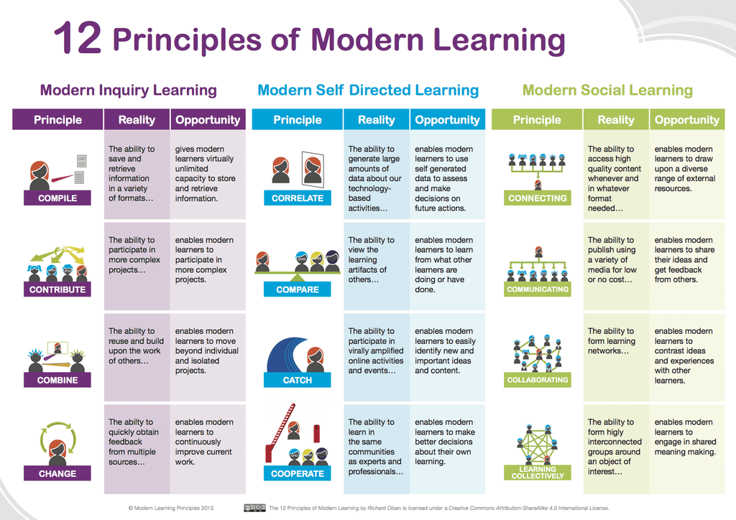
toughteacher .com
2.7 Innovative Techniques
Teachers were asked to try using these new methods and observe the effectiveness of each one then, collect data from different teachers at different stages.
1. Use combinations of media–classic and modern together, leveraging one against the other. Music, video streams, short videos (like TikTok), video games, plays, poems, film, posters, poems, essays, novels, podcasts, etc
2. Have students analyze diverse media forms for their strengths and weaknesses–and involve both classic and digital forms.
3. Have students turn essays into videos into podcasts into letters into simply-coded games into poems into apps. (See also #7.)
4. Allow students to choose media while you choose themes and/or academic and/or quality standards.
5. When designing units, choose the media first, then the standards (yes, this likely goes against what you were taught–but give it a try).
6. Insist all student work ‘leaves the classroom’ and is published–then design units accordingly.
7. Use RAFT: Role, Audience, Format, and Topic/Tone/Theme. Then have them revise media in response to new roles, audiences, formats, or topics, tones, or themes. Martin Luther King’s “I Have a Dream Speech” in a new format (a video?), or to a new audience (modern hip-hop artists?), or with a new tone (angry?). Students experimenting here are experimenting with media design, which is exactly what authors do.
8. Use a thematic focus to design units, assessments, project-based learning–whatever activities students ‘touch.’ One of the hallmark characteristics of classic literature is that it endures. This is, in part, due to the timelessness of the human condition. Love lost, coming of age, overcoming obstacles, civil rights, identity, and more are all at the core of the greatest of literary works.
The ability to the texts to nail these conditions gives them their ability to endure, so teach through that. The author (e.g., Shakespeare) or media form (e.g., a play) may not seem relevant to a student–and that’s okay. The author chose that form based on prevailing local technology. Help them focus on what is being said and why–and how.
9. Use tools for digital text annotation on pdfs, note-sharing, and more to help students mark text, document questions and insights, and revisit thinking or collaborate with others during the reading of classic texts.
10. Create social media-based reading clubs. Establish a hashtag that anchors year-long discussion of certain themes, authors, text, or whatever other category/topic that makes sense for your curriculum.
11. Have students create and produce an ongoing podcast or YouTube channel on, as above, relevant themes, authors, texts, etc.
12. Connect the old with the new in authentic ways to center the knowledge demands of modern readers.
2.8 Challenges of teaching literature
What is the most serious problem of teaching English literature to students in different levels from the point of view of English teachers?
Among the problems in EFL literature teaching - low motivation, lack of confidence, inadequate teaching methods, exam stress, underqualified teachers, insufficient in-service training - students‟ proficiency levels have been always standing out as the most critical (Abdullah, T. et al, 2007; Arvidson & Blanco, 2004; Buyukyavuz & Inal, 2008; Brown, 2000; Cetintas, 2010; Ganakumaran, 2002; Karci & Vural, 2011; Katz, 2001; Krishnasamy, 2015; Mwape, 1984).

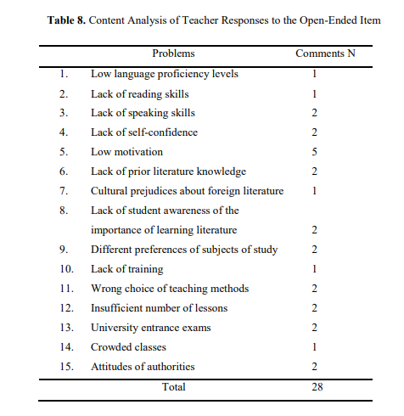
şıklı, C., & Tarakçıoğlu, A.Ö. (2017).
As Table 8 shows, among the diverse views represented by teacher comments, low motivation of students to study English literature comes fifth as a serious problem. There were also made a few comments on students‟ lack of speaking and reading skills as well as on low proficiency levels, which can be all summed up as roughly referring to language proficiency. To make statistical results of the qualitative dataset more meaningful and comparable to the findings of the quantitative dataset, the procedure of grouping items under three general categories was also applied to 15 items presented in Table 8. Thus, low language proficiency levels, lack of reading and speaking skills, low motivation, lack of self-confidence, lack of prior literature knowledge, lack of student awareness of the importance of learning literature, different preferences for subjects of study and cultural prejudices were assigned to the category of student-related problems. Lack of training and wrong choices of teaching methods were placed under the category of teacher related problem. And finally, university entrance exams, insufficient number of lessons, crowded classes and attitudes of authorities were grouped under the category of problems related to external factors.
As shown in Table 9, it appears there were more references to student-related problems than to teacher-related problems and external factor-related problems taken together.
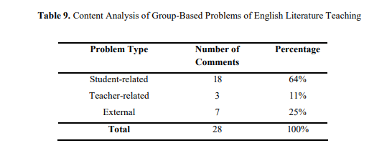
şıklı, C., & Tarakçıoğlu, A.Ö. (2017).
Table 9 shows, the majority of teachers (64%) seem to agree that the most serious problem faced by English literature teaching is student-related. 25% of teachers made references to external factors such as university exams and insufficient teaching materials. And only 11% of teachers supported the view that teacher-related factors were the major source of problems in English literature teaching. In the light of the above, it appears that the findings of both quantitative and qualitative datasets generally overlap and, therefore, confirm the argument of a number of studies that student-related problems, particularly low proficiency levels, constitute the most serious problems of English literature teaching in EFL contexts. (Abdullah & al, 2007; Arvidson & Blanco, 2004; Buyukyavuz & Inal, 2008; Brown, 2000; Cetintas, 2010; Ganakumaran, 2002; Karci & Vural, 2011; Katz, 2001; Krishnasamy, 2015; Mwape, 1984
Section Three Reflective and Experience.
My experience of studying literature in school has always been about knowing the literary periods, being able to name the most important authors that characterized those periods, having knowledge of the literary styles of the different authors and their works, being able to identify different kinds of styles and figures of speech, paraphrasing the oldest works, and lastly reading. Curiously though, we only read very few or very little of the works we had to have knowledge of, most often poetry, short stories and abstracts or summaries of novels. Reading novels for school occurred as a separate practice from the literature we did in class with the teacher, usually as homework during the holidays; if I actually enjoyed the novel, it was just a "bonus" and I did not expect to. Reading for pleasure was something I did in my spare time, when I could choose books that were appropriate for my age and my interests, but I was never allowed to read those books for school, and neither did I expected to: I knew the novels I read for school had to be representative of the literary world of my culture, yet it wasn’t. I noticed that the study of literature as I know it is not a common practice in our governmental upper secondary school, especially in the English classroom, where "doing literature" is usually reading and, sometimes, discussing a novel. As a future teacher of English, I wanted to investigate more what it is meant with literature in the English classroom and how that is represented in the curriculum and by the teachers. More ever, I was always wondering why do English teachers still using old methods that are irrelevant to the technology era.
When I reflect back to the first year I commenced teaching at this level, I was excited to facilitate the course, though I failed to do it one or the other ways. Now I could recall those days. To me, my lessons were ‘marvelous’ presentations for the first two or three months. I basically did not apprehend the students’ interests and their level of English. Neither was I able to collect feedback from them at earlier. Later, I came to know that students had not enjoyed my classes, nor had many of them got any points in understanding the value of literature, writing, grammar and reading lessons. Then I thought there was an urgent need to make some changes in my classroom practices, strategies and activities. Some of the following strategies really assisted me to make the class interactive and lively, and to sustain learners’ motivation of the heterogeneous class I was teaching. Adding technology, video discussion, social media news, animation movies, in the class made it more enjoyable. Curriculum designers should use different types of literature, modern and old, to vary the content and make it more enjoyable.

Teaching literature for primary for many years, and dealing with age between (10-12) made me face a lot of challenges, one of them is making literature interesting for their students, Often the material is old, as in Shakespeare, or it is confusing, as in Whitman. So, I had to adapt way to teach literature without my students falling asleep at their desks.
Here are a few tips to waking them up.
1-Bring literature to life. Have the students perform the story that they are reading. Assign each student a role to play. They must study that character carefully. This activity engages the student in the material, which is essential in holding their interest.
2-Have the students create artwork. They can draw maps, paint scenes, make a character collage, build a story website or build a model of a setting in the literature. Again, the key is to have them connect to the material.
3-Play games. There are plenty of games you can adapt to the literature text you are studying. You can adapt Jeopardy, hangman, Wheel of Fortune or just about any other game show you have seen on TV. Another great idea is to have the students themselves create a game that fits the text you are studying.
4-Assign the students to be Teacher for the Day. Put the students in groups, and assign each group a section of the literature being studied. The group will be responsible for teaching the class the assigned section.
5-Write it out. Assign each student a character from the book and have them write letters to the author, discussing the story. They can ask the author questions and comment on the story. Another way to have them write about the story is to keep an online blog that discusses the literature they study throughout the school year.
6-Laugh a lot. Nothing makes literature more boring than a teacher who reads the material in a monotone. Much of literature is very amusing, and you should encourage the students to laugh with the author.
7-Participate in the above activities! Students love it when their teacher joins in.
8-Ask the principal if you can display the students’ artwork in the hallway or library, or if your students can perform their play in during an assembly.

Section Four Conclusion

Literature in Education is aimed at developing the potential of students in a holistic, balanced and integrated manner encompassing the intellectual, spiritual, emotional and physical aspects in order to create a balanced and harmonious human being with high social standards. It is therefore, the primary aim of incorporating literature into the English Language syllabus is to improve students’ language ability. Our observations the benefits of using humour, interactive discussion, encouragement, role playing and raising critical questions as important tools during classroom teaching. We also conclude that constant self-assessment and reflection can be used as a guiding tool by educators.
We have indicated that few teachers employed variety of approaches and activities in order to ensure students’ understanding of literary text. Classroom observations indicated that the Information-Based Approach and Paraphrastic Approach were among the most favored by teachers in the teaching programs. The incorporation of using translation of L1 is considered as an option for teachers to help weaker students to understand the text, and thus, to guide them to analyze the literature element of the text. This can be seen as to support students who have limited proficiency in the language to learn literature. However, teachers couldn’t apply new techniques due to many challenges in the educational system. Learning process could only be done in the classroom with teachers. Teachers were seen to use list of questions provided in the text to ensure students understand the learning. Students were instructed to utilize all materials provided by teachers and to finish the task in time. Less exploration of thinking abilities is enhanced during the learning. This is due to some reasons of different perception in the teaching of children’s literature. Literature should be taught in a way out of examination oriented. Thus, students will have an opportunity to express out their thinking abilities creatively and critically. Teaching literature needs variety of elements and preparations to match the modern technology. Encouraging students to watch movies and write a report about is turned to be an effective way.

Reference:
Ahmad, F., Aziz, J. (2009). Students’ perception of the teachers’ teaching of literature communicating and understanding through the eyes of the audience. European Journal of Social Sciences, 7(3), 17-26.
Bwalya L (2005) Oral Literature: Study Material. UNZA.
Encarta (2009). digital multimedia encyclopedia published by Microsoft from 1993 to 2009
Davids M (1983) Understanding Literature. Michigan: Michigan press.
Hanconck P (2006) What is Literature. Sydney: Australia
Li, D. (2011). How to teach and learn English literature in e-education era. International Journal of e-Education, e-Business, e-Management and E-Learning, 1, 241-245.
Lu, Z., Liu, M. (2011). Foreign language anxiety and strategy use: A study with Chinese undergraduate EFL learners. Journal of Language Teaching and Research, 2(6), 1298–1305.
Silavwe, A., Mwewa, T., and Mkandawire, S. B. (2019). Understanding the Concept of Functional Literacy by Selected Residents of Lusaka District of Zambia. Journal of Lexicography and Terminology, 3 (2), 1 -30
Why literature has many definitions posted on October 30, 2011 by sitwe
Soltan, R. (2010). The effectiveness of literature small discussion groups strategy in developing the short story analysis skills of university language majors, Ain Shams University. Retrieved from
https://www.teachthought.com/literacy/strategies-for-teaching-literature/
Journal of Language and Linguistic Studies Vol.1, No.1, April 2005
Elliot, R. 1990. “Encouraging reader-response to literature in ESL situations” in ELT Journal. Vol 44, No. 3, p.p:191-198
Helton, C.A, J.Asamani and E.D.Thomas. 1998. “A ‘Novel’ Approach to the Teaching of Reading”. Tennessee State: Tennessee State University, p.p: 1-5, Available Internet Address: http: // www.nade.net / documents / SCP98 / SCP98.19.pdf
Hiller, J.P. 1983. “Teaching Poetry in the Foreign Language Classroom: Theory and Practice.” Unpublished PhD Dissertation. Stony Brook: State University of New York.
Lenore, K.L. 1993. The Creative Classroom A Guide for Using Creative Drama in Classroom. U.S.A.: Elsevier, Inc.
Maley, A. 1989. “Down from the Pedestal: Literature as Resource” in Literature and the Learner: Methodological Approaches. Cambridge: Modern English Publications.

