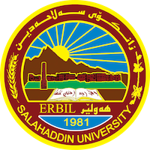
Academic Curriculum Vitae
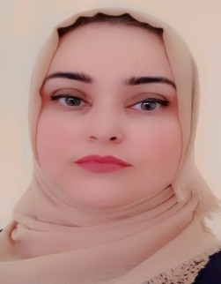
Personal Information:
Academic Title: Assistant Lecturer
Email: (university email) dunya. ali@su.edu.krd
Mobile: 0750 5482276

Education:
- Bachelor of Kurdish Language - College of Languages - Salahaddin University (2009-2010)
- Master Degree in Kurdish Literature - College of Languages - Salahaddin University (2015)
- PhD student (at present) in College of Languages - Salahaddin University

Employment:
- Started as assist. Researcher in College of languages – Salahaddin university in (2011)

Qualifications
- Teaching qualifications in 2015
- IT qualifications in 2011
- Language qualification Certified from Center of Languages of Salahaddin university in 2022
- Any professional qualification: Persian Language Certified in 2017 فارسی
- You could put any professional courses you have attended: (N/A)
Teaching experience:
teaching courses as per mentioned below...
- Kurdology
- ئەدەبى کۆن
- زازاوە ئەدەبییەکان
- رێبازە ئەدەبییەکان
- ئەدەبي مندالآن
- رەخنەى ئەدەبى
- گفتوگۆى ئەکادیمى
- رەوانبێژى

Research and publications
- State all researches, publication you made.

Conferences and courses attended
ئامادەبوون لە کۆنفرانسى فەیلى لە هۆلى سەعد عەبدڵلا
Funding and academic awards
- List any bursaries, scholarships, travel grants or other sources of funding that you were awarded for research projects or to attend meetings or conferences.

Professional memberships
- List any membership you hold of any professional body or learned society relevant to your research or other life activities.

Professional Social Network Accounts:

- https://academics.su.edu.krd/dunya.ali
- https://www.facebook.com/dunya.shahab?mibextid=ZbWKwL

