Ministry of Higher Education Subject: Advanced Database System
Salahaddin University- Erbil Time: 2 Hours
College of Science Date: 14/5/2023
Computer Science& IT Department Final Exam 2nd Semester Trial: 1st
3rd CS and IT 2022-2023 Marks: %50

Q1: Answer the Following Questions: (10 Marks)
A: Complete the following: (6 Marks)
1- A -------------is a collection of multiple, logically interrelated databases distributed over a computer network.
2- ------------- is types of access of data, read/write, etc.
- Represent the user view as a collection of tables use the ------------------ to do this.
- Understanding ------------------------------------- are key to understanding SQL and query processing.
- If the system should match to existing systems or some modules are yet ready, the ----------------method is usually used.
- ---------- Consists of a single DB and DBMS stored at one site with users distributed across the network.

B: From the relation PROJ below: (4 marks)
- Write information to find Horizontal Fragmentation ( with output)
- Write information to find vertical Fragmentation (with output)
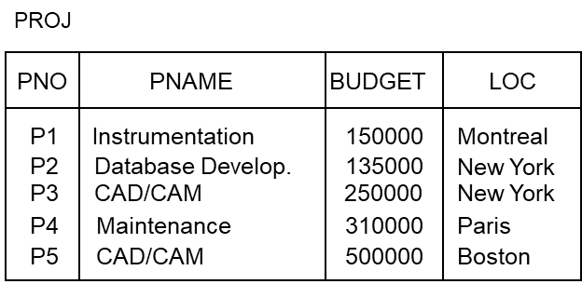

Q2: From the relation below by using relation algebra. (10 Marks)
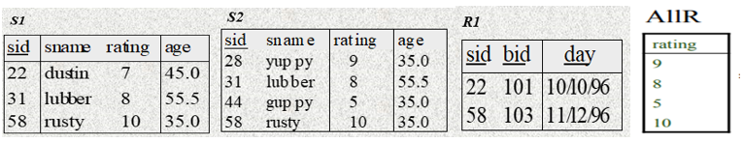
A: Find the output of:
- S2×AllR (2 Marks)
- ρ(sid−>sid1) (S1) × ρ(sid−>sid2) (R1) (2 Marks)
- π Sname(σ S2.rating<AllR.rating(S2×AllR)) (3 Marks)
B: Write the query in relation algebra to find Natural join between S1and R1 (3 Marks)
Q3: Answer the Following Questions: (15 Marks)
- What is the Network transparency of distributed DBMS architecture
- What is the disadvantages of DDBMS?
- Draw the architecture models for Distributed DBMS (DBMS implementation alternatives)
Q4: Compare between the followings: (15 Marks)
- Centralized and distributed databases
- Centralized allocation And Partitioned allocation
- Reference architecture for a DDBMS and Reference Architecture for a Federated MDBS (Explain by graph only)
Answer the Question
Answer: Q1: (10 Marks )
A: (6 Marks)
1- Distributed database (DDB)
- Qualitative information.
- EAR method.
- Relation Algebra & Calculus
- down-top
- Centralized

B: (4 Marks)
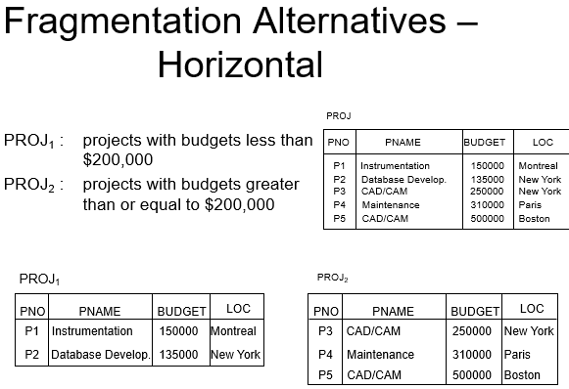

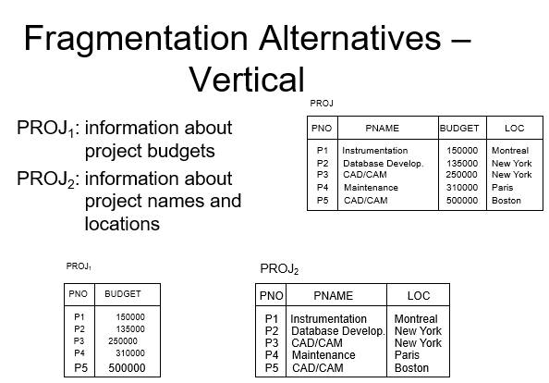

Answer Q2: (10 Marks)
- S2×AllR (2 Marks)
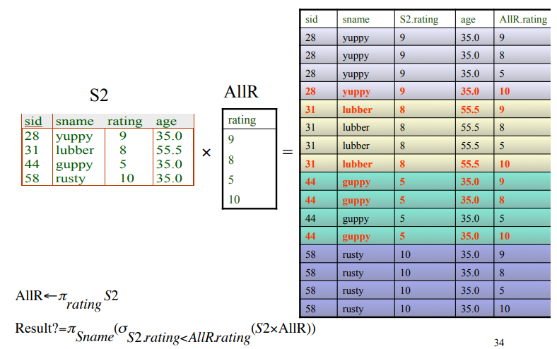
- ρ(sid−>sid1) (S1) × ρ(sid−>sid2) (R1) (3 Marks)
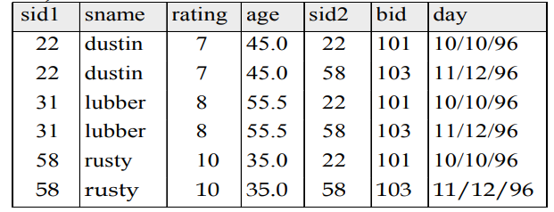

- π Sname(σ S2.rating<AllR.rating(S2×AllR)) (3 Marks)
sid sname |  | S2.rating | age |  | AllR.rating
28 | yuppy | 9 |  | 35.0 | 10
31 | lubber | 8 |  | 55.5 | 9
44 | guppy | 5 |  | 35.0 | 9
44 | guppy | 5 |  | 35.0 | 8
44 | guppy | 5 |  | 35.0 | 10

B: Write the query in relation algebra to find Natural join between S1and R1 (3 Marks)
Psid , sname, rating,age,bid,day(σ _{Sid.s1=Sid.R1}(S1 x ρ sid , sname, rating,age,bid,day (R1))

Q3: Answer the Following Questions: (15 Marks)

1- What is the Network transparency of distributed DBMS architecture
– Location transparency: an operation on data is independent of both the location and the system where it is executed
– Naming transparency: unique name is provided for each object in the DB

2- What is the disadvantages of DDBMS?
The disadvantages of a DDBMS are that it

- Complexity
- Cost
- Security
- Integrity control more difficult
- Lack of standards
- Lack of experience
- Database design more complex

3-Draw the architecture models for Distributed DBMS (DBMS implementation alternatives)

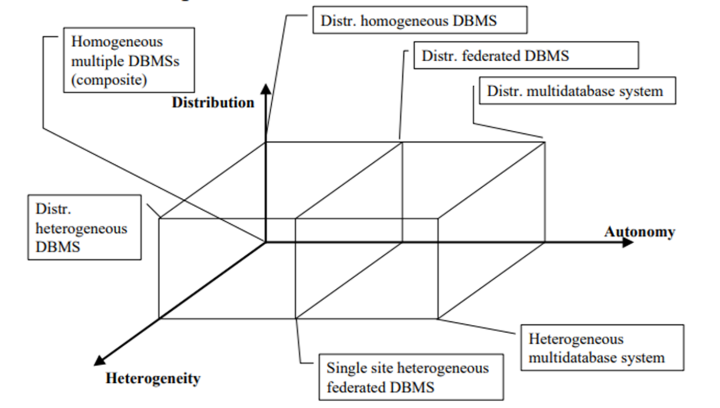

Q4 : Answer (15 marks)
1-The main differences between centralized and distributed databases :
- Centralized databases store data on a single CPU bound to a single physical/geographical location. Distributed databases which manages all its different storage devices remotely, as it is not necessary for them to be kept in the same physical and/or geographical location.
- Centralized databases are easier to maintain up to date than distributed databases, because distributed databases require additional (often manual) work to keep the data to stored .
- If data is lost in a centralized system, retrieving it would be much harder. If, however, data is lost in a distributed system, retrieving it would be very easy, because there is always a copy of the data in a different location of the database.
- Designing a centralized database is generally much less complex than designing a distributed database, as distributed database systems are based on a hierarchical structure.

2- Centralized allocation And Partitioned allocation
– Centralized allocation
∗ Consists of a single DB and DBMS stored at one site with users distributed across the network
– Partitioned allocation
∗ Database is partitioned into disjoint fragments, each fragment assigned to one site

3- Reference architecture for a DDBMS and Reference Architecture for a Federated MDBS (Explain by graph only)

Reference architecture for a DDBMS
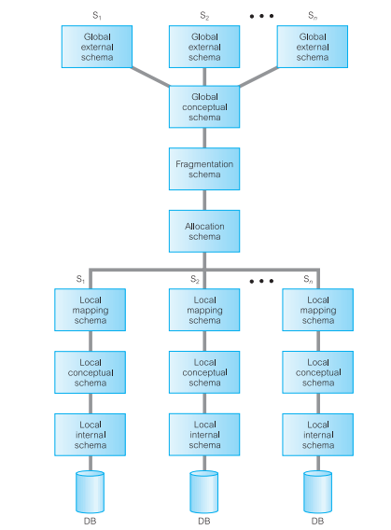
Reference Architecture for a Federated MDBS
