Salahaddin University – Hawler Final practical Examination Subject : Database-SQL
Education College / Scientific Depts. 1 Trial Time : 1.15 Hours
Computer Dept. 2016 – 2015 Date : 19/5 /2015
IT Branch Marks : % 20 CS&IT Stage: 3rd Class
Q1:

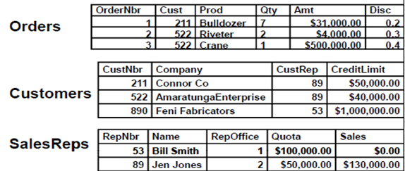
From multiple table above please answer the following questions
1-which salesReps have taken the order name is Bulldozer

2-Get full details of all orders whose salesReps is Jen Jones

Q2: A: list only type of date Functions
B: list only the type of Row-Level function
C: list only the type of constraints you doing over your database

Answers
  - A:
  - DATE
  - Time
  - Smalldatetime
  - Datetime
  - Datetime2
        - Datetimeoffset
B:
- Arithmetic operation on a column
- The round Function
- The ISNULL function
- The Null function
- The Top function
- DISTINCT Function

C: We will focus on the following constraints:
- NOT NULL
- UNIQUE
- CHECK
- PRIMARY KEY
- FOREIGN KEY

2016 With best wishes Dr. Haider Haddad

