.
% 15 3rd class CS Group B practical Exam 1-12-2021

Consider the following relations and answer the following queries:

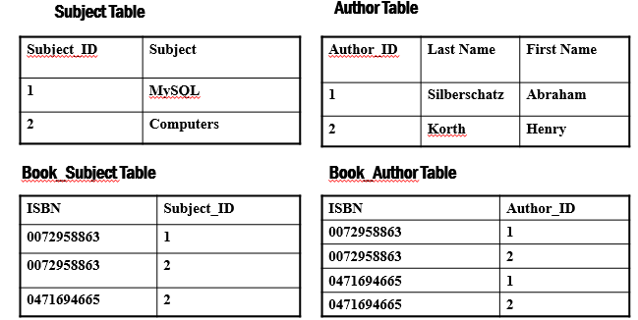

- Create constrant check on the field Author_ID
- Insert Database subject by default to Subject table.
- Howmany Authors in table Author
- Find the lastname from Author whose dosn`t begin with letter k and FirstName dosn`t begin with letter k

-------------------------------------------------------------------------------------------------------------------
%15 3rd class IT Group B practical Exam 1-12-2021
Consider the following relations and answer the following queries:

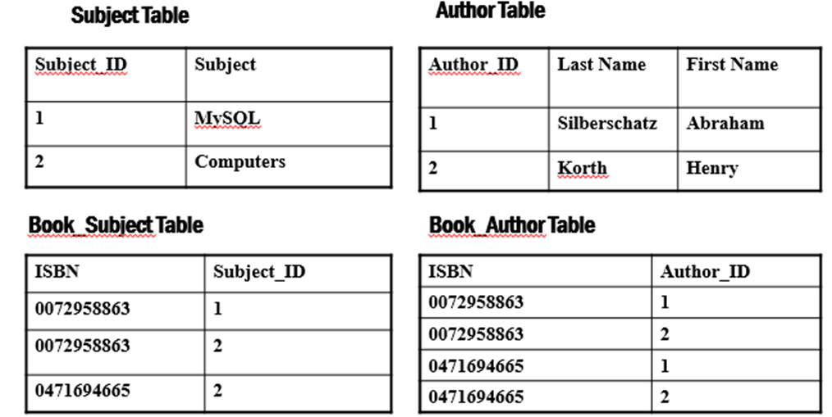

- Create constrant check on the field Author_ID
- Insert Database subject by default to Subject table.
- Howmany Authors in table Author
- Find the lastname from Author whose dosn`t begin with letter k and FirstName dosn`t begin with letter k

