Mycotoxins )Fungal toxins(

Mycotoxins are low-molecular-weight natural products produced as secondary metabolites by filamentous fungi that have deleterious effects on human and animal consumers. They are structurally diverse, deriving from a number of biosynthetic pathways. One fungal species may produce many different mycotoxins and/or the same mycotoxin produce by different fungal genera.
The reason for the production of mycotoxins is not yet known; they are neither necessary for growth nor the development of the fungi. The production of toxins depends on the organism infected and its susceptibility, metabolism, and defense mechanisms.
Some mycotoxins are formed in the field, some in storage, storage conditions that favor production of mycotoxins including temperature and moisture. Types of Mycotoxins:
The presence of mycotoxins in feedstuffs reduces the feed quality in terms of both energy and protein value. High moisture content (>12%) and grain damage favors mold growth.
Classification of mycotoxins

Classification according to the target organs:
- Hepatotoxins (liver tissues): Aflatoxins, ochratoxins.
- Nephrotoxins (kidney tissues): Citrinin, ochratoxin A, oxalic acid.
- Neurotoxins (nervous system tissues) : Patulin, cyclopiazonic acid,
- Enterotoxins (alimentary organs and canal) T-2 toxin
- Dermotoxins(skin): Trichothecenes
Classification according to the mycotoxicoses
- Aspergillotoxicosis
- Penicillotoxicosis
- Fusariotoxicosis
- Pithomycotoxicosis
- Stachybotryotoxicosis

Mycotoxicoses
Mycotoxicoses are diseases caused by toxins produced by many fungi, mainly those belonging to the genera Aspergillus, Penicillium and Fusarium which are common contaminants of food and feed and affect man and animals.
The degree of toxicity depending on a variety of factors, such as age, sex, weight, nutrition, metabolism, exposure to infectious agents, and the occurrence of other mycotoxins, as well as the type of toxin, mechanism of action, and levels of intake

The mycotoxicoses may be divided into two general forms :

(1) Acute primary mycotoxicoses when high to moderate amounts of mycotoxins are consumed. Specific symptoms and signs of the toxic effect of the mycotoxins can be seen.

(2) Chronic primary mycotoxicoses result from moderate to low levels of mycotoxin intake. Often non-specific effects such as reduced weight gain and reproductive efficiency occur.

Occurrence and Importance of Mycotoxins in Foods
During different food processing technologies, including cooking, boiling, baking, frying, baking, and pasteurizing, most mycotoxins remain chemically and thermally stable. Regulatory limits on significant levels of mycotoxins in food and feed are established by various authorities worldwide Food and Drug Administration (FDA), the World Health Organization (WHO). toxins are detected and identified by thin layer chromatography,HPLC, ELISA mass spectroscopy and fluoroumetric methods

The most important toxins are:

1. Aflatoxins:
Aflatoxins are difuranocoumarin derivatives by many strains of Aspergillus flavus and A. parasiticus, There are different types of aflatoxins, B1, B2, G1, G2, M1, M2. Under UV. light the spots of aflatoxin B1 or B2 fluoresce blue and that of aflatoxins G1 or G2 fluoresce green. Aflatoxin B1 (AFB1, is the most extremely toxic, mutagenic and carcinogenic type. is considered when ingested to be the most potent naturally occurring heptacarcinogen (liver carcinogen), mutagenic (DNA damaging), teratogenic, and immunosuppressive effects. Symptoms of acute aflatoxicosis in humans include vomiting, abdominal pain, jaundice, pulmonary edema, coma, convulsions, and death.

Aflatoxins have been found as natural contaminants in many types of food including peanut, corn, rice, wheat, and barely and in animal feeds. Carcinogenic.

2. Ochratoxins:
Ochratoxins are iso-coumarin phenylalanine, produced mainly by Aspergillus ochraceus and Penicillium viridicatum. Ochratoxin A is a potent nephrotoxin and hepatotoxin. This is also known as Balkan nephropathy.

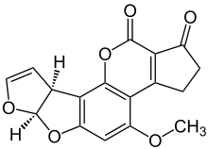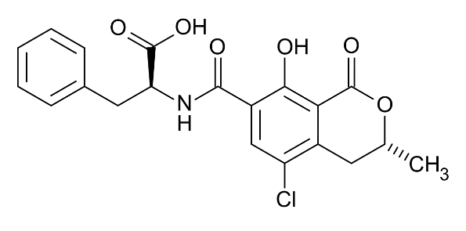
Aflatoxin Ochratoxins

Ochratoxin was reported in cereals, in species, in alcoholic beverages such as in wines and in beer, in dried vine fruits, in coffee and chocolate. In a human disease of kidney referred to as Balkan endemic nephropathy, is associated with a high incidence of kidney, pelvis, ureter, and urinary bladder tumors.
It is also suspected that the inhalation of OTs via air and dust caused by the opening of Egyptian tombs may have led to the deaths of archaeologists. In 1999 Kramer, a German microbiologist identified several species of mold spores in the dark, dry tomb. Kramer hypothesized that when the tomb was first opened, the fresh air could have caused the spores to be blown into the air and infect the archaeologists through their nose, mouth, or eyes, the spores could lead to systemic infection or even death to the infected individuals.

3. Patulin
Patulin polyketide lactone produced by several species of Penicillium, Aspergillus, and Byssochlamys. Food which are more susceptible to contamination by patulin are apples and by-products (puree and juices).
Patulin has been reported as mutagenic, neurotoxic, immunotoxic, and to cause gastrointestinal damages in rodents.

4. Fusariotoxicosis:
species of Fusarium that infecting the grain of developing cereals such as wheat and maize. They include a range of mycotoxins, such as:

a. Trichothecenes
are sesquiterpenoid toxins produced by members of the Fusarium genus, although other genera (e.g. Trichothecium and Stachybotrys), cause alimentary toxic aleukia (ATA). The most common symptoms of T-2 exposure are headache, vertigo, fatigue, tachycardia, salivation and fever.
The most frequent contaminants are deoxynivalenol (DON), also known as vomitoxin, nivalenol (NIV), while T-2 toxin is rarer.
In experimental animals, trichothecenes are 40 times more toxic when inhaled than when given orally, some reports showing trichothecene involvement in the development of "sick building syndrome".

b.DON (vomitoxin)
Deoxynivalenol is almost the primary mycotoxin associated in cattle with reduced feed intake and milk production.

c.Zearalenone
induces estrogenic response in ruminants. Large doses are associated with abortions in cattle. Other cattle responses may include poor reproductive performance, and mammary gland enlargement of virgin heifers, poor feed intake, a loss of milk production.

d.Fumonisin
occur in cereals originating from pathogenic fungi. Horses are extremely sensitive to fumonisin. can cause leukoencephalomalacia . It is also known as "crazy horse disease" and "the blind staggers

5-Ergot Alkaloids
The EA group of mycotoxins is tryptophan-derived alkaloid (Ergotamine, lysergic acid and ergot alkaloid) are derived from the genus Claviceps, Cause ergotism when consumed by human or animal, cause burning pain, convulsions, hallucination, and spontaneous amputation of extremes. In the Middle Age (ergotism, historically known as St. Anthony’s Fire), Claviceps species are produced instead of kernels on grain ears or seeds on grass heads, with large and dark sclerotia representing the final stage of the disease, known as “ergots”.

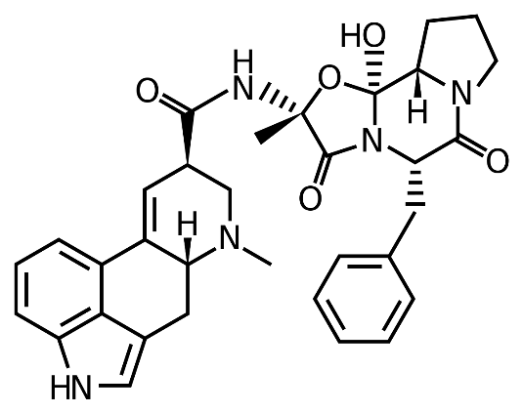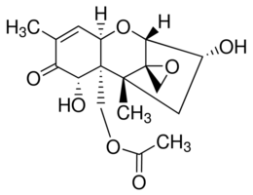
Ergotamine Trichothecen

