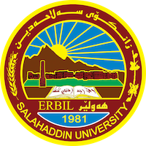
Academic Curriculum Vitae
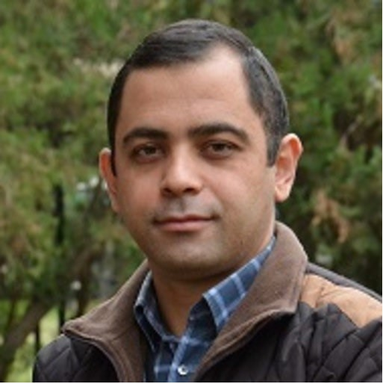
Personal Information:
Full Name: Hisham Khalil Mustafa
Academic Title: Assistant Lecturer
Email: (university email): Hisham.mustafa@su.edu.krd
Mobile:00964 750 4532596

Education:
- B.Sc. in Geology, 2001, Salahaddin University-Erbil, College of Science.
- M. Sc. In Geology, 2006, University of Mosul-Iraq
Employment:
- Geology department/ College of Science- Salahaddin University-Erbil, October 10, 2001 – 3 Sep. 2006 as Assistant Geologist
- Geology department/ College of Science- Salahaddin University September 4, 2006 – present as Assistant Lecturer
Qualifications
-Teaching methods -Salahaddin University- 3 Months- 2007
- Arc-GIS training course- College of Science- 2022
Teaching experience:
- General Geology- College of Agriculture 2022
- Engineering Geology -College of Engineering 2023
- Practical sedimentary Rocks-ESP department 2010 till now
- Practical Subsurface Geology 2023
- Practical Petroleum Geology 2009-2010

Research and publications
- An Insight to the Sedimentological Developments of Quaternary Detritus Ring Fluvial Network, Altun Kupri Paleolake, NE IRAQ
https://doi.org/10.46717/igj.54.2B.11Ms-2021-08-31

Professional memberships
-Kurdistan Geologists Syndicate 2001 until now
- Kurdistan Teachers Union - 2008 until now

Professional Social Network Accounts:
https://orcid.org/my-orcid?orcid=0009-0007-4490-7033
https://www.researchgate.net/profile/Hisham-Mustafa
https://scholar.google.com/citations?hl=en&user=X66W_K4AAAAJ&view_op=list_works&authuser=1&gmla=AJsN-F5oDUeRTcypHUdQGgP3L0nMfxrtFpTp9hLozQBbkgM4Y_usNXqGjORJvsKZ-BPkajAorRBpzEw6ftXTQm1V3qF-gANmFQ
https://www.linkedin.com/in/hisham-mustafa-843342147/

