# Salahaddin University-Erbil Subject: Power System Analysis

College of Engineering Final Term Exam Stage: 4th Power

Electrical Engineering Dept. 2021-2022 Time: 120 minutes

QUESTION 1 [10+25 Marks]

1. Write a formula for converting the per-unit impedance of the old base into a new base system.
2. The nodal admittance equations of the system in p.u values is

$$\left[\begin{aligned}-j16.75 j11.75 j5 \\ j11.75 -j19.25 j7.5 \\ j5 j7.5 -j12.5\end{aligned}\right]\left[\begin{aligned}v_{1} \\ v_{2} \\ v_{3}\end{aligned}\right]=\left[\begin{aligned}1∠-90^{0} \\ 0 \\ 0.95∠0^{0}\end{aligned}\right]$$

Using $Y_{22}$ as the initial pivot to eliminate node 2 by Kron reduction method

QUESTION 2[25 Marks]

How do you find all elements of the Jacobian matrix in the Newton-Raphson load flow method? (with illustration of all formula of real and reactive power w.r.t the voltage angle and the voltage magnitude)

QUESTION 3[40 Marks]

Using Fast Decoupled method to study the power flow of the power system shown in figure below? (Use Sbase 100MVA and just try two iterations)

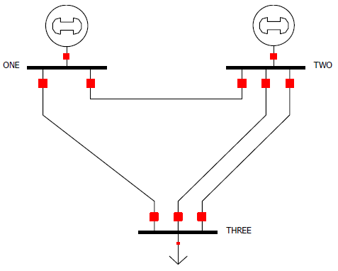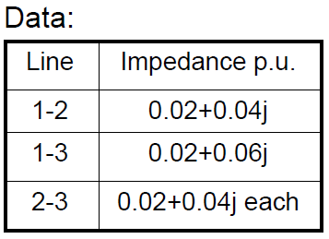

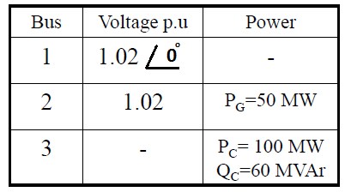

Typical answers

Q1/ 1)







–j9.5779 j8.0519

j8.0519 –j9.5779

Q2/









Q3/



B’=[-60 40; 40 -55] , B”=[-55]

inv(B’)= [-0.0324 -0.0235;-0.0235 -0.0353] , inv(B”) =[-0.0182]







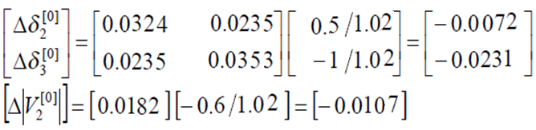

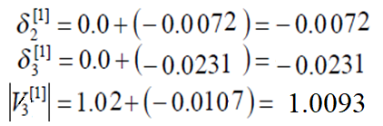

Draw the sequence network for the system shown in figure below. Determine the fault current when (i) L-L-G and (ii) L-L fault occurs at point F.

The p.u reactances are referred to the same base as follows:

|  |  |  |  |
| --- | --- | --- | --- |
|  | $$z_{1}$$ | $$z_{2}$$ | $$z_{0}$$ |
| G1 | 0.05 | 0.3 | 0.2 |
| G2 | 0.03 | 0.15 | 0.25 |
| Line 1 | 0.7 | 0.3 | 0.3 |
| Line 2 | 0.7 | 0.3 | 0.3 |
| Transformer 1 | 0.12 | 0.12 | 0.12 |
| Transformer 2 | 0.1 | 0.1 | 0.1 |

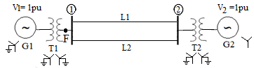

**Typical solution of PSA**

**Answer Q1**

1. 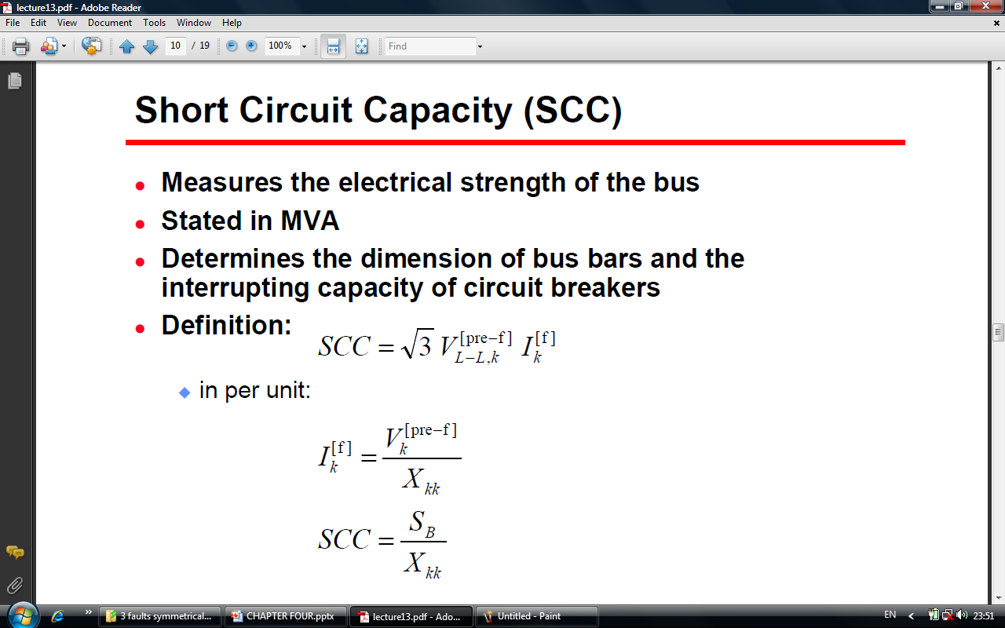
2. 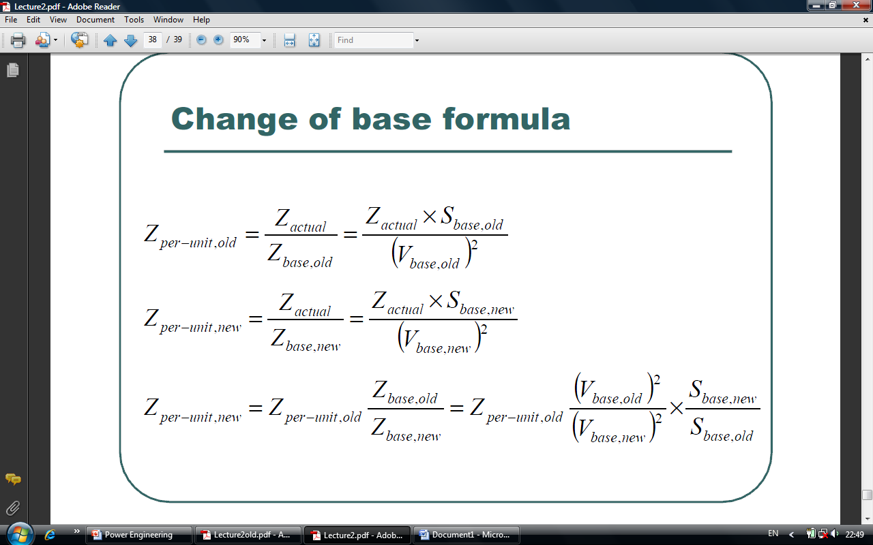

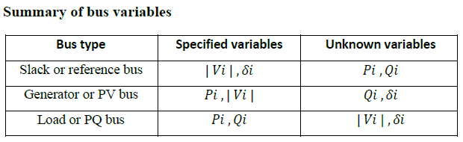

If= (0.97*0.3)/(0.2*0.1)=14.55pu



$Ybus=\left[\begin{aligned}-j12 j3 j5 \\ j3 -j15 j8 \\ j5 j18 -j13\end{aligned}\right]$

1. J= 15*15

**Answer Q2**

Let δ2=00

Ybus=[20-j10 -20+j10; -20+j10 20-j10]; B”=[-10] ; inv(B”)=[-0.1]

P2= V2V1|Y21|*cos(26.565051-0+0)+V2V2|Y22|cos(26.565051)=1*(-20)+1*(20)=0

ΔP2=2-0=2

Δδ2=- (-0.1)*2/1 = 0.2; δ2 = 0+ 0.2 =0.2

P2= V2V1|Y21|*cos(26.565051-0.2+0)+V2V2|Y22|cos(26.565051-0.2+0.2)=1*(-)+1*(20)=

ΔP2=2-()=

Δδ2=- (-0.1)* /1 =; δ2 = 0.2+ =

**Answer Q3**

