Salahaddin University-Erbil Subject: Power System Operation & Control
College of Engineering Final Term Exam Stage: 4th Power
Electrical Engineering Dept. 2021-2022 Time: 120 minutes

QUESTION 1 [7+7+7+7+7 Marks]
Choose the correct answer

1) The most possible fault occur on the transmission line is
a. 3-phase fault b. L-G fault c. L-L fault d. L-L-G fault

2) What is the value of the L-L fault current?
a. $3I_{a_{o}}$ b. $-\frac{3E}{X_{1}+{(X}_{2}//X_{o}^{'})}*\frac{X_{2}}{X_{2}+X_{o}^{'}}$ c. $\frac{-j\sqrt{3}E}{X_{1}+X_{2}}$ d. $\frac{3E}{X_{1}+X_{2}+X_{o}^{'}}$

3) What is the penalty factor of a plant if its incremental loss is 0.29 ?
a. 3.45 b. 0.71 c. 1.4 d. 0.29 e. None of these

4) In L-L-G fault
a. all sequence voltages are equal b. only positive and negative sequence voltages are equal c. all sequence currents are equal d. only positive and negative sequence currents are equal

5) The steady-state stability limit is equal to
a. $P_{mechanical}$ b.$\frac{\left|E\right||V_{inf}|}{X}sinδ$ c. $\frac{\left|E\right||V_{inf}|}{X}cosδ$ d. $\frac{\left|E\right||V_{inf}|}{X}$

QUESTION 2 [20 Marks]
The incremental cost characteristics of two generators delivering 170 MW are as follows:
$\frac{dC_{1}}{dP_{1}}=10+0.2P_{1}$ and $\frac{dC_{2}}{dP_{2}}=16+0.2P_{2}$. Find the optimal dispatch values of P₁ and P₂.
(Neglect power limits and transmission line losses)

QUESTION 3 [20 Marks]
A 100MVA, 11kV, three-phase synchronous generator was subjected to different types of faults: three-phase fault 3000A ; Line-to-Line fault 2500A ; Line-to-ground fault 2000A . The generator neutral is solidly grounded. Find the per unit value of three sequence reactances of the generator?

QUESTION 4 [25 Marks]
A 50 Hz generator has reactance 0.1pu is supplying 400MW to an infinite bus (with 1.0pu voltage and unity p.f) through two parallel transmission lines. Determine the critical clearing time for a temporary three-phase-to-ground fault which shown in figure below. H = 6 seconds.
(select S_{base} 100MW)

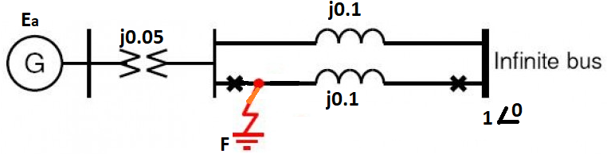

Answer

Q2/

Q3/

QUESTION 1 [10+10+10+10 Marks]
Figure below shows the equivalent network of a 50Hz generator is supplying 280MW to an infinite bus with 1 p.u voltage and unity p.f. through two parallel transmission lines. A temporary three-phase to ground bolted fault occur at point F (Middle of second transmission line). Per unit inertia constant H = 4 sec. Compute
- Machine power angle relations before, during and after faults.
- The maximum allowable machine angle.
- The critical fault clearing angle.
- The critical fault clearing time.
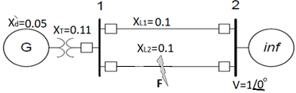

QUESTION 2 [35 Marks]

The fuel-cost curves of two generators are given as follows:

The penalty factor for the first generator (the slack bus) is equal to one. For the second generator the partial derivative of the losses with respect to
$$P_{G2} is \frac{dP_{loss}}{dP_{G2}}=0.2$$

Calculate the optimal dispatch values of PG1 and PG2 for load + losses of 1000 MW.

QUESTION 3 [7+18 Marks]
- Define the Power Quality
- State types of Power Quality Problems with figures illustrated for problems

Typical solution of PSA

Answer Q1

Answer Q2

Answer Q3

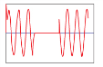
1) Power quality can be defined as “the measure, analysis, and improvement of the bus voltage to maintain a sinusoidal waveform at rated voltage and frequency.”
2) Types of Power Quality Problems
1- Momentary Interruption
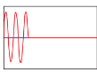
2- Temporary Interruption
3- Long-Term Outage

4- Sag or Undervoltage

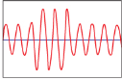
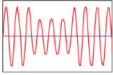
5- Swell or Overvoltage

6- Transient, Impulse, or Spike
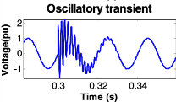

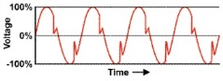
7- Notch

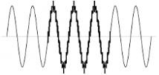
8- Noise

9- Harmonic Distortion
