CONNECTIVE TISSUE (C.T.)

- C.T. is widely distributed all over the body.

- Every organ is composed of or ensheathed by some C.T.

- C.T. consists of cells and extracellular matrix that includes fibers and specialized types of proteins forming the ground substances.
- All C.T. contain isolated cells surrounded by extracellular matrix.

- The C.T. cells synthesis their own matrix that hold organs together.

- C.T. viscosity and tensile strength vary according the arrangement of their matrix fibrous and amorphous materials.
Function of C.T.

The functions of the various types of C.T. are generally depending on the types of cells, fibers, and the characters of the ground substances in the matrix. The functions include the binding together, support, and physical and immunologic protection of other tissues and organs, as well as storage.

- Connective tissue composed of:- C.T. fibers; C.T. cells; and Matrix

- The Fundamental Components: Connective tissue types differ in microscopic appearance, but all consist of cells, fibers, and ground substance (matrix). Connective tissue types and subtypes are classified according to the amounts, types, and proportions of these components.
A- Connective Tissue Fibers

1- Collagen Fibers

- They are found in all connective tissues and in the reticular laminae of certain basement membranes.
- They are flexible and have high tensile strength.

- With L/M. the fibers are wavy with variable width and length.

- They are stained pink with Eosin, blue with Mallory, and green with Masson's trichrome.

- With E/M. appears as bundles of fine fibrils, uniform in diameter, the surface show transverse bands at equal distances (68 nm).

EM picture of collagen fibers showing the striation (arrows within the circle)

2- Reticular Fibers

- The fibrils are branched, with a narrow diameter, and do not bundle to form thick fibers.

- Reticular fibers provide a supporting framework for cellular constitutes of various organs.
- They are not stained by routine H&E stain, stained with Silver technique, and they are PAS positive (contain sugar group) fibers.
- Reticular cells produce the collagen of reticular fibers in Hemopoietic and lymphatic tissues.
- Fibroblasts produced reticular fibers in other locations.- Schwann cells secret reticular fibers in endoneurium (Nervous system).

- Smooth muscles in the wall of blood vessels and of the alimentary canal secret reticular fibers and other collagen.

3- Elastic Fibers

- Elastic fibers are thin and branched fibers.

- They allow tissue to respond to stretch and distension.
- Elastic fibers are interwoven with collagen fibers to limit the dispensability of tissue and prevent excessive stretching.
- We cannot identify elastic fibers from collagen fibers with routine H&E stain, but we can do with special ORCEIN stain as shown in the next figure.
- Elastic fibers are produced as collagen by fibroblast and smooth muscle cells.
- Elastic fibers present in arterial walls, interalveolar septa, bronchi and bronchioles of the lungs, vocal ligaments, and ligamenta flava of the vertebral column.

B- Connective Tissue Matrix

-The ground substance is a viscous, clear with high water content.

- With the light microscope, it appears amorphous in sections of frozen tissues stained with

PAS.

- But it lost during tissue fixation and dehydration in routine H&E stain for the paraffin sections.
- The extracellular matrix is a complex structure that surrounds and supports cells within tissue.
- The CT matrix contains variety of fibers (collagen and elastic), and ground substance that occupies the spaces between the cells and fibers.

- The matrix provides mechanical and structural support as well as tensile strength for the tissues.
- It also provides pathways for cell migration, and cell differentiation.

- It functions as a biochemical barrier and has a role in regulating the metabolic activity.

- The matrix has the ability to bind growth factors which in turn enhance cell growth.

- It facilitates cell communication (transmission of molecules and information across the plasma membranes).

C- Connective Tissue Cells

- Resident (Fixed) Cells:-

- Fibroblasts - Myofibroblasts

- Macrophage - Adipose cells

- Mesenchymal stem cells - Mast cells

- Pericytes

- Transient (Migrating) Cells:-

- Lymphocytes - Plasma cells

- Neutrophils - Monocytes

- Basophils - Eosinophils

Fibroblast

- Fibroblasts, the most abundant cell type in the C.T., are responsible for synthesis of most extracellular matrix.
- They are derived from undifferentiated mesenchymal cells, and are present in two states:- Active and Inactive (quiescent) form.

1- Active fibroblast

- Present in close association with collagen bundles.
- The cells are elongated, fusiform, flattened

cells with branching processes, pale staining cytoplasm, and large, dark stained, granular nucleus.
- Marked increase or rER, free ribosomes, enlarged Golgi.

2- Inactive fibroblast (Fibrocytes)

- Smaller, more ovoid cell , cells with acidophilic cytoplasm, and small deeply stained nucleus.- The cytoplasm contain few rER, abundance of free ribosomes.

Myo-fibroblast

- They are modified fibroblast demonstrate some characters similar to both fibroblast and smooth muscle cells.
- EM reveals that myofibroblasts have bundles of actin filaments similar to those of smooth muscle cells.
- They are abundant in areas of wound healing.

Mesenchymal stem cells

They are the precursors of most connective tissue cells. Embryonic mesenchyme comprises a loose network of stellate cells and abundant intercellular fluid. Some mesenchymal cells remain undifferentiated in adult connective tissue and constitute a reserve population of stem cells called adventitial cells, which are difficult to distinguish from some fibroblasts.

Pericytes (Perivascular cells)

- They are branched cells with flattened nuclei.

- Derived from undifferentiated mesenchymal cells.

- Surround endothelial cells of blood capillaries and venules.

- They have the characters of both smooth muscle cells and endothelial cells.
- They can differentiate into fibroblasts and smooth muscle cells

(myo-epithelial cells).

Plasma cells

- They are derived from B-lymphocytes that have interacted with antigen to produce and secret antibodies.
- Plasma cells are scattered throughout C.T., particularly in areas of inflammation and where microorganisms enter the tissues.
- Once they are differentiated, they have limited migratory capacity, and a short lifespan (2 –

3 weeks).

- Plasma cells are large, ovoid cells (20um) with an eccentric nucleus, where hetero-chromatin radiating from the center giving it a clock faces or cartwheel appearance.
- Their cytoplasm is intensely basophilic with well developed rER with closely spaced cisternae, few mitochondria scattered between rER, acidophilic inclusion (Russel Bodies), pale area close to the nucleus contain Golgi bodies and centrioles .

EM and diagrammatic illustration of plasma cell

Mast cell

- Mast cells are derived from bone marrow (Basophils), and differentiate in C.T., and present along

B.Vs.

- They are large, ovoid cells (20 – 30um), with spherical nucleus and granulated cytoplasm.

- The cell surface contains numerous microvilli and folds.

- The cytoplasm contains small amount of rER, mitochondria, and a Golgi apparatus.

- There are two types of human mast cells has been identified based on the morphology and biochemical properties:--
- C.T. mast cells have cytoplasmic granules with lattice-like internal structure, and they contain granule-associated tryptase and chymase (MCTC).
- Mucosal mast cells have granules with a scroll-like internal structure, and produce tryptase only (MCT).
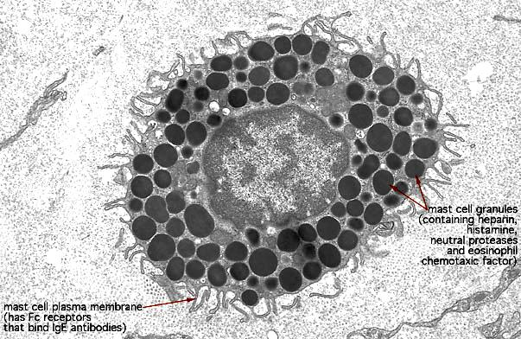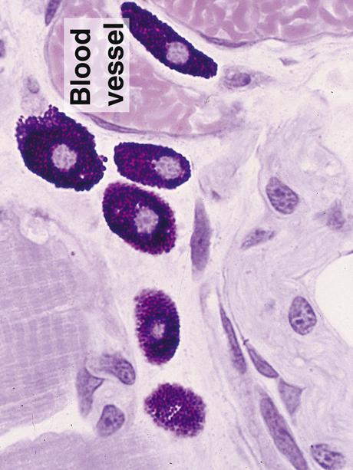

EM and light microscopic picture of mast cell showing the cytoplasmic granules

Phagocytes
-Macrophages (Histiocytes) are phagocytic cells and are derived from monocytes.

- The surface shows numerous folds and finger like projections.

- Macrophages contain large Golgi apparatus, rER, sER, mitochondria, indented or kidney shaped nucleus, secretory vesicles and many lysosomes.
- Their function is phagocytosis, either as a defense activity (phagocytosis of bacteria), or as a clean up operation (phagocytosis of cell debris), and acting as antigen presenting cells
- When encounter large foreign bodies they fuse to form multinucleated cells that engulf the foreign bodies (foreign body giant cells).
- Macrophages localized in certain region of the body were given specific names:--

- Kupffer cells: in liver - Dust cells: in lung

- Langerhans cells: in skin - Monocytes: in blood

- Osteoclast: in bone - Microglia: in brain

Adipocytes (Fat cells)
- Adipocytes are C.T. cell store neutral fat, and produce a variety of hormones.

- They are differentiated from undifferentiated mesenchymal cells, and accumulate fat in their cytoplasm.
- There are two types of fat cells:-
- Unilocular fat cells as in white adipose tissue.

- Multilocular fat cells as in brown adipose tissue.

- Unilocular fat cells are large, spherical cells (120um), store fat gradually making the cytoplasm and the nucleus displaced peripherally giving the cell a signet ring appearance.
- Also, there are a small Golgi apparatus, few mitochondria, sparse rER, and abundant free ribosomes.

Histogenesis:
- Unilocular adipocytes derive from mesenchymal precursor cells that resemble fibroblasts. The appearance of numerous small lipid droplets in the cytoplasm signals the transformation of these cells into lipoblasts. As lipid accumulation continues, the small droplets fuse until a single lipid droplet forms.
- The multilocular adipocytes of brown fat derive from mesenchymal precursors that assume an epithelial shape and arrangement.

Reticular cells

Reticular cells are typically stellate with long, thin cytoplasmic processes. Each has a central, pale, irregularly rounded nucleus and a prominent nucleolus. In the cytoplasm, the number of mitochondria and the degree of development of the Golgi complex and RER arevariable. They produce the reticular fibers that form the network stroma of hematopoietic and lymphoid tissues. Some can phagocytose antigenic material and cellular debris. Others (antigen-presenting cells) collect antigens on their surfaces and help activate immuno- competent cells to mount an immune response.

Other blood derivative connective tissue cells

- Neutrophils | - Eosinophils
- Basophils | - Lymphocytes | - Monocytes

