Dr. Khabat A.Ali

Questions of histology
1. Answer with true or false (there is penalty for wrong answers)
• Lymphoid tissue is found in the intestinal tract
• The thymus increases in size with age
• The neutrophils have the highest count in human blood
2. Define: Stereocilia, thymus, muscle spindle.
3. Mention the type of epithelium for the following:

Esophagus
urinary bladder
conjunctiva
skin
endothelium

4. What are the functions of bone?
5. Compare

Skeletal muscles | Cardiac muscles

6. How you explain racial color difference?
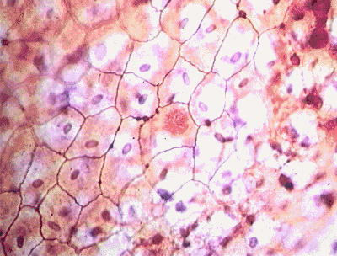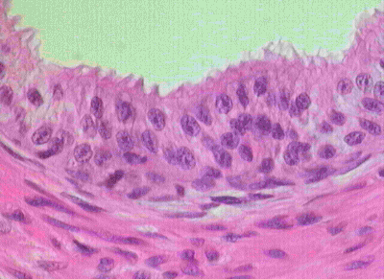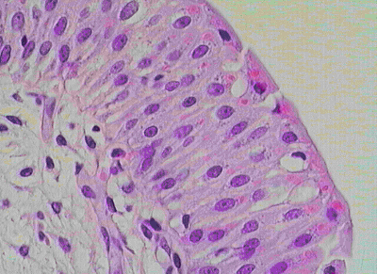7. Identify & Label the following:

8. Compare between skeletal & cardiac muscles regarding: Nuclei, t-tubule, mitosis, intercalated disk, contraction
9. Give five differences between white & brown fat.
10. Mention in order the layers of the epidermis.
11. Enumerate the types of hair in human.
12. Describe the gross appearance of different types of cartilage
13. Enumerate the main functions of bone.
14. Discuss the apical cell surface specialization.
15. What are the characteristic features found in human face skin?
16. The type of muscle in the tongue is……
17. The white fiber has a……………..diameter than red fiber
18. The central dark line that bisects the muscle fiber (by E.M) is…………
19. The epithelial lining of urinary bladder is ….……………
20. What is lymphocyte?
21. What are the light & electron microscopical features of cardiac muscles?
22. What are the features of human hair?
23. What are the layers that separate air from blood in the lung?
24. What is capillary?
25. Mention (in order) layers of skin from uppermost to lower most layer.
26. What is membrane?
27. Regarding connective tissue:
• Define
• Classify
• Mention the types
• What are the functions?
• What are the components?
28. How lymphatic vessels differ from blood vessels?
29. What are osteoblasts & osteoclasts?
30. Pseudostratified epithelium:
• Define
• What are the functions?
• Mention the location.
31. What is lymphocyte?
32. What are the light & electron microscopical features of cardiac muscles?
33. Define the epithelium, functions & classification. Give examples.
34. What are the cells found in the respiratory tract?
35. What are the histological differences between artery & vein?
36. What are the functions of bone, & how bone is formed?
37. What are granulocytes & agranulocytes?
38. Compare between different types of adult human cartilage.
39. What are the factors that determine human’s skin color?
40. : Compare between cardiac & smooth muscles in:
a. T- Tubules, striation, site, neural control, response to injury.
b. 33: What are the types of human hair? Give examples
41. What is integument? What are the functions?
42. Classify bones depending on anatomical basis with examples.
43. Draw & label a sarcomere showing: Z-disk, I-band, M-line, H-band, A-band
44. Enumerate five fixed cells of connective tissue.
45. Give an example for each of the following: Flagellated cell, Sesamoid bone, Type IV
collagen, largest leukocyte, transitional epithelium
46. Draw & label a peudounipolar neuron.
47. Define blood & mention the functions.
48. What is the difference between active & inactive fibroblast
49. Define: osteoclast, megakaryocyte, myelin, Hassall corpuscle, parenchyma

50. Define: serosa, Brown fat
51. What are the types of epithelium in the following?
a. Skin
b. esophagus
c. Urinary bladder
52. Enumerate the functions of?
a. Skin
b. Myelin
53. Draw & label pseudo stratified epithelium.
54. Choose the most appropriate:
55. Hibernating animals mostly contain a. White fat
b. Brown fat
56. Skin colour is due to pigment called i. Hemosidrin
ii. Lipofuscin iii. Melatonin

57-Answer the following

1: Define: Serosa, Brown fat
2: What are the types of epithelium in the following?
a) skin
b) Esophagus
c) Urinary bladder
3: enumerate the functions of?
a) Skin
b) Myelin
4: draw & label pseudo stratified epithelium.
5: choose the most appropriate:
Hibernating animals mostly contain
1. White fat
2. Brown fat
Skin colour is due to pigment called
1. Hemosidrin
2. Lipofuscin
3. Melatonin

6- Answer with true or false (there is penalty for wrong answers)
1. Lymphoid tissue is found in the intestinal tract
2. The thymus increases in size with age
3. The neutrophils have the highest count in human blood

7: Describe the gross appearance of different types of cartilage

8: Enumerate the main functions of bone.

9: Discuss the apical cell surface specialization.

10: What are the characteristic features found in human face skin?

11: Fill in the blanks:

1. The type of muscle in the tongue is……
2. The white fiber has a……………..diameter than red fiber
3. The central dark line that bisects the muscle fiber (by E.M) is…………
4. The epithelial lining of urinary bladder is ….……………

12: What is lymphocyte?

13: What are the light & electron microscopical features of cardiac muscles?

14: What are the features of human hair?

15: What are the layers that separate air from blood in the lung?

16: What is capillary?

17: Mention (in order) layers of skin from uppermost to lower most layer.

18: What is membrane?

19: Regarding connective tissue:

a) Define b) Classify
c) Mention the types
d) What are the functions?
e) What are the components?

20: How lymphatic vessels differ from blood vessels?

21: What are osteoblasts & osteoclasts?

22: Pseudostratified epithelium:

a) Define
b) What are the functions?
c) Mention the location.

23: What is lymphocyte?

24: What are the light & electron microscopical features of cardiac muscles?

25: Define the epithelium, functions & classification. Give examples.

26: What are the cells found in the respiratory tract?

27: What are the histological differences between artery & vein?

28: What are the functions of bone, & how bone is formed?

29: What are granulocytes & agranulocytes?

30: Compare between different types of adult human cartilage.

31: What are the factors that determine human’s skin color?

32: Compare between cardiac & smooth muscles in:

T- Tubules, striation, site, neural control, response to injury.

33: What are the types of human hair? Give examples

34: A-What is integument? What are the functions?
B- Classify bones depending on anatomical basis with examples.

35: A-Draw & label a sarcomere showing: Z-disk, I-band, M-line, H-band, A-band

B-Enumerate five fixed cells of connective tissue.

36: A-Give an example for each of the following:

Flagellated cell, Sesamoid bone, Type IV collagen, largest leukocyte, transitional epithelium

B-Draw & label a peudounipolar neuron.

37: Define blood & mention the functions.

38: Define: Stereocilia, thymus, muscle spindle.

39: A- Mention the type of epithelium for the following: Esophagus, urinary bladder, conjunctiva, skin, endothelium
B-What are the functions of bone?

40: A-How you explain racial color difference?

B-Compare between skeletal & cardiac muscles regarding: Nuclei, t-tubule, mitosis, intercalated disk, contraction
41: A- Give five differences between white & brown fat.

B- Mention in order the layers of the epidermis.

42: A-Enumerate the types of hair in human.

B-What is the difference between active & inactive fibroblast

43: Define: osteoclast, megakaryocyte, myelin, Hassall corpuscle, parenchyma

