زانکۆی سەلاحەدین-هەولێر
Salahaddin University-Erbil

Prevalence of Helicobacter pylori in Erbil city/Iraq
Research project
Submitted to the department of Biology /College of Education in partial fulfillment of the requirements for the degree of BSc. in Biology

By
Asuda Khaled Muhamadamen
Supervised by
Prof. Dr. Khadija Khalil Mustafa Barzani
2022-2023

﴿قُلْ هَلْ يَسْتَوِي الَّذِينَ يَعْلَمُونَ وَالَّذِينَ لاَ يَعْلَمُونَ إِنَّمَا يَتَذَكَّرُ أُولُو الألْبَابِ﴾
سورة الزمر / الآية 9

SUPERVISOR CERTIFICATE
This research project has been written under my supervision and has been submitted for the award of the degree of BSc. in Biology with my approval as a supervisor.

Signature:
Name: Dr. Khadija Khalil Mustafa
Date:

I confirm that all requirements have been fulfilled
Signature:
Name: Assist. Prof. Dr. Kazhal M. Sulaiman
Head of the department of biology
Date:

DEDICATION
This work is dedicated to
My family
My special friends
My supervisor

ACKNOWLEDGEMENTS
First of all, I would like to thank the merciful of "ALLAH" help me to successfully complete my study.
My deepest gratitude to my supervisor Prof. Dr. Khadija Kh. M. Barzani for her supervision and choosing of this project, scientific guidance, and support during the period of the study.
My deepest thanks to the deanery of the Education College, head and all staff of biology department for their kindness and support
Iwould like to express my thanks to the Ministry of Higher Education and Scientific Research and presidency of Salahaddin University /Erbil.
Thanks for all my friends who help me to complete my study and thanks for my family which help me for complete my research.

SUMMARY
Helicobacter pylori is a spiral-shaped Gram-negative bacterium, which plays a role in the development of gastritis, peptic ulcers, and gastric cancers in humans. In present study the total number of patients admitted both Komary and Rizgary Teaching hospital in Erbil city/ Iraq during 2019,2021,2022 were 2,320 patients including 898 males and 1,422 females with age ranged from 10- 60 years old and the specimens was took from blood and stool. The results showed that 1,233 (160.99%) patients infected with H. pylori . However, the H. pylori infection in females was higher than males in current study which were 232 (53.46%) and 127 (45.04 %). It is worth to mention , the results of asking of 50 individuals including 35 females and 15 males; showed that most of individuals with H. pylori had a significantly higher risk of experiencing psychological distress beside its symptoms and depressive mood regardless of H. pylori infection .

TABLE OF CONTENTS
Title Page
SUPERVISOR CERTIFICATION……..……………………………………….III
DEDICATION……………………………………………………………….……IV
ACKNOWLEGEMENT….…………………………………………………........V
ABSTRACT.…………………………………………………………………….....VI
TABLE OF CONTENT………….……………………………………………….VII
LIST OF TABLES AND FIGURES……………………………………………..VIII
1. INTRODUCTION…………………………………………………………..…..1
2. LITERATURE REVIEW………………………………………………….…..3
2.1Helicobacter pylori History…………………………………………………......3
2.2 Helicobacter pylori Morphology……………………………………………....4
2.3H.pylori Pathogenesis…………………………………………………………...5
2.4 Risk factor………………………………………………………………………7
2.5 Helicobacter pylori Diagnosis……………………………………………..…....8
2.2 Helicobacter pylori Transmission…………………………………………….10
2.3 Association Between H.pylori and Human psychology…………….………..10
3. METHODOLOGY…………….…………………………………….………….12
4. RESULTS AND DISCUSSION…………………………………………..……13
5. CONCLUSSION……………………………………………………………….21
6. RECOMMENDATION………………………………………………………..21
7. REFERENCES…………………………………………………………………22

LIST OF TABLES AND FIGURES
TABLE 1. Total cases, number and percentage of infected and non-
infected patients with H. pylori in 2019 ………………………….…………....14
TABLE 2. Total cases, number and percentage of infected and non-
infected patients with H. pylori in 2021……………………………………….14
TABLE 3. Total cases, number and percentage of infected and non-
infected patients with H. pylori in 2022………………………………….…….15
TABLE 4.Positive and Negative for H. pylori from blood and stool specimens in 2019………………………………………………………………….…………...17
TABLE 5.Positive and Negative for H. pylori from blood and stool specimens in 2021……………………………………………………………………………....18
TABLE 6.Positive and Negative for H. pylori from blood and stool specimens in 2022…………………………………………………………….…………………19
FIGURE 1. Helicobacter pylori shape. .……………..……….……………...…...4
FIGURE2. Helicobacter pylori pathogenesis…………………………….……….6
FIGURE3. Number of males and females infected with Helicobacter pylori in2019,2021.2022 ………………………………………………………….……15

- INTRODUCTION
Annually, people are significantly infected with digestive system because of the presence of bacteria known as Helicobacter pylori. H. pylori infects more than half of the worlds’ population and always causes chronic gastritis , they may progress to severe complications such as peptic ulcer, gastric adenocarcinoma and gastric MALT lymphoma (Malfertheiner et al. ,2022). H. pylori is a Gram- negative microaerophilic bacillus bacterium that infects the epithelial lining of the stomach ( Hooi et al. , 2017) . H. pylori is causative agent of human gastric disease (Boltina et all, 2019). The bacterium is urease , catalase and oxidase-positive is spiral- shaped and possesses 3-5 polar flagella that are used for motility (Sowaid et al. , 2022). About half the worlds’ population is infected with this bacterium , although only a proportion of infected individuals develop symptomatic disease (Covacci et al. ,2000). Individuals infected can be asymptomatic or show occasional episodes of abdominal discomfort ,bloating ,belching ,nausea and vomiting (Salih, 2009). H. pylori is strongly associated with duodenal ulcers (present in as many as 90%of cases) gastric ulcers (up to 80%), and malignancy; it can lead to mucosa-associated lymphoid tissue (MALT) lymphoma and gastric cancer in as many as 90%of cases (Shatila, 2022). The number of White blood cell (WBC), neutrophil, lymphocyte , platelet count(PLT) and mean platelet volume (MPV)values and ratios between them are used as an inflammatory indicater. Neutrophil/lymphocyte ratio (NLR) and Platelet/lymphocyte ratio (PLR) are the most important of these indicators and they were studied recently to determine the severity of various disease , gastric cancer and H. pylori infection (Boyuk et al. , 2020) . Different modes of H.pylori infection transmission have been indicated among which are oral-oral, fecal-oral and gastric- oral routs (Miyaji et al., 2000). Diagnosis of H.pylori infection can be achieved by invasive techniques involving endoscopy and biopsy (such as direct microscopic examination ,rapid urease test , culture and molecular evaluation of biopsy samples) and by non-invasive approaches ,including the 13C-or 14C-urea breath test ,13C-urea blood test , fecal antigen test , serologic method and molecular method (Tarhinia et al., 2018).
The H. pylori is one of the most common bacterial infections worldwide, and the prevalence rates vary among countries and populations even in the same country.

2. LITERATURE REVIEW
2.1 Helicobacter pylori History
Helicobacter pylori infect 30-70% of worlds’ population (Pop et al , 2022). It stimulations indicate that H.pylori spread from East Africa around 58000years ago later evolving into many strains with varing degrees of pathogenicity (Thaker , 2016). H.pylori was not until 40 years ago that is association with gastritis inflammation was demonstrated (Shatila, 2022). H. pylori is the single bacterium classified as a group I carcinogen by the World Health Organization (WHO) (Pop et al., 2022). H. pylori was first identified in the stomach of dogs as a spiral microorganism by Giulio Bizzozero in 1892 . As they are Campylobacter-like spiral microorganisms, they were named Campylobacter pyloridis by Barry Marshall and Robin Warren in 1983. Named it “Helicobacter pylori” in 1989, as it has a helical structure and is mostly found in the pyloric region of the stomach (Öztekin et al., 2021). The relationship between H. pylori and gastric cancer was investigated in 1991 and 1994, and the International Agency for Research on Cancer, a branch of the World Health Organization, reported that H. pylori is carcinogenic in humans, which was reconfirmed in 2009 on the basis of epidemiological data . In the United States, the National Institute of Health reported in 1994 that H. pylori may be the primary cause of peptic ulcer disease and should be treated. Marshall and Warren were awarded the Nobel Prize in 2005 for their work on H. pylori in the field of physiology “for discovering the role of H. pylori bacteria in gastritis and peptic ulcer disease (Öztekin et al., 2021).

2.2 Helicobacter pylori Morphology
Helicobacter pylori is a spiral-shaped or coccoid , Gram-negative bacterium is the most common infectious agent of gastric diseases worldwide, H. pylori is a 0.5–1 µm wide, 2–4 µm long, short helical, S-shaped (Figure 1) and infects more than half of the world’s population (Öztekin et al., 2021). H. pylori exhibits a typical spiral or curved shape on the surface of gastric mucosal epithelial cells and is 2.5−4.0 μm in length and 0.5−1.0 μm diameter based on biopsy specimen observation (Wu et al., 2021). The bacterium is urease, catalase, and oxidase- positive is spiral-shaped and possesses 3 to 5 polar flagella that are used for motility (Sowaid et al. , 2022). Bacterial motility generated by unipolar flagella is essential for penetration of the mucosal layer of the stomach by the helical form. Motility also facilitates antigen-specific association with the gastric epithelium (Hirukawa et al. , 2018).

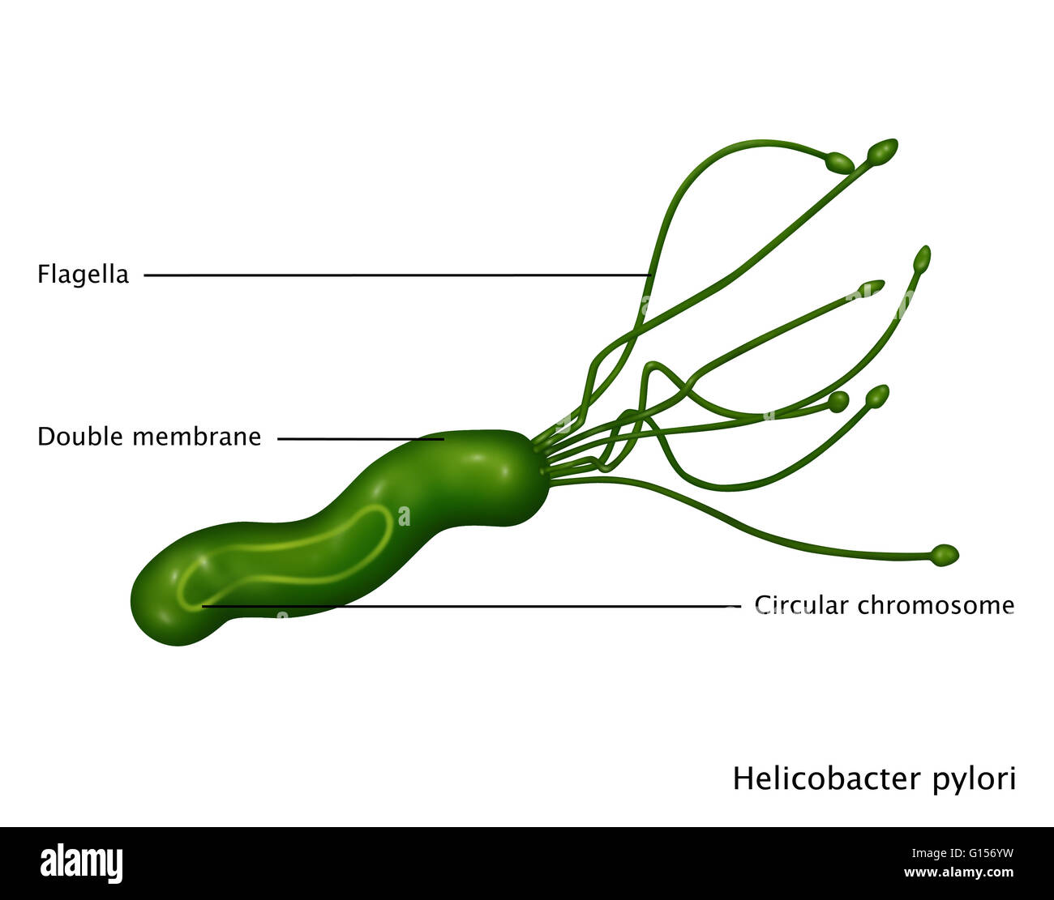
Figure 1. Helicobacter pylori shape
Many researchers also point out that the spiral shape is crucial for proper colonisation of the stomach, and it determines the cork-screwing penetration of dense mucin . Nevertheless, the spiral shape is not the only morphological form created by H. pylori. The large heterogeneity of H. pylori morphological forms includes also the presence of curved/straight rods, filamentous forms, and coccoid forms (Krzyżek and Gościniak, 2018). Several studies have shown through directed mutagenesis that H. pylori morphological changes are mainly dependent on the genes involved in the peptidoglycan synthesis. The involvement of some genes in peptidoglycan structure change, and consequently the morphological change, has been demonstrated through directed mutagenesis; but the mechanism by which the loss of spiral shape occurs remains elusive so far . The evaluation of cell morphology has suggested a relation between the adaptation to water in H. pylori strains and the permanent loss of the spiral shape (Fernandes et al. , 2016). Changes in cell morphology when cultured in vitro under favorable conditions, the majority of H. pylori bacteria have a spiral appearance, but exposure to unfavorable conditions typically results in the conversion to a coccoid form . The H. pylori strains lost their spiral shape after a 168-h exposure period to water (Fernandes et al. , 2016). A study of the bacterial shape’s role in movement showed that a mutation in the cell shape determinants causing the bacteria to adopt a straight rod morphology reduced the speed of bacterial movement by 7–21% (Ansari andYamaoka, 2019).
2.3 H .pylori Pathogenesis
H. pylori is easily killed in hydrochloric acid solutions with a pH below 4.0. It is quite paradoxical for a microorganism whose primary site is the stomach (Figure 2). H. pylori continues to live in the lower part of the stomach by penetrating the mucus layer of the stomach through the contribution of its spiral shape and flagella . To neutralise the acidic pH-related bactericidal activity against H. pylori, which can colonise the gastric epithelial surface, H. pylori hydrolyses urea to ammonia and carbon dioxide with the urease enzyme it produces (Öztekin et al. , 2021). Immune activation elicited by H. pylori begins with the recognition of the bacterial pathogen-associated molecular patterns (PAMPs) by PRRs that are expressed by the innate immune cells or gastric epithelial cells. The major classifications of PRRs, including toll-like receptors (TLRs), NOD-like receptors (NLRs), C-type lectin receptors (CLRs), and retinoic acid-inducible gene (RIG)-I-like receptors (RLRs), are all involved in H. pylori recognition and innate immune activation(Cheok et al., 2022). The epithelial cell of the human gastric region prevents the adhesion, proliferation, and movement of invading pathogens through its ability to form a tight structure. Pathogens like H. pylori disrupt the gastric barrier by the production of harmful soluble components.

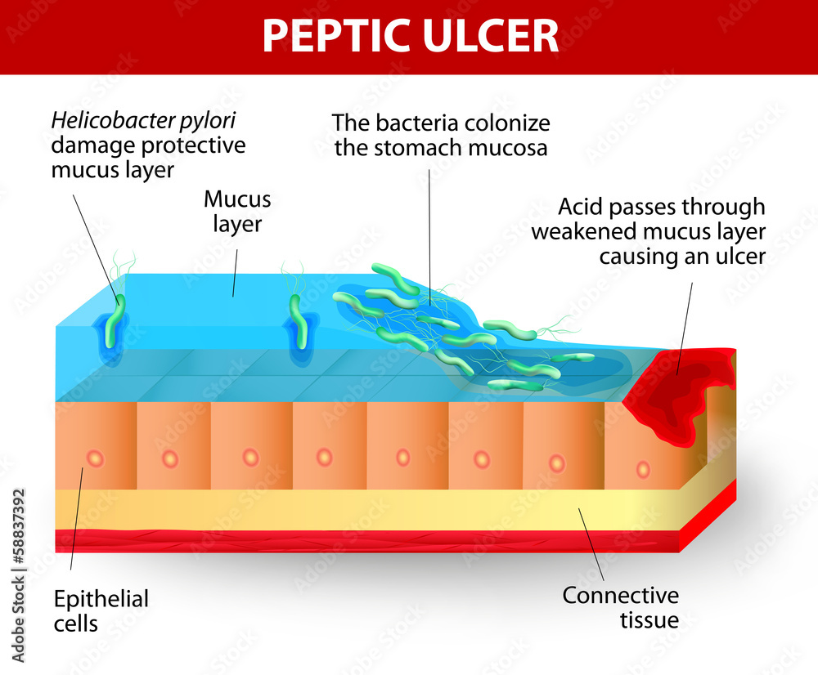
Figure 2. Helicobacter pylori pathogenesis
It also adheres to many epithelial cellreceptors and stimulates various signalling pathways within the host. The colonization and the establishment of diseases and infection by H. pylori depend on four major stages: adaptation to the acidic environment of the gastric mucosa, the movement towards and penetration of the epithelial cell barrier, attachment to specifc receptors, and fnally, tissue damage and other detrimental health effects ( Sharndama and Mba, 2022). After entering the host stomach, H. pylori utilizes its urease activity to neutralize the hostile acidic condition at the beginning of infection. Flagella-mediated motility is then required for H. pylori to move toward host gastric epithelium cells, followed by specific interactions between bacterial adhesins with host cell receptors, which thus leads to successful colonization and persistent infection.( Kao et al., 2016).
2.4 Risk Factor
Risk factors can be categorized on a societal or individual level. The former encompasses geographic location; economic development; and sanitation, including access to clean food and water . Low familial socioeconomic status and overcrowding (i.e., crowded living conditions and large family sizes) are also associated with increased H. pylori prevalence . Consumption of unpasteurized dairy products , sheepherding , high-risk occupations (healthcare) , obesity , male gender , and the gut microbiome pose an increased risk of infection. Smoking and alcohol are two variables that are controversial with respect to their role in H. pylori infections (Shatila and Thomas, 2022). Other virulence factors such as vacuolating cytotoxin (VacA) or cytotoxin-associated antigen (CagA) make major contributions to the development of H. pylori chronic gastritis, which is a complex process involving also the contribution of the host’s immune responses . Vac A is expressed by approximately 50% of H. pylori strains in its mature form and enables the synthesis of pro inflammatory cytokines, also facilitating chronic colonization of the gastric mucosa . In addition, VacA is able to change the structure of anions within endosomes, causing osmotic edema and subsequent apoptosis in the gastric epithelium . CagA, probably the most important virulence factor of H. pylori, if present, contributes to the activation of certain pro inflammatory pathways such as NF-kB, resulting in severe inflammatory responses, but at the same time, it favors the production of catalase, which enhances the survival of H. pylori within the host’s gastric microenvironment by hindering the formation of reactive oxygen compounds from hydrogen peroxide ( Mărginean et al., 2022).

2.5 Helicobacter pylori Diagnosis
Infection may be symptomatic or asymptomatic (without visible ill effects). It is estimated that up to 70% of infection is asymptomatic. The bacteria have been isolated from feces, saliva and dental plaque of infected patients, which suggests gastro-oral or fecal-oral as possible transmission routes. It is estimated that about 2/3 of the world population are infected by the bacterium.(Karlik et al., 2002).
Each of the diagnostic tests used to detect the presence of H. pylori has advantages, disadvantages, and limitations, and the necessity of endoscopy is taken into account when classifying the methods. Combinations of more than one test give more reliable results (Öztekin et al., 2021).
Endoscopy a conventional endoscopic exam is usually performed to diagnose H. pylori- associated diseases, such as peptic ulcer diseases, atrophic gastritis, MALT lymphoma, and gastric cancer. Endoscopy is also an instrument routinely used to obtain specimens, usually gastric mucosa from biopsy (sowaid et al. , 2022). Histology gastric biopsies from the antrum and body are immersed in formalin and sent to pathology department for embedding and section onto glass slides under routine preparations for microscopic examination ( Wong etall,1997). Rapid urease test widely used test in endoscopy room for rapid detection of H. pylori infection. A gastric biopsy from the antrum is placed in the urea broth (5% urea solution with phenol red). If there is preformed urease produced by H. pylori in the biopsy specimen, the urease will hydrolyze urea in the broth to ammonium ions ( Wong et al., 1997, Mărginean et al., 2022). Culture Although it should be stated that H. pylori culture is not a routine procedure in initial diagnosis, in many bacteriology laboratories H. pylori isolation via the culture of biopsy samples is a routine second line approach ( Kalali et al. , 2015).
Polymerase chain reaction to detect H. pylori infection, PCR has been used extensively for the diagnosis of H. pylori from gastric biopsy specimens, saliva, stool, gastric juice, and variable specimens. PCR provides excellent sensitivity , fewer bacteria required in the sample specificity, greater than 95%, as compared with other conventional tests and has more accurate faster results of detecting H. pylori in patients with bleeding. Several target genes including 16S rRNA, 23S rRNA, UreA, UreB, glmM, UreC, HSP60, CacA, and VacA genes, had been used for detection of H. pylori (Sowaid et al., 2022).
Serology H. pylori infection provokes both local and systemic antibody responses. The response typically includes a transient rise in IgM, followed by a rise in IgA and IgG throughout the infection. The most commonly employed method is enzyme-linked immunosorbent assay (ELISA). Others include latex agglutination and Western blotting. Serology tests can be applied to whole blood, saliva, urine or serum samples (Wong et al., 1997).
Urea breath test (UBT) is one of the most accurate method available for the detection of H. pylori infection . It is suitable for initial diagnosis as well as post-treatment evaluation and long term monitoring. UBT involves giving a test meal to delay gastric emptying first, and then to drink an oral dose of urea labelled with carbon-13 or carbon-14. If H. pylori is present, the carbon-labelled urea will be broken down by the urease produced by the organism to become labelled carbon dioxide that can be detected in the patient’s breath ( Wong et al., 1997).
Stool Antigen Test (SAT) identifies the H. pylori antigen in stools, and it requires a small sample of feces that can be collected at home if it is sent to a laboratory within an appropriate time (Mărginean et al., 2022 , Shatila et al., 2022).

2.6 Helicobacter pylori Transmission
Although there are well-described risk factors for infection, and plausible hypotheses, the precise mode of transmission has not been definitively established. Most infection appears to occur in early childhood, with a minority of cases developing in adults. There is strong evidence from epidemiology and genetic studies of person-to-person transmission, particularly within families. Mothers appear to be particularly important in transmission to their young children. Ingestion of the organism seems most plausible via the gastro–oral or oral–oral route. Fecal–oral transmission appears less likely, at least in developed countries. Whether transmission occurs via water, food, household pets, or flies is still a matter of speculation (Katelaris et al., 2021).
2.7 Association Between H.pylori and Human Psychology
Helicobacter pylori and nonsteroidal anti-inflammatory drugs have long displaced stress as accepted causes of peptic ulcer, and authoritative sources now commonly discount or ignore a role for psychosocial factors. The concept that psychological factors contribute to ulcer etiology has not disappeared, but no prospective studies have linked stress with incident medically confirmed ulcer in population-based data sets taking all major risk factors into consideration (Levenstein et al.,2015). Upper digestive tract diseases, including both functional dyspepsia and dyspeptic symptoms in the course of gastritis or peptic ulcers, were considered for many years to be psychosomatic. The presence of H. pylori-negative upper digestive tract abnormalities, such as peptic ulcers, and the fact that not all H. pylori-infected patients develop ulcers, with only 10%-15% of them presenting dyspeptic symptoms, suggest a role for other individual factors, including nervous system imbalance, as an indispensable cofactor in gastritis or ulcer disease pathogenesis ( Budzyński and Kłopocka, 2014). The brain-gut axis is anatomically based in the central (CNS), peripheral (PNS, enteric nervous system, or “little brain”), and autonomic nervous systems (ANS), and modulates gastrointestinal function via the regulation of the gastrointestinal immune system, mucosal inflammation and intestinal microbiota in response to stress, emotions and environmental influences. This circuitry acts bidirectionally, playing a role both in upper (peptic ulcer, functional dyspepsia) and lower [irritable bowel syndrome (IBS), inflammatory bowel disease (IBD)] digestive tract homeostasis, appetite and weight control, modulation of the gut-associated immune system and in the coordination of the gastrointestinal tract with the overall physical and emotional state of the organism ( Budzyński and Kłopocka, 2014). Dyspepsia, a common disorder throughout Europe, is prevalent in about 30% of the general population. It is defined as recurrent or persistent pain or discomfort in the upper abdominal region, with or without contamitant symptoms like postprandial fullness, bloating, nausea, vomiting, heartburn, or regurgitation. Various researchers point out that psychological factors like neuroticism, anxiety, and depression are more prominent in functional and in organic dyspepsia patients, than in healthy people (Quartero et al., 1999).

- METHODOLOGY
In Current study the data and information were collected for three years (2019,2021,2022) from the medical records of in Komary and Rizgary Teaching hospitals in Erbil city in Iraqi Kurdistan Region including 2,320 patients including 898 males and 1,422 females with age ranged from 10- 65 years old . In 2019, 716 patients were admitted to different hospitals including 282 males and 434 females with age ranged from 14- 60 years old . While in 2021, 750 patients were admitted to different hospitals including 300 males and 450 females with age ranged from 10- 65 years old. Moreover in 2022, 854 patients were admitted to different hospitals including 316 males and 538 females with age ranged from 10- 65 years old and all specimens were taken from blood and stool. The form was made for all cases after the final diagnosis of H. pylori which identified by a physician and containing scientific name of bacteria, number of infected patients, gender, and clinical source. On the other hand, 50 ( 35 females and 15 males) infected persons with H. pylori were taken and asked about adverse effects of disease on their psychological status.

- RESULTS AND DISCUSSION
The total number of patients admitted both Komary and Rizgary Teaching hospital in Erbil city during 2019,2021,2022 were 2,320 patients including 898 males and 1,422 females with age ranged from 10- 60 years old and the specimens was took from blood and stool. Depending on hospital medical records the results showed that 1,233 (160.99%) patients infected with H. pylori as illustrated in table (1,2,3) .
In 2019, 716 patients were admitted to different hospitals in Erbil city including 282 males and 434 females with age ranged from 14- 60 years old and the specimens was took from blood and stool. Depending on hospital medical records the results showed that 359 (50.14%) patients infected with H. pylori as illustrated in table (1). However , the H. pylori infection in female was higher than male in current study which were 232 (53.46%) and 127 (45.04 %), respectively (Figure 3).
While in 2021, 750 patients were admitted to different hospitals in Erbil city including 300 males and 450 females with age ranged from 10- 65 years old and the specimens was taking from blood and stool. The results showed that 524 (69.87%) patients infected with H. pylori as illustrated in table (2). Furthermore, the H. pylori infection in female was higher than male in current study which were 360 (80%) and 164 (54.67 %), respectively (Figure 3).
Moreover in 2022, 854 patients were admitted to different hospitals in Erbil city including 316 males and 538 females with age ranged from 10- 65 years old and the specimens was taking from blood and stool. The results in this year showed that 350 (40.98%) patients infected with H. pylori as showed in table (3). The H. pylori infection in female was higher than male in current study which were 129 (40.82%) and 221 (41.82 %), respectively (Figure 3).
Table 1. Total cases, number and percentage of infected and non- infected patients with H. pylori in 2019.
Gender | Total cases | No. of infected patients | % of infected patients | No. of non- infected patients | % of non- infected patients
Male | 282 | 127 | 45.04 | 155 | 54.96
Female | 434 | 232 | 53.46 | 202 | 46.54
Total | 716 | 359 | 50.14 | 357 | 49.86

Table 2. Total cases, number and percentage of infected and non- infected patients with H. pylori in 2021.
Gender | Total cases | No. of infected patients | % of infected patients | No. of non- infected patients | % of non- infected patients
Male | 300 | 164 | 54.67 | 136 | 45.33
Female | 450 | 360 | 80 | 90 | 20
Total | 750 | 524 | 69.87 | 226 | 30.13

Table 3. Total cases, number and percentage of infected and non- infected patients with H. pylori in 2022.
Gender | Total cases | No. of infected patients | % of infected patients | No. of non- infected patients | % of non- infected patients
Male | 316 | 129 | 40.82 | 187 | 59.18
Female | 538 | 221 | 41.08 | 317 | 58.92
Total | 854 | 350 | 40.98 | 504 | 59.02

The bacterium H. pylori olonize the stom h in pproxim tely half of the world’s population. H.pylori is strongly associated with duodenal ulcers (present in as many as 90% of cases), gastric ulcers (up to 80%), and malignancy; it can lead to mucosa-associated lymphoid tissue (MALT) lymphoma, as well as gastric cancer in as many as 90% of cases . Among many unique characteristics of H. pylori, one of the most remarkable is its capacity to persist for decades in the harsh gastric environment due to the inability of the host to eliminate the infection. Unlike other viruses and bacteria, H. pylori have evolved the ability to colonize the highly acidic environment found within the stomach by metabolizing urea to ammonia via urease, which generates a neutral environment enveloping the bacterium (Sowaid et al., 2022).
Infection with this bacterium is associated with gastritis, peptic ulcer, adenocarcinoma, and gastric mucosa-associated lymphoid tissue lymphoma. Besides being a pathogen with worldwide prevalence, H. pylori show increasingly high antibiotic resistance rates, making the development of new therapeutic strategies against this bacterium challenging (Angela et al., 2020).Urease is an important adjuvant factor for bacterial colonization since it breaks urea into ammonia such that the increase in gastric pH required for bacterial survive in the gastric microenvironment can be determined. H. pylori has developed an acid acclimation mechanism that promotes adjustment of periplasmic pH in the harsh acidic environment of the stomach by regulating urease activity .( Mărginean et al., 2022).
The variations in peptic ulcer in different geographical, historical, and social contexts are unequivocal evidence of the influence of ways of life in this disease. The specific elements that contribute to the variations probably include diet, alcohol, cigarette smoking, emotional strain, personality, and genotype and this does not 11 exclude the possibility that a major single causal effect awaits discovery (Marshall, 1997). Ahmed et al., (2008) and Alipour (2021) assessed the relationship between subjects with a history of gastric or duodenal ulcer and the risk of infection in their offspring in population which is considered the population being considered at high risk of stomach cancer. It was observed that the transmission of H. pylori may be influenced by the presence of ulcer or that H. pylori strains causing peptic ulcer may be more infective than other strains as published in earlier studies. Chances of exposure are widespread and infection occurs early in life under the age of five. About 79-83% of the population is exposed to H. pylori during the first two decades of life (Graham et al., 1991; Gill et al., 1994). Also these results support the hypothesis that sex-specific metabolic factors are associated with H. pylori infections (Wu et al., 2022). The explanation behind in the females more than males it was that people under stressful conditions develop low immunity, so they are more liable for contracting the infection.
On the other hand, in 2019 all specimens were taken from patients’ blood and stool. In 470 blood specimens 230 of them (48.94%) were positive for H. pylori including 70 males and 160 females, while 240 specimens were negative for H. pylori including 90 males and 150 females. In addition to 246 stool specimens which 129 of them ( 52.44%) were positive for H. pylori including 57 males and 72 females, while 117 specimens were negative for H. pylori including 65 males and 52 females (Table 4).

Table 4. Positive and Negative for H. pylori from blood and stool specimens in 2019.
Specimens | Positive for H. pylori |  |  | Negative for H. pylori
Blood  (470) | Male | Female | Total | Male |  | Female | Total
 | 70 | 160 | 230 | 90 | 150 |  | 240
Stool  (246) | 57 | 72 | 129 | 65 | 52 |  | 117
Total | 127 | 232 | 359 | 155 | 202 |  | 357
In 2021; 450 blood specimens 250 of them(55.56%) were positive for H. pylori including 180 males and 70females , while 200 (44.44%) specimens were negative for H. pylori including 85 males and 115 females. In addition to 350 stool specimens which 300 of them (85.71 %) were positive for H. pylori including 200 males and 100 females, while 50 (14. 29%) specimens were negative for H. pylori including 27males and23 females (Table 5).
Table 5. Positive for H. pylori from blood and stool specimens in 2021.
Specimens | Positive for H. pylori |  |  | Negative for H. pylori
Blood  (450) | Male | Female | Total | Male |  | Female | Total
 | 180 | 70 | 250 | 85 | 115 |  | 200
Stool  (350) | 200 | 100 | 300 | 27 | 23 |  | 50
Total | 380 | 170 | 524 | 112 | 138 |  | 250

In 2022 in contrast to other years 520 blood specimens 249 of them (47.88%) were positive for H. pylori including 98 males and 151 females, while 271 specimens were negative for H. pylori including 94 males and 177 females. In addition to 334 stool specimens which 101 of them ( 30.24%) were positive for H. pylori including 31 males and 70 females, while 233specimens were negative for H. pylori including 93 males and 140 females (Table 6).

Table 6. Positive and Negative for H. pylori from blood and stool specimens in 2022.
Specimens | Positive for H. pylori |  |  | Negative for H. pylori
Blood  (520) | Male | Female | Total | Male |  | Female | Total
 | 98 | 151 | 249 | 94 | 177 |  | 271
Stool  (334) | 31 | 70 | 101 | 93 | 140 |  | 233
Total | 129 | 221 | 350 | 187 | 317 |  | 504

It means that taking of stool specimens are better than blood specimens for detection of H. pylori infection according to present study in year 2019 and 2022 while reverse is true for year 2022 and these results may be related to sample size . Accurate and simple tests for the detection of H. pylori infection are available; There are different methods for H. pylori infections which are breath tests, blood tests, stool test, endoscopy, simple Poo Tests, serologic method, and molecular methods (Kaur et al., 2010). In addition, the prevalence of H. pylori infections varies between studies based on geographical locations, environmental factors, sociodemographic characteristics, and socioeconomic status. Besides the genetic diversity of H. pylori, environmental factors (i.e. socioeconomicstatus, diet and smoking) and host genetic susceptibility have been reported to be related to the infection outcome (Correa and Piazuelo, 2008).
It is worth to mention , the results of asking of 50 individuals including 35 females and 15 males; showed that most of individuals with H. pylori had a significantly higher risk of experiencing psychological distress and depressive mood regardless of H. pylori infection status and beside to the symptoms and signs it was observed that it also cause insomnia , anxiety , their fears to some types of food, eating outside the home and restaurants, breath distress, and nervous and as a result of these psychological symptoms lead to reducing immunity, limited evidence from case increasing risk of bleeding and complications. Various researchers point out that psychological factors like neuroticism, anxiety, and depression are more prominent in functional and in organic dyspepsia patients, than in healthy people (Quartero et al., 1999).
The close relationship of gastrointestinal function with brain function and mental status is known as the “gut-brain axis.” In particular, previous studies have shown that psychological factors are associated with the symptoms of irritable bowel syndrome (Takeoka etall, 2017 ) . H. pylori infection is one of the most common infections in humans that may progress to gastric cancer based on these findings and others, H. pylori prevalence differs from one year to another and may differ between various age groups within the same country. Interestingly, there were significant differences in H. pylori positive rates between males and females, and this may be due to the sample size differences of the genders selected which rates were not similar to one another.

- CONCLUSSION
The present study concluded that infection wit H. pylori in Erbil is very high and the infection in female more than male. On the other hand, taking of stool specimens are better than stool specimens for detection of H. pylori infection and more accurate and simple test. Individuals with H. pylori had a significantly higher risk of experiencing psychological distress and depressive mood regardless of H. pylori infection.
- RECOMMENDATION
Further study on the H. pylori by using molecular studies and their effects on psychological status of patients because its poorly investigated.
.

REFERENCES
AHMED, K.S., KHAN, A.A., AHI, J.D. & HABIBULLAH, C.M. 2008. Parental history of ulcer and the prevalence of Helicobacter pylori infection in their offsprings. Indian J Med Microbiol. 26(1), 90.64.
ALIPOUR, M. 2021. Molecular Mechanism of Helicobacter Pylori-Induced Gastric Cancer. Journal of Gastrointestinal Cancer. 52, 23–30.
ANGELA, B., MUÑOZ, J., ALBA, A. & FILIPA, F. 2020. Bacteriophages of Helicobacter pylori. Frontier in Microbiology. 11.
ANSARI, S. & YAMAOKA, Y. 2020. Helicobacter pylori virulence factor cytotoxin-associated Gene A (CagA)-mediated gastric pathogenicity. International journal of molecular sciences, 21, 7430.
BOLTIN, D., DOTAN, I. & BIRKENFELD, S. 2019. Improvement in the implementation of Helicobacter pylori management guidelines among primary care physicians following a targeted educational intervention. Annals of gastroenterology, 32, 52.
BOYUK, B., SAYDAN, D., MAVIS, O. & ERMAN, H. 2020. Evaluation of Helicobacter pylori Infection, Neutrophil–Lymphocyte Ratio and Platelet–Lymphocyte Ratio in Dyspeptic Patients. Gastroenterology Insights, 11, 2-9.
BUDZYŃSKI, J. & KŁOPOCKA, M. 2014. Brain-gut axis in the pathogenesis of Helicobacter pylori infection. World Journal of Gastroenterology: WJG, 20, 5212.
CHEOK, Y. Y., TAN, G. M. Y., LEE, C. Y. Q., ABDULLAH, S., LOOI, C. Y. & WONG, W. F. 2022. Innate immunity crosstalk with Helicobacter pylori: pattern recognition receptors and cellular responses. International Journal of Molecular Sciences, 23, 7561.
CORREA, P. & PIAZUELO, M.B. 2008. Natural history of Helicobacter
pylori infection. Dig Liver Dis, 40, 490-6.
COVACCI, A., TELFORD, J. L., GIUDICE, G. D., PARSONNET, J. & RAPPUOLI, R. 1999. Helicobacter pylori virulence and genetic geography. Science, 284, 1328-1333.
FERNANDES, R. M., SILVA, H., OLIVEIRA, R., ALMEIDA, C., AZEVEDO, N. F. & VIEIRA, M. J. 2017. Morphological transition of Helicobacter pylori adapted to water. Future Microbiology, 12, 1167-1179.
GILL, H., MAJUMDAR, P., SHAKKARAN, K. & DESAI, H.G. 1994. Age-related prevalence of H. pylori antibodies in Indian subjects. Indian J Gastroenterol. 13,92- 94.
GRAHAM, D.Y., ADAM, E., REDDY, G.T., AGAWAL, J. P. & AGARWAL, R. 1991. Seroepidemiology of Helicobacter pylori infection in India: Comparison of developing and developed countries. Dig Dis Sci. 36, 1084-1088.
HIRUKAWA, S., SAGARA, H., KANETO, S., KONDO, T., KIGA, K., SANADA, T., KIYONO, H. & MIMURO, H. 2018. Characterization of morphological conversion of Helicobacter pylori under anaerobic conditions. Microbiology and immunology, 62, 221-228.
HOOI, J. K., LAI, W. Y., NG, W. K., SUEN, M. M., UNDERWOOD, F. E., TANYINGOH, D., MALFERTHEINER, P., GRAHAM, D. Y., WONG, V. W. & WU, J. C. 2017. Global prevalence of Helicobacter pylori infection: systematic review and meta-analysis. Gastroenterology, 153, 420-429.
HUNT, R., ARMSTRONG, D., KATELARIS, P., AFIHENE, M., BANE, A., BHATIA, S., CHEN, M.-H., CHOI, M. G., MELO, A. C. & FOCK, K. M. 2017. World gastroenterology organisation global guidelines: GERD global perspective on gastroesophageal reflux disease. Journal of clinical gastroenterology, 51, 467-478.
KAMBOJ, A.K, COTTER, T.G. & OXENTENKO, A.S. 2017. Helicobacter pylori: the Past, Present, and Future in Management. Mayo Clin Proc.;92(4):599–604.
KALALI, B., FORMICHELLA, L. & GERHARD, M. 2015. Diagnosis of Helicobacter pylori: Changes towards the Future. Diseases, 3, 122-135.
KAO, C., SHEU, B. & WU, J. Helicobacter pylori infection: An overview of bacterial virulence factors and pathogenesis. Biomed J. 2016; 39: 14-23.
KARLıK, B., AVCı, A. & YABANıGÜL, A. T. 2009. Classification of helicobacter pylori according to national strains using Bayesian learning. Mathematical and Computational Applications, 14, 241-251.
KAURE, B., BALGIR, P.; KUMAR, B. & GARG, N. 2010. Helicobacter pylori infection: efficacy of probiotics and role of genome wide association studies. iMedPub Journals Archives of Clinical Microbiology. 1(4).3. doi: 10:3823/21
KRZYŻEK, P. & GOŚCINIAK, G. 2018. Morphology of Helicobacter pylori as a result of peptidoglycan and cytoskeleton rearrangements. Gastroenterology Review/Przegląd Gastroenterologiczny, 13, 182-195.

LEVENSTEIN, S., ROSENSTOCK, S., JACOBSEN, R. K. & JORGENSEN, T. 2015. Psychological stress increases risk for peptic ulcer, regardless of Helicobacter pylori infection or use of nonsteroidal anti-inflammatory drugs. Clinical Gastroenterology and Hepatology, 13, 498-506. e1.
MALFERTHEINER, P., MEGRAUD, F., O’MORAIN, C., GISBERT, J., KUIPERS, E., AXON, A., BAZZOLI, F., GASBARRINI, A., ATHERTON, J. & GRAHAM, D. 2017. European helicobacter and microbiota study group and consensus panel. Management of Helicobacter pylori infection-the Maastricht V/Florence Consensus Report. Gut, 66, 6-30.
MĂRGINEAN, C. O., MELIȚ, L. E. & SĂSĂRAN, M. O. 2022. Traditional and Modern Diagnostic Approaches in Diagnosing Pediatric Helicobacter pylori Infection. Children, 9, 994.
MARSHELL, B. J. 1997. The future of H. pylori eradication: a personal perspective. Alimentary Pharmacology and Therapeutics. 11 (1), 109-15
MIYAJI, H., AZUMA, T., ITO, S., ABE, Y., GEJYO, F., HASHIMOTO, N., SUGIMOTO, H., SUTO, H., ITO, Y. & YAMAZAKI, Y. 2000. Helicobacter pylori infection occurs via close contact with infected individuals in early childhood. Journal of gastroenterology and hepatology, 15, 257-262.
ÖZTEKIN, M., YıLMAZ, B., AĞAGÜNDÜZ, D. & CAPASSO, R. 2021. Overview of Helicobacter pylori Infection: clinical features, treatment, and nutritional aspects. Diseases, 9, 66.
POP, R., TĂBĂRAN, A.-F., UNGUR, A. P., NEGOESCU, A. & CĂTOI, C. 2022. Helicobacter Pylori-induced gastric infections: From pathogenesis to novel therapeutic approaches using silver nanoparticles. Pharmaceutics, 14, 1463.
QUARTERO, A., POST, M., NUMANS, M., DE MELKER, R. & DE WIT, N. 1999. What makes the dyspeptic patient feel ill? A cross sectional survey of functional health status, Helicobacter pylori infection, and psychological distress in dyspeptic patients in general practice. Gut, 45, 15-19.
SALIH, B. A. 2009. Helicobacter pylori infection in developing countries: the burden for how long? Saudi journal of gastroenterology: official journal of the Saudi Gastroenterology Association, 15, 201.
SHARNDAMA, H. C. & MBA, I. E. 2022. Helicobacter pylori: An up-to-date overview on the virulence and pathogenesis mechanisms. Brazilian Journal of Microbiology, 1-18.
SHATILA, M. & THOMAS, A. S. 2022. Current and future perspectives in the diagnosis and management of Helicobacter pylori infection. Journal of Clinical Medicine, 11, 5086.
SOWAID, Y. I., ALI, K. O. M. & HUSSIAN, S. S. A. Detection of Helicobacter pylori by rapid urease test and PCR technique from gastric biopsies.
TAKEOKA, A., TAYAMA, J., KOBAYASHI, M., SAGARA, I., OGAWA, S., SAIGO, T., HAYASHIDA, M., YAMASAKI, H., FUKUDO, S. & SHIRABE, S. 2017. Psychological effects of Helicobacter Pylori‐associated atrophic gastritis in patients under 50 years: A cross‐sectional study. Helicobacter, 22, e12445.
TARHINI, M., FAYYAD-KAZAN, M., FAYYAD-KAZAN, H., MOKBEL, M., NASREDDINE, M., BADRAN, B. & KCHOUR, G. 2018. First-line treatment of Helicobacter pylori in Lebanon: Comparison of bismuth-containing quadruple therapy versus 14-days sequential therapy. Microbial pathogenesis, 117, 23-26.
THAKER, Y., MOON, A. & AFZALI, A. 2016. Helicobacter pylori: A review of epidemiology, treatment, and management. J Clin Gastroenterol Treat, 2, 1-5.
WONG, W., GU, Q., LAM, S., FUNG, F., LAI, K., HU, W., YEE, Y., CHAN, C., XIA, H. & YUEN, M. 2003. Randomized controlled study of rabeprazole, levofloxacin and rifabutin triple therapy vs. quadruple therapy as second‐line treatment for Helicobacter pylori infection. Alimentary pharmacology & therapeutics, 17, 553-560.
WU, H., GU, L., MA, X., TIAN, X., FAN, S., QIN, M., LU, J., LYU, M. & WANG, S. 2021. Rapid Detection of Helicobacter pylori by the naked eye using DNA aptamers. ACS omega, 6, 3771-3779.
WU, Y., ZENG, H., ZHANG, M., LI, ., TANG,Y., LI , X., SHANYOU, Y., QIFENG, W., JINGHUA , W., XIANJIA, N.& XIAOYIN, Z. 2022. Sex-Specific Risk Factors Associated with Helicobacter pylori Infection Among Individuals Undergoing Health Examinations in China. International Journal of General Medicine. Vol.15.P: 5861-5868.

Specimens

Specimens | N0. (%) of Positive Cases in 2019 | N0. (%) of Positive Cases in 2021 | N0. (%) of Positive Cases in 2022
Blood | 230 (48.94%) | 250 (55.65%) | 249 (47.88%)
Stool | 129 (52.44%) | 300 (85.71%) | 101 (30.24%)
Total | 359 (50.13) | 524 (65.5%) | 350 (40.98%)

