Trypanosoma

The genus Trypanosoma (Gr., trypanon= auger, soma=body) is parasitic in the blood of most of the vertebrates like fishes, amphibians, reptiles, birds and mammals. Many species of genus Trypanosoma are pathogenic, while many species are non-pathogenic. The disease caused by Trypanosoma is called trypanosomiasis. Of all the species of Trypanosoma, only three species are pathogenic in man, viz., Trypanosoma gambiense , T. rhodesiense and T. cruzi. T. gambiense and T. rhodesiense live as parasite in the human blood and cause a deadly disease known as sleeping sickness in Africa, while T. cruzi causes the chagas' disease in children in South America. Their transmission from one vertebrate host to other takes place by invertebrate blood-sucking animals like insects and leeches. These animals are referred to as vectors. Here we shall describe the structure and life cycle of a well-known parasite Trypanosoma gambiense which causes a very serious disease in man known as African sleeping sickness.

TRYPANOSOMA GAMBIENSE
SYSTEMATIC POSITION
Phylum: Protozoa
Subphylum: Sarcomastigophora
Superclass: Mastigophora
Class: Zoomastigophorea
Order: Kinetoplastida
Genus: Trypanosoma
Species: gambiense

DISTRIBUTION
Commonly, areas near the rivers and lakes having low marshy land have the greatest incidence of infection because the insect vector inhabits in these areas.

HABIT AND HABITAT
Trypanosoma gambiense lives as a parasite in the blood, lymph, lymph nodes, spleen, or cerebrospinal fluid of man and in the intestine of blood-sucking fly Glossina palpalis (Tsetse fly).

STRUCTURE

Shape and size: Trypanosoma gambiense has a slender, elongated, colorless, sickle-shaped and flattened microscopic body which is tapering at both the ends. The anterior end is more pointed than the posterior end which is blunt. Its body length varies from 15 to 30 microns and width from 1 to 3 microns.
Pellicle and undulating membrane: The body is covered by a thin, elastic and firm pellicle. It maintains the general shape of the body. The pellicle is pulled out into an irregular membranous fold to one side when its flagellum beats. This fold is called undulating membrane, which is supposed to be an adaptive structure for locomotion in a viscous environment (blood, lymph) where it lives.

Flagenum: Flagellum is single in Trypanosoma, i.e., it is uniflagellate. The flagellum arises from the basal granule situated near the posterior end of the body. The flagellum runs forward and remains attached all along the length of the body marking the boundary of undulating membrane. After reaching the anterior end of the body, the flagellum becomes free and hangs freely as free flagellum.

Kinetoplast. Just posterior to basal granule, there is a small, spherical or disc-shaped parabasal body or kinetoplast which contains extranuclear DNA and, hence, it is a self-duplicating body. The kinetoplast is related to locomotion.

Cytoplasm: Its cytoplasm is differentiated into ectoplasm and endoplasm. The cytoplasm contains numerous granules like Goigi body, mitochondira, endoplasmic reticulum and nucleus.
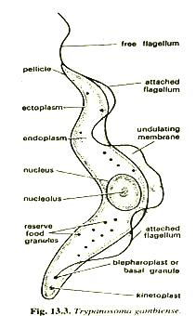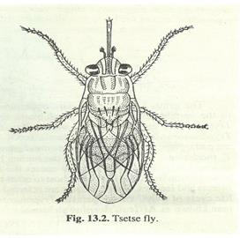

POLYMORPHIC FORMS OF TRYPANOSOMA

Trypanosoma is a polymorphic form. Hoare (1966) has noticed as many as six morphologic stages in the life cycle of different species of Trypanosoma. Some polymorphic forms are as below:
1. Leishmanial (amastigote). It has small, oval or rounded body with a nucleus. Basal granule and kinetoplast in form of reduced dots placed in front of nucleus. Flagellum reduced, fibre-like embedded in the cytoplasm, external flagellum is not found.
2. Leptomonad (promastigote). It has an elongated body with nucleus in its center. The basal granule and kinetoplast ate situated at the anterior end. A free flagellum originated from the basal granule and no undulating membrane is formed.

3. Crithidial (epimastigote). Its body is short, elongated but stumpy. The basal granule and kinetoplast are situated in front of nucleus which is central. A long flagellum arises from basal granule and becomes free anteriorly. Undulating membrane ill-developed.

4. Trypanosome (trypomastigote). Its body is elongated and slender. The basal granule and kinetoplast are situated at the posterior end of the body. Flagellum is large and becomes free anteriorly. The undulating membrane is well developed.

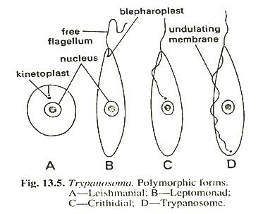
LOCOMOTION

Trypanosoma gambiense performs its locomotion by the wavy movements of the undulating membrane and by the flagellum.
NUTRITION

Nutrition is saprozoic. Trypanosoma gambiense feeds by Osmotrophy on the blood and tissue fluids of its host.

RESPIRATION
Respiration is basically anaerobic because it lives in an environment without oxygen. The absorbed glucose undergoes glycolysis to release energy necessary for metabolic activities.

EXCRETION

The metabolic waste products are directly diffused out through its pellicle or general body surface into its external environment.

REPRODUCTION

Trypanosoma gambiense reproduces asexually by longitudinal binary fission. Sexual reproduction is not known in this species. .

Longitudinal Binary Fission

In the longitudinal binary fission (Fig. 13.6), the division is initiated by basal granule (blepharoplast) and followed by the kinetoplast. Next, a new flagellum begins to grow out along the margin of the undulating membrane. The nucleus then divides and this division is followed by the longitudinal division of the cytoplasm, commencing from the anterior end and extending backwards, till the daughter individuals separate. By repeated division, the parasites increase in the blood of the vertebrate host until the blood is swarmed with them.
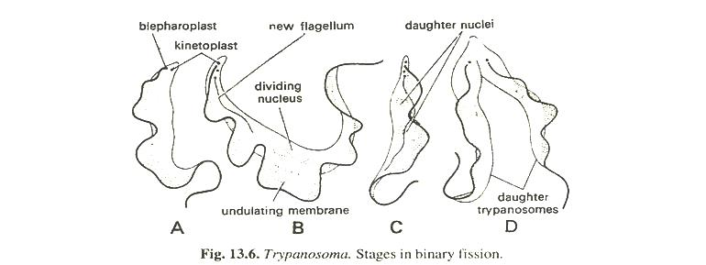

LIFE CYCLE

The life cycle of Trypanosoma gambiense is completed within two hosts. i.e., digenetic (Gr., di=double; genos=race), a primary vertebrate and secondary invertebrate host or vector. The vertebrate host is man and the invertebrate host is blood sucking fly, Giassina palpalis (Tsetse fly). Trypanosoma gambiense lives harmlessly in the blood of antelopes.

Part of Life Cycle in Man

When an infected fly bites a man it inoculates a few parasites in the blood of man. The parasites first live in the blood of the infected man, but later find their way into the cerebrospinal fluid. While the parasites are in the blood, the infected man develops a kind of fever termed Gambia fever, but when they reach the cerebrospinal fluid, various nervous symptoms are produced in the patient leading to a lethargic condition, which has given the name sleeping sickness to the disease. The parasites multiply by longitudinal binary fission in the blood and produce three forms of individuals, viz., (i) long and thin forms with a free flagellum, (ii) short and stumpy forms with a reduced flagellum and (iii) intermediate forms. It has been observed that the parasites periodically increase and decrease in number in the blood of man. During the period of decrease the short and stumpy forms, which have great resisting power, survive the period of depression and the rest die. These short and stumpy forms are capable of development in the intermediate host, Glossina palpalis (Testse fly).

Part of Life Cycle in Tsetse fly

When a tsetse fly sucks the blood of an infected man, a number of parasites enter into the midgut of the fly along with the blood. These parasites remain in the midgut of the fly for a few days and start multiplying by longitudinal binary fission. After tenth to fifteenth day long slender forms appear in great numbers which move forward to the proventriculus. After several more days the trypanosomes make their way to the fly's salivary gland. In the salivary glands they become attached to the walls and undergo another rapid phase of multiplication by longitudinal binary fission and develop into crithidial forms. The crithidial forms are characterized by a shorter flagellum and undulating membrane. Flagellum and undulating membrane do not extend in the hinder part of the body. Kinetoplast and basal granule are situated above the nucleus towards the anterior end. Here the development continues for 2-5 days and the crithidial forms produce metacyclic forms (Trypanosome forms) which are now infective. These metacyclic forms pass down through the ducts and hypopharynx. When the fly bites a man, the metacyclic forms enter the blood of man along with the saliva of the fly. The whole cycle in the fly usually takes 2-30 days.

TRANSMISSION

Transmission from one vertebrate host to another is effected by an intermediate host which is a blood-sucking fly, Glossina palpalis (Tsetse fly). The transmission occurs in two ways.

1. Mechanical or direct transmission. When a tsetse fly (carrier fly) bites a man infected with Trypanosoma, some Trypanosomes stick to the proboscis of the fly and when the fly bites another man the Trypanosome are introduced into his blood, provided the time between two successive bites does not exceed 24 hours. Such a transmission is termed mechanical or direct as the fly acts merely as a mechanical carrier and parasites do not undergo any changes in it.

2. Cyclical transmission. When the fly sucks the blood of an infected man, the parasites along with the blood enter the midgut of the fly, remain there for two days and start multiplying. Parasites can be inoculated in the blood of another man only after undergoing through a set of stages. This type of transmission is known as cyclical transmission.

RESERVOIRS

Trypanosomes are harmless to their natural vertebrate hosts which are wild antelopes, pigs, buffaloes, etc. These wild antelopes and referred mammals are not harmed by the parasite, hence, they act as reservoir hosts from which infection is spread by the vectors or intermediate hosts.

