Invertebrates adaptations for aquatic environments:
Breathing under Water (respiration):
All aquatic invertebrates must breathe oxygen. The best source of oxygen is the air. Many aquatic invertebrates take their oxygen directly from the air, even though they live in the water. They may come to the surface and capture air on their bodies (e.g., under the wing covers), with their legs, or with hydrophobic hairs (hairs that repel water) on the outside of their bodies. Some gulp air directly through breathing tubes. Water also contains dissolved oxygen. Most of this oxygen is picked up by the water at its surface where the water comes into direct contact with the air. Any agitation of the water's surface, such as by wind or current, increases the amount of dissolved oxygen in the water. Aquatic plants also release oxygen into the water during photosynthesis. In addition, cooler water holds more dissolved oxygen than warmer water. Many aquatic invertebrates take oxygen directly from the water through internal or external gills, directly through the skin, or through the use of a bubble of air which is attached to their bodies and which they take with them below the water's surface. These bubbles can extract oxygen from the water and function as physical gills. Insects either breath through gills or from the surface. Insects that breathe air do not have lungs; instead, they breathe through holes or spiracles that are located either along their bodies or at the end of breathing tubes. The spiracles open into a network of tubes (trachea) that takes oxygen to the cells of the insect. Crustaceans have gills covered by their exoskeletons; they pump water over the gills by fanning some of their legs. Worms can exchange oxygen directly through their skin. Some snails collect air in their shells when they are at the water's surface, others breathe through gills, and others obtain oxygen by pumping water through their bodies
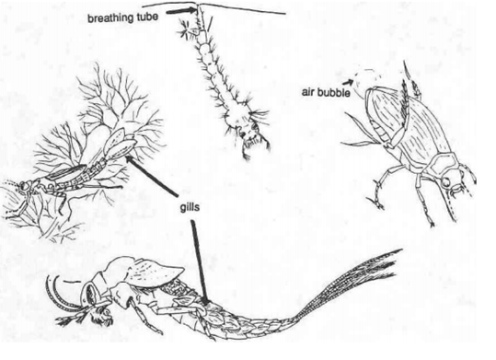
Finding Food:
A basic process in aquatic ecology, as in all ecology, is energy flow—the movement of chemical energy within a food chain. A simple aquatic food chain might go something like this. A small crustacean feeds on algae (an herbivore) and is in turn eaten by a small fish which is then eaten by a predaceous beetle larva. When several of these simple food chains interact together with detritivores (decomposers) and omnivores (organisms that eat animal and vegetable matter), they form a more complex structure that we call a. food web. The aquatic environment, like the terrestrial environment, supports herbivores, predators, omnivores, and scavengers. Herbivores graze on aquatic algae, mosses, and other aquatic plants. Predators chase down their prey or wait in ambush for prey to pass by as they hide, camouflaged in plants or under rocks. Predators often have large, sharp mouthparts or grasping claws. Omnivores eat just about anything, plant or animal. Scavengers (detritivores or decomposers) feed on dead and decaying plants and animals. Some invertebrates (filter feeders) filter fine particles of food from the water through netlike structures or by pumping water through their bodies. When scientists study the structure and functioning of food webs, they use a specialized vocabulary to describe the relationships among organisms. A term often used in the study of food webs and energy flow is trophic, a word that comes from a Greek root meaning to nourish. Trophic structure, then, is the nutritional interrelationships among organisms in a particular food chain or web. In this context, the word nutritional is virtually synonomous with the word energy.
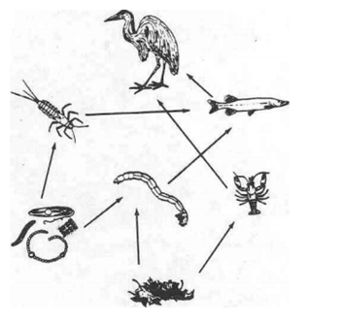

Protection from Predators:
To avoid predation, some aquatic invertebrates wear protective shells; others build protective cases of sand, pebbles, or plant material. Some rely on camouflage; others hide under rocks or depend on their ability to flee. Examples of structures constructed by an insect are the cases made by caddis flies. These cases serve as both protective covering and camouflage. Some species construct cases from grass blades, some from sand grains and small pebbles, others from sticks or other debris. An interesting example of an adaptation for fleeing is exhibited by dragonfly nymphs. Although a dragonfly nymph is a predator, it can also be prey for a larger, stronger animal. To escape, nymphs use their respiratory apparatus for a double purpose. To breathe, they have a rectal gill. They take in and expel water through the rectum and extract oxygen from the water. When threatened, they expel this water forcefully, making themselves Jet-propelled.

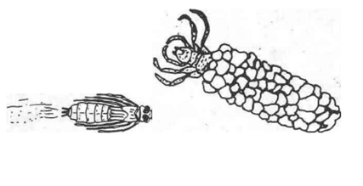

Locomotion (living in and moving around the environment):
Aquatic invertebrates have many adaptations that allow them to move about their environment they may swim, burrow, or climb about on rocks or plants. Swimming invertebrates may have legs modified to function as paddles. Their legs may have clusters (patches) of hairs that act very much like feathers on the wing of a bird and allow the aquatic invertebrate to "fly" under water. Some invertebrates crawl about on the substrate (bottom surfaces) of the pond or stream; others cling to plants and logs. These invertebrates may have claws that help them cling to various surfaces. Animals that crawl on the substrate of a swiftly flowing stream must be able to cling tightly or be washed downstream. Many have flattened bodies. Leeches, a type of worm, cling to the substrate with a "suction cup" appendage (sucker). Snails, limpets (a type of snail with an uncoiled shell), and flatworms adhere to the substrate by clinging with the flat undersides of their bodies. Many aquatic invertebrates burrow in the substrate of a stream or pond. Aquatic earth worms push their way through the soil with muscular contractions of their bodies. Mussels pull their shells along and through the bottom material with a muscular foot. Some invertebrates, such as burrowing mayflies, have legs that are spade like. Burrowing invertebrates, such as sludge worms or burrowing mayflies, and some midge and caddis fly larvae, may construct tube like homes on the bottom. The water's surface is a unique habitat that many aquatic invertebrates are able to exploit. The surface of the water behaves as if there were a film across it. This film like property of water is called surface tension. Very lightweight animals are able to walk on the surface of the water. In fact, some small invertebrates may actually have difficulty breaking through the surface tension.
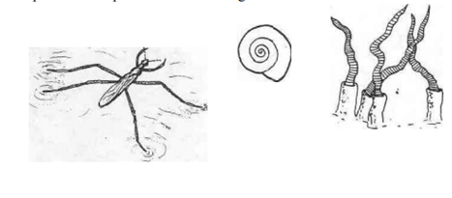
Life Cycles and Reproduction (non-insects):
Some aquatic invertebrates, such as aquatic worms, mollusks, and most of the crustaceans, live their entire lives in water. Crayfish can leave the water for short periods of time, but most species spend most of their lives in the water. Those that dig burrows with chimney like entrance holes live near the water. They also return to the water to reproduce. Crayfish mate during the late winter or early spring, and later in the spring the female lays her eggs. She carries them in a mass under her tail. The egg mass looks very much like a raspberry, and a female carrying egg is said to be "in berry". When the young crayfish hatch, they ride along under their mother's tail for a week or more. After a few days, the fully formed but miniature crayfish are on their own. Very young crayfish can often be found hiding and feeding in masses of algae or among plants in shallow water. Water fleas are tiny crustaceans. Most of the populations are females that reproduce parthenogenically, that is, the eggs develop without fertilization by a male. Water Fleas are born alive. Occasionally, males are produced and mate with some of the females. Eggs produced in this manner are cysts capable of lying dormant for years before hatching. Aquatic snails, such as ram's hom snails and limpets, are hermaphrodites which mean that each organism has both male and female reproductive organs. Any two snails can mate and fertilize each other's eggs. Male and female river snails, however, are separately sexed. Most aquatic snails lay gelatinous masses of eggs on plants and substrate. A few species of snails give birth to live, fully formed young. Even though fingernail clams look like miniature versions of mussels, they reproduce very differently. Fingernail clams are hermaphrodites. Sperm is released into the water and picked up by the gills, where the eggs are fertilized. The eggs then develop in a brood pouch. Fingernail clams later give birth to fully formed baby fingernail clams, tiny versions of their parents. Most freshwater mussels are either male or female. The males release sperm into the water. Some of these sperm are picked up by the females and their eggs are fertilized in the gills. Early development takes place in the gills, but later, thousands of tiny larvae are released and attach themselves to the gills of fish. Until they are ready to transform into adults, these larvae, or glochidia, live as parasites on the gills of fish. Some species of mussels release their glochidia into the gills of only one species of fish.
Life Cycles and Reproduction (insects):
Aquatic insects are a very diverse group and demonstrate a wide variety of life cycles and reproductive strategies. Many aquatic insects have immature stages that live in water but adult (reproductive) stages that live near water. Some insects experience incomplete metamorphosis in which the immature stage (nymph) lives in the water. It resembles the adult but lacks wings. The older nymphs develop "wing pads", which are the developing wings. When they molt into adulthood, they leave the water with their now functional wings. Dragonflies, damselflies, true bugs (giant water' bugs, water scorpions, water boatmen and water striders), stoneflies, and mayflies demonstrate this life cycle. The female giant water bug deposits her fertilized eggs, which may number over one hundred, onto the back of the male by secreting water proof glue. The male then carries them with him until they hatch, usually in about ten days. Because dragonflies and damselflies are highly predaceous, getting the sexes together for mating is tricky! Males have developed a unique way to solve this problem. A male takes sperm from the tip of his abdomen and places it in a receptacle near the base of his abdomen. He then seeks out a female, grabs her behind the head with claspers on the end of his abdomen. She then reaches around with her abdomen and couples with the sperm receptacle. After she has been inseminated, both fly off, still in tandem, and she lays her eggs in the water. Often the male does not release the female until she has completed laying her eggs, thus preventing other males from fertilizing her eggs. Some aquatic insects demonstrate complete metamorphosis in which the eggs hatch into a larval stage that is very different in appearance from the adult. For example, flies, which include mosquitoes and midges, have soft-bodied larvae without segmented legs. When the larva is ready to transform into an adult, it must enter a pupal stage for the change to adult to take place. The larvae of beetles, caddis flies, and dobsonflies have segmented legs and may have a hardened, chitinized body.
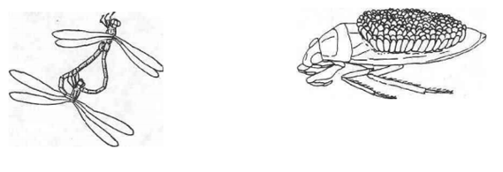

Dispersal (Getting around):
Adults of many aquatic insects can fly; they simply crawl out of the water and fly to a new pond or stream. Crayfish are capable of leaving a stream and trekking across land. In some species of invertebrates, the immature stages live in the water and the adults are terrestrial. Many invertebrates must rely on occasional flooding to relocate to a new area. Sometimes the sticky eggs or the tiny young of snails hitch a ride on the feet of ducks and other water birds. To move about within a pond or stream, invertebrates crawl or swim. One means of dispersal commonly used by invertebrates in a stream is to allow the current to carry them downstream. Drifting requires very little energy and quickly moves an invertebrate to a new area. Other insects have very specialized adaptations. Whirligig beetles swim on the surface film of quiet waters. Each of its compound eyes is divided into two parts. The lower part looks under the water while the upper portion looks up into the air. The larva of the phantom midge has bubbles of air trapped inside its body so it remains buoyant and floats near the water surface.
