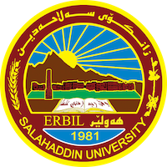
Academic Curriculum Vitae
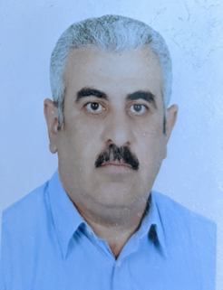
Personal Information:
Full Name: Majeed Toma Hanna
Academic Title: Lecturer
Email: (majeed.hanna@su.edu.krd)
Mobile: 07508998626

Education:
- Secondary School, Ankawa secondary School (1980-1981).
- B.Sc., Salahaddin University /Erbil, College of Science, Dept. of Geology (1986).
- M.Sc., Salahaddin University /Erbil, College of Science, Dept. of Geology (1993).
- Ph.D., Mosul University, College of Science, Dept. of Earth Sciences (2008).
Employment:
- Salahaddin University/Erbil - College of Science - Department of Geology (7/9/1993).
Qualifications
- Pedagogy Course, Salahaddin University /Erbil.
Teaching experience:
- Undergraduate:
- Invertebrate Palaeontology 2nd year.
- Micropalaeontology 3rd year.
- Biostratigraphy 4th year.
- Field Geology 3rd year.
- Palaeoecology 4th year.
- Stratigraphy (Practical only) 3rd year.
- Structural Geology (Practical only) 3rd year.
- Igneous and Metamorphic Rocks (Practical only) 2nd year.
- Postgradutae:
- Advanced Invertebrate Palaeontology.
- Advanced Micropalaeontology.
- Advanced Palynology.
Research and publications
- Palynology of the Cretaceous - Tertiary boundary at Hujran Area, Northeastern Iraq. Unpub. M.Sc. Thesis, Salahaddin University/Erbil.
- Palynology of the Upper Part of Baluti Formation (Upper Triassic) and the Nature of its Contact with the Sarki Formation (Lower Jurassic) at Amadyia District, Northern Iraq. Unpub. Ph.D. Thesis, Mosul University.
- Palaeoenvironmental Interpretation of the Upper Triassic Baluti Formation in two selected sections at Amediya District, Kurdistan Region- Iraq: Insights from Palynofacies Study. Journal of Zankoy Sulaimani, 123-134.
Conferences and courses attended
- None.
Funding and academic awards
- None.

Professional memberships
- None.
- Professional Social Network Accounts:
- https://www.researchgate.net.
- https://scholar.google.com/citations?user=aWjAK7MAAAAJ&hl=en.
- https://orcid.org/0009-0009-9009-5632.

