Salahaddin University Sedimentary Petrography Date 27 /02 / 2023
College of Science 2st Semester Examination 3rd Class
Earth Sciences & Petroleum Department Time Allowed 80 mins.
Q1/ Say True or False in front of these sentences and corrected underline:
1-Compaction and clay cementation is more dominant than other diagenetic in Ora Formation.
2-A solution of Cobalt nitrate is a best methods to distinguish heavy from light minerals.
3-Stable conditions of oligomict conglomerate is mainly find in recycled orogeny.
4-Textural maturity is refers to relative abundance of stable to unstable grains.
5-Debris flow dominated near-shore in Daxing Conglomerate matrix supported conglomerate.
6-Sandstnoes contain at least 95% of quartz grains is referred to sub-arkosic sandstone.
7-Fluid inclusions temp. of Q3 in Ora Formation and indication of dolomitization conditions.
8-Greywacke is refers to sands with matrix more than 15%.
(16 marks)
----------------------------------------------------------------------------------------------------------
Q2/ Contrast between the following sentences below:- (Answer Three only)
1-Gentic & Empirical classification of quartz grains.
2-Primary & Secondary recrystallization in polycrystalline quartz grains (Young, 1976).
3-Depositional fabrics & diagenetic fabrics.
4-Cement & Matrix. (15 marks)
-------------------------------------------------------------------------------------------------------
Q3/Answer the following sentences below:-
1-The importance and significance of heavy minerals study.*
2-Sketch diagram of diamond diagram by Basu et al., (1975).
3-Mention factors influence the concentration segregation of gravel in nearshore (Clifton,2003).
(18 marks)

Good Luck Examiner
Dr.Muhamed F.Omer
Assistant Professor of Sedimentology

Typical Answer
Q1/
1-Compaction and quartz cementation is more dominant than other diagenetic in Ora
Formation. False
2-Astating of Cobalt nitrate is best methods to distinguish types of feldspars . False
3-Stable conditions of oligomict conglomerate is mainly find in epicontinental seas. False
4-Textural maturity is refers to relative abundance of matrix and degree of rounding and
sorting. False
5-Debris flow dominated near-shore in Daxing Conglomerate is matrix supported conglomerate.
True.
6-Sandstnoes at least 95% of quartz grains referred to quartz arenite sandstones. False
7-Fluid inclusions temp. of Q3 in Ora Formation and indication of hydrothermal burial
conditions. False
8-Greywacke is refers to sands with matrix more than 15%. True
--------------------------------------------------------------------------
Q2/ Contrast between the following sentences below:-
1-Gentic & Empirical classification of quartz grains.
1st Genetic classification developed by Krynine ( 1947). An attempt is made of allot each quartz grains to a specific environment of formation: plutonic, volcanic, schistose, stretched, metaquartzite, reccrystallized metaquartzite, and hydrothermal. Based on inclusions and grain shape. 2nd Empirical classification by Folk(1974) based on two categorizes a- by extinction include straight extinction, slightly undulose extinction and strongly undulose extinction b-Inclusions include abundant vacuoles, rutile needles and a few microlite.

2-Primary & Secondary recrystallization in polycrystalline quartz grains (Young, 1976).
Primary Recrystallization : small 50mu, non-undulose extinction, smooth crystal boundaries, Unstable grains.
Secondary Recrystallization : developed large grains , non-undulose extinction, smooth
crystal boundaries, Stable grains.

3-Depostional fabrics & diagenetic fabrics.
Depositional fabrics : Grain orientation, grain size, grain identification, Modal composition,
provenance.
Diagenetic fabrics: M. Compaction, Ch. Compaction, cementation, dissolution, replacement.

4-Cement & Matrix

Matrix :The smaller or fine-grained, constituents material enclosing or filling the interstices between the larger grains or particles of the sediments. They often consist of argillaceous material or calcareous mud (micrite).
Cement: The cement of the terrigenous sediments comprises the post-depositional (diagenetic) precipitated mineral material that occur in the spaces among the individual grains, there by binding the grains together as a rigid, coherent mass( ex.. lithification of the rocks ) .The most common cements are silica ( quartz, chalcedony, opal), carbonates ,Calcite, dolomite and siderite

--------------------------------------------------------------------------------
Q3/Answer the following sentences below:-
1-The importance and significance of heavy minerals study.
1- Provenance.
2-The climate of the source are.
3-Hydraulics of the transport agent.
4-Stratigraphic correlations.
5-Trace element transport path, maps sediment transport paths and to outline bodies.
6-Zircon geochronology is another method for determining dating sediments refers to Precambrian and Cambrian.
7-Its also can be used for facies correlations indicating sedimentary dispersal from particular source areas which undergoing tectonic evolution.

2-Sketch diagram of diamond diagram by Basu et al., (1975).
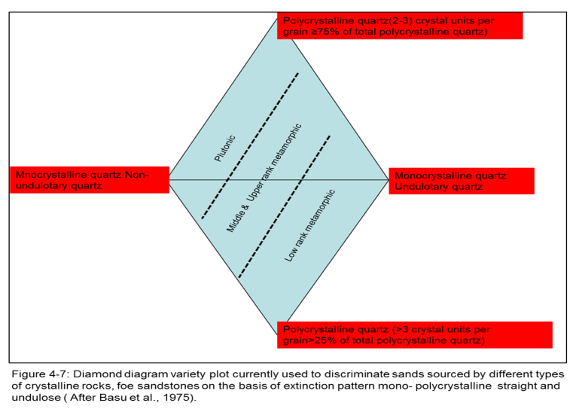

3-Mention factors influence the concentration of gravel in nearshore segragation (Clifton,2003).
1-Selective winnowing of associated sand.
2- Differential transport under shoaling waves or other processes.
3-Fluctuations of physical energy
4-Seafloor morphology.

