

**Department of ………Geology…….**

**College of …………Science… ……….**

**Salahaddin University**

**Subject: …Sedimentology Theory**

**1st Semester 2023-2024**

**Course Book – (Year 3)**

**Lecturer's name: Dr.Muhamed Fakhri Omer**

**Assistant Professor of Sedimentology**

**Postdoctoral /Warsaw University-Poland 2014**

**Academic Year: 2023/2024**

**Course Book**

|  |  |  |
| --- | --- | --- |
| **1. Course name** | **Sedimentology Theory** | |
| **2. Lecturer in charge** | **Dr. Muhamed Fakhri Omer** | |
| **3. Department/ College** | **Geology Department/Science College** | |
| **4. Contact** | **e-mail:** [**muhfakhri2005@gmail.com**](mailto:muhfakhri2005@gmail.com)  [**Muhamed.Omer@su.edu.krd**](mailto:Muhamed.Omer@su.edu.krd)  **Tel: (optional): 009647701348322** | |
| **5. Time (in hours) per week** | **For example Theory: 2**  **Practical: 2 hours 4groups A,B,C,D** | |
| **6. Office hours** | **Availability of the lecturer to the student during the week** | |
| **7. Course code** |  | |
| **8. Teacher's academic profile** | **Academic Qualification:**  B.Sc of Geology at Baghdad University 1988.  -M.Sc of Sedimentology at Baghdad University 2000.  -10/4 /2004 employed at Salahaddin University-Science  College/ Geology Department as Assistant Lecturer.  -2012 got Ph.D. of Sedimentology at Baghdad University  changed the tittle position into Lecturer.  -2013Granted Post-Doctoral Scholarships at Warsaw University/ Poland for six months from 31-12-2013 until 30-06-2014.  **Training courses and conferences:**  -Participated 1st Geological conference of Kirkuk University at  Applied Geology department from 27-28th November  2012 with oral presentation.  -Participated 2nd An international Geological conference  of GeoShale 2014 Warsaw/ Poland from 24-26th  September 2014 with oral presentation.  -Participated 4th International conference on Geology  and Geoscience held in Dubai April 2017 with oral  presentation.  -Session on SEM-CL from 20/11/2010 to 20/01/2011 at  Aarhus University (Denmark).  -Participated 3rd International Conference on Geology & Earth Sciences 2018 at Rome with oral presentation.  Participated European Geosciences Union Conference held in Vienna May 2022. | |
| **9. Keywords** | **Siliciclastic, , Sandstone, grain size, porosity, Sedimentary structures** | |
| **10. Course overview:**  This should not be less than 200 words  1-Textures of sedimentary rocks. 7-Fluivial environments.  2-Grain size. 8- Deltaic environments.  3-Roundness and sorting. 9-Tidal Flat environments.  4-Sedimentary structures 10- Facies Anaalysis.  5-Biogenic sedimentary structures. 11- Paloecurrent Analysis  6-Transportation & Sedimentation 12-Application of sedimentology.  **Sedimentary rocks may have**  **1. Clastic (fragmental) texture**   * **Grains are stuck together.** * **Characteristic of clastic sedimentary rocks.** * **Examples: sandstone and conglomerate.**   **2. Non-clastic (crystalline) texture**   * **Interlocking crystals.** * **Characteristic of chemical sedimentary rocks.**   **Examples: limestone, dolomite, and chert**  **Grain sizes can be determined by:**   * **Direct measurement with calipers or meter sticks.**   **For particles larger than several centimeters.**   * **Screening and petrographic microscope.**   **For particles from 2 mm to about 1/16 mm.**   * **Pipette or hydrometer (settling rates in water)**   **For particles less than 1/16 mm**   * **MaturityDepends on how many cycles of erosion and redeposition the components of a rock have undergone.** * **There are two types of maturity:**   **1. Compositional maturity**  **Compositional maturity = quartz + chert / feldspars + rock fragments.**  **2. Textural maturity**  **Textural (structural) maturity = sorting and roundness of sand-sized grains.**  **Mineral compostions:-**   * **The most common minerals in sedimentary rocks are:**  1. **Quartz** 2. **Clay minerals** 3. **Feldspars** 4. **Carbonates (calcite and dolomite)** 5. **Rock fragments**  * **Small amounts of amphibole, pyroxene, and mica.** | | |
| **11. Course objective:**  This should not be less than 100 words  The objectives of this course can be summarizing by:-  -The importance to studying this subject in 1st semester is to understanding the relationships between grains and texture and provenance of sedimentary rocks. Also in this semester will study the methods of studying sedimentary rocks in addition to diagenetic processes. Sedimentology is the study of the processes of formation, transport and deposition of material that accumulates as sediment in continental and marine environments and eventually forms sedimentary rocks. Most sedimentary deposits are the result of transport of material as particles. Moreover of detritus may be purely due to gravity but more commonly it is the result of flow in water, air, or dense mixtures of sediment and water. The methodology of analyzing sedimentary rocks, recording data and interpreting them in terms of processes and environments. The character of sediment in any depositional environment will be determined by the physical, chemical and biological processes that have occurred during the formation, transport and deposition of the sediment. | | |
| **12. Student's obligation**    -In this part the lecturer have responsibility to teach the students in a best method to understanding the subject Sedimentology Theory. Also it can be summarizing in to these points:-  1-Field trip to Koya Distric to understand and studying sedimentary structures and main  concept of sedimentology. After we come back from filed all sedimentology group  request to prepare a report and make a seminar.  2- Every three weeks there is Quiz.  3- End of Semester there is an examination theory.  4-Activity of the student. | | |
| **13. Forms of teaching**  -In this part the main forms of teaching in the practical sedimentary petrography are:-  1-White Board.  2-Data show.  3-Power point. | | |
| **14. Assessment scheme**  -The scores of theory Sedimentology out of 15% 1st Semester and subdivision into:  **Theory Examination: 10%**  **Quiz 1%**  **Report 1%**  **Activity of student 3%.** | | |
| **15. Student learning outcome:**  This should not be less than 100 words  -The main outcome of this course are:-  1-How the students after graduation will be understand a main objective of the subject  Sedimentology and application.    2-The main point about field is being able to observe and record accurately what  you see.  3-Distingush between different sedimentary structures in field and significant importance.  4-A min difference shallowing and deeping upwards facies.  5-The main differences between fluvial and deltaic environments based on lithofacies and  Economic importance of them.  6-Important and significant of the Paleocurrent Analysis and their applications.  7-Porosity in sedimentary rocks and relationships with reservoir rocks. | | |
| **16. Course Reading List and References‌:**  -The student during 2nd semester it’s necessary to burrow one of the text books below from Central library or College library as a good reference.  **Text Book Theory Sedimentology 3rd Year 2023-2024**  1-1- Blatt, H., Middleton, G., Murray, R., 1980, Origin of Sedimentary Rocks, 2nd  ed., *Prentice-Hall*, Englewood Cliffs, 634P.  2- Boggs, S. J, 2006, Principles of Sedimentology and Stratigraphy.4th ed., *Prentice-Hall*, 662P.  3- Folk, R. L., 1974, Petrology of Sedimentary Rocks, *Hemphill Publication Company,* Texas, 170P.  4- Nichols, G., 1990, Sedimentology and stratigraphy, *Black Well Science*, 355P.  5- Pettijohn, F. J., Potter, P. E., and Seiver, R., 1987, Sand and sandstone, *Springer-Verlag*, New York, 553P.  6- Selley, R. C., 2000, Applied Sedimentology, *Academic Press*, 521P.  7- Tucker, M.E., 1981, Sedimentary petrology an introduction, Volume 3, *Blackwell scientific Publications*, 252P.  *Dr.Muhamed F.Omer*  *Assistant Professor of Sedimentology*  **International Journals related to Sedimentary Petrography**:  1- Basu, A., Young, A. W., Suttner, L. J., James, W. C., and Mack, G. H., 1975, Re-evaluation of the use of undulatory extinction and polycrystalline in detrital quartz for provenance interpretation: *Jour.Sedi.Petrol*., Vol.45, pp.873-882.  2-Bernet, M., Bassett, K., 2005. Provenance analysis by single quartz grain SEM-CL/  Optical microscopy, Journal of Sedimentary Research, 75, 496-504.  3- Flügel, E., 1982. Microfacies Analysis of Limestones. Springer-Verlag, Berlin,  Heidelberg, New York, 633 pp.  4- Folk, R.L., 1962. Spectral subdivision of limestone types. In: Ham, W.E. (Ed.),  Classification of Carbonates Rocks – A Symposium, vol. 1. American Association  of Petroleum Geologists Memoir, pp. 62–84. | | |
| **17. The Topics:** | | **Lecturer's name** |
| In this section the lecturer shall write titles of all topics he/she is going to give during the term. This also includes a brief description of the objectives of each topic, date and time of the lecture  -The importance of studying the topic subject is to  **1-** Learn student identification of grain size analysis and their  Applications.  **2-** Learn student an main concept and fundamental aspects of  the transportation & sedimentation and consequence of these  processes.  Each term should include not less than 16 weeks | | Dr.Muhamed F.Omer  Assistant Professor of Sedimentology |
| **18. A. Theory Topics (If there is any)** | |  |
| In this section The lecturer shall write titles of all theory topics he/she is going to give during the term. This also includes a brief description of the objectives of each topic, date and time of the lecture  **1st Lec. Introduction about Sedimentology and**  **Procedure of sampling in a field.**  **2nd Lec. Grain Properties.**  **3rd Lec. Sedimentary Structures concept and classifications part 1.**  **4th Lec. Sedimentary Structures part 2.**  **5th Lec. Biogenic Sedimentary Structures part 3.**  **6th Lec. Paleoucrrent Analysis and applications.**  **7h Lec. Transportation & Sedimentation.**  **8th Lec. Facies Analysis and lithofacies.**  **9th Lec.** **Depositional system fluvial environments.**  **10th Lec. Depositional system deltaic environments.**  **11th Lec. Depositional system tidal flat.**  **12th Lec. Depositional system shallow marine environments.**  **13thLec. Deep marine environments.**  **14th Lec. Models of depositional environments.**  **15th Lec. Basin Analysis.**  **18. B. Practical Topics**  In this section The lecturer shall write titles of all practical topics he/she is going to give during the term. This also includes a brief description of the objectives of each topic, date and time of the lecture  **1st Lab. Introduction and the purpose of studying this subject**  **&Procedure of sampling in a field. (Study details about**  **kinds of sampling in field and significant).**  **2nd Lab. Texture of Sediments Particle Morphology.**  **(Factors controlling morphology of the grains.)**  **3rd Lab. Texture of Sediments Particle Morphology.**  **4th Lab. Paleocurrent Analysis.**  **( A significant and importance of paleocurrent analysis)**  **5th Lab. Application of Paleoucrrent Analysis.**  **( Application of paleocurrent in field and measuring dip**  **and strike and paleoslope).**  **6th Lab. Grain Size Analysis.**  **( finning and coarsening upwards cycles)**  **7h Lab. Statistical Parameters of grain size analysis.**  **( Measuring sorting and skewness and mode).**  **8th Lab.** **Statistical Grain-Size Parameters of recent**  **Depositional Environments.**  **9th Lab. Bed form and Sedimentary Structures.**  **( stages of generating sedimentary structures according**  **to flow and grain size)**  **10th Lab. Porosity and effects in sedimentary rocks.**  **( Factors controlling porosity in sedimentary rocks**  **and types).**  **11th Lab. Fulviatile & Deltaic Environments.**  **( A main diffrences between fluvial and deltaic**  **Environments and their economic application.)**  **12thLab. Basin Mapping Methods.**  **(Sedimentary basins according to Wilson Models).**  **13th Lab. Structure Contour Maps.**  **( Determination source rocks and reservoir rocks).** | | Lecturer's name;-Dr.Muhamed Fakhri Omer  ex: (2 hrs)  ex: 10/09/2023  Lecturer's name: Dr.Muhamed Fakhri Omer  ex: (2 hrs)  ex: 23/09/2023 |
| **19. Examinations:**  ***1. Compositional:*** In this type of exam the questions usually starts with Explain how, What are  the reasons for…?, Why…?, How….? **Quiz**  With their typical answers  Examples should be provided  ***2.******True or false type of exams:***  In this type of exam a short sentence about a specific subject will be provided, and then students will comment on the trueness or falseness of this particular sentence. Examples should be provided  ***3. Multiple choices:***  In this type of exam there will be a number of phrases next or below a statement, students will match the correct phrase. Examples should be provided.   |  |  | | --- | --- | | Name: |  | | 1-Paleocurrent analysis |  | | 2- Modes |  | | 3-Models |  | | 4-Rose diagram |  | | 5-Application |  | | 6-Grain size analysis |  | | 7-Type of models |  | | 8- Type of frequency Curve. |  | | 9-Determine type of sorting |  | | 10-Determine type of Skewness |  |   Quiz 2.5% Practical Sedimentology 2023 (**Sample of Quiz**)   |  |  | | --- | --- | | Name: |  | | **1-Determine type of roundness**  **according to zing Diagram.** |  | | **1-Determine spheresity** |  | | **2-Grain size table** |  | | **3-Types of models.** |  | | **4-Shape of frequency curve.** |  | | **5- Value of sorting according to Folk**  **( 1974)** |  | | **6- Value of Skewness according to**  **Folk ( 1974).** |  | | **7-Determine type of porosity.** |  | | **8-Realtionships between IVG and**  **cement.** |  | | **9-Determine type of contacts** |  | | **10- A common contacts.** |  | | | |
| **20. Extra notes:**  - As am I a lecturer of the subject ” Sedimentology” I suggest that:  1- The laboratory needs more and new geo software.  2- A sufficient funding to go field trip every 3 weeks.  3- Provide our laboratory with new instrument e.g. SEM and XRD . | | |
| **21. Peer review**  .‌‌ | | |

**Salahaddin University Sedimentation Theory Date 17 /12/ 2023**

**College of Science 2nd trail 3rd Class**

**Department of Geology 2023-2 Time 2 hours**

**Q1/Say true or false in front of these sentences and corrected underline:-**

1- The flaser bedding is produced in environments in which conditions favor deposition

of mud over sand. (  **False** ) **Sand over mud**

2- The lateral changes from piedmont to alluvial fan to flood plain are associated with

changes in sedimentary structures and fossils. ( **False**  ) **Gradient, grain size and sorting**

3- A common of secondary porosity in sedimentary rocks are interparticle and

intraparticle porosity.(**False**) **Intercrystal, moldic, fracture, cavern, boring, vugs, fenestral**

4-The paleocurrent study for braided rivers characterized by low sinuosity rivers and

unimodal with low degree of variance. ( **True** )

5- Syndepositional sedimentary structures are formed at the time of deposition. ( **True**  )

6-The characteristics of deltaic sediments is as a vertical sequence of is fining-upward units,

produced by progradation (building-up) of the delta plain. ( **False**  )

**Coarsening-upward- produced by progradation (bluiding up) of delta front**.

7-Unit B of Bouma sequence is attributed to lower part of the flow regime. ( **False** )

**Shooting flow regime**

(14 marks)

**Q2/ Compare between the following sentences in short answer: - (Answer four only)**

1-Sediments and sedimentary rocks.

**Sediments are unconsolidated or loosely cemented deposits –non-lithified rocks.**

**Sedimentary rocks are consolidated or well cemented deposits- lithified rocks.**

2-Convolute and slump structure on the basis sense of movement and nature of

deformation.

**- Convolute bedding sense of movement is vertical. Nature of deformation is plastic**

**(Sediment lack of shear strength).**

**-Slump structure sense of movement is horizontal. Nature of deformation is brittle**

**(Sediment possess shear strength)**

3-Traction deposits and density current deposits.

**1-Traction deposits are mainly by rolling and saltating bed load, the fabric and**

**structure deposited are commonly cross-bedded deposits.**

**2- Density current deposits are originated from combination of traction and**

**suspension. They are characterized by mixture of sand, silt, clay and lack of**

**cross-bedded and show graded-bedded.**

4-Normal and reverse graded bedding.

**Normal graded bedding: where the coarsest particles at the base give way to finer**

**particles higher up, results through deposition from waning flows, and it is typical of**

**turbidity current and storm-current deposits.** **The normal grading can be form by**

**several processes**

1. **Sedimentation from suspension clouds generated by storm activity.**
2. **2-Deposition in the last phases of heavy flood**.

**Reverse graded bedding:** **where the coarsest particles at the top give way to finer particles**

**bottom. Can arise from an increasing strength of flow during sedimentation, but more**

**commonly from grain dispersion and buoyancy effects. Laminae deposited on beaches by**

**swash–backwash are commonly reversely graded, as are cross- beds deposited by**

**avalanching and grain.**

5-Deposits on fluvial and wave dominated deltas.

**On fluvial dominated deltas , deposits typically consist in part of sand, and possibly gravel, deposited near river mouth, forming distributary mouth bar deposits .**

**On wave and tide dominated deltas sediment is reworked and winnowed by these processes, creating well-sorted delta front sheet sands that are cross-bedded on a variety of scales.**

(16 marks)

**Q3/ (Answer three only)**

1-Mention features and characteristics of fluviatile sandstones.

**1- Fluviatile sandstones in general are usually sharp-based and cross-bedded, with flat**

**bedding and cross-lamination.**

**2-They may be lenticular ( infill's stream channels).**

**3- Texturally and compositionally, fluviatile sandstones are immature to submature**

**sandstones, depends on the provenance and transport distance.**

**4-Many are arkoses and litharenite sandstones.**

**5-Many fluviatile sediments were deposited under semi-arid climates and so are**

**mostly red from the early diagenetic formation of hematite.**

**6-Many are polymicitic with both extra and intra –formational clasts and have**

**pebble support fabric.**

**7- Fossils are not common in river sediments and mostly consist of plant material and**

**skeletal fragments of fresh water and terrestrial animals, especially fish.**

**8- The fining up-ward sequences can be repeated many times in fluviatile sequence.**

2-Factors controlling porosity and permeability in sedimentary rocks.

**1.Grain Size\ Por. increses and Per. decreases with decreasing grain size..**

**3-Grain shape (Sphericity & Roundnessicity) Por. & Per. increases with decreasing roundness and sphericity**

**2-Soting\ Per, and Por. increases with increasing sorting**

**4-Packing\ Por. & Per. decreases with increasing ,**

**Grain orientation\ Por. & per. decreases with increasing orientation**.

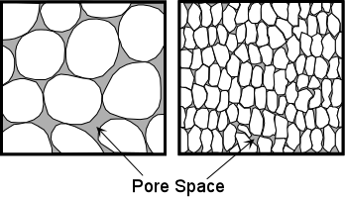  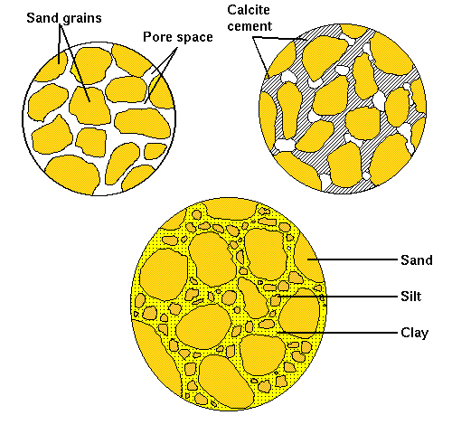

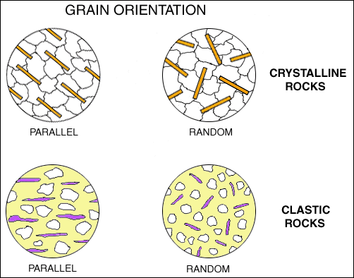

3- Discuss alluvium may be serve as an aquifer or a petroleum reservoir with sketch diagram.

**Alluvium may serve as an aquifer or a petroleum reservoir because of its porosity and permeability. Obviously the storage capacity and flow characteristics of alluvial deposits will vary according to the sorting and cementation of the sands, and to the overall sand: shale ratio. Thus the blanket sands of braided outwash plains normally have better continuity than the often isolated point bar sands of meander channel alluvium (Fig.1) .Giant structural traps occur in thick reservoir sands of braided channel system , while small stratigraphic traps where the reservoir may be only several meters thick extend**

**for a few kilometers In meandering fluvial channel.**

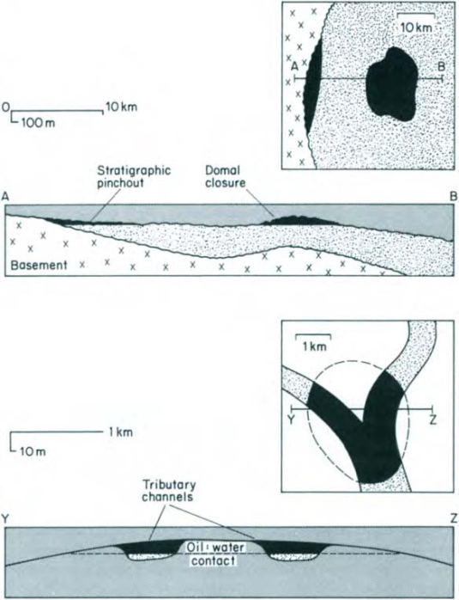**Figure 1:** : Diagrammatic maps and sections illustrating the differences in scale and style in petroleum entrapment in the alluvium of braided (upper) and meandering (lower).

4- Schematic diagram showing low density of turbidity currents and discus briefly.

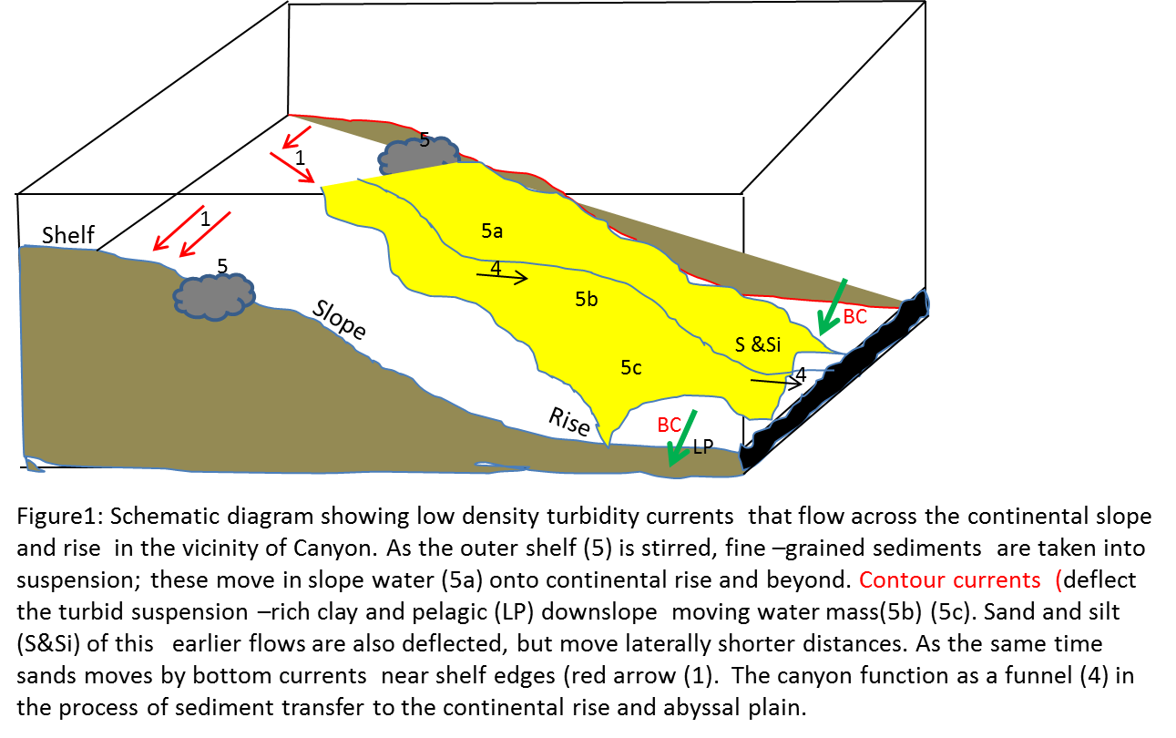

(24marks)

**Q4/ Fill blanks:-**

**Ichofacies Substrate Environment Water depth Water energy**

**Cruziana** Soft ground Marine

sand

**Trypanites** Rockground Rocky coasts, reefs,

Hard grounds.

**Zoophycos** Slope-abyssal

**Nereites** Tubidity current

(6 marks)

*Good Luck*

*Examiner*

*Dr.Muhamed F.Omer*

*Ph.D. of Sedimentology*

**Salahaddin University Practical Sedimentation Date 11/11/ 2023**

**College of Science Monthly examination 3rd Class**

**Geology Department 120 minutes**

**Q1/A- Choose the most convenient terms and put inside circle.**

*Questions about field trip Nov.6h 201*9.

1-Reactivation surface was observed in which station? Indication about?

a-station 1 b-station 2 c-station 3 d- none of them

a-increase flow b-non-erosion c-decrease flow d-rapid erosion

2-Type of drainage pattern in station 1 is

a-radial b-dendritic c-trellis d-angular

3-Kind of Asymmetrical ripple mark was observed in station 2

a-lunate b- sinuous c-caternary d-linguoid

4-Erosional sedimentary structures observed in Injana Formation

a-flute mark b-boring c-ripple mark d- impact mark

5- U. Bakhtiari Formation in station No.1 is considered a type of

a-autocyclic b-allocyclic c-lagonal cycle d-none of them

6- Reverse graded-bedded is which station where observed ?

a-station1 b-station 2 c-station 3 d-none of them

7- Abundant channel & active channel sequence are typical of

a-braided stream b-Ox bow lakes c-meandering stream d-delta sequence

8-Number of the cyclicty in U.Bakhtiari Formation?

a-three cycle b-two cycle c-four cycle d-one cycle. **(18 marks)**

9- Bidirectional current are common features in station

a-station 1 b-station 2 c-station 3 d-none of them

10- Fore set & bottom set is a common features were observed in:

a-ripple mark b-groove marks c-tabular cross-bedded d-flute marks

11- The tectonic zone of three stations of field trip to Koya is;

a-imbricate zone b-high folded zone c-low folded-zone d-thrust zone

-----------------------------------------------------------------------------------------------

**Q1/b-** Write characteristics of station number 1 in last field trip on Nov. 2018:-

**(6 marks)**

Q1/C- Mention the process that control nature of sedimentary structures by Reading (2004).

**(5 marks)**

------------------------------------------------

**Q2/-Fill blanks with the following sentences: -**

1-The common contact between grain fabrics are ------------------and --**-------------**---.

2**-**Mention Author Name of one textbook used in 1st Semester ------------------.

3-Packing is largely dependent on the ----**-----------**--- and ---**------------**--.

4-Channel sampling includes---**------------**--and-----------------.

5- River sands are often ---**-------**-----Skewed since much clay and silt not removed.

6-According to Riley (1953) determine sphericity for grain Dc =8.5, Di=5.5 --**-----------**---

7-According to Folk (1970), if the sorting greater than 4.00Ǿ are considered ---------------------.

8-A sharp contact between different environments can explain by plotting

--------------------------versus --------------------- **(12 marks)**

**------------------------------------------------------------------------------------------------------**

**Q3/A- Determine the following sentences from the sketch diagrams drawn below**:-

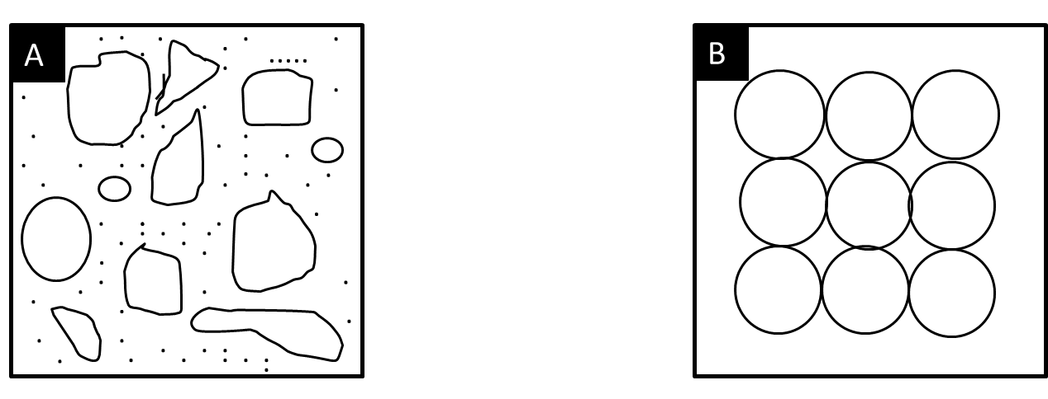

1-The maturity is -------------. 1-The maturity is---------------

**(12 marks)**

2-Sorting for this sediment is---------------. 2-Sorting for this sediment is --------------.

3-Type of packing is----------------. 3-Type of packing is ----------------.

4-Depos. Envi is --------------------. 4-Depos. Envi. is --------------------.

5-Fabric is supported by -----------------. 5-Fabric is supported by ------------------------ .

6- Type of reservoir rocks ---------------. 6-Type of reservior rocks is ----------------------.

**Q3/B-** Grain size analysis data of ancient sediments tabulated by weight% in different

**(47 marks)**

Environments as shown on Table 1. Now determine the following sentences:-

**Table 1**

1-Histogram and frequency curves for table1.

|  |  |  |
| --- | --- | --- |
| **Ǿ** | **Class** | **Grams** |
| 0 | V.sand | 8.0 |
| 1 | C.sand | 13.1 |
| 2 | M.sand | 25.5 |
| 3 | F.sand | 2.10 |
| 4 | VF.sand | 0.5 |

2- Value of mode.

3-Type of modal.

4- Mention only factors that control sorting.

5-Comment on the segments of depositional

environments.

**Typical Answer**

**Salahaddin University Practical Sedimentation Date 11/11/ 2023**

**College of Science Monthly examination 3rd Class**

**Geology Department 120 minutes**

**Q1/A- Choose the most convenient terms and put inside circle.**

*Questions about field trip Nov.6h 201*9.

1-Reactivation surface was observed in which station? Indication about?

a-station 1 b-station 2 c-station 3 d- none of them

a-increase flow b-non-erosion c-decrease flow d-rapid erosion

2-Type of drainage pattern in station 1 is

a-radial b-dendritic c-trellis d-angular

3-Kind of Asymmetrical ripple mark was observed in station 2

a-lunate b- sinuous c-caternary d-linguoid

4-Erosional sedimentary structures observed in Injana Formation

a-flute mark b-boring c-ripple mark d- impact mark

5- U. Bakhtiari Formation in station No.1 is considered a type of

a-autocyclic b-allocyclic c-lagonal cycle d-none of them

6- Reverse graded-bedded is which station where observed ?

a-station1 b-station 2 c-station 3 d-none of them

7- Abundant channel & active channel sequence are typical of

a-braided stream b-Ox bow lakes c-meandering stream d-delta sequence

8-Number of the cyclicty in U.Bakhtiari Formation?

a-three cycle b-two cycle c-four cycle d-one cycle.

(18 marks)

9- Bidirectional current are common features in station

a-station 1 b-station 2 c-station 3 d-none of them

10- Fore set & bottom set is a common features were observed in:

a-lingiud ripples b-groove marks c-tabular cross-bedded d-flute marks

11- The tectonic zone of three stations of field trip to Koya is;

a-imbricate zone b-high folded zone c-low folded-zone d-thrust zone

**Q1/B** Write characteristics of station number 1 in last field trip Nov.6th 2019

1-Pannorama field view.

2-Steep slope and bad vegetation.

3-Typical of siliciclastic sedimentary rocks of U. Bakhtiari Formation.

4-A main recharge water to Erbil city.

5-Conglomarate are clast supported fabric and well sorted.

6-Highst point of study area.

7-It’s a triangle point between Shalga, Dlopa and Bastora rtivers.

8-Foot mountains is covered by residual soil (6 marks)

**Q1/C** Mention the process that control nature of sedimentary structures by Reading (2004):-

1-Energy level of hydraulic regime.

2- Type of sediment available.

3-Direction of wave and storm-generated currents, with respect to shore line or intra shelf

sediment sources.

4-Amount of subsequent post waves or storms physical and or biological reworking.

5-Water depth play subordinate role (5 marks)

---------------------------------------------------------------------------

**Q2/-Fill blanks with the following sentences: - Each blank include 1 mark**

1-The common contact between grain fabrics are ----**Point**----and --**long**---.or

**concave-convex** or **suture**

2**-**Mention Author Name of one textbook used in 1st Semester ---**Folk**----Or **Pettijohn** or

**Potter** or **Tucker** or **Selley** or **Nicholas** or **Miall** or **Boggs**.

3-Packing is largely dependent on the --**grain size**--, ----**shape**--- and ---**sorting**--.

4-Channel sampling includes---**Pan**--and----**Pile**----.

5- River sands are often ---**Positively**-----Skewed since much clay and silt not removed.

6-According to Riley (1953) determine sphericity for grain Dc =8.5, Di=5.5 --**0.80**---

7- According to Folk (1974), if the sorting greater than 4.00Ǿ are considered

**extremely poorly sorted**.

8-A sharp contact between different environments can explain by plotting

------**Sorting**-----versus --------**Skewness**-----------. (12marks)

**Q3/A- Determine the following sentences from the sketch diagrams drawn below**:-



1-The maturity is Immature. 1-The maturity is Supermature

2-Sorting for this sediment is poorly sorted. 2-Sorting for this sediment is well sorted.

3-Type of packing is rhombohedral. 3-Type of packing is cubic.

4-Depos. Envi is glacier enivronment. 4-Depos. Envi. is Shelf or shallow marine.

5-Fabric is supported by Matrix. 5-Fabric is supported by grains.

6- Type of reservoir rocks Bad 6-Type of reservior rocks is Good

**(12 marks)**

**--------------------------------------------------------------------------**

**Q3/B-** Grain size analysis data of ancient sediments tabulated by weight% in different

Environments as shown on Table 1. Now determine the following sentences:-

1-Histogram and frequency curves for table1.

2- Value of mode.

3-Type of modal.

4- Mention only factors that control sorting.

5-Comment on the segments of depositional environments

**Table 1**

|  |  |  |  |
| --- | --- | --- | --- |
| **Ǿ** | **Class** | **Grams** | **Wt.%** |
| **0** | **V.C. sand** | **8.0** | **16.26** |
| **1** | **C.sand** | **13.1** | **26.62** |
| **2** | **M.sand** | **25.5** | **51.83** |
| **3** | **F.sand** | **2.1** | **4.26** |
| **4** | **V.F. sand** | **0.5** | **1.01** |

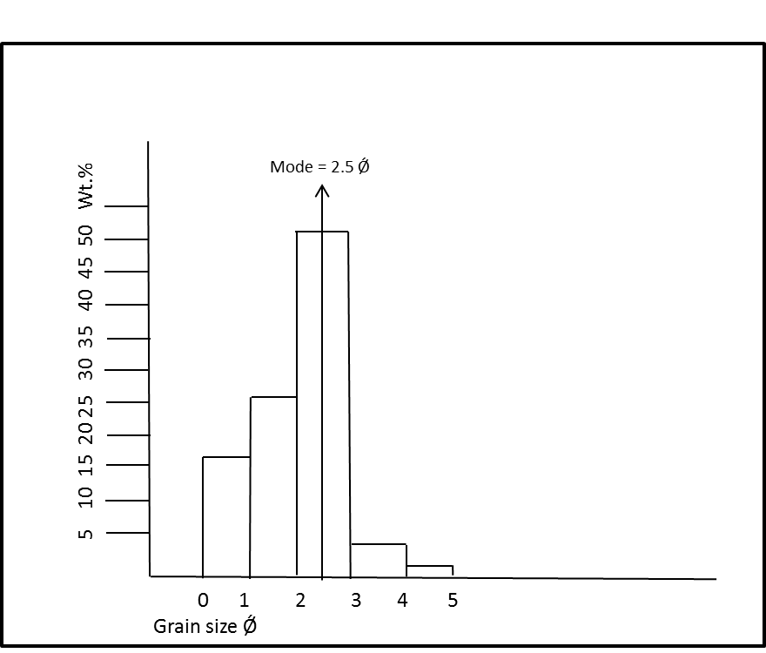

**-Mode value =2.5Ǿ**

**-Type of modal Unimodal**

**-Factors control type of sorting**

1-Source of sediment.

2-Grain size itself.

3-Sediment quickly deposit and sediment have been reworked.

**Comments:-**

*Measurement of grain size* by the techniques generates large quantities of data that must be reduced to more condensed, thus grain size analysis is a fundamental physical property of sedimentary rocks and, a such a useful descriptive property (Boggs, 2006).

The result of this problem showing that most class of grains are M.grain size of sandstone. The shape of frequency curve is bell shaped and mode equal 2.5 Ǿ therefore it should be has a good sorting. Although there is no gravel and mud included in this analysis of grain size, an indication of well sorted and most of silt and mud has been removed by wave action of tidal currents. However large populations of particles are concentrated between classes between 2-3 Ǿ, this aditonal evidence of good significance of shallow marine environments.

Although study of grain size date used in a variety of other ways by (Syvitski, 1991), especially coastal sea level fluctuations and sea level sequence stratigraphy. In the current study the deposition of sediment is quickly deposit because there is no gravel & mud and mostly are re-worked of sedimentary rocks.

Because the grain size affects the related derived properties porosity and permeability, the grain size of potential properties reservoir rocks is of considerable interested to petroleum geologist and sedimentologist. M. grain size sandstone are well sorted and better reservoir rocks. Thus the size and sorting of sediment may reflect the sedimentation mechanisms and depositional conditions. Grain size are assumed to be useful for interpreting the depositional environments of ancient sedimentary rocks.

