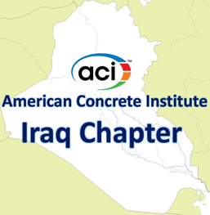 | Agenda of Virtual Meeting  Board of Directors  10:00 – 11:00 a.m.  Friday, March 04, 2022  Zoom meeting
Members in attendance
Alaa C. Galeb, President
Abdulkader Al-Hadithi, Vice President
Faris Rashid, Past President Riadh Al Mahaidi, Director
Suhair Al Habboubi, Director Haitham H. Muteb, Director
Saad Al Taan, Director
Absent members

None

Visitors
Kais F. Sarsam, Past Director
Omar Qarani, Past Director
Maan S. Hassan, Chair of Certification Committee
Saheb Khidher, Chair of Public Relations Committee
Assim Lateef Chair of Website Committee
Alaa Alzuhairi Chair of Education Committee
Dilshad Khder Amen, Past Director
Dilshad Kakasor Ismael, Past Director
Tariq Al Attar, Past Director
Raed Al Saedi, Past Director
Razaq Ferhadi, Past Director
Ali N. Attiyah, Executive Director
The mission of the Board of Directors:
To have general supervision of the affairs of the chapter, it shall authorize and appoint the chairs of such administrative and technical committees and assign to them such duties and such authority, as it deems needful to carry on the work of the chapter.
- Call to order
The meeting is called to order by President Alaa C. Galeb at 10:00 a.m.

- Welcome and Introductions
All in attendance introduced themselves and the President welcomed the attendees.

- Approval of Minutes
None.

- Approval of Agenda – additions/deletions
None.
- Establishment of the Iraqi Concrete Society
Dr. Alaa Alzuhairi will present briefly the activities required to establish the Iraqi Concrete Society.
- Student Project Competition
Dr. Haitham H. Muteb will present the draft of the Student Project Competition announcement.

- Establishment of ACI Student Chapters
Dr. Omer Qarani will give a brief about establishment of Student Chapters in Iraqi Universities.
- Webinar on Fibre Reinforced Concrete Code
The Board of Directors will discuss organizing a webinar on the new published Fibre Reinforced Concrete Code.
- Meeting with ACI
The Board of Directors will discuss the request of ACI for meeting with Iraq Chapter to discuss its activities.
- Next Meeting
The next meeting will be at 10 a.m., Friday, April 01, 2022.
- Adjourn

