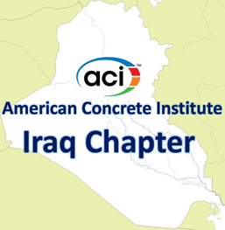 | Agenda of Virtual Meeting  Board of Directors  10:00 – 11:00 a.m.  Friday, Sept. 02, 2022  Zoom Meeting
Members in attendance
Alaa C. Galeb, President
Abdulkader Al-Hadithi, Vice President
Faris Rashid, Past President Riadh Al Mahaidi, Director
Suhair Al Habboubi, Director Haitham H. Muteb, Director
Saad Al Taan, Director
Absent members

None

Visitors
Kais F. Sarsam, Past Director
Omar Qarani, Past Director
Maan S. Hassan, Chair of Certification Committee
Saheb Khidher, Chair of Public Relations Committee
Assim Lateef, Chair of Website Committee
Alaa Alzuhairi, Chair of Education Committee
Dilshad Khder Amen, Past Director
Dilshad Kakasor Ismael, Past Director
Tariq Al Attar, Past Director
Raed Al Saedi, Past Director
Razaq Ferhadi, Past Director
Ali N. Attiyah, Executive Director
The mission of the Board of Directors:
To have general supervision of the affairs of the chapter, it shall authorize and appoint the chairs of such administrative and technical committees and assign to them such duties and such authority, as it deems needful to carry on the work of the chapter.
- Call to order
The meeting is called to order by President Alaa C. Galeb at 10:00 a.m.

- Welcome and Introductions
All in attendance introduced themselves and the President welcomed the attendees.

- Approval of Minutes
None.

- Approval of Agenda – additions/deletions
None.
- International Partnership Agreement with ACI
The Director Dr. Suhair Al Habbobi will describe briefly the signing of the International Partnership Agreement IPA between the Iraqi Ministry of Construction and ACI.
- Iraqi Concrete Society
Dr. Alaa Al Zuhairi will describe briefly establishing the Iraqi Concrete Society.

- Student Project Competition
The Director Dr. Haitham will describe briefly the Student Project Competition.
- Establishing ACI Student Chapters
The Board of Directors decided to discuss forming an ACI student chapter in one university or more next meeting.
- Adding new member to Chapter Committees
The Consultant Faris Rasheed will suggest adding new member to the Chapter Committees.
- Next Meeting
The next meeting will be at 10 a.m., Friday, Oct. 07, 2022.
- Adjourn

