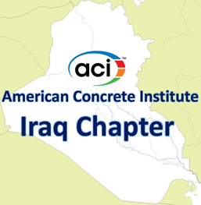 | Minutes of Virtual Meeting  Board of Directors  10:00 – 11:00 a.m.  Friday, Dec. 02, 2022  Zoom Meeting
Members in attendance
Alaa C. Galeb, President
Abdulkader Al-Hadithi, Vice President
Faris Rashid, Past President Riadh Al Mahaidi, Director
Suhair Al Habboubi, Director Haitham H. Muteb, Director
Saad Al Taan, Director
Absent members

None

Visitors
Kais F. Sarsam, Past Director
Omar Qarani, Past Director
Maan S. Hassan, Chair of Certification Committee
Saheb Khidher, Chair of Public Relations Committee
Assim Lateef, Chair of Website Committee
Alaa Alzuhairi, Chair of Education Committee
Dilshad Khder Amen, Past Director
Dilshad Kakasor Ismael, Past Director
Tariq Al Attar, Past Director
Raed Al Saedi, Past Director
Razaq Ferhadi, Past Director
Ali N. Attiyah, Executive Director
The mission of the Board of Directors:
To have general supervision of the affairs of the chapter, it shall authorize and appoint the chairs of such administrative and technical committees and assign to them such duties and such authority, as it deems needful to carry on the work of the chapter.
- Call to order
The meeting is called to order by President Alaa C. Galeb at 10:00 a.m.

- Welcome and Introductions
All in attendance introduced themselves and the President welcomed the attendees.

- Approval of Minutes
None.

- Approval of Agenda – additions/deletions
None.
- Student Project Competition
The vice president, Dr. Abdulkader Al-Hadithi will describe briefly the coordination with Iraqi Engineers Union on the celebration of competition winner.

- Establishing ACI Student Chapters
The Executive Director, Dr. Ali N. Attiyah described will describe briefly the efforts to establish ACI Student Chapters.
- New Directors
The Board of Directors will discuss the nomination of new directors. Four new directors will be selected for voting.
- Next Meeting
The next meeting will be at 10 a.m., Friday, Jan. 06, 2023.
- Adjourn

