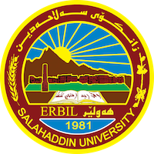
Academic Curriculum Vitae
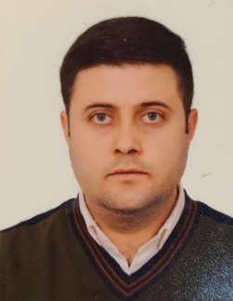
Personal Information:
Full Name: Rebin Birzo SALEH
Academic Title: Assistant Lecturer
Email: rebin.saleh@su.edu.krd
Mobile: 009647504904245

Education:
- 2012-2013: (Ph. D in Analytical Chemistry). The title of the thesis is (Flow-injection extraction-spectrophotometric determination of permanganate and chromate with crown ether). Department of Chemistry, College of Education, University of Baghdad, IRAQ.
- 2012-2013: (M.Sc. in IT Management). University of Bradford - UK.
- 1975-1979: (B.Sc. in Software Engineering). Department of Software Engineering, College of Engineering, University Salahaddin Hawler - Iraq.

Employment:
- 2013 – Now : Department of Computer Science, College of Science/ University of Salahaddin, Erbil, IRAQ.

Qualifications
- Teaching qualifications : STEM
- IT qualifications : Computer Security
- Language qualifications : IELTS Band 7

Teaching experience:
- Management Information System
- E-Business
- Information Security
- Computer Applications

Research and publications

Funding and academic awards
- STEM funding for university teachers

Professional memberships

2014- till now member of Kurdistan Teachers union.
- 2010- till now member of Kurdistan Engineers.

ORCID ID: https://orcid.org/0009-0000-9952-8574
Academic Profile: http://academics.su.edu.krd/rebin.saleh
Scholar Account: https://scholar.google.com/citations?user=Vj9jzpkAAAAJ&hl=en

