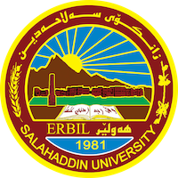
Academic Curriculum Vitae

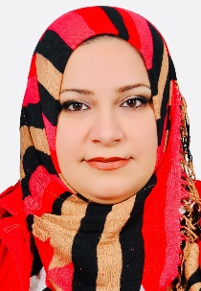
Personal Information:
Full Name: Saja Ataallah Muhammed
Academic Title: Lecturer Assistant
Email: saja.muhammed@su.edu.krd
Mobile: 0750452155

Education:
- BSc. (2001) Baghdad University/ College of Science/ Computer Science Department
- MSc. (2014) Salahaddin University/ College of Education/ Computer Science & Information Technology Department
Employment:
- 2003-2011: programmer assistant to advanced programmer at Salahaddin University/ College of Education/ Computer Science & IT department.
- 2014-Present: Lecturer Assistant at Salahaddin University/ College of Science/ Computer Science & IT department.

Qualifications
- Teaching qualifications
- IELTS: (23/2/2023 ) Overall Band Score (6.0)

Teaching experience:
- Discrete Mathematic for undergraduate 1st stage students
- Web Programming course for undergraduate 2nd stage students: HTML+CSS
- Web Programming course for undergraduate 3rd stage students: HTML+CSS+javaScript+jQuery
- Artificial Intelligence for undergraduate 4th stage students

Research and publications

Conferences and courses attended
- Training Courses
  - ‘Introduction to Lab View Program’ (11-15 September 2022)
  - اتقان لغة جافا سكربت on (25-29 September 2022)
- Conferences
  - ‘Third International Conference of Mathematics and its Applications’. Salahaddin University- College of Science.(29-31 August 2022)

Professional memberships
- سه‌نته‌رى روشه‌نبيرى زانكوى سه‌لاحه‌ددين
- يه‌كێتى مامۆستايانى كوردستان
Professional Social Network Accounts:

- ReserchGate
  - https://www.researchgate.net/profile/Saja-Muhammed
- LinkedIn
  - https://www.linkedin.com/in/saja-albayaty-15554573/
- Google Scholar
- https://scholar.google.com/citations?hl=en&user=UJqAumQAAAAJ&view_op=list_works&gmla=AJsN-F7Ry_3teJFQdq-Lpgq8WyTuOnjzX_mduADfmS8EuOfUVl5gwJVDc7AIBNy4OBhdJFUwMADPR-IKfVBM5GvdeAvyO5IA412AngMHpXBBTlabqrA8s8qEyVpAk0D4YfMzEHKmUKpp
- Twitter
  - https://mobile.twitter.com/Saja_Atta
- Facebook
  - https://www.facebook.com/profile.php?id=100004923098323

