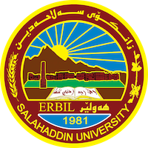
Academic Curriculum Vitae
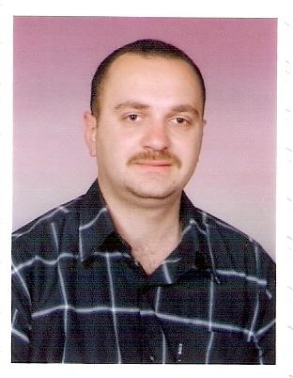
Personal Information:
Full Name: Salar Jamal Abdulhameed Al-Atroshi
Academic Title: Lecturer
Email: salar.atroshi@su.edu.krd
Mobile: +96407504950055

Education:
- MSc at University of Information Technology and Communications (Baghdad 2003-2004).
Name of Thesis: - Decomposition as a prefix to Image Compression.
- BSc at University of Mosul /Computer Department (2000-2001).
Employment:
- Member of Academic Staff in the Software and Informatics Engineering Department from 2004 till now.
Qualifications
- Teaching qualifications awarded by Salahaddin University-Erbil
- IELTS language qualification

Language Proficiency:
- Kurdish: Native Language
- English: Excellent
- Arabic: Fluent
Teaching experience:
- Data Security, Computational Theory, Discrete Mathematics, Combinatorics and Graph Theory, Image Processing, Computer Architecture, Operating System, Software Engineering, Visual Basic, Python, and C++.
Research and publications
- Al-Atroshi, A. M., Al-Aubaidy, S.T. and Abdulhameed, S. J., 2010. An Application of Integration (GBOM & GPS) for Quick Response Manufacturing. AL-Rafidain Journal of Computer Sciences and Mathematics, 7(1), pp.117-133.
- Rashid, T. A. and Abdulhameed, S. J., 2014 “Support Vector Machines for Predicting Electrical Fualts”, Engineering and Technology Journal, University of Technology, 32(8), pp. 1931-41.
- Hamadamen, N.I., Abdulhameed, S.J. and Abdulkrim, H.K., 2021. Production survey of designing a hybrid optical amplifier (HOP) for WDM systems by using EDFA and Raman amplifiers. J Des Eng, 7, pp.7476-91.

- Al-Atroshi, S.J.A. and Ali, A.M., 2023. Facial Expression Recognition Based on Deep Learning: An Overview. Iraqi Journal of Science, 64(3), pp.1401-1425, doi: 10.24996/ijs.2023.64.3.32.

Professional memberships
- Member of the Kurdistan Computerist Syndicate.
- Member of the Kurdistan Teachers Union.
- Member of the following scientific journals:
- Reviewer for Iraqi Journal of Science, University of Baghdad, Iraq.
- Reviewer for Journal of Pure and Applied Sciences (ZANCO), Salahaddin University-Erbil, Erbil, Kurdistan Region, Iraq.
Professional Social Network Accounts:

- Profile links of ReserchGate: https://www.researchgate.net/profile/Salar-Abdulhameed
- profile links of Google Scholar: https://scholar.google.com/citations?user=jlUohNwAAAAJ&hl=en
- ORCID ID: https://orcid.org/0000-0002-9387-369X

