Q 1/ fill in the gaps
- For the best hatchability an egg must lose ……………. Of its weight …………… of incubation
- Disinfection it is a …………………………………………………………………………
- The humidity in incubators must be up to ………………. And it should be ……………… in hatcheries
- Good cleaning and disinfection procedures within the hatchery are necessary to …….................. and continually minimize the level of ……………………………………………
- We can know the loss of humidity or liquid eggs by ……………………
- (cleaning and disinfection)
……………………………......... : after every transfer
- Do not fumigate the eggs after the first day of incubation because ……………………………………………………………………………………………..

Q 2/ answer the following questions

- Innumerate the cleaning and disinfection objectives:

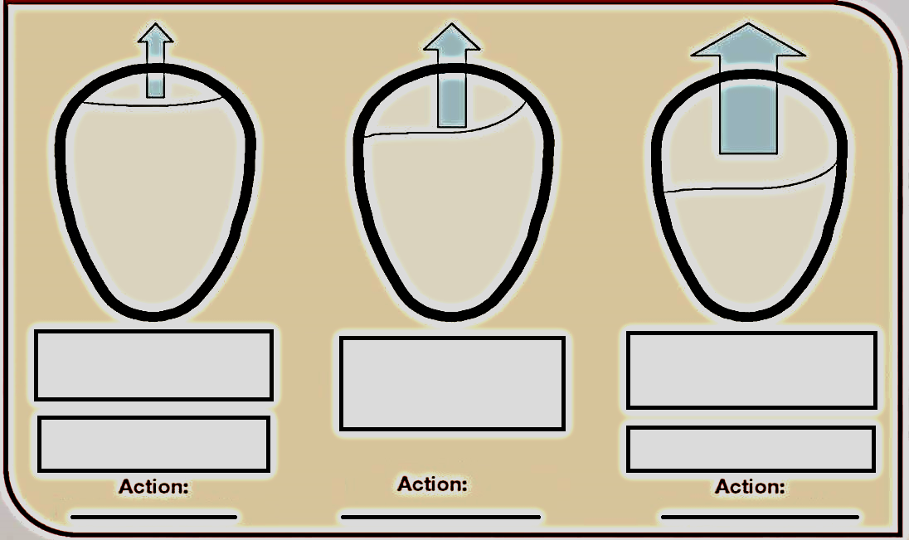

- Answer
- The rate of egg moisture that is lost depends on:
- In sanitation it is good practice to use different color uniforms according to location or task because:
- What is the result of not turning eggs:

Q3/ a/ Write about daily duties in hatcheries (daily works).
b/ Draw the hatchery building design and sections.
Q4/ a/ write define of egg?
b/ Could we send dirty eggs and floor eggs to the hatchery? How?

