Lec. 5 & 6
Components of Innate Immunity
- External and internal body surface.
- Soluble (humoral) mediators.
- Phagocytosis.
- Extracellular killing.
- Inflammation.
A- External body surface – Barrier defense - or called mechanical barriers to infection- contribute to innate immunity by inhibiting the attachment and penetration of infectious agents.
The barrier defenses are those layers on the outer surface of the body that protect the deeper tissues. The intact skin is one of the most important barrier defenses, and the largest organ of the body. Skin is the first line of defense which prevents the entry of pathogen and it is impermeable to most infectious agents. The skin is made up of cells called epithelial cells.
The intact skin consists of two distinct portions: -
- Epidermis – outer, thinner portion of the skin that is direct contact with the external environment. The cells of this portion fit together with no space between the cells, making the layers of the skin impermeable or hard to penetrate, so the microorganisms can not pass between skin cells. A second aspect of skin structure that is important is its multi-layered nature, the layers cover each other and the newest layers are toward the inside the body.
Cells of the epidermis: the top – most layer of skin
- Kerationcytes (95%): Predominantly act as barrier cells (the wall), contain a layer of protective protein called keratin, in addition the dryness of the skin, is a major factor in inhibiting microbial growth on the skin. When the skin is moist, skin infections are very common especially fungal infection such as athletic foot, these fungi hydrolyze keratin when water is available.
- Dendritic cells (2-3%): main immune system cell (the lookout) that picks up foreign invaders and travels out of the skin to lymph nodes to alert the body that something is wrong in skin.
- Melanocytes (1-2%): produce melatonin or pigment that protect the skin against sun damage (the paint on the wall|).
2 -Dermis –The inner, thicker portion of the skin, which is composed of connective tissue.
Cells of dermis – the second layer of the skin
- Fibroblasts – give strength or toughness to skin.
- Endothelial –linings of blood vessels.
- T- cells- immune system cells that fight foreign invaders (the troops).
The bacteria most likely to cause infection are the staphylococci that normally inhabit the epidermis hair follicles, sweat and oil glands of the skin, infections of the skin and underlying tissues frequently occur as a result of burns, cuts, wounds or other conditions that break the skin.
Many organisms live on or in the skin as members of the normal flora, they are harmless as long as they do not cause disease or they do not enter the body. Normal flora suppresses the growth of pathogenic bacteria and fungi by: -
1- Competition for essential nutrients.
2- Production of microbicidal substances.
3- Prevent the attachment of pathogen in their sites.
Most bacteria fail to survive for long time on the intact skin because of the direct inhibitory effects (antibacterial and antifungal activity) of fatty acid and lactic acid in sweat and sebaceous secretions, which are interfere with the membrane of bacteria (G –ve). The low pH of the skin (between 3-5), which is due to this fatty acid, also has antimicrobial effect make the skin unpleasant media for pathogen.
Note - fatty acid release by sebaceous glands that present in the subcutaneous layer of the skin and healthy for skin.
B- Internal body surface (Mucosal surface)
The second barrier defense that is important is the mucous membrane. These membranes are found lining the tracts of the body (Respiratory, digestive tract-----etc). Mucosa membrane is also made of epithelial cells, but of a different sort than skin.
Throughout the mucous membranes, there are specialized cells called goblet cells, these cells produce and secrete sticky thick liquid called mucus onto the surface of the membranes. The function of mucus is: -
1- Keep the membranes moist, or prevents the tract from drying out.
2- Acts to trap foreign bodies (Dust, soot and microorganisms).
3- Acts as a protective barrier to block the adherence of bacteria to epithelial cells or preventing any contact between any pathogen and areas not covered by skin.
The foreign material which is trapped in by mucus is removed by mechanical stratagems such as cilliary movement. For examples: -
Coughing and sneezing- movement of the cilia remove the microbe and prevent them to enter the lung.
Washing actions of tears, saliva, urine and other body fluids which assist to help in flushing microbes from the body.
Vomiting and diarrhea- eliminate pathogenic organisms.
Beating of cilia of epithelial cells in the respiratory tract removes contaminating microorganisms that become trapped in the mucus. This mechanism can be damaged by air, smoking, viruses and alcohol. The damage leads the host to bacterial infection.
Note- Some pathogens can survive on the moist secretions of a mucus membrane, and these pathogens may penetrate the membrane if they are present in large numbers. This penetration may be facilitated by toxin produced by such organisms. E.g., Entamoeba histolytica, Enteroinvasive E. coli and Treponema palladium.
If the microorganisms penetrated the body, three or four defensive operation comes into play: -
1- The destructive effect of soluble chemical factor such as bactericidal enzymes.
2- The mechanisms of phagocytosis.
3- Extracellular killing by natural killer cell.
4- Inflammation.
A/ Chemical barriers to infection
Saliva/ is produced by the salivary glands, saliva helps by
- Dilute and wash away the m.o from both the surface of the teeth and the mucus membrane of the mouth, this help and prevent colonization by microbes.
- Contain enzymes – lysozyme – that damage the microbial cell wall and membrane and cause leakage of cytoplasm.
- Contain antibodies that opsonize microbes.
Tears / Secrete by tear duct that are found inside corners of the eye, near the nose. The functions of tears are: -
- Washing the eyes, so removing the m.o before they can penetrate into the soft tissue of the eye ball.
- Contain lysozyme which lyses bacteria.
Sebum / Is produced by sebaceous gland that prevent hair from drying, also forms a protective film over the surface of the skin, the component of the sebum is unsaturated fatty acids (like caprylic acid) which inhibit the growth of pathogenic bacteria and fungi, and fatty acid denature proteins of the cell membrane.
The sweat glands of the skin produce perspiration which help maintain body temperature, eliminate certain waste and flush m.o from the surface of the skin. Perspiration also contains lysozyme which inhibit the growth of G +ve bacteria.
Vaginal secretions / Lactic acid removes microbes from genital tract by maintain acidic environment to m.o. An acid environment kills most pathogenic microbes while promoting the growth of non-pathogenic bacteria like Lactobacillus in the vagina.
Spermine / A pH dependent polyamine found in seminal fluids which inhibits the growth of G +ve bacteria.
Lysozyme / Also known as muramidase or N- acetyle muramide glycanhydrolase. Is a basic protein present in a number of secretions such as tears, saliva, urine and mucus, it is also found in cytoplasmic granules of the polymorphonuclear neutrophils (PMN). Large amounts of lysozyme can be found in egg whites. This enzyme damage bacterial cell walls (G +ve) by catalyzing or hydrolysis of the glycosidic bond that connects N-acetylmuramic acid and N-acetylglycose amine.
Opsonin / Is any molecule that act as a binding enhancer for the process of phagocytosis, for example, by coating the negatively-charged molecules on the membrane. Opsonin like antibodies IgG & IgA, complements fragments, C3b, C4b and mannose-binding lectin. Both the membrane of a phagocytosing cell and its target have negative charge (zeta-potential) making it difficult for the two cells to come close together. During the process of opsonization, Ags are bound by Ab and/or complement molecules. Phagocytic cells express receptors that bind opsonin molecules, these include Fc receptors, with the Ag coated in these molecules, binding of the Ag to the phagocyte is greatly enhanced. Most phagocytic binding cannot occur without opsonization of the Ag.
B-Lysin / Is a protein produced by platelet when they rupture during coagulation, can lyses many G +ve bacteria by acting as a cationic detergent. Lactoperoxidase / Is found in saliva and milk. Its mechanism of action is similar to that of myeloperoxidase (equal to catalase). It splits H2O2 and release toxic oxygen metabolite (O-, O-3, OH-) which destroy bacteria.
Humoral factor / contribute to nonspecific immunity, like antibody & complement. Normal serum can kill and lyses some G – ve bacteria, this property is the result of the combined action of Ab & complement fragments, both of which are present in normal serum. The activities destroyed by heating the serum at 56 C⁰ for 30 min.
Interferon –INF- / Termed interferon because they “interfere” with viral replication. Are natural proteins produced by the cells of the immune system in response to challenges by foreign agents such as viruses, tumor cells and parasites. INF is produced by a cell in response to the presence of double-strand RNA, a key indicator of viral infection. INF produced by virally infected cells to protect other cells in the area. Mechanisms of INF
1- secreted IFNs bind to cell surface IFN-receptor,
2- induce host cell proteins that inhibit viral replication
3- active Natural Killer (NK) cells to lyse infected cells and to secrete cytokines
4-IFNs serve as a firebreak to prevent spread of virus in tissue.

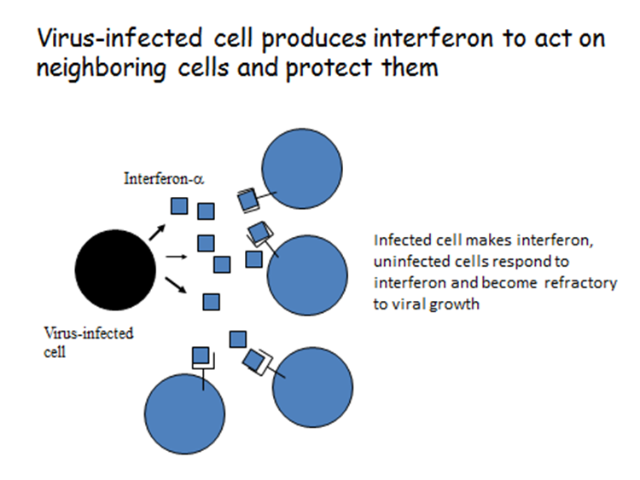

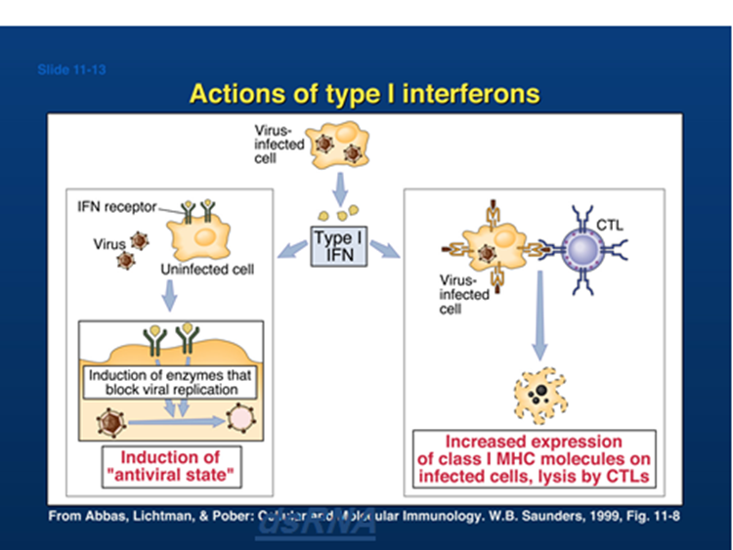

There are three types of INFs: -
1- INF-α – secreted by macrophage and other leukocytes, is induced by viruses.
2- INF –β – secreted by fibroblast also induced by viruses and synthetic polynucleotide.
3- INF –δ – secreted by T-cell after stimulation with the specific Ag.
Protective effects of INF: -
1- Activate cellular genes, including neighboring cells to produce antiviral proteins that interfere with the translation of viral m-RNA.
2- Block viral translation by two enzyme-mediated processes protein kinase & oligonucleotide polymerase.
3- Enhancing T- cell activity.
4- Activating macrophage.
5- Increasing the cytotoxic action of natural killer (NK) cell.
C-reative protein (CRP) / Is a protein found in the blood in response to inflammation (an acute phase protein). It is produced by the liver and by fat cells (Adipocytes). Its level increase or rise during inflammatory processes occurring in the body due to a rise in the plasma concentration of IL-6 which is produced by macrophages as well as adipocytes. It is assisted in complement binding to foreign and damaged cells and enhances phagocytosis by macrophages which express a receptor for CRP. It is used mainly as a marker of inflammation, apart from liver failure.

Lactoferrin / Also known lactotransferrin- is protein with antimicrobial activity (bactericide & fungicide), and is part of innate defense mainly at mucosas. It is found in milk, many mucosal secretions such as saliva and tears and in secondary granules of PMN. Human colostrums has the highest concentration followed by human milk. Lactoferrin antimicrobial activity is due to its high affinity for Fe+3 (ferric state). When LF proteolysis produces lactoferricin, kaliocin (small peptide with antimicrobial activity).

