Lec.7 & 8 Immunology
-------------------------------------------------------------------------------------------------------------------
Endocytosis /Is the process by which material is taken into a cell and enclosed within a piece of plasma membrane. There are three major endocytic pathways: -
1- Pinocytosis / involves ingestion of very small particles such as macromolecules. Hence pinocytosis cannot be seen under microscope.
2- Receptor-mediated endocytosis/ occurs upon binding of matter to one or more specific receptors on the surface of the cells.
3-Engulfment of a particulate substance (such as bacteria) by a cell is called phagocytosis. The cells which engulf the bacteria is called a phagocytic cell.
Phagocytosis / Phago: from Greek, meaning eat, Cyte: from Greek, meaning cell. Ingestion of microbes or particles by a cell. Is the principle host mechanism for elimination of most microorganisms, and was first discovered by Eli Metchnikoff in 1882. Neutrophil and macrophages are the principal cells involved in this processes and both of them are derived from a stem cell in the bone marrow.
Hematopoiesis / The process by which the blood cells grow, divide and differentiate is called hematopoiesis. There are three classes of blood cells produced from hematopoietic stem cells.
1- Erythrocytes (Red blood cell or RBC) are responsible for oxygen and carbon dioxide transport.
2- Leucocytes (White blood cells or WBC) are involved in host defense. There are different types of leucocytes
a/ Microphage or Granulocyte (Neutrophil, Acidophil &Basophils).
B/Macrophage or granulocyte (Monocyte & Lymphocyte).
3- Platelets (Thrombocytes) play an important role in blood coagulation and they are responsible for arresting the bleeding from blood vessels.
Hematopoietic stem cells (HSCs) are small cells and they arise in the mesoderm of the yolk sac during the first week of embryonic life. Within two months after conception most of the HSCs migrate to the fetal liver, later HSCs begin to colonize the developing bone marrow cavities. After birth, throughout a person's life, the bone marrow is the site of stem cell renewal and blood cells production, with aging the hematopoietic activity in long bones decreases so that after puberty hematopoietic is largely confined to the axial skeletal bones such as pelvis sternum ribs.

Cells of the Immune System
All immune system cells are called white blood cells, or leukocytes can be divided into two main groups based on their appearance under the light microscope:
• Granulocytes / (Neutrophils (stain lilac), Basophils (stain blue-purple), and Eosinophils (stain red or orange).
• A granulocytes / Monocytes à Macrophages: professional phagocytes - present in virtually all tissues - Lymphocytes - Dendritic cells
A / Granulocyte
All contain granules filled with chemicals that are important in their function Three types:
1/ Neutrophils-
• / Commonly called polymorphonuclear leukocytes (PMNs) because of the multilobed nature of their nuclei (Multinucleated).
• / Highly phagocytic (professional phagocytes) and motile, so they freely migrate into sites of inflammation.
• / Active in the initial stages of infection. Or predominate in early inflammatory responses
• / Granules contain antimicrobial substances and degradative enzymes
• Ability to leave the blood, enter infected tissues, destroy microbes/foreign particles ingest bacteria, dead cells, and cellular debris.
• Neutrophils become phagocytic when encountering infectious material.
• /Cells are short lived (8 days spending much of this time in the tissues and only about 6-12 hours in circulation) and become a component of the purulent exudate.
• A common sign of bacterial infection is a high neutrophil count in the blood (Neutrophilia) and their number may rise to 20.000 cell/µl of blood. They are the first cell type to respond to most bacterial and fungal infections. Causes of neutrophilia are
• Pathologic like bacterial infection - certain viruses and fungi.
• Inflammatory responses to tissue death like burn and snake bites.
• Drugs like steroid and lithium.
• While the neutropenia is the decreased in peripheral blood absolute neutrophil count below the lower limit of normal. Causes of neutropenia are
• Decreased Production of WBCs like bone marrow disease and malignancies that affect the bone marrow.
• Increased Neutrophil Destruction like certain bacteria.
Mature neutrophil contains several granules: -
A/ Primary (azurophilic) granules azurophilic; characteristic of young neutrophils; / called azurophilic because they stain dark blue with wright stain) contain many antimicrobial substances, these granules fuse with phagosome resulting in the degranulation of the granules into the phagosome. The contents of the granules act on the phagocytosed microbes and degrade them such as (myeloperoxidase – lysozyme – defensins – proteinase – phosphatase……)
B/ Secondary granules/ specific for mature neutrophils, contain lysozyme, NADPH oxidase, lactoferrin and B12-binding protein. It is suggested that the secondary granules are released to the of the neutrophil and they modify the inflammatory response.
NOTES/ The cytoplasm of the leukocyte has numerous vesicles called lysosomes which contain a variety of hydrolytic enzymes capable of breaking down most protein and carbohydrate.
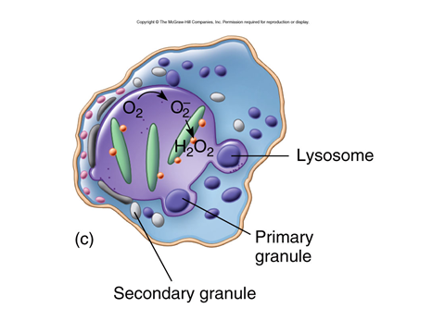
2/ Eosinophil /
• Somewhat phagocytic.
• Have the ability to leave the blood.
• Major function is to produce toxic proteins against certain parasites such as worms.
• Spends little time in the blood (6 to 12 hours) before it locates in the skin, or respiratory tract, most of them are found in connective tissues which are present throughout the human body (few days).
• Their granules contain peroxidase, lysozyme and other digestive enzyme.
• Eosinophil is usually associated with allergic conditions such as asthma.
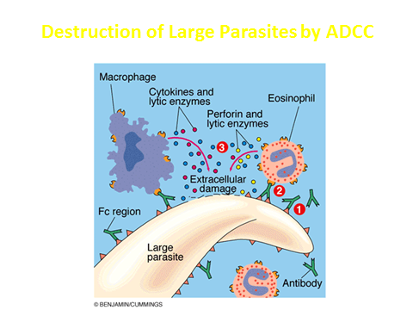
3 / Basophile
• Nucleus does not always segment.
• Increase in response to same conditions that cause eosinophils to respond.
• Basophile have many of the properties of tissue mast cells (basophile have membrane receptors for Fc region of IgE.
• Produce histamine, important in inflammation and allergic response.
Monocytes and Macrophages / Are the largest of all WBC and the third common in the circulation (Neu and Lym). They are motile cells and move freely into inflammatory sites, they are known as scavenger cells of the body because they engulf and digest microbes, foreign particles and debris from injured sites.
• Monocytes are produced in the bone marrow, enter the circulation, and migrate to the inflammatory site, where they develop into macrophages.
• Not actively phagocytic until they leave circulating blood, enter the body tissues, and mature into macrophages.
• Monocyte stay in blood for about 70 hours. Become macrophages in tissue and live for several months or longer.
• Wandering macrophages: Originate from monocytes that leave blood and enter infected tissue, and develop into phagocytic cells.
• Fixed Macrophages (Histiocytes): Located in liver, nervous system, lungs, lymph nodes, bone marrow, and several other tissues. The macrophages in different tissues are called by different names ( Blood – Monocyte / Bone marrow – monoblast or promonocytes / Any soild tissue – histocyte / Liver – kupffer cell / Lung – Aleveolar / Central nerve system - Microglia).

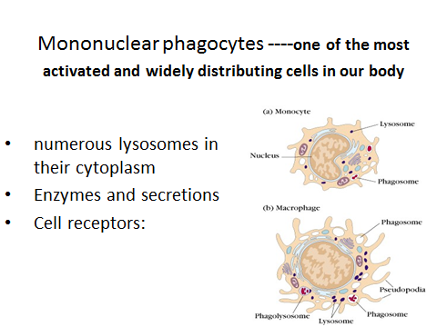
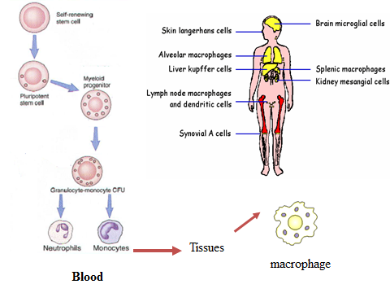

Macrophages functions
1. Macrophages phagocytose bacteria and kill them during the first entry of them by phagocytosis.
2. With lymphocytes the macrophages play important role in acquired immunity. They are the principle antigen presenting cells (APCs) to T-cells.
3. Macrophage removes old damaged and dying cells of the body.
4. Macrophage secrete many cytokines (such as interleukin 1, 6 and 12, tumor necrosis factor) that influence the growth and activity of many other cells.
Lymphocytes
• Natural killer (NK) cells- destroy virus-infected and abnormal cells
• B lymphocytes and T lymphocytes are involved in adaptive immunity
– B cells: produce antibody
– T cytotoxic cells: destroy infected host cells
– T helper cells: coordinate immune response

Dendritic Cells
• Found in the skin and other points of pathogen origin.
• They are involved in the activation of acquired immunity.
• Phagocytosis and killing of microorganisms.
• Function as antigen presenting cells (APC)
• In the blood and tissues – mature and migrate to the lymph nodes
Cell Communication
• Cells of the immune system must be able to communicate with each other
• They use cytokines
• Cytokines bind to surface receptors
• Then induce change in these cells, such as growth, differentiation, movement or cell death.
Cytokines: - 4 kinds:
1. Chemokines: important in chemotaxis of immune cells
2. Interferons: glycoproteins important in the control of viral infections; also help regulate cells involved in immune response
3. Interleukins: important in innate immunity, inflammation, and adaptive immunity
4. Tumor necrosis factors: help kill tumor cells, initiate programmed cell death (apoptosis).

Cells of the Immune System
• Can move from one part of the body to another, traveling through circulatory systems
• Always found in normal blood
• Some play dual functions in both innate and acquired immune response
Phagocytosis / Phago: from Greek, meaning eat, Cyte: from Greek, meaning cell. Ingestion of microbes or particles by a cell.
Is the principle host mechanism for elimination of most microorganisms, and was first discovered by Eli Metchnikoff in 1882. Neutrophil and macrophages are the principal cells involved in these processes and both of them are derived from a stem cell in the bone marrow. Hematopoiesis
The engulfment, digestion, and subsequent processing of microorganisms by macrophages and neutrophils
1) Chemotaxis& attachment: Phagocytes are chemically attracted to site of infection
a- Attraction by chemotactic substances (microbes, damaged tissues).
b- Attachment by receptors on surfaces of phagocytes. (Phagocyte plasma membrane attaches to surface of pathogen or foreign material). Adherence can be inhibited by capsules (S. pneumoniae) or M protein (S. pyogenes).
2) Ingestion:
* Phagocyte pseudopodia surround organism forming phagosome
* Opsinins and co-factors enhance phagocytosis
* Fusion with phagocyte granules and release
digestive, toxic contents
3-Killing (two microbicidal routes)
a- Oxygen depended system (powerful microbicidal agents)
Oxygen converted to superoxide, anion, hydrogen peroxide, activated oxygen and hydroxyl radicals.
b- Oxygen-independent system (anaerobic conditions)
Digestion and killing by lysozyme. Lactoferrin, low pH, cationic proteins and hydrolytic and proteolytic enzymes.
