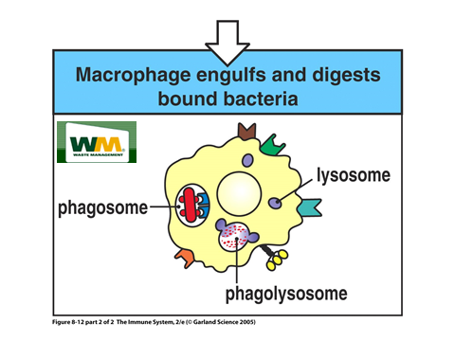

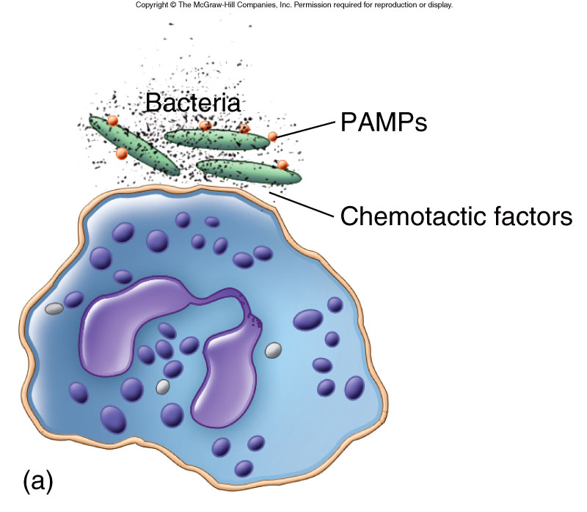

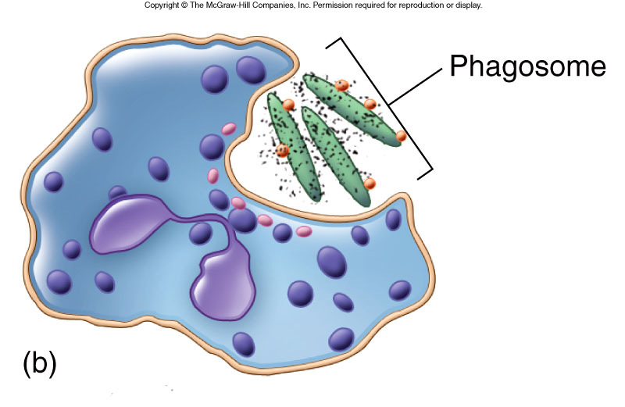

PAMPs / Pathogen – associated molecular pattern
The surface of some microorganism bears repeating pattern of molecular structures that are recognized by cells of the innate immune system. The molecules of the host cell which bind to the PAMPs are known as pattern recognition receptors (PRRs) in human such as toll – like receptors (TLRs).
Examples of PAMPs :- bacterial lipopolysaccharides found on the cell membranes of G –ve bacteria, Peptidoglycan and lipotechoic acid from G + ve bacteria, flagellin and nucleic acid from viruses such as double- strand RNA.
TLR / Toll – Like Receptor
Are family of membrane bound proteins expressed on cell surface of the innate immune system such as Macrophage , Dendritic cell and Neutrophil.They recoginized PAMPs.
Antigen-Presenting Cell (APC)
Cells that process and present forign materiales in a form that can be recogenized bt T- cell such as macrophage, dendritic cell and B-cell.

