Immunolog y
Immunoglobuline
Antibodies are the protective agents of the immune system. The immune system uses antibodies to identify and neutralize foreign invaders, called antigens, such as bacteria and viruses. Antibodies constitute an essential part of the adaptive immune system.
Ab is: Glycoprotein in serum and tissue fluid, Produced by B- lymphocytes in response to an antigen. They bind to specific sites on antigen surfaces. React specifically with antigen, there are five classes of Ab: IgG, IgM, IgA, IgD, IgE.
Ab don’t kill organisms, they:
1- Can inactivate an invader (combine with bacterial toxins or viruses to prevent attachment to target cells (“inactivation”).
2- Initiate the process of activating phagocytic cells and other natural killers.
Antibody structure:
They belong to group of plasma proteins called “globulins.”
- All Ig molecules consist of one or more basic units of 4 polypeptides (amino acid chains).
- 2 identical, longer and larger heavy chains (H) and 2 identical, shorter and smaller light chains (L) held together by a number of disulphide (S-S) bonds.
- One L-chain is attached to each heavy chain, and the 2 heavy chains are attached to each other.
- The L-chains are of M.W of 25.000 Dalton and H-chains have a M.W of 50.000-75.000 Dalton.
- Have the shape of a letter “Y”. The “arms” of the “Y” bind antigens. The tail of the “Y” is responsible for biological activity.
- L- and H-chains are subdivided into Constant (C) and Variable regions(V).
- L-chain consists of 1 VL and 1 CL regions.
- H-chains consist of 1 (VH) and 3 or 4 (CH1), (CH2), (CH3), (CH4), e.g. IgG and IgA have 3 constant regions and IgM and IgE have 4 constant regions.
- The Variable regions of both L and H-chains are responsible for Ag binding whereas the constant regions are responsible for performing biological functions like complement activation, crossing of placenta, etc.
- The constant region is identical in all antibodies of the same isotype, but differs in antibodies of different isotypes.
- The variable region of the heavy chain is located at the tip of the chain. It differs in antibodies produced by different B cells, but is the same for all antibodies produced by a single B cell.

Immunoglobulin classes- There are 5 classes of Ig on the basis of structure of constant regions of heavy chains. These are IgG, IgA, IgM, IgD and IgE.
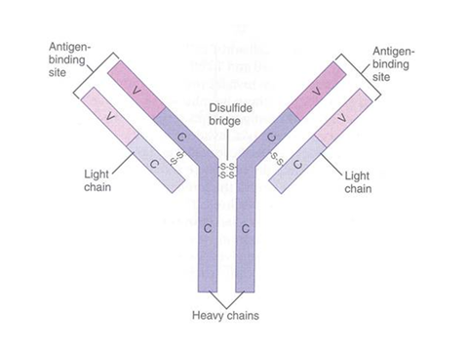
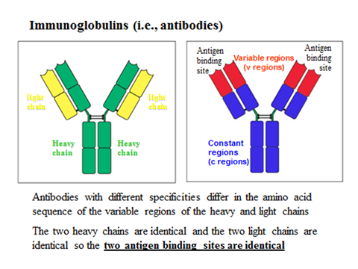
IgG
- Is present in the serum at a concentration of 12mg/ml, constituent about 80% of total Ig and 15% of total plasma proteins.
- Half-life is about 23 days.
- Structurally consists of one basic unit (monomer) consisting of 2-L chains and 2-H chains.
Biological functions
1- Crossing of placenta- IgG is the only Ig that cross the placenta (blast cells have Fc receptor for IgG) and thereby confer natural immunity to the fetus.
2- Agglutination- It can agglutinate specific Ag. This is very important because Ag-Ab complexes are easily phagocytosed and destroyed by phagocytic cells.
3- Opsonisation- IgG acts as an opsonising antibody. Opsonisation is the process by which an Ag is coated by Ab and facilitated the effective pagocytosis.
4- Activation of complement- The classic pathway of complement activation is accomplished by IgG leading to lysis of target cells.
5- Immobilisation of bacteria- It can immobilise many motile bacteria and thereby helps in phagocytosis.
6- Antibody dependent cell mediated cytotoxicity (ADCC)- Used to destroy large organisms (e.g.: worms). Target organism is coated with antibodies and bombarded with chemicals from nonspecific immune cells (NK-cell) and specific cell (Tc-cell) such as perforine and granenzyme.
7- Neutralisation - IgG inactivates viruses by binding to their surface and neutralize toxins by blocking their active sites.

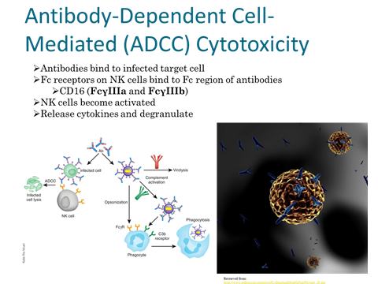
IgM
1- Structure: Pentamer
2- Percentage serum antibodies: 5-10%
3- Location: Blood, lymph, B cell surface as receptor (monomer)
4- Half-life in serum: 5 days
4- Complement Fixation: Is an excellent Ab to activate complement because of its pentameric form.
5- Placental Transfer: No
6- First antibodies produced during an infection.
7- agglutinating antigens.
IgA
1- Structure: Dimer
2- Percentage serum antibodies: 10-15%
3- Location: Secretions (tears, saliva, intestine, milk), blood and lymph.
4- Half-life in serum: 6 days
5- Complement Fixation: No
6- Placental Transfer: No
7- Localized protection of mucosal surfaces.
8- Provides immunity to infant digestive tract.
IgE
1-Least common serum Ig.
2-Binds to basophils and mast cells (Does not require Ag binding).
3-Allergic and hypersensitivity reactions.
4-Parasitic infections (Helminths.
5-Does not fix complement.

IgD
1-Present in very small amount in serum.
2-B cell surface Ig.
3-Does not bind complement.




