General Virology/1st Lecture Introduction to virology

History of virology
- Edward Jenner (1798) introduced the term virus in microbiology. Virus in Greek means poison. Edward Jenner noticed that milk maids who infected with cowpox develop immunity against smallpox. He was assumed that the vesicle fluid that has been taken from the hand of the milk maid contained a poison (virus) that was responsible for immunity.
- Rabies vaccination by Louis Pasteur in 1886.
- Introduction of concept of ‘filterable agents’ for plant pathogens (Dimitri Ivanofsky, Beijerinck in late 1880’s) showed that a disease in tobacco was caused by a virus
- First filterable agent from animals described – foot and mouth disease in cattle (Loeffler and Frosch in 1898)
- First human filterable agent described - yellow fever virus (Reed in 1901)
- Linkage of viruses with cancer (Ellerman, Bang 1908; Rous 1911)
- Description of bacteriophages (Twort and D’Herelle in 1915)
- Visualization of viruses by EM and x-ray crystallography (1939, 1941)
- 1950s virology had grown
- In 1953, Crick & Watson proposed principles of virus structure
- Development of tissue culture systems (Sanford, Enders, Gay, Eagle 1948-1955); growth of poliovirus in culture
- In 50’s & 60’s Klug and others confirmed that several (unrelated) “spherical” viruses had icosahedral symmetry
- Discovery of many agents; explosion in molecular biology (past 45-50 years)
- Viruses are infectious agents with both living and non-living characteristics
1. Living characteristics of viruses
a. They reproduce at a fantastic rate, but only in living host cells.
b. They can mutate.
2. Non-living characteristics of viruses
a. They are acellular, that is, they contain no cytoplasm or cellular organelles.
b. They carry out no metabolism on their own and must replicate using the host cell's metabolic machinery. In other words, viruses don't grow and divide. Instead, new viral components are synthesized and assembled within the infected host cell.
c. The vast majority of viruses possess either DNA or RNA but not both.
- General characters of viruses:
1. Virus particles are very small in size; they are between 20-500 nm in diameter.
2. Viruses are obligate intracellular parasites. They replicate only inside living cells.
3. Multiply inside the cells by replicating their genomes which either DNA or RNA, but never both.
4- Viruses lack cellular organelles, such as mitochondria and ribosomes but they depend on infected cells to provide all their needed organelles.
5. Virus does not affect with antibiotics.
6. Most viruses sensitive to interferon.
7. Viruses cannot grow on artificial media, but only in living cells (specific host, Lab animals, chicken embryonated eggs & tissue culture).
8. Viruses cannot be seen by ordinary microscope, but only by Electron microscope (EM).

Size of Virus
- Smallest infectious agents, they can only be seen with an electron microscope
  - A smallest virus -Paroviruses- around 20 nm in diameter
  - A largest virus -Mimi viruses (Poxviruses)- up to 450 nm in diameter
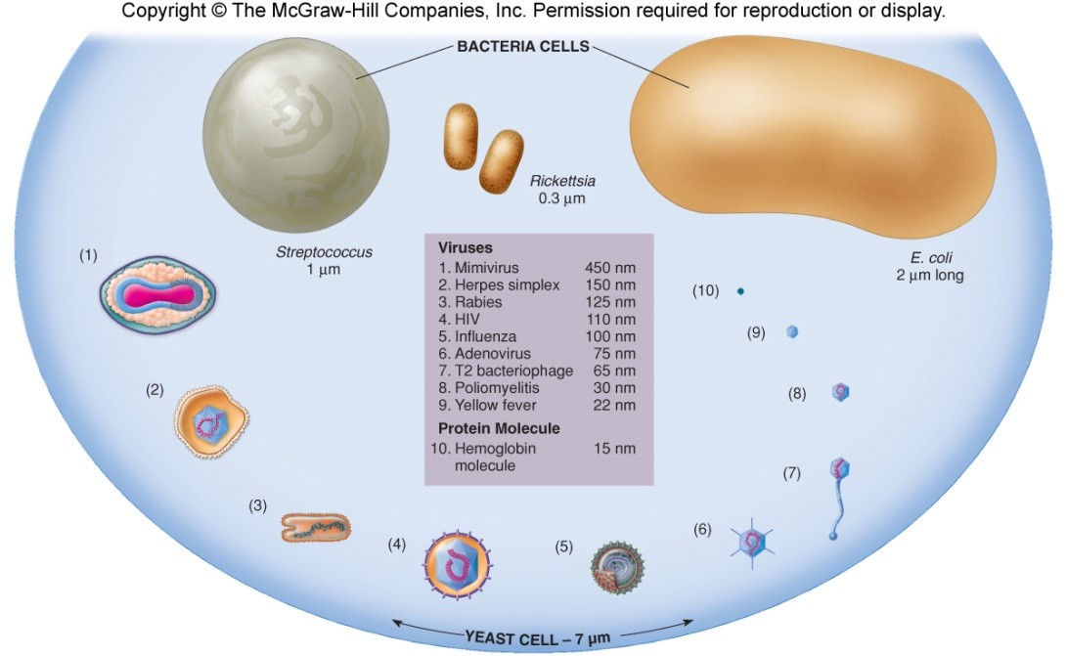

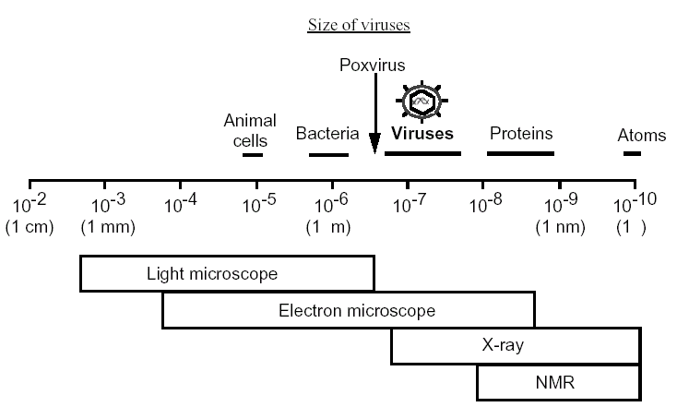
Reasons for studying viruses:-
1-Some viruses cause disease and are important agents of many human diseases e.g. common colds, rabies….etc. Also play roles in the development of several types of cancer.
2-There is a requirement to understand the nature of viruses, how they replicate and how they cause disease. This knowledge permits the development of effective means for prevention, diagnosis and treatment of virus diseases through the production of vaccines, diagnostic and techniques, and antiviral drugs. These medical applications therefore constitute major aspects of the science of virology.
3-Veterinary virology and plant virology are also important because of the economic impact of the many viruses that cause disease in domestic animals and crop plants: foot and mouth disease virus and rice yellow mottle virus are just two examples.
4-Some viruses are useful: Some viruses are studied because they have useful current or potential applications.
• Phage typing of bacteria: Some groups of bacteria, such as some Salmonella species, are classified into strains on the basis of the spectrum of phages to which they are susceptible.
• Sources of enzyme: A number of enzymes used in molecular biology are virus enzymes. Examples include reverse transcriptase from retroviruses and RNA polymerases from phages.
• Pesticides: Some insect pests are controlled with baculoviruses and myxoma virus.
• Anti-bacterial agent: In the mid-20th century phages were used to treat some bacterial infections of humans. Interest waned with the discovery of antibiotics, but has been renewed with the emergence of antibiotic-resistant strains of bacteria.
• Anti-cancer agents: Genetically modified strains of viruses, such as herpes simplex virus and vaccinia virus, are being investigated for treatment of cancers.
• Gene vectors for protein production: Viruses such as certain adenoviruses are used as vectors to take genes into animal cells growing in culture.
• Gene vectors for treatment of genetic disease: Children with severe combined immunodeficiency have been successfully treated using retroviruses as vectors to introduce into their stem cells a non-mutated copy of the mutated gene responsible for the disease.
Evolutionary Origin of Viruses
The origin of viruses is not known. There are profound differences among the DNA viruses, the RNA viruses, and viruses that utilize both DNA and RNA as their genetic material during different stages of their life cycle. It is possible that different types of agents are of different origins. Two theories of viral origin can be summarized as follows:
(1) The Progressive (Vagrancy) Hypothesis: Viruses may be derived from DNA or RNA nucleic acid components of host cells that became able to replicate autonomously and evolve independently. They resemble genes that have acquired the capacity to exist independently of the cell.
(2) The Regressive (Degeneracy) Hypothesis: Viruses may be degenerate forms of intracellular parasites. There is no evidence that viruses evolved from bacteria, though other obligatory intracellular organisms, e.g. rickettsia and chlamydia presumably did so. However, poxviruses are so large and complex that they might represent evolutionary products of some cellular ancestor.
(No Single Hypothesis May Be Correct)
Where viruses came from is not a simple question to answer. One can argue that retroviruses arose through a progressive process. Mobile genetic elements gained the ability to travel between cells, becoming infectious agents. And also argue that large DNA viruses arose through a regressive process whereby once-independent entities lost key genes over time and adopted a parasitic replication strategy. Finally, the idea that viruses gave rise to life perhaps all viruses arose via a mechanism yet to be uncovered. Today's basic research in fields like microbiology, genomics, and structural biology may provide us with answers to this basic question.
Reaction to physical and chemical agents:
1. Heat and cold viral infectivity is generally destroyed by heating at 50-60 °C for 30 min. Viruses can be preserved at -90 °C or-196 C0 (liquid nitrogen).
2. PH Viruses can be preserved at physiological PH (7.3).
3. Ether susceptibility: Ether susceptibility can be used to distinguish viruses that possess an envelope from those that do not.
4. Detergents: Nonionic detergents solubilize lipid constituents of viral membranes. The viral proteins in the envelope are released. Anionic detergents also solubilize viral envelopes; in addition, they disrupt capsids into separated polypeptides.
5. Salts: Many viruses can be stabilized by salt in concentrations of 1mol/L. e.g. MgCl₂, MgSO₄, and Na₂SO₄
6. Radiation: Ultraviolet, X-ray, and high-energy particles inactivate viruses.
7. Formaldehyde: Destroys viral infectivity by reacting with nucleic acid.
8. Antibiotics: Antibacterial antibiotics have no effect on viruses.
Definitions
- Virology: the science which deals with study of viruses as causative agents of very important diseases that occurs in human, animals, plants and other living organisms (insects, bacteria,…).

- Viruses: The smallest and simplest form of life on earth, which can replicate only in living susceptible cells.

- Virion: The complete infective virus particle, which in some instances (adenoviruses, papovaviruses, picornaviruses) may be identical with the nucleocapsid. In more complex virions (herpesviruses, myxoviruses), this includes the nucleocapsid plus envelope.

- Detective virus: A virus particle that is functionally deficient in some aspect of replication. Defective virus may interfere with the replication of normal virus.

- Pseudovirus: During viral replication the capsid sometimes encloses host nucleic acid rather than viral nucleic acid. Such particles look like ordinary virus, particles when observed by electron microscopy, but they do not replicate. Pseudovirions contain the “wrong” nucleic acid.

- Viroids: Single strand RNA genome and the smallest known pathogens affects plants much smaller than viruses ,no protein coat

- Prions: Infectious particles that are entirely protein no nucleic acid highly heat resistant in animal affects nervous tissue and results in
    - Bovine spongiform encephalitis (BSE) “mad cow disease”
    - Scrapie in sheep
    - kuru & Creutzfeldt-Jakob Disease (CJD) in humans

- Bacteriophage: Virus that infects prokaryotic (bacterial) cells

