General Virology/2nd Lecture Structure & Symmetry of Virus
Generalized Structure of Viruses
Viral components: 1- Capsid
2-Nucleic acids
3-Envelope
4-Glycoprotein

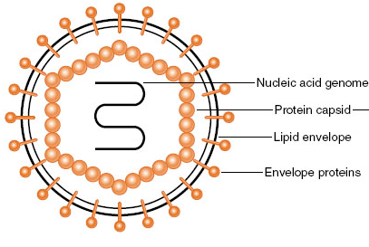
Principles of Virus Structure
Viruses come in many shapes and sizes. Structural information is necessary for virus classification and for establishing structure-function relationships of viral proteins.
Types of Symmetry of Virus Particles
Electron microscopy, cryo-electron microscopy, and x-ray diffraction techniques have made it possible to resolve fine differences in the basic morphology of viruses. Viral architecture can be grouped into three types based on the arrangement of capsomeres and the morphology of the nucleocapsid subunits:
(1) Cubic symmetry, e.g. Adenoviruses
(2) Helical symmetry, e.g. Orthomyxoviruses
(3) Complex structures, e.g. Poxviruses and Bacteriophag
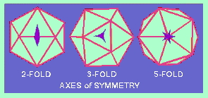
Cubic Symmetry (Icosahedral): All cubic symmetry observed within animal viruses is of the icosahedral pattern. The icosahedron has 20 faces (each an equilateral triangle), 12 vertices, and fivefold, threefold, and twofold axes of rotational symmetry. The vertex units have five neighbors (pentavalent), and all others have six (hexavalent).
Helical Symmetry: In cases of helical symmetry, protein subunits are bound in a periodic way to the viral nucleic acid, winding it into a helix. The filamentous viral nucleic acid-protein complex (nucleocapsid) is then coiled inside a lipid-containing envelope.
Complex Structures: Some virus particles do not exhibit simple cubic or helical symmetry but are more complicated in structure. For example, poxviruses are brick-shaped, with ridges on the external surface and a core and lateral bodies inside.

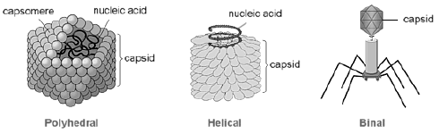
Chemical Composition of Viruses
Viral Protein: The structural proteins of viruses have several important functions:
- Their major purpose is to facilitate transfer of the viral nucleic acid from one host cell to another.
- They serve to protect the viral genome against inactivation by nucleases.
- Participate in the attachment of the virus particle to a susceptible cell.
- Provide the structural symmetry of the virus particle.
- The proteins determine the antigenic characteristics of the virus.
- Some surface proteins may also exhibit specific activities, e.g. influenza virus hemagglutinin agglutinates red blood cells.
Viral Nucleic Acid
Viruses contain a single kind of nucleic acid—either DNA or RNA—that encodes the genetic information necessary for replication of the virus. The genome may be single-stranded or double-stranded, circular or linear, and segmented or non-segmented. The type of nucleic acid, its strandedness, and its size are major characteristics used for classifying viruses into families. The size of the viral DNA genome ranges from 3.2 kbp (hepadnaviruses) to 375 kbp (poxviruses). The size of the viral RNA genome ranges from about 7 kb (some picornaviruses and astroviruses) to 30 kb (coronaviruses).
Viral RNAs exist in several forms. The RNA may be a single linear molecule (eg, picornaviruses). For other viruses (eg, orthomyxoviruses), the genome consists of several segments of RNA. The isolated RNA of viruses with positive-sense genomes (ie, picornaviruses, togaviruses) is infectious, and the molecule functions as an mRNA within the infected cell. The isolated RNA of the negative-sense RNA viruses, such as rhabdoviruses and orthomyxoviruses, is not infectious.
Viral Lipid Envelopes
Envelopes vary in: Size, Morphology, Complexity, and Composition. A number of different viruses contain lipid envelopes as part of their structure. The lipid is acquired when the viral nucleocapsid buds through a cellular membrane in the course of maturation. The specific phospholipid composition of a virion envelope is determined by the specific type of cell membrane involved in the budding process. For example, herpesviruses bud through the nuclear membrane of the host cell, and the phospholipid composition of the purified virus reflects the lipids of the nuclear membrane.
(a) virions lacking envelopes = naked viruses (b) virions having envelopes = enveloped viruses
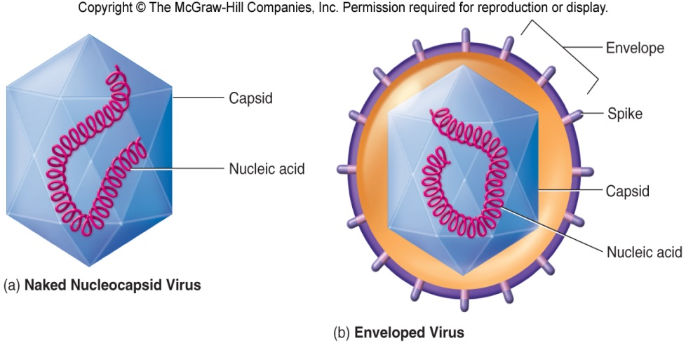
Viral Glycoproteins
Viral envelopes contain glycoproteins. In contrast to the lipids in viral membranes, which are derived from the host cell, the envelope glycoproteins are virus-encoded. However, the sugars added to viral glycoproteins often reflect the host cell in which the virus is grown.
- It is the surface glycoproteins of an enveloped virus that attach the virus particle to a target cell by interacting with a cellular receptor.
- They are also often involved in the membrane fusion step of infection.
- The glycoproteins are also important viral antigens.
Viral Enzyme
Some viruses carry enzymes inside the virions. The enzymes are present in very small amounts and are probably not important in the structure of the virus particles; however, they are essential for the initiation of the viral replicative cycle when the virion enters a host cell examples include an
1-RNA polymerase carried by viruses with negative-sense RNA genomes (e.g, orthomyxoviruses, rhabdoviruses) that is needed to copy the first mRNAs,
2- Reverse transcriptas an enzyme in retroviruses that makes a DNA copy of the viral RNA, an essential step in replication and transformation.
3-At the extreme in this respect are the poxviruses, the cores of which contain a transcriptional system; many different enzymes are packaged in poxvirus particles.
Classification of Viruses
-Virus classification is the process of naming viruses and placing them into a taxonomic system.
- Virus Taxonomy: A Science with dynamic field, based on information -Uses techniques and theories of: -Collating and describing, identification and classification, grouping and naming of viruses
Basis of Classification:
The following properties have been used as a basis for the classification of viruses:
(1) Virion morphology, including size, shape, type of symmetry, presence or absence of peplomers, and presence or absence of membranes.
(2) Virus genome properties, including type of nucleic acid (DNA or RNA), size of genome in kilobases (kb) or kilobase pairs (kbp), strandedness (single or double), whether linear or circular, sense (positive, negative, ambisense), segments (number, size), nucleotide sequence, G + C content.
(3) Physicochemical properties of the virion, including molecular mass, buoyant density, pH stability, thermal stability, and susceptibility to physical and chemical agents, especially ether and detergents.
(4) Virus protein properties, including number, size, and functional activities of structural and nonstructural proteins, amino acid sequence, modifications, and special functional activities (transcriptase, reverse transcriptase, neuraminidase, fusion activities).
(5) Genome organization and replication, including gene order, number and position of open reading frames, strategy of replication, and cellular sites (accumulation of proteins, virion assembly, virion release).
(6) Antigenic properties
(7) Biologic properties, including natural host range, mode of transmission, vector relationships, pathogenicity, tissue tropisms, and pathology.
There are four main schemes used for the classification of viruses:
- The International Committee on Taxonomy of Viruses (ICTV) system
- LHT System of Virus Classification
- Baltimore Classification – 7 classes
- Holmes classification
Universal System of Virus Taxonomy (International Committee on Taxonomy of Viruses)
A system has been established in which viruses are separated into major groupings—called families—on the basis of virion morphology, genome structure, and strategies of replication. Virus family names have the suffix -viridae. Within each family, subdivisions called genera are usually based on physicochemical or serologic differences. Criteria used to define genera vary from family to family. Genus names carry the suffix -virus.
- Formed and governed by the Virology Division of the International Union of Microbiological Societies (IUMS), established in 1966
- Update publication on taxonomy at approximately 3-year intervals
- develop an internationally agreed taxonomy for viruses
- maintain an index of virus names
- maintain an ICTV database, that records the data that characterize each named viral taxon, with their common names in all major languages
- A minor point is that names of orders and families are italicized, unlike in the International Code of Nomenclature for algae, fungi, and plants and International Code of Zoological Nomenclature.
- In 2000, the International Committee on Taxonomy of Viruses (ICTV) had organized more than 4000 animal and plant viruses into 56 families, 9 subfamilies, and 233 genera, with hundreds of viruses still unassigned.

Order (-virales)
Family (-viridae)
Subfamily (-virinae)
Genus (-virus)
Species: Species names generally take the form of [Disease] virus.

BALTIMORE CLASSIFICATION
Baltimore classification (first defined in 1971) is a classification system that places viruses into one of seven groups depending on. Named after American Biologist David Baltimore, a Nobel Prize-winning biologist
- It is basically based on the method of viral synthesis.
- It groups viruses into families according to their type of genome.
- A combination of their nucleic acid (DNA or RNA).
- Strandedness (single-stranded or double-stranded).
- Sense (+ or -).
- Method of replication.
Baltimore groups are:
- dsDNA viruses (e.g. Adenoviruses, Herpesviruses, Poxviruses)
- ssDNA viruses (+ strand or "sense") DNA (e.g. Parvoviruses)
- dsRNA viruses (e.g. Reoviruses)
- (+)ssRNA viruses RNA (e.g. Picornaviruses,Togaviruses)
- (−)ssRNA viruses RNA (e.g. Orthomyxoviruses, Rhabdoviruses)
- ssRNA-RT viruses RNA with DNA intermediate in life-cycle (e.g. Retroviruses)
- dsDNA-RT viruses (e.g. Hepadnaviruses)

Baltimore Classification of Viruses
HOLMES CLASSIFICATION:
Holmes (1948) used Carolus Linnaeus's system of binomial nomenclature to classify viruses into 3 groups under one order, Virales. They are placed as follows:
- Group I: Phaginae (attacks bacteria)
- Group II: Phytophaginae (attacks plants)
- Group III: Zoophaginae (attacks animals)

LHT System of Virus Classification
- The LHT System of Virus Classification is based on chemical and physical characters like nucleic acid (DNA or RNA), Symmetry (Helical or Icosahedral or Complex), presence of envelope, diameter of capsid, number of capsomers.
- This classification was approved by the Provisional Committee on Nomenclature of Virus (PNVC) of the International Association of Microbiological Societies (1962).
Definition
Capsid: The protein shell, or coat that encloses the nucleic acid genome. Molecular structure- composed of regular, repeating subunits that give rise to their crystalline appearance
Capsomer: Morphologic units seen in the electron microscope on the surface of icosahedral virus particles. Capsomer represents clusters of polypeptides.
Envelope: A lipid-containing membrane that surrounds some virus particles. It is acquired during viral maturation by a budding process through a cellular membrane. Virus encoded glycoproteins are exposed on the surface of the envelope. These projections are called peplomers.
Nucleocapsid: The protein-nucleic acid complex representing the packaged form of the viral genome.
Tegument: more commonly known as a viral matrix, is a cluster of proteins that lines the space between the envelope and nucleocapsid of all herpesviruses. The tegument generally contains proteins that aid in viral DNA replication and evasion of the immune response, typically with inhibition of signaling in the immune system and activation of interferons. The tegument is usually released shortly after infection into the cytoplasm.
Structural units: The basic protein building blocks of the coat. They are usually a collection of more than one non identical protein subunit. The structural unit is often referred to as a protomer.

