General virology /3rd Lecture Viral Replication

Viruses multiply only in living cells. The host cell must provide the energy and synthetic machinery and the low-molecular-weight precursors for the synthesis of viral proteins and nucleic acids. The viral nucleic acid carries the genetic specificity to code for all the virus-specific macromolecules in a highly organized fashion.
In order for a virus to replicate, viral proteins must be synthesized by the host cell protein-synthesizing machinery. Therefore, the virus genome must be able to produce a usable mRNA. Various mechanisms have been identified which allow viral RNAs to compete successfully with cellular mRNAs to produce adequate amounts of viral proteins.
Virus Growth Phases: (Eclipse phase, Latent phase)
Eclipse phase
- Phase during which the virion has entered the cell and before progeny virus are made. No infectious virus is present during this phase.

- Period in which virus gains control of host synthetic machinery and produce components required to assemble into virus

- Defined as the period between addition of virus and the appearance of assembled virus progeny inside the cell

Latent phase
- The period following the eclipse phase from the time of disappearance of the infecting virus to the appearance of infectious virus in the surroundings virus are internal and must be released to be assayed.

- Because animal viruses may not have a classic burst of viruses but rather release virus slowly over a long period of time it is possible to find large internal pools of virus.

Stages of Viral Growth Cycle (Viral Infections)
The virus growth cycle can be divided into stages which are sequential, although in many cases these stages tend to meld together almost taking place simultaneously. Range in time from minutes to hours depending on the virus and the host. The first three stages Attachment, Penetration, Uncoating give rise to the eclipse period. Early transcription, translation, (non- structure protein Viral genome replication), late transcription, translation (structure protein capsid), Assembly (Maturation), and Release
1. Attachment (Adsorption)
2. Entry (Pentration)
3. Uncoating
4. Biosynthesis
- Early viral mRNA synthesis
- Early viral protein synthesis
- Viral genome replication
- Late viral mRNA synthesis
- Late viral protein synthesis
5. Maturation (Assembly)
6. Release
Note: all of the six steps are not relevant to all viruses; the steps do not always occur in the same order and some viruses have an additional step. In the later stages of replication several steps occur concurrently. For many viruses, transcription, translation, genome replication, virion assembly and exit can all be in progress at the same time.

Cell receptors and co-receptors
A virion attaches via one or more of its surface proteins to specific molecules on the surface of a host cell. These cellular molecules are known as receptors and the recognition of a receptor by a virion is highly specific, like a key fitting in its lock. It has been found that some viruses need to bind to a second type of cell surface molecule (a co-receptor) in order to infect a cell.
1-Virus attachment sites
Receptor sites:
  - Can be proteins, lipopolysaccharides, techoic acids, etc.
  - Viruses typically can only infect a limited number of hosts (also known as host range).
  - Does not require energy
> HIV – CD4 + T cells
> HSV-1 – fibroblast growth factor receptor
Each virion has multiple sites that can bind to receptors, and each site is made up of regions of one or more protein molecules. The virus attachment sites of naked viruses are on the capsid surface, sometimes within depressions (e.g. poliovirus).The virus attachment sites of some naked viruses are on specialized structures, such as the fibers and knobs of (adenoviruses), while the virus attachment sites of enveloped viruses are on the surface glycoproteins.

2- Entry of animal viruses into cells
  - energy-dependent step
Three general mechanisms of entry
  - endocytosis ; entire virus engulfed by the cell and enclosed in a vacuole or vesicle
  - fusion of virus envelope with cell membrane
  - Direct Penetration (viropexis)
-Naked Virus
After binding to receptors animal viruses must cross the plasma membrane to gain entry to the host cell. They may do this either at the cell surface or they may cross the membrane of an endosome, which a vesicle is formed by part of the plasma membrane pinching off into the cytoplasm (endocytosis).

-Enveloped viruses
There are two processes whereby infection of the cell may occur: either fusion of the virion envelope with the plasma membrane, or endocytosis followed by fusion of the virion envelope with the endosome membrane .Both processes involves the fusion of the virion envelope with a cell membrane, either the plasma membrane or a vesicle membrane.
3- Genome uncoating
Uncoating can be defined as the complete or partial removal of the capsid to release the virus genome. Depending on the virus, the process can take place
• At the cell surface, the capsid remaining on the exterior surface of the cell.
• Within the cytoplasm; at a nuclear pore.
• Within the nucleus.
In some cases the virus genome may initiate a latent infection rather than a complete replication cycle.
4-Biosynthesis (Virus genome replication)
The genome of the infecting virus is replicated so that viral transcription can be amplified and to provide copies of the genome for progeny virions. Generally, DNA viruses copy their genomes directly to DNA and RNA viruses copy their genomes directly to RNA. There are, however, some DNA viruses that replicate their genomes via an RNA intermediate and some RNA viruses that replicate their genomes via a DNA intermediate. Single-stranded genomes are designated as plus or minus depending on their relationship to the virus mRNA. Plus strand genomes have the same sequence as the mRNA (except that in DNA thymine replaces uracil), while minus-strand genomes have the sequence complementary to the mRNA. Single-stranded DNA is converted to dsDNA prior to copying.
The genomes of most DNA viruses are replicated in the nucleus. The genomes of most RNA viruses are replicated in the cytoplasm, but those of the minus-strand RNA viruses with segmented genomes are replicated in the nucleus. The key enzymes involved in virus genome replication are DNA polymerases and RNA polymerases. Many viruses encode their own polymerase, but some use a host cell enzyme. A DNA virus requires a DNA-dependent DNA polymerase.
- Protein synthesis-2 types
1-structural protein
2- Non-structural (enzyme for replication)

Assembly and Release of virions from cells
The final two stages of our generalized replication cycle: assembly of virions and their exit from the cell. There is a requirement for a virion to be a stable structure that will survive in the environment as an infectious entity. There is, however, also a requirement for a virion to become unstable during infection of a host cell so that the viral genome can be released. Once threshold quantities of progeny virus genomes and structural proteins have accumulated in the infected cell, assembly of virions can commence. These components are assembled into nucleocapsids. If the virion also contains lipid then the assembly process also includes the acquisition of this component, either as an internal membrane or as an envelope.
Enveloped virions acquire their membrane envelopes by one of two mechanisms; either they modify a host cell membrane and then nucleocapsids bud through it, or the virus directs synthesis of new membrane, which forms around the nucleocapsids.
Virion exit from the infected cell
The virions of many viruses are released from the infected cell when it bursts (lyses), a process that may be initiated by the virus. Virions that acquire envelopes from internal membranes of the cell exit the cell in other ways. Some are transported to the cell surface in vesicles, which fuse with the plasma membrane to release the virions. Anywhere from 3,000 to 100,000 virions may be released, depending on the virus. Entire length of cycle- anywhere from 8 to 36 hours
- 2 processes of Release:
1. Rupture or lysis of cell membrane
2. Budding through the outer membrane

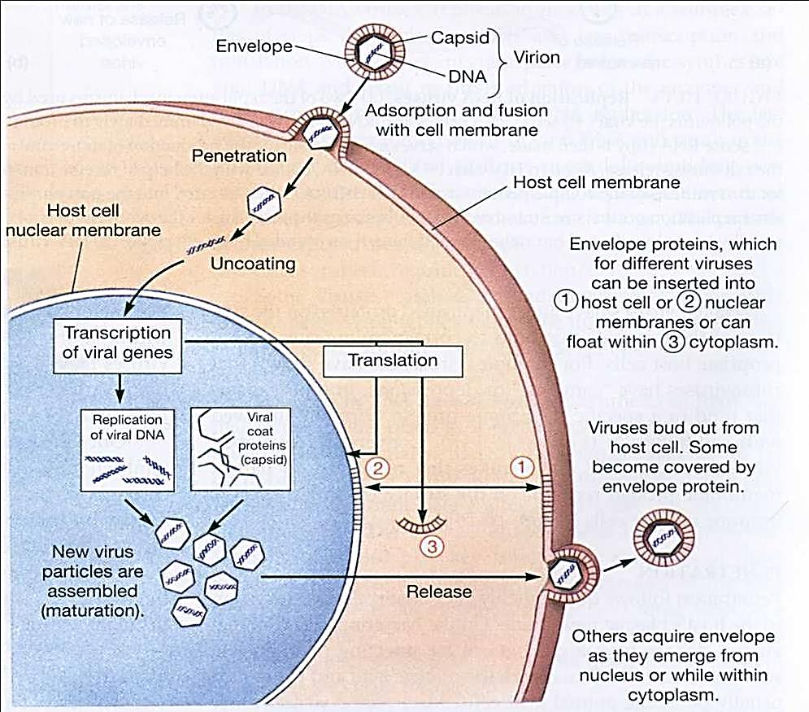

Steps in viral replication process

All infections are not productive

- PRODUCTIVE INFECTIONS
> occur in permissive cells infectious virus

- ABORTIVE INFECTIONS
> No infectious virus produces because:
a. cell is non-permissive
b. virus may be defective lack certain genes for replication & requires the help of another virus (dependo or helper virus)

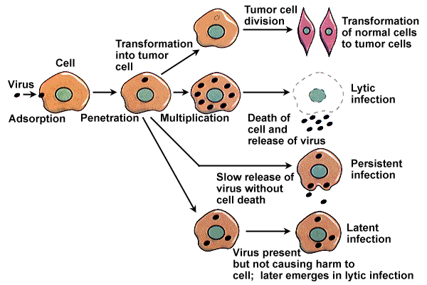
Summary of viral infection effects on cells

