General Virology/4th Lecture Viral Diagnostic
-----------------------------------------------------------------------------------------------------------------------------
Detection –Isolation- Diagnosis
-Storage and Collection of Biological Specimens for Viral Testing
- What types of specimens are collected to diagnose?
  - Respiratory tract infections: Nasal and bronchial washings, throat and nasal swabs, sputum
  - Eye infections: throat and Conjunctival swab/scraping
  - Gastrointestinal tract infections: stool and rectal swabs
  - Vesicular rash: vesicle fluid, skin scrapings
  - Maculopapular rash: throat, stool, and rectal swabs
  - CNS (encephalitis and meningitis cases): stool, tissue, saliva, brain biopsy, cerebrospinal fluid
  - Genital infections: vesicle fluid or swab
  - Urinary tract infections: urine
  - Blood borne infections: blood
Viral Transport Medium (VTM)
- Used to store & transport specimens
- Isolates & maintains virus integrity
- Prevents bacteria and fungi growth
- Can be made in a lab or purchased
- Different types of VTM:
  - Animal specimen collection
  - Viral isolation of human specimens
Composition of VTM
- Salt solution – ensures proper ionic concentrations
- Buffer - maintains pH
- Protein - for virus stability
- Antibiotics or antifungals – to prevent contamination
Storing VTM
- Sterile collection vials containing 1-3 ml of VTM
- VTM can be stored in a freezer at -20°C until use
- VTM can be stored for short periods of time at 4 - 8 °C

Diagnostic Methods in Virology
Direct Detection | Indirect Detection | Serology
Virus particles  Electron Microscopy (morphology of virus particles, immune electron microscopy) | Tissue culture  cytopathic effect, Haemabsorption, immunofluorescence | Immunofluorescence technique (IF)
Viral antigen  Immunofluorescence, ELISA etc. | Chick embryo  pocks on CAM, Haemagglutination, inclusion bodies | Haemagglutination inhibition test (HI)
Viral nucleic acid  hybridization with specific nucleic acid probes, polymerase chain reaction (PCR) | Laboratory animals  disease or death | Neutralization test (NT)
Cytopathology  Light Microscopy (histological appearance, inclusion bodies) |  | Enzyme linked immunosorbent assay (ELISA)

-Cultivation of Viruses (Indirect Detection)
Many viruses can be grown in cell cultures or in fertile eggs under strictly controlled conditions. Growth of virus in animals is still used for the primary isolation of certain viruses and for studies of the pathogenesis of viral diseases and of viral oncogenesis. Viral growth in an embryonated chick egg may result in death of the embryo (eg, encephalitis viruses), production of pocks or plaques on the chorioallantoic membrane (eg, herpes, smallpox, vaccinia), or development of hemagglutinins in the embryonic fluids or tissues (eg, influenza).
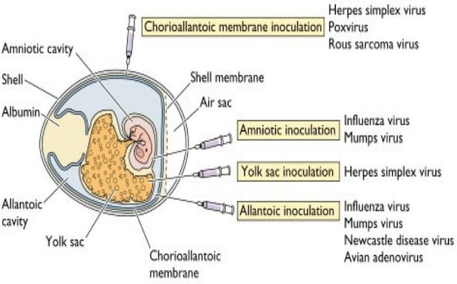
Routs of Viral Inoculation in Chicken Embryonated Egg
The availability of cells grown in vitro has facilitated the identification and cultivation of newly isolated viruses and the characterization of previously known ones. There are three basic types of cell cultures:
1-Primary cultures are made by dispersing cells (usually with trypsin) from freshly removed host tissues. In general, they are unable to grow for more than a few passages in culture.
2-Diploid cell lines are secondary cultures which have undergone a change that allows their limited culture (up to 50 passages) but which retain their normal chromosome pattern.
3- Continuous cell lines are cultures capable of more prolonged—perhaps indefinite—growth that have been derived from diploid cell lines or from malignant tissues. They invariably have altered and irregular numbers of chromosomes. The type of cell culture used for viral cultivation depends on the sensitivity of the cells to a particular virus.

Detection of Virus-Infected Cells (Direct Detection)
Multiplication of a virus can be monitored in a variety of ways:
1. Development of cytopathic effects, ie, morphologic changes in the cells. Types of virus-induced cytopathic effects include cell lysis or necrosis, inclusion formation, giant cell formation, and cytoplasmic vacuolization. Most viruses produce some obvious cytopathic effect in infected cells that is generally characteristic of the viral group.
2. Appearance of a virus-encoded protein, such as the hemagglutinin of influenza virus. Specific antisera can be used to detect the synthesis of viral proteins in infected cells.
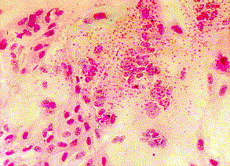3. Adsorption (hemadsorption) of erythrocytes to infected cells, due to the presence of virus-encoded hemagglutinin (parainfluenza, influenza) in cellular membranes. This reaction becomes positive before cytopathic changes are visible and in some cases occurs in the absence of cytopathic effects.

4. Detection of virus-specific nucleic acid. Molecular-based assays such as polymerase chain reaction provide rapid, sensitive, and specific methods of detection.
5. Inclusion Body Formation In the course of viral multiplication within cells, virus-specific structures called inclusion bodies may be produced. They become far larger than the individual virus particle and often have an affinity for acid dyes (eg, eosin). They may be situated in the nucleus (herpesvirus), in the cytoplasm (poxvirus), or in both (measles virus). In many viral infections, the inclusion bodies are the site of development of the virions (the viral factories). Variations in the appearance of inclusion material depend largely upon the tissue fixative used. The presence of inclusion bodies may be of considerable diagnostic aid. The intracytoplasmic inclusion in nerve cells—the Negri body—is pathognomonic for rabies.

Quantitation of Viruses
A- Physical Methods
1-Quantitative nucleic acid-based assays such as the polymerase chain reaction can determine the number of viral genome copies in a sample. Both infectious and non-infectious genomes are detected.
2-A variety of serologic tests such as radioimmunoassays (RIA) and enzyme-linked immunosorbent assays (ELISA) can be standardized to quantitate the amount of virus in a sample. These tests do not distinguish infectious from noninfectious particles and sometimes detect viral proteins not assembled into particles.
3-Certain viruses contain a protein (hemagglutinin) that has the ability to agglutinate red blood cells of humans or some animal. Hemagglutination assays are an easy and rapid method of quantitating these types of viruses. Both infective and non-infective particles give this reaction; thus, hemagglutination measures the total quantity of virus present.
4-Virus particles can be counted directly in the electron microscope by comparison with a standard suspension of latex particles of similar small size. However, a relatively concentrated preparation of virus is necessary for this procedure, and infectious virus particles cannot be distinguished from non-infectious ones.
B-Biologic Methods
1-End point biologic assays depend on the measurement of animal death, animal infection, or cytopathic effects in tissue culture at a series of dilutions of the virus being tested. The titer is expressed as the 50% infectious dose (ID50), which is the reciprocal of the dilution of virus that produces the effect in 50% of the cells or animals inoculated. Precise assays require the use of a large number of test subjects.
2- Plaque assay: The most widely used assay for infectious virus. Monolayers of host cells are inoculated with suitable dilutions of virus and after adsorption are overlaid with medium containing agar or carboxymethylcellulose to prevent virus spreading throughout the culture. After several days, the cells initially infected have produced virus that spreads only to surrounding cells. Multiple cycles of replication and cell killing produce a small area of infection, or plaque. The length of time from infection to when plaques can be visualized for counting depends on the replication cycle of the virus and can range from a few days (eg. poliovirus) to 2 weeks or more (eg.SV40). Under controlled conditions, a single plaque can arise from a single infectious virus particle, termed a plaque-forming unit (PFU). The cytopathic effect of infected cells within the plaque can be distinguished from uninfected cells of the monolayer with or without suitable staining, and plaques can usually be counted macroscopically. The ratio of the number of infectious particles to the total number of virus particles varies widely, from near unity to less than one per 1000, but often is one per several hundred.
3- Certain viruses, eg, herpes and vaccinia, form pocks when inoculated onto the chorioallantoic membrane of an embryonated egg. Such viruses can be quantitated by relating the number of pocks counted to the viral dilution inoculated.
Identification of a Particle as a Virus
When a characteristic physical particle has been obtained, it should fulfill the following criteria before it is identified as a virus particle:
(1) The particle can be obtained only from infected cells or tissues.
(2) Particles obtained from various sources are identical regardless of the cellular origin in which the virus is grown.
(3) The degree of infective activity of the preparation varies directly with the number of particles present.
(4) Destruction of the physical particle by chemical or physical means is associated with a loss of viral activity.
(5) Certain properties of the particles and infectivity must be shown to be identical, e.g., their sedimentation behavior in the ultracentrifuge and their pH stability curves.
(6) The absorption spectrum of the purified physical particle in the ultraviolet range should coincide with the ultraviolet inactivation spectrum of the virus.
(7) Antisera prepared against the infectious virus should react with the characteristic particle and vice versa. Direct observation of an unknown virus can be accomplished by electron microscopic examination of aggregate formation in a mixture of antisera and crude viral suspension.
(8) The particles should be able to induce the characteristic disease in vivo.
(9) Passage of the particles in tissue culture should result in the production of progeny with biologic and antigenic properties of the virus.

