General Virology/Lecture 5
Mechanisms of Viral Transmission
- Aerosols- inhalation of droplets, e.g. Rhinoviruses, or Adenoviruses.
- Fecal-Oral - e.g. Astroviruses, Caliciviruses; these viruses cause acute gastroenteritis.
- Vector-borne - e.g. in Arthropods such as mosquitos, ticks, fleas: Arboviruses
- Close personal contact - especially exchange of bodily fluids: Sex; Blood, e.g. Herpesviruses
Viral transmission patterns
- Horizontal Transmission: Direct person-to-person spread.
- Vertical Transmission: transfer infection from parents to offspring. Several forms of vertical transmission can be distinguished:
1. Neonatal infection at birth, e.g. AIDS
2. Infection in utero e.g. CMV, Rubella
3. Germ line infection - via ovum or sperm

General pattern of viral infection
1-Acute viral infection is characterized by rapid onset of disease, a relatively brief period of symptoms, and resolution within days. It is usually accompanied by early production of infectious virions and elimination of infection by the host immune system.
2-Persistent infections may involve stages of both silent and productive infection without rapidly killing or even producing excessive damage of the host cells. There are three types of overlapping persistent virus-host interaction that may be defined as latent, chronic and slow infection.
3-Virus latency (or viral latency) is the ability of a pathogenic virus to lay dormant (latent) within a cell, denoted as the lysogenic part of the viral life cycle. A latent viral infection is a type of persistent viral infection.
4-Slow virus disease is a disease that, after an extended period of latency, follows a slow, progressive course spanning months to years, frequently involving the central nervous system and ultimately leading to death.
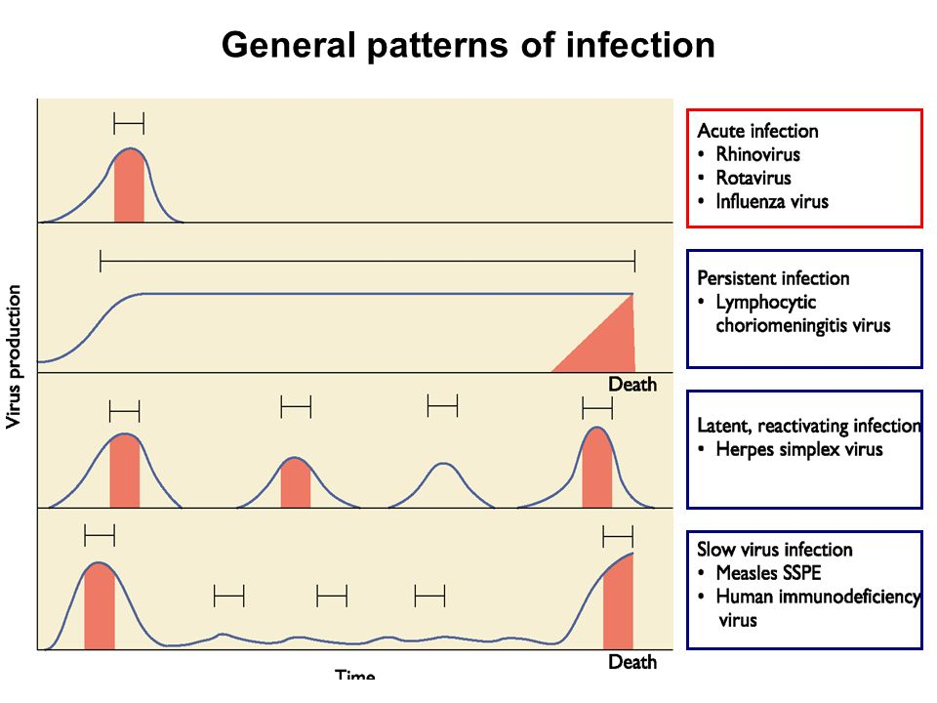
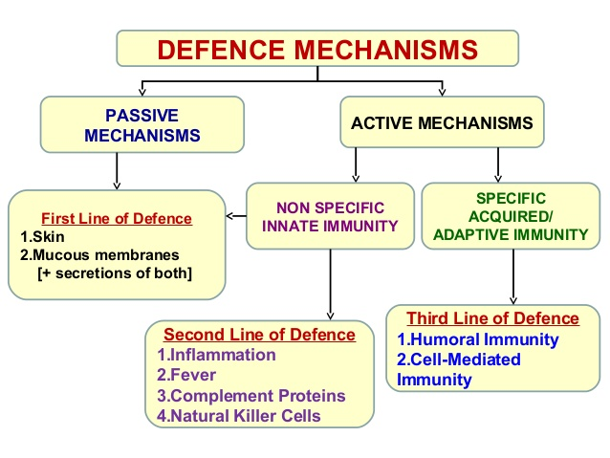

Immunity to viruses (What prevents most viruses from causing disease?)
- Skin
  - Innate immune (non-specific) mechanisms (Interferon, Natural killer cells, Complement, macrophages, and apoptosis) restrict the early stages of infection and delay spread of virus.
- As a viral infection proceeds, the adaptive (specific) immune response unfolds.
  - Antibodies
  - Cytotoxic T cells
- Viruses have evolved strategies to evade the immune response.
- Responses to viral antigens can cause tissue damage. (Immunopathology)
Innate (non-specific) immune response to viral infection
- Body surface
- Early non-specific or innate immune
  - Interferon (IFN)
    - Type I IFNs (IFN α and IFN β) (virus-infected cells)
    - Type II IFN or IFN γ (activated T and NK cells)
  - Natural killer (NK) cells
  - Macrophages
Interferons
- Interferons are proteins produced by cells infected with viruses, or exposed to certain other agents, which protect other cells against virus infection or decrease drastically the virus yield from such cells. Interferon itself is not directly the anti-viral agent, but it is the inducer of one or many anti-viral mechanisms
- Viral-infected cells secrete IFNs (e.g., IFN alpha and beta) to "warn" neighboring cells (IFNs enter neighboring cells produce proteins that block viral reproduction and degrade viral RNA)
- IFN gamma (immune interferon)- Secreted by lymphocytes
- Widespread immune mobilizing effects
- Activates macrophages
- Since IFNs activate NK cells and macrophages, indirectly fight cancer (Anti-Tumor)
- Artificial IFNs used to treat hepatitis C, genital warts, multiple sclerosis, hairy cell leukemia

Activities of interferon
1-Antiviral actions- Interferons initiate an antiviral state in cells
-Block viral protein synthesis
- Inhibit cell growth

2- Immunomodulatory action -Interferon alpha and beta activate NK cell
- Interferon alpha and gamma activate macrophages
- Interferon increase MHC antigen expression
- Regulate the activates of T cell
3-Other actions – Interferon regulate inflammatory processes
- Regulate tumor growth

Diseases currently treated with (IFN-alpha and IFN-beta)
- Hepatitis C
- Hepatitis B
- Papilloma warts and early trials with cervical carcinoma
- Kaposi sarcoma of AIDS,
- colon tumors
- Kidney tumors ( usually in combination with other drugs).
- Basal cell carcinoma
- Breast cancer combined with tamoxifen.
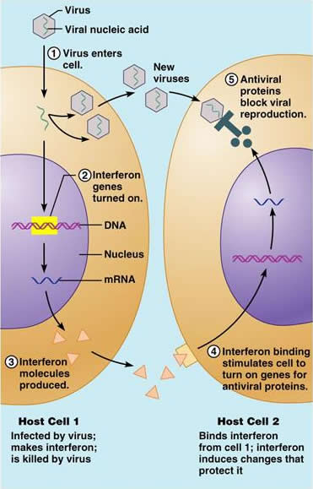

Natural killer cells (NK cells) are a type of cytotoxic lymphocyte critical to the innate immune system. ... Typically, immune cells detect major histocompatibility complex (MHC) presented on infected cell surfaces, triggering cytokine release, causing lysis or apoptosis. Or a lymphocyte able to bind to certain tumor cells and virus-infected cells without the stimulation of antigens, and kill them by the insertion of granules containing perforin.
- NK cells are Activated by IFN-alpha/beta
- NK cells are Activated by IFN-alpha and IL-2 and activate macrophage
- NK cells target and kill virus infected cells
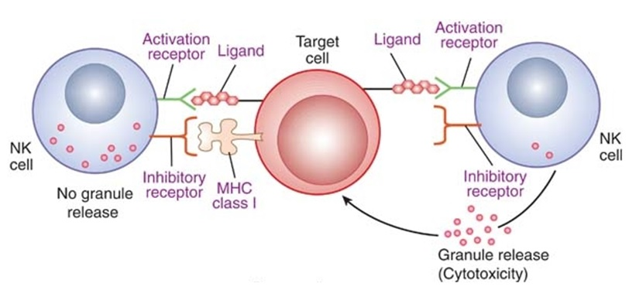

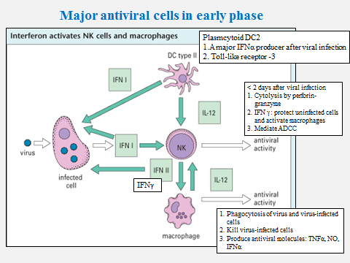
Adaptive (specific) immune response to viral infection
- Cytotoxic T lymphocytes (CTLs)
- Helper T (Th) cells
- Antiviral antibodies
Viral Infection and Adaptive immunity
1- Viral Neutralization by Humoral Antibody
  - What is crucial to the preventing of the spread of the virus during acute infection and in protecting against reinfection?
    - ANTIBODIES
    - If antibody is produced to the viral receptor, it can block infection altogether by preventing viral binding to the host cells
        - i.e. Secretory IgA in mucous secretions
    - Viral Neutralization by antibody sometimes occurs after viral attachment
      - Some may block viral penetration by binding to epitopes necessary to mediate fusion of the viral envelope with the plasma membrane
      - Some cause the lysis of the enveloped virions
      - Some agglutinate viral particles and function as an opsonizing agent
2-Cell-Mediated Antiviral Mechanisms
  - Antibodies, although crucial in containing the spread of the virus, are not able to eliminate the virus once infection has occurred
    - Once infection occurs, cell-mediated immune mechanisms become the most important
  - 2 main components of cell-mediated antiviral defense
    - 1. CD8+ T_{c} cells
    - 2. CD4+ T_{h}1 cells (CD4+ T_{c} cells)
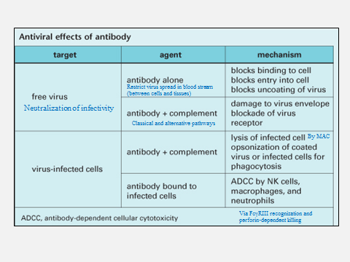

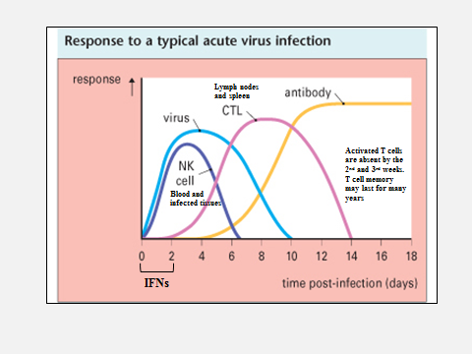
Viral Invasion of Host-Defense Mechanisms
  - Viruses encode proteins that interfere at various levels with specific or nonspecific host defenses
    - Some develop strategies to evade the action of IFN-α & IFN-β
    - Some inhibit the antigen presentation by infected hosts by preventing antigen delivery to class I MHCs
    - Some reduce levels of class II MHCs on cell surface
    - Others evade complement-mediated destruction
    - Some cause generalized immunosuppression-direct viral infection of lymphocytes or macrophages
    - Some constantly change their antigens
      - i.e. Influenza
- downregulates transport of MHC to surface (Adenovirus; herpesvirus; measles)
- Increases endocytosis of MHC
- Neurons express little MHC
- Mutation to new epitopes
- Latency
- Blocked by viral proteins which may bind to host proteins promoting apoptosis
- Produce mimic proteins that inhibit apoptosis

