General Virology/Lecture 6
Survey of DNA-Containing Viruses

Poxviruses
1- Large brick-shaped or ovoid viruse 220–450 nm long x 140–260 nm wide x 140–260 nm thick.
2-Particle structure is complex, with a lipid-containing envelope.
3-The genome is linear, covalently closed, double-stranded DNA, 130–375 kbp in size.
4-Poxvirus particles contain about 100 proteins, including many with enzymatic activities, such as a DNA-dependent RNA polymerase.
5-Replication occurs entirely within the cell cytoplasm.
6-All poxviruses tend to produce skin lesions. Some are pathogenic for humans (Smallpox, Vaccinia, Molluscum contagiosum); others that are pathogenic for animals can infect humans (Cowpox, Monkeypox).

Herpesviruses
1- Large family of viruses 150–200 nm in diameter.
2-The nucleocapsid is 100 nm in diameter, with cubic symmetry and 162 capsomeres, surrounded by a lipid-containing envelope.
3-The genome is linear, double-stranded DNA, 125–240 kbp in size. The presence of terminal and internal reiterated sequences results in several isomeric forms of genomic DNA.
4-Virions contain over 30 proteins.
5-Latent infections may last for the life span of the host, usually in ganglial or lymphoblastoid cells.
6-Human herpesviruses include herpes simplex types 1 and 2 (oral and genital lesions), varicella-zoster virus (chickenpox and shingles), cytomegalovirus, Epstein-Barr virus (infectious mononucleosis and association with human neoplasms), human herpesviruses 6 and 7 (T lymphotropic), and human herpesvirus 8 (associated with Kaposi's sarcoma). Other herpesviruses occur in many animals.
Adenoviruses
1-Medium-sized (70–90 nm)
2- non-enveloped viruses exhibiting cubic symmetry, with 252 capsomeres.
3- Fibers protrude from the vertex capsomeres.
4-The genome is linear, double-stranded DNA, 26–45 kbp in size.
5- Replication occurs in the nucleus.
6- At least 51 types infect humans, especially in mucous membranes, and some types can persist in lymphoid tissue. Some adenoviruses cause acute respiratory diseases, conjunctivitis, and gastroenteritis. Some human adenoviruses can induce tumors in newborn hamsters. There are many serotypes that infect animals.
Polyomaviruses
1-Small (45 nm), non-enveloped, heat-stable, ether-resistant viruses exhibiting cubic symmetry, with 72 capsomeres
2-The genome is circular, double-stranded DNA, 5 kbp in size.
3-These agents have a slow growth cycle, stimulate cell DNA synthesis, and replicate within the nucleus.
4-Known human polyomaviruses are JC virus, the causative agent of progressive multifocal leukoencephalopathy, and BK virus, associated with nephropathy in transplant recipients. SV40 also infects humans and has been recovered from human tumors. Most animal species harbor one or more polyomaviruses. They produce chronic infections in their natural hosts, and all can induce tumors in some animal species.
5-Polyomaviruses were formerly a part of the Papovaviridae family before it was split into two families.
Papillomaviruses
1- Former member of the Papovaviridae family. Similar to polyomaviruses in some respects, but with a larger genome (8 kbp) and particle size (55 nm).
2-There are many genotypes of human papillomaviruses, also known as "wart" viruses; certain types are causative agents of genital cancers in humans.
3-Papillomaviruses are very host and tissue-specific. Many animal species carry papillomaviruses.
Hepadnaviruses
1- Small (40–48 nm) viruses
2- Circular double-stranded DNA molecules that are 3.2 kbp in size. The viral DNA in the particles contains a large single-stranded gap. The virion carries a DNA polymerase able to make fully double-stranded molecules.
3- Replication involves repair of the single-stranded gap in the DNA, transcription of RNA, and reverse transcription of the RNA to make genomic DNA.
4-The virus consists of a 27-nm icosahedral nucleocapsid core within a closely adherent envelope that contains lipid and the viral surface antigen.
5-The surface protein is characteristically overproduced during replication of the virus, which takes place in the liver, and is shed into the bloodstream.
6-Hepadnaviruses cause acute and chronic hepatitis; persistent infections are associated with a high risk of developing liver cancer. Three viral types are known that infect mammals (humans, woodchucks, and ground squirrels) and another that infects ducks.
Parvoviruses
1- Are very small viruses with a particle size of about 18–26 nm.
2- The particles have cubic symmetry, with 32 capsomeres, but they have no envelope.
3-The genome is linear, single-stranded DNA, 5.6 kb in size.
4- Replication occurs only in actively dividing cells; capsid assembly takes place in the nucleus of the infected cell. Many parvoviruses replicate autonomously, but the adeno-associated satellite viruses are defective, requiring the presence of an adenovirus or herpesvirus as "helper." Human parvovirus B19 replicates in immature erythroid cells and causes several adverse consequences, including aplastic crisis, fifth disease, and fetal death.

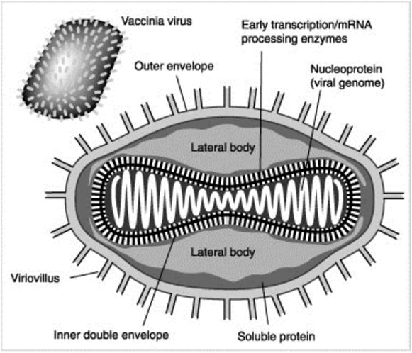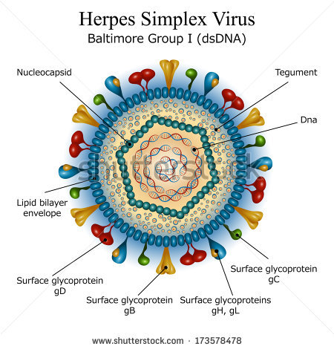
Poxviruses Herpesviruse
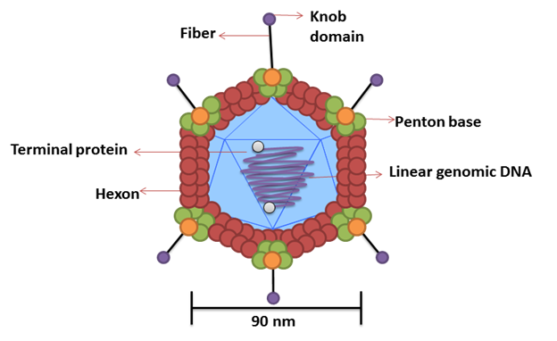
Adenovirus Parvoviruse

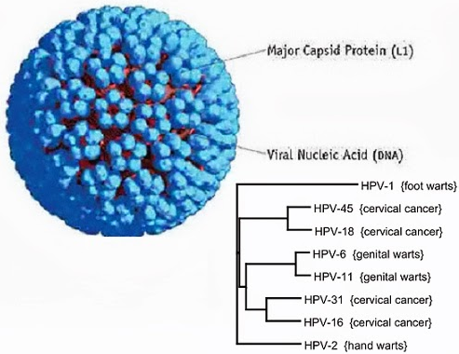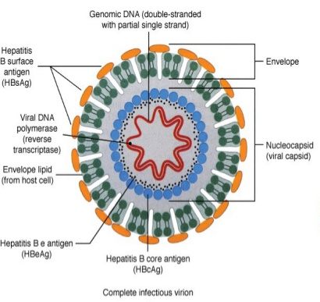
Papillomaviruse Hepadnaviruse

