General Virology/Lecture 7
Survey of RNA-Containing Viruses
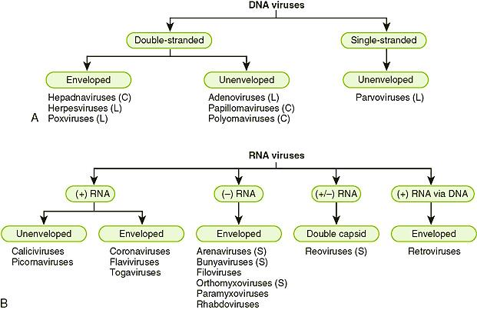
Picornaviruses
1- Small (28–30 nm), cubic symmetry.
2- Genome is single-stranded and positive-sense (act as an mRNA), and is 7.2–8.4 kb in size.
3-The groups infecting humans are enteroviruses (poliovirus, coxsackievirus, and echoviruses and unclassified viruses), rhinoviruses (more than 100 serotypes causing common colds), and hepatovirus (hepatitis A).
4- Rhinoviruses are acid-labile and have a high density; enteroviruses are acid-stable and have a lower density. Picornaviruses infecting animals include foot-and-mouth disease of cattle and encephalomyocarditis of rodents.
Astroviruses
1- Similar in size to picornaviruses (28–30 nm), but particles display a distinctive star-shaped outline on their surface.
2- The genome is linear, positive-sense, single-stranded RNA, 6.4–7.4 kb in size.
3- These agents may be associated with gastroenteritis in humans and animals.
Caliciviruses
1- Similar to picornaviruses but slightly larger (27–40 nm). Particles appear to have cup-shaped depressions on the surface.
2- The genome is single-stranded, positive-sense RNA, 7.4–8.3 kb in size; the virion has no envelope.
3- An important human pathogen is Norwalk virus, the cause of epidemic acute gastroenteritis.
Reoviruses
1- Medium-sized (60–80 nm), non-enveloped viruses having icosahedral symmetry. Particles have two or three protein shells with channels extending from the surface to the core; short spikes extend from the virion surface.
2- The genome is linear, double-stranded, segmented RNA (10–12 segments), totaling 16–27 kbp in size. Individual RNA segments range in size from 680 to 3900 bp.
3- Replication occurs in the cytoplasm; genome segment reassortment occurs readily.
4-Reoviruses of humans include Rotaviruses, which have a distinctive wheel-shaped appearance and cause gastroenteritis. Antigenically similar reoviruses infect many animals. The genus Coltivirus includes Colorado tick fever virus of humans.
Arboviruses
1- An ecologic grouping (not a virus family) of viruses with diverse physical and chemical properties. All of these viruses (there are over 350 of them) have a complex cycle involving arthropods as vectors that transmit the viruses to vertebrate hosts by their bite.
2- Viral replication does not seem to harm the infected arthropod. Arboviruses infect humans, mammals, birds, and snakes and use mosquitoes and ticks as vectors.
3- Human pathogens include dengue, yellow fever, encephalitis viruses, and others.
4- Arboviruses belong to several virus families, including togavirus, flavivirus, bunyavirus, rhabdovirus, arenavirus, and reovirus.
Togaviruses
1- Many arboviruses that are major human pathogens, called alphaviruses as well as rubella virus belong in this group.
2- They have a lipid-containing envelope, it measures 70 nm.
3- Their genome is single-stranded, positive-sense RNA, 9.7–11.8 kb in size.
4- An example is eastern equine encephalitis virus. Rubella virus has no arthropod vector.
Flaviviruses
1- Enveloped viruses, 40–60 nm in diameter.
2- Containing single-stranded, positive-sense RNA. Genome sizes vary from 9.5 kb (hepatitis C) to 11 kb (flaviviruses) to 12.5 kb (pestiviruses).
3- This group of arboviruses includes yellow fever virus and dengue viruses. Most members are transmitted by blood-sucking arthropods. Hepatitis C virus has no known vector.
Arenaviruses
1- Pleomorphic, enveloped viruses ranging in size from 50 to 300 nm (mean, 110–130 nm).
2- The genome is segmented, circular, single-stranded RNA that is negative-sense and ambisense, 10–14 kb in total size.
3- Replication occurs in the cytoplasm. The virions incorporate host cell ribosomes during maturation, which gives the particles a "sandy" appearance.
4- Most members of this family are unique to tropical America (the Tacaribe complex). All arenaviruses pathogenic for humans. Lassa fever virus of Africa is one example. These viruses require maximum containment conditions in the laboratory.
Coronaviruses
1- Enveloped 120-160nm particles the nucleocapsid is helical, 9–11 nm in diameter
2- Un-segmented genome of positive-sense, single-stranded RNA, 27–32 kb in size.
3- Coronaviruses resemble orthomyxoviruses but have petal-shaped surface projections arranged in a fringe, like a solar corona.
4- These viruses have narrow host ranges.
5- Most human coronaviruses cause mild acute upper respiratory tract illnesses "colds" but a new coronavirus identified in 2003 causes a severe acute respiratory syndrome (SARS). Toroviruses, which cause gastroenteritis, form a distinct genus. Coronaviruses of animals readily establish persistent infections and include mouse hepatitis virus and avian infectious bronchitis virus.
Retroviruses
1- Spherical, enveloped viruses (80–110 nm in diameter). Particles contain a helical nucleocapsid within an icosahedral capsid
2- Genome contains two copies of linear, positive-sense, single-stranded RNA of the same polarity as viral mRNA. Each monomer RNA is 7–11 kb in size.
3- Replication is unique; the virion contains a reverse transcriptase enzyme that produces a DNA copy of the RNA genome. This DNA becomes circularized and integrated into host chromosomal DNA. The virus is then replicated from the integrated "provirus" DNA copy.
4- Retroviruses are widely distributed; there are also endogenous proviruses resulting from ancient infections of germ cells transmitted as inherited genes in most species.
5- Leukemia and sarcoma viruses of animals and humans, foamy viruses of primates, and lentiviruses (human immunodeficiency viruses; visna of sheep) are included in this group. Retroviruses cause acquired immunodeficiency syndrome (AIDS) and made possible the identification of cellular oncogenes.
Orthomyxoviruses
1- Medium-sized 80-120nm enveloped viruses exhibiting helical symmetry. The internal nucleoprotein helix measures 9–15 nm.
2-Particles are either round or filamentous, with surface projections that contain hemagglutinin or neuraminidase activity.
3- Genome is linear segmented single-stranded RNA negative-sense,totaling 10–13.6 kb in size.
4- During replication, the nucleocapsid is assembled in the nucleus, whereas the hemagglutinin and neuraminidase accumulate in the cytoplasm.
5- All orthomyxoviruses are influenza viruses that infect humans or animals. The segmented nature of the viral genome permits ready genetic re-assortment when two influenza viruses infect the same cell, presumably fostering the high rate of natural variation among influenza viruses.
6- Transmission from other species is thought to explain the emergence of new human pandemic strains of influenza A viruses.
Bunyaviruses
1- Spherical or pleomorphic, 80-120nm enveloped particles. Virion particles contain three circular, helically symmetric nucleocapsids about 2.5 nm in diameter and 200–3000 nm in length.
2- The genome is made up of a triple-segmented, circular, single-stranded, negative-sense or ambisense RNA, 11–19 kb in overall size.
3- Replication occurs in the cytoplasm.
4- The majority of these viruses are transmitted to vertebrates by arthropods (arboviruses). Hantaviruses are transmitted not by arthropods but by persistently infected rodents, via aerosols of contaminated excreta. They cause hemorrhagic fevers and nephropathy as well as a severe pulmonary syndrome.
Bornaviruses
1- Enveloped, spherical (80–125 nm) viruses.
2- Genome is linear, single-stranded, non-segmented, negative-sense RNA, 8.5–10.5 kb in size.
3- Unique among non-segmented, negative-sense RNA viruses, replication and transcription of the viral genome occur in the nucleus.
4- Borna disease virus is neurotropic in animals; postulated association with neuropsychiatric disorders of humans is unproved.
Rhabdoviruses
1- Enveloped virions resembling a bullet, flat at one end and round at the other, measuring about 75 x 180 nm. The envelope has 10-nm spikes.
2- Genome is linear, single-stranded, non-segmented, negative-sense RNA, 13–16 kb in size.
3- Viruses have broad host ranges.
4- Rabies virus is a member of this group.
Paramyxoviruses
1- Similar to but larger than orthomyxoviruses (150–300 nm). Particles are pleomorphic. The internal nucleocapsid measures 13–18 nm.
2- The linear, single-stranded, non-segmented, negative-sense RNA is 16–20 kb in size.
3- Both the nucleocapsid and the hemagglutinin are formed in the cytoplasm.
4- Those infecting humans include mumps, measles, parainfluenza, and respiratory syncytial viruses.
5- These viruses have narrow host ranges.
6- In contrast to influenza viruses, paramyxoviruses are genetically stable.

Filoviruses
1- Enveloped, pleomorphic viruses that may appear very long and thread-like. They typically are 80 nm wide and about 1000 nm long. The envelope contains large peplomers.
2- Genome is linear, negative-sense, single-stranded RNA, 19 kb in size.
3- Marburg and Ebola viruses cause severe hemorrhagic fever in Africa.
4- These viruses require maximum containment conditions (Biosafety Level 4) for handling.

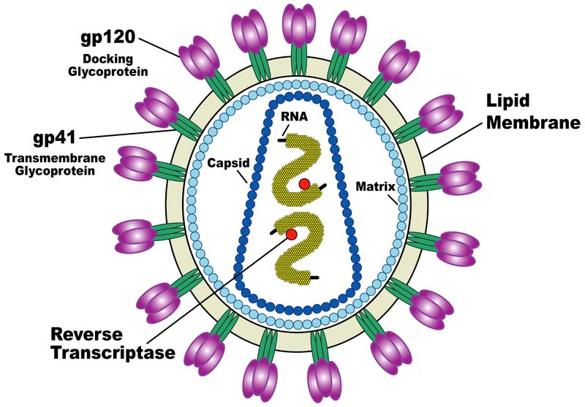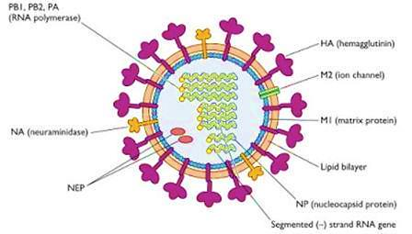
Retroviruses Orthomyxovirus

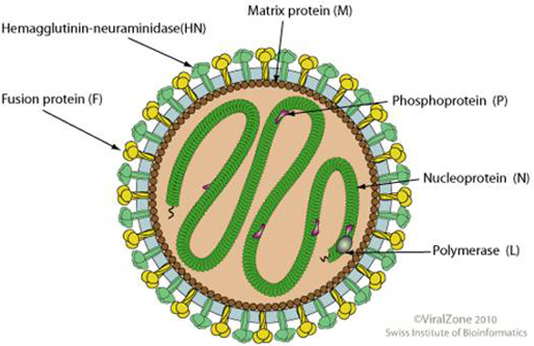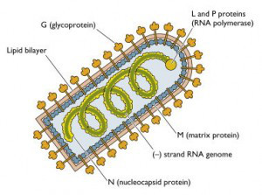
Paramyxoviruse Rhabdoviruse
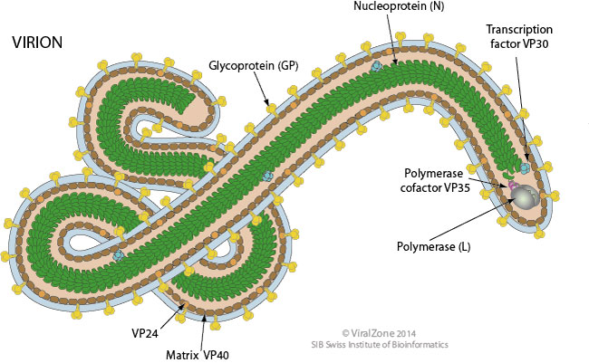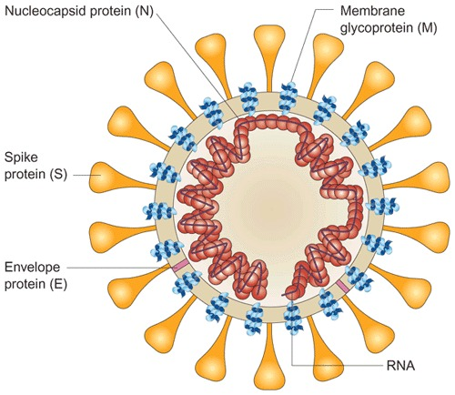
Filoviruse Coronaviruse
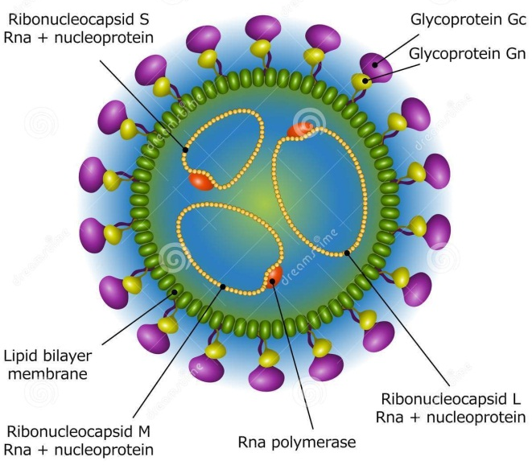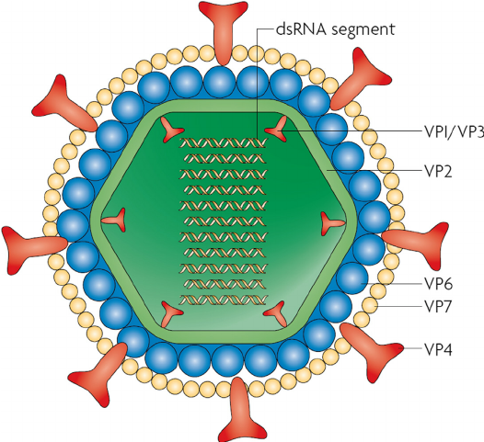
Bunyaviruse Reoviruses (Rotavirus)

Viroids
1- Small infectious agents that cause diseases of plants.
2- Viroids are agents that do not fit the definition of classic viruses. They are nucleic acid molecules (MW 70,000–120,000) without a protein coat.
3- Plant viroids are single-stranded, covalently closed circular RNA molecules consisting of about 360 nucleotides and with a highly base-paired rod-like structure.
4- Viroids replicate by an entirely novel mechanism.
5- Viroid RNA does not encode any protein products; the devastating plant diseases induced by viroids occur by an unknown mechanism.
6- To date, viroids have been detected only in plants; none have been demonstrated to exist in animals or humans.
Prions
1- Infectious particles composed solely of protein with no detectable nucleic acid.
2- Highly resistant to inactivation by heat, formaldehyde, and ultraviolet light that inactivates viruses.
3- The prion protein is encoded by a single cellular gene.
4- Prion diseases, called "transmissible spongiform encephalopathies," include scrapie in sheep, mad cow disease in cattle, and kuru (Creutzfeldt-Jakob disease) in humans.

General Virology/Lecture 8
Prevention & Treatment of Viral Infections
Antiviral Chemotherapy
Unlike viruses, bacteria and protozoans do not rely on host cellular machinery for replication, so processes specific to these organisms provide ready targets for the development of antibacterial and antiprotozoal drugs. Because viruses are obligate intracellular parasites, antiviral agents must be capable of selectively inhibiting viral functions without damaging the host, making the development of such drugs very difficult. Another limitation is that many rounds of virus replication occur during the incubation period and the virus has spread before symptoms appear, making a drug relatively ineffective.
There is a need for antiviral drugs active against viruses for which vaccines are not available or not highly effective—the latter perhaps because of a
1- Multiplicity of serotypes (e.g. rhinoviruses)
2- Because of a constantly changing virus (e.g. influenza, HIV).
Antivirals can be used to treat established infections when vaccines would not be effective. Antivirals are needed to reduce morbidity and economic loss due to viral infections and to treat increasing numbers of immunosuppressed patients who are at increased risk of infection.
Molecular virology studies are succeeding in identifying virus-specific functions that can serve as targets for antiviral therapy. The most amenable stages to target in viral infections include attachment of virus to host cells; uncoating of the viral genome; viral nucleic acid synthesis; translation of viral proteins; and assembly and release of progeny virus particles. In reality, it has been very difficult to develop antivirals that can distinguish viral from host replicative processes.
However, in the last decade a number of compounds have been developed that are of value in treatment of some viral diseases, particularly against herpesviruses and HIV infections. The mechanisms of action vary among antivirals. Oftentimes the drug must be activated by enzymes in the cell before it can act as an inhibitor of viral replication; the most selective drugs are activated by a virus-encoded enzyme in the infected cell.
Future work is necessary to learn how to minimize the emergence of drug-resistant variant viruses and to design more specific antivirals based on molecular insights into the structure and replication of different classes of agents.

Viral Vaccines
The purpose of viral vaccines is to utilize the immune response of the host to prevent viral disease. Several vaccines have proved to be remarkably effective at reducing the annual incidence of viral disease. Vaccination is the most cost-effective method of prevention of serious viral infections.
General Principles
Immunity to viral infection is based on the development of an immune response to specific antigens located on the surface of virus particles or virus-infected cells. For enveloped viruses, the important antigens are the surface glycoproteins. Although infected animals may develop antibodies against virion core proteins or non-structural proteins involved in viral replication, that immune response is believed to play little or no role in the development of resistance to infection.
The pathogenesis of a particular viral infection influences the objectives of immunoprophylaxis. Mucosal immunity (local IgA) is important in resistance to infection by viruses that replicate exclusively in mucosal membranes (rhinoviruses, influenza viruses, rotaviruses). Viruses that have a viremic mode of spread (polio, hepatitis, measles) are controlled by serum antibodies. Cell-mediated immunity also is involved in protection against systemic infections (measles, herpes).
Certain characteristics of a virus or of a viral disease may complicate the generation of an effective vaccine. The existence of many serotypes, as with rhinoviruses, and of large numbers of animal reservoirs, as with influenza virus, makes vaccine production difficult. Other hurdles include the integration of viral DNA into host chromosomal DNA (retroviruses) and infection of cells of the host's immune system (HIV).
Killed-Virus Vaccines
Inactivated (killed-virus) vaccines are made by purifying viral preparations to a certain extent and then inactivating viral infectivity in a way that does minimal damage to the viral structural proteins; mild formalin treatment is frequently used. For some diseases, killed-virus vaccines are currently the only ones available.
Killed-virus vaccines prepared from whole virions generally stimulate the development of circulating antibody against the coat proteins of the virus, conferring some degree of resistance.
Advantages of inactivated vaccines are that there is no reversion to virulence by the vaccine virus and that vaccines can be made when no acceptable attenuated virus is available.
The following disadvantages apply to killed-virus vaccines:
(1) Extreme care is required in their manufacture to make certain that no residual live virulent virus is present in the vaccine.
(2) The immunity conferred is often brief and must be boosted, which not only involves the logistic problem of repeatedly reaching the persons in need of immunization but also has caused concern about the possible effects (hypersensitivity reactions) of repeated administration of foreign proteins.
(3) Parenteral administration of killed-virus vaccine, even when it stimulates circulating antibody (IgM, IgG) to satisfactory levels, has sometimes given limited protection because local resistance (IgA) is not induced adequately at the natural portal of entry or primary site of multiplication of the wild virus infection—eg, nasopharynx for respiratory viruses, alimentary tract for poliovirus . Serum and secretory antibody response to orally administered, live attenuated poliovaccine and to intramuscular inoculation of killed poliovaccine.
(4) The cell-mediated response to inactivated vaccines is generally poor.
(5) Some killed-virus vaccines have induced hypersensitivity to subsequent infection, perhaps owing to an unbalanced immune response to viral surface antigens that fails to mimic infection with natural virus.
Attenuated Live-Virus Vaccines
Live-virus vaccines utilize virus mutants that antigenically overlap with wild-type virus but are restricted in some step in the pathogenesis of disease.The genetic basis for the attenuation of most viral vaccines is not known, as they were selected empirically by serial passages in animals or cell cultures (usually from a species different from the natural host). As more is learned about viral genes involved in disease pathogenesis, attenuated candidate vaccine viruses can be engineered in the laboratory.
Attenuated live-virus vaccines have the advantage of acting like the natural infection with regard to their effect on immunity. They multiply in the host and tend to stimulate longer-lasting antibody production, to induce a good cell-mediated response, and to induce antibody production and resistance at the portal of entry.
The disadvantages of attenuated live-virus vaccines include the following:
(1) The risk of reversion to greater virulence during multiplication within the vaccine.
(2) Unrecognized adventitious agents latently infecting the culture substrate (eggs, primary cell cultures) may enter the vaccine stocks. Viruses found in vaccines have included avian leukosis virus, simian polyomavirus SV40, and simian cytomegalovirus. The problem of adventitious contaminants may be circumvented through the use of normal cells serially propagated in culture (eg, human diploid cell lines) as substrates for cultivation of vaccine viruses.
(3) The storage and limited shelf life of attenuated vaccines present problems, but this can be overcome in some cases by the use of viral stabilizers (e.g., MgCl₂ for polio vaccine).
(4) Interference by coinfection with a naturally occurring, wild-type virus may inhibit replication of the vaccine virus and decrease its effectiveness. This has been noted with the vaccine strains of poliovirus, which can be inhibited by concurrent infections by various enteroviruses. Trivalent live oral poliovaccine or a combined live measles, mumps, and rubella vaccine is effective.
Future Prospects
Molecular biology and modern technologies are combining to devise novel approaches to vaccine development. Many of these approaches avoid the incorporation of viral nucleic acid in the final product, improving vaccine safety. The ultimate success of these new approaches remains to be determined.
(1) Use of recombinant DNA techniques to insert the gene coding for the protein of interest into the genome of an a virulent virus that can be administered as the vaccine (such as vaccinia virus).
(2) Including in the vaccine only those sub-viral components needed to stimulate protective antibody, thus minimizing the occurrence of adverse reactions to the vaccine.
(3) Use of purified proteins isolated from purified virus or synthesized from cloned genes (a recombinant hepatitis B virus vaccine contains viral proteins synthesized in yeast cells). Expression of cloned genes sometimes results in formation of empty virus-like particles (VLPs).
(4) Use of synthetic peptides that correspond to antigenic determinants on a viral protein, thus avoiding any possibility of reversion to virulence since no viral nucleic acid would be present although the immune response induced by synthetic peptides is considerably weaker than that induced by intact protein.
(5) Development of edible vaccines whereby transgenic plants synthesizing antigens from pathogenic viruses may provide new cost-effective ways of delivering vaccines.
(6) Use of naked DNA vaccines potentially simple, cheap, and safe in which recombinant plasmids carrying the gene for the protein of interest are injected into hosts and the DNA produces the immunizing protein.
(7) Administration of vaccine locally to stimulate antibody at the portal of entry (such as aerosol vaccines for respiratory disease viruses).

