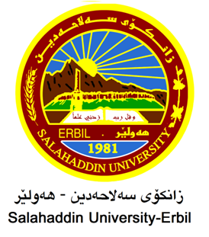

Dust Particle Monitoring for Air Quality Assessment in Erbil city, Kurdistan Region of Iraq
Research Project
Submitted to the Department of (Biology) in partial fulfillment of the requirements for the degree of BSc. in Biology

By
Fatima Fakhir Maghdid
Supervised by
Dr. Tara Mohammed Hassan

APRIL – 2023

