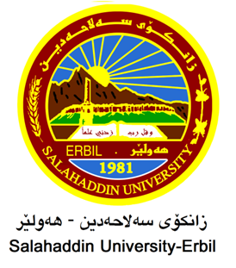

Evaluation of Rainwater Quality in Erbil city, Kurdistan Region of Iraq.
Research Project
Submitted to the Department of (Biology) in partial fulfillment of the requirements for the degree of BSc. in Biology

By
Fatima Sdiq Jihangir

Supervised by
Dr. Tara Mohammed Hassan

APRIL – 2023

