1. The concept of ______________, that is separation of substances between two solutions colloidal and true solution by use of _________ membrane.

2. ___________ groups like (OH, CHO, CO, COOH, NH2, CONH2, SH) _________ the permeability, while Increases the length of carbon chain ________ polarity and increase solubility and consequently ________ permeability.
3. the permeability rates_________ with Temperature increasing, but increase the (T) more than (60C) called ___________, in this case the cell membranes become _____________.
4.___________ pressure lead to produce liquid droplets on the edges of the plant leaves, this phenomenon is known as ___________ , it’s appear when the transpiration rate is low and humidity is high, such as during the night
5. Factors affecting dialysis rate_____________, ______________, _______________, _____________.

- When the transpiration occurs in the leaves, losses of water molecules through the stomata, develops a large __________ pressure (low water potential), and they pull other water molecules by cohesion force, water molecules are also attracted to the sides of the tracheids and vessels by adhesion force.

Hypotonic solution (less – tention solution ) contains a lower concentration of dissolved (solutes) substances than the cell
Hyper tonic solution (more-tention solution ) contains a higher concentration , of solutes than the cell placed in it
An experiment explain the effect of (o.p)for the external solution on the rate of absorption.
Factor affecting on water absorption ?
Difference between active absorption and passive absorption ?
From epidermis to endoderm there are two path ways in which water can flow

3ml of external water + some drops of I2 indictor colorless proof to the nonexistence of starch because starch with I2 gives the blue color

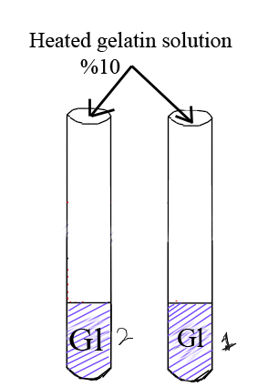
3ml of external water + some drops of AgNO3 precipitation or formation white component of AgNO3 proof to the presents of Cl- ions.
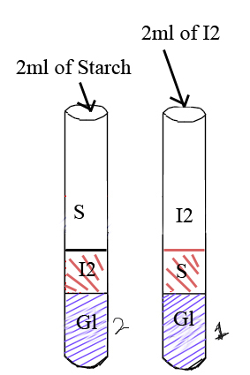
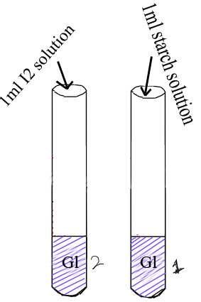

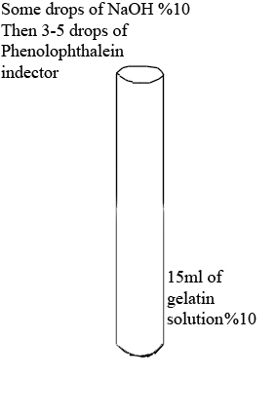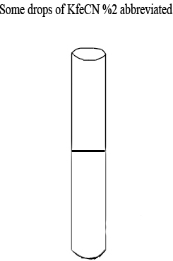

The biological importance of osmosis includes:
- That’s means osmosis required :
- Water potential gradient .
- Semi permeable or partially permeable membrane

solution(1) Nacl 80% Nacl 20%solution (2)
(less) lower solvent ← more solvent
(more) high solute ← less solute
Solvent molecules
high osmotic pressure ← low(O.P)

