Q1/ Fill the following blanks with correct words:(9M)
- Cells of Zygnema contain a pair of star shape(stellate ) Chloroplast, each one having a single central pyrinoid
- Cell movement is effected by the direction and intensity of light.
- Dinophyta are comes from the Greek word pyrrh which means…wherling, more of them are responsible the phenomena of Bioluminescence in the sea is due to in these organisms.
- Both cyanobacteria and bacteria are procaryotic. .
- Agar is used extensively in laboratory research as a nutrient for growing bacteria.
- conjugation is the type of sexual reproduction occurs between some filamentous algae.
- Desmids are divided into two semi-cells by a distinct (isthmus)

Q2/ In each of the following, determine whether the statement is True or False with correction the false: (10M)
- The name Desmid comes from the fact that early researchers thought that they were made up of two cells joined together.
- The transverse flagellum in Rhodophyta provides backward motion.
- The zygote of spirogyra forms outside the conjugation tube.
- Cells of Zygnema contain a pair of spiral shape chloroplast.
- Algae can be found in almost every environment on earth even in volcano.

Q3 / Answers
Akinetes: are of widespread occurrence in the blue-green and green algae. They are essentially enlarged vegetative cells that develop a thickened wall in response to limiting environmental nutrients or limiting light. They are extremely resistant to drying and freezing and function as a long-term anaerobic storage of the genetic material of the species.
Bioluminescence: Members of Pyrrhophyta produce light when Luciferin is oxidized by Luciferase (enzyme), when ATP and oxygen are present. The dinoflagellates glow as it gets dark and brighten when agitated
Alginates, or alginic acids, commercially extracted from brown seaweeds, such as Laminaria, are used in ice creams to limit ice crystal formation (producing a smooth texture)
Thallus: There is no specialization of the algal body into roots, stems, Leaves, and without vascular tissues. The Photosynthetic portion of the algae is a thallus, while the attachment portion comprises hair-like rhizoids, for this reason, old classification systems, put the algae into a grouping known as the Thallophyta
sporangia. Spores may be produced within ordinary vegetative cells or within specialized cells or structures called

Q4/A/ Enumerate only 3 of the following: (9M)
- Basis of classification in algae
- In algae the nitrogen fixation occurs by means of
- Types of sexual reproduction in Algae.
- Dinoflagellate play an important part in the biology of coral reefs
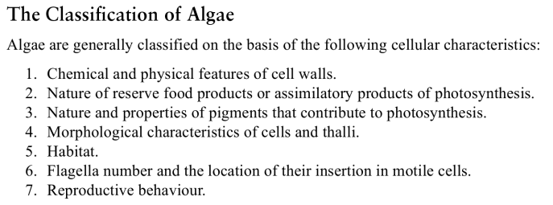
Answers 1-
2-Nitrogen Fixation:
In algae the nitrogen fixation occurs by means of:
1-Nitrogen fixing enzyme.
2-Enzymes whose functions reduction of acetylene to ethylene (reduce nitrogen).
3-Hetrocystis has a great role in N2 fixation, because it lacks in oxygen or in an aerobic condition, because in nature nitrogen fixation occur in absence of oxygen.

3. Types of sexual reproduction in Algae
- Isogamouse
- Anisogamouse
- Heterogamouse
- Oogamouse

- These play an important part in the biology of coral reefs:
- provide nutrients for coral
- accelerate skeletal formation (calcification)
- give coral its color
- receive shelter in return
- Coral bleaching occurs when reef-building corals lose their endosymbiotic dinoflagellates.

Q4/B 1- Range of thallus structure in Algae (diagram)
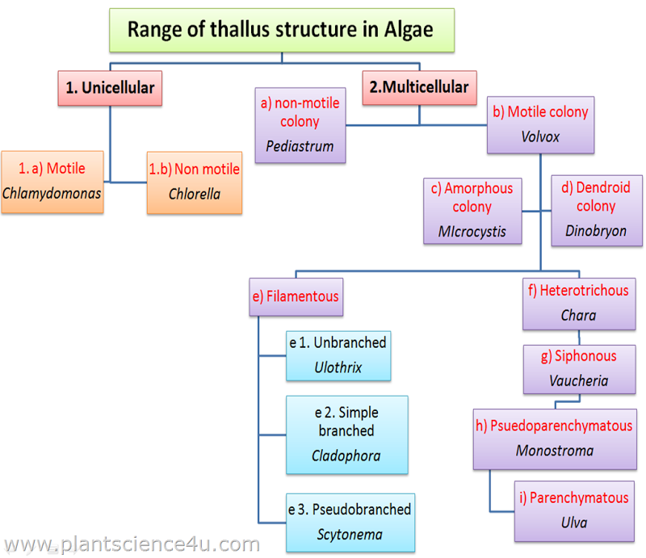

Scalariform conjugation:
2. Lateral conjugation: This type of conjugation is also divided into:
A. Direct lateral conjugation.
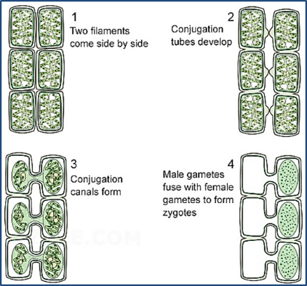
B. In direct lateral conjugation 2A 2B
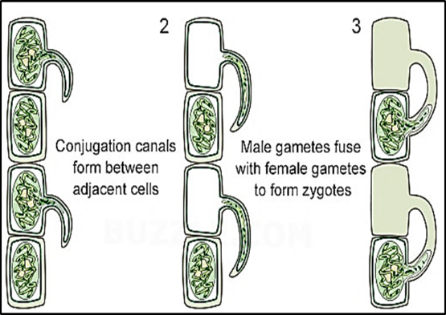
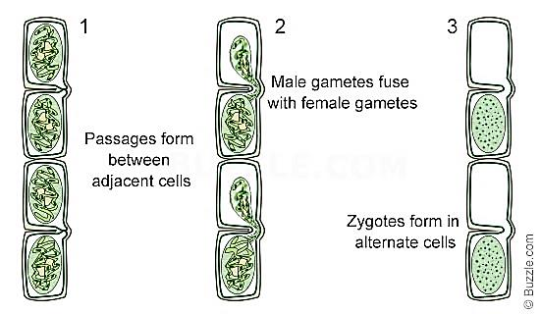
1

