**Short-term load forecasting using nonlinear dynamic time series autoregressive with feedback for AZADI control-station Erbil-Iraq**

***Abstract****— The load forecasting is a human or computational technique for accurate preanticipation of electrical load to enhance reliable operation and optimal planning control of system plant for electrical energy flowing without facing any economical and technical limitations, therefore appropriate estimation for present and future consumption cost of electrical loads which are necessary to predict the load demand for generating near to accurate power.*

*During advanced technology at the last few decades, artificial neural networks(ANNs) have been extensively employed in electrical system, they are trained using historical data obtained from plant station. This work is intended to be a study of short-term load forecasting (STLF) basis for a power predicted applied to the actual past load data displayed from Azadi station for Feb.2022 were used in training and validation system of neural grid. The result was evaluated by mean square percentage error of (32.7) for the forecasting dynamic time series method to solve the data over hours, days, and weeks in advance, using a kind of non-linear filtering. Short-term load forecasting tried out with main stages; predicted power load data sets, network training, and forcasting. Neural network used has 3-layers: an input, a hidden, and an output layer. The number of hidden layer neurons can be varied for the different network performance. The active power generation faces economical and technical challenges, therefore appropriate evaluation of loads are much needed.*

***Index Terms****— ANN, STLF, Neurons.*

1. **INTRODUCTION**

As a result of technology progress companionship with modern civilization, the power system plant become more complex, facing the challenge of power demands growth, therefore all developing nations with restrictions on their economical income-sources uses an alternate neural grids method in computation forecasting modes to avoid system short come either of conservative or optimistic statuses, furthermore, the reliable operation and planning control of power system requires an accurate predesigned model for electricity consumption and load forecasting data [1], which acts main gates in supporting an electric generating companies to build all requirements contained purchasing power, infrastructure progressing, grids configuration, voltage control, and load connecting [2]-[3].

In a deregulated power marketing, to provide consumer’s uninterrupted delivery of electric power, there must be a proper prediction, modeling, evaluation, and forecasting of present and future demand during electric system expansion [4].

Till now, there’s no substantial method to store electricity within transmission lines or distribution areas of system parts, consequently, for reaching ideal power utilization design, the generating stations face predicaments challenging with the load growth figure and high consumption cost [5], therefore alternative to classical procedure becoming useful as neural networks based on computational analysis with inductive learning process to tell the electric planner about consumer’s load demand, also have the exact capability to solve complicated problems of power generation, because the electrical load variation exhibit several levels, not only within seasons but also in months, weeks, and days of the same week, due to different climatic factors such as temperature, darkness, (cloudy/sunny) day, ...etc., which effect on load attitude [6]

According to the time duration, the load forecasting can be divided into three denominations [7]-[8]-[9]:

1. STLF; short-term load forecasting, generally based on previous data of day- hours, days, and even weeks, (STLF) with main advantages as input gates for an electrical designer to anticipate load flows preventing any obstruction, also to make appropriate decisions for fuel sort and purchasing cost.
2. MTLF; middle term load forecasting, set from one week to a year, used for scheduling maintenance time.
3. LTLF; long-term load forecasting, indicator to load data for a time longer than a year with forecast benefits to determine future capacity and expansion for power system planning, and cost of all types of equipment for a new building.

The nature study of each electrical load forecasting type needs a special predicted model for different (modes/time) operations within the utility generating station. The features of these forecasts pattern are different from each other [10]. For instance, carry out (STLF) in some electrical areas may be we anticipate the hourly load demand for the next day with an acceptable level of accuracy, whereas, is very hard to forecasts the next year's peak load with the same accuracy.

In recent decades, various approaches have been extensively researched and carried out to predict a load forecasting model, in general, they were distributed into couple categories [11]-[12]-[13], they are; the classical methods (usually used in past time) based in statistical analysis group included different mathematical models studying with human experts, such as, regression analysis methods, time series, and grey prediction approaches and so on, these modes provide visible susceptibility of load data translation, but with major associated drawback of stalemating models, make them less favorite comparing with smart computational machine systems [14], and the second auto techniques, for example, fuzzy logic mode, and an artificial neural network, are distinguished method related with computerized intelligence tools used in design and simulation analysis, successfully established, tested and trained in programmable forecasting networks.

STLF: our present work approved with a short-term load forecasting model to estimate imminent demand power, is the basic target and first fundamental requirement to create automatic control decisions for improving the economic operation joint to appropriate energy dispatch, in connecting or disconnecting the generation power units, load switching, and so on [15], hence, obtaining an ideal optimizing system. To attain an accurate model design for (STLF), system operators need to construct all information concerning a 24 hours per day schedule of the power market and participant's load type. Different factors that effects (STLF) model architecture include: time details; for example, day hours, and weekdays load demand. Economic condition is a second factor containing; the costs of new buildings construction, and energy conversion from the generation side to distribution load area via transmission part related to high performance with the necessity of lower cost in traditional portion. A third factor; acts as the major important operator with different parameters for (STLF) forecasted model; for instance, (cloudy or sunny) day, sunset, and environment temperature, the rapid variation in temperature leads to considerable error [16], upon intelligence learning property, the daily load information must be related into consideration to reach good results for (STLF) models. Two approaches are applied; the first is to build different forecasts network for the same day [17]- [18], while the second use only one mode per day but considers variable input factors for a day's information [17]-[19], increasing input variables number, results more converge to the desired values. The two types with their benefits; the first can be used for a large number of relatively small-size grids, while the second design need only one large network ANN.

The architecture of artificial neural network models thought behavior like the human mind, containing cells known as neurons, which respond to act in all orders of central nervous system, the computerized machine algorithm refers to a neural network composed a large number of elements indicated as neurouns contain multi-input variables are collected altogether, so they adjusted to indicate their corresponding weight, and one out set, the result obtained from a neural network training used in back-propagation as entrance data for next chain, until a recent output reached the accurate absolute error point, with remarkable learning ability, during computer operating time, the ANN’s mode is extremely powerful in solving a linear or non-linear large scale complex problems, hence they are requested in implementation to load forecasting function of power system design [20], our present study of multi-layer scheme of STLF models linked with ANN enhanced by the learning capability to illustrate the relation between input and output elemenets.

There are 4-pattern adapted to simulate the architecture of artificial neural networks: single-layer model, multi-layer perceptions is the second approach, Hop field mode is the third one, and finally Kohonen network [21]. The neural network with multi-layers is the most wide-spread employed mode [4]-[6]. The network is depicted in fig (1), composed of A 3-layer perceptron; an entries layer, many hidden layers, and an output layer. The network can be explained as a function of an M-dimensional input space vector starting with summation and adjusting the weight of each of four neurons coming, so the weighted element is passed through the processing function to give the N-dimensional space vector as an active value of the output neuron.

This function can be written in the form:

$y=f(x;w)$ (1)



Fig. 1. Multi-layer schematic diagram (MLP) ANN. Note that "Fig." is abbreviated [5].

Where:

$y:$ is output vector

$x$: is input vector

$w$:is the matrix containing neuron-weights within hidden layer = *i*

1. **RELATED WORKS**

STLF; is the key gate for the electric power system load forecasting , therefore different algorithms, models, techniques, have been used in the past, in earlier days statistical approach such as regression , expert systems , played an adequate load forecasting model [22].

One of the widely used STLF techniques is the autoregressive integrated moving average. These time series models that use past observations of the load demand to predict future values, has been applied to STLF in power stations in several studies, including Jena and Kalyanmoy [23], and Lopez et al. [24]. These studies have shown that the ARIMA models can provide accurate load forecasts for short-term duration.

Another popular STLF technique is the artificial neural network (ANN) model. ANN models are a type of machine learning technique that can learn the patterns and relationships in the data to make accurate forecasts. ANN models have been applied to STLF in power stations in several studies [25]. These studies have shown that ANN models can provide accurate and reliable load forecasts for short-term horizons, and can outperform other forecasting techniques in some cases.

Other STLF techniques that have been applied to power station load forecasting include fuzzy logic models [26], support vector regression (SVR) models (Hong et al., 2009) [27], and wavelet transform models (Zhang et al., 2022) [28]. These techniques have shown promise in providing accurate load forecasts for short-term objectives, but further research is needed to fully evaluate their effectiveness.

Using Neural Network with Genetic Algorithm used in STLF, take in consideration various weather factors , the most common variables are ; humidity and temperature degree [9].

In recent years, there has been a growing interest in the application of hybrid models that combine multiple STLF techniques to improve forecasting accuracy. Hybrid models have been applied to STLF in power stations in several studies, including Li, Xiaolan and J. Zhou (2022) [29]. These studies have shown that hybrid models can provide more accurate load forecasts than single technique models, and can help to address the limitations and weaknesses of individual models.

Overall, there have been significant research efforts in the development of STLF models for power station load forecasting. The above-mentioned techniques are just a few examples of the many approaches that have been explored. While there is no single model that can provide accurate forecasts in all situations, it is clear that STLF is essential for the efficient and reliable operation of power stations, and will continue to be an important research area for the foreseeable future.

All our results are closed to the results of researchers (e.g Short- Term Load Forecasting Using ANN Technique used by Samsher (2012) [7] , or the work G.A. Depoju (2007) in Application of Neural Network to load forecasting in Nigerian Electrical power system [1].

1. **SIMULATED MODEL**

The physical system can be presented by a structure Mode shows in Fig. 2, and simulink model Fig. 3; An input/output relationship are characterized all over the predicting process of block system based on two hidden layers each with four neurons and an algorithm of Levenberg-Marquardt, with a feedback.

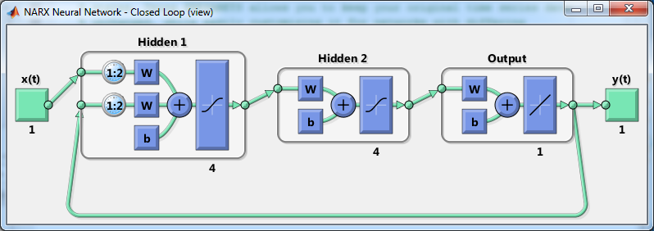

FIG. 2. Model Structure.

The Simulink model developed in MATLAB for load forecast prediction utilizes an artificial neural network (ANN) with two hidden layers and one output layer, incorporating feedback mechanisms. This model aims to accurately predict future load demand based on historical data and relevant input variables. The first hidden layer receives the input data and applies a set of weights and biases to perform initial feature extraction. The second hidden layer further refines the extracted features, capturing complex relationships and patterns in the data. The output layer then combines the processed information and produces the load forecast prediction. Feedback connections within the model allow for continuous learning and refinement, as the predicted outputs can be compared with the actual load data, enabling adjustments to the model's parameters and enhancing its predictive accuracy. This Simulink model provides a powerful tool for load forecast prediction, facilitating efficient resource allocation and decision-making in various domains.

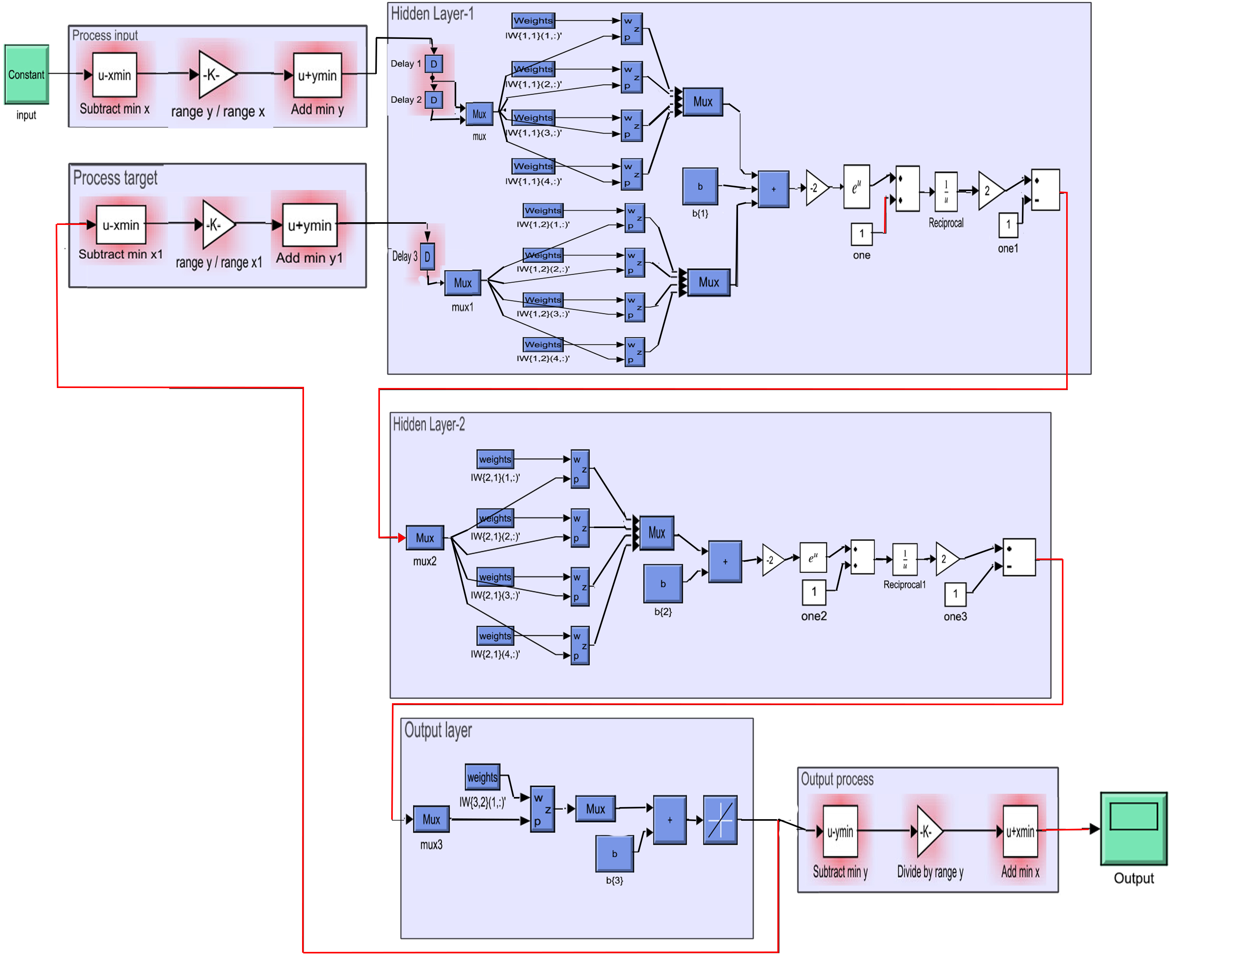

FIG. 3. Simulink Mode.

Levenberg-Marquadt is proposed as an optimum algorithm due to quick speed, that is the most suited algorithm to medium scale short-term models [30]. In the network, the Jacobian and Hessian matrices can be defined in equations (2) and (3), for the network training with an identified weight (threshold) value to extract the response of the system behavior and determining the error time based, histogram, correlation, and comparison of the output vector vs Target matrix's results.

The Jacobian matrix can be defined as:

$\left[J\right]=\left[\begin{matrix}\frac{{∂f}_{1}}{{∂x}_{0}} & … & \frac{{∂f}_{1}}{{∂x}_{n}} \\ ⋮ & ⋱ & ⋮ \\ \frac{{∂f}_{n}}{{∂x}_{0}} & … & \frac{{∂f}_{n}}{{∂x}_{n}}\end{matrix}\right]$ (2)

Also, the Hessian matrix Computed as:

$\left[H\right]=\left[\begin{matrix}\begin{matrix}\begin{matrix}\frac{∂^{2}f}{{∂x}_{0}^{2}} & \frac{∂^{2}f}{{∂x}_{0}{dx}_{1}} & … \\ \frac{∂^{2}f}{{∂x}_{1}{∂x}_{0}} & \frac{∂^{2}f}{{∂x}_{1}^{2}} & … \\ ⋮ & ⋮ & ⋱\end{matrix} & \begin{matrix}\frac{∂^{2}f}{{∂x}_{0}{∂x}_{n}} \\ \frac{∂^{2}f}{{∂x}_{1}{∂x}_{n}} \\ ⋮\end{matrix}\end{matrix} \\ \begin{matrix}\begin{matrix}\frac{∂^{2}f}{{∂x}_{n}{∂x}_{0}} & \frac{∂^{2}f}{{∂x}_{n}{∂x}_{1}} & …\end{matrix} & \frac{∂^{2}f}{{∂x}_{n}^{2}}\end{matrix}\end{matrix}\right]$ (3)

Before setting an initial parameters of the system like maximum iteration time, training accuracy, hidden nodes, and weights, we should batch the normalized input and output learning samples, after many training experiences essentially must follow the detective logic guide with low-error calculation, which stops automatically in general when the learning step reducing the result error by decreasing the mean square error of the validation parameters, are adjusted to 5% of total samples of hours/days/weeks all over the specific month.

Two hidden layers are suggested to construct the model depending on Levenberg–Marquardt algorithm with two time delay and four neurons on each. The rest of the remaining samples time stepped in row series matrix adjusted to 80% training data and 15% testing data, to achieve the high model performance optimization in a relevant function and parameters acceptance.

1. **Results**

The overall data obtained from the hourly received load input and target of the Azadi control station leads to the following predicting results, which describe the forecasting performance of the system and comparison getting the error that help us to make accurate decision for better preparation our station for the coming load using lowest and efficient neural system’s hidden layers and neurons.

Fig. 4, shows the Main Squared Error (MSE) versus epochs, the graph illustrated Network Performance over the training implementation which is pre-fixed Epochs number, Validation, and Testing. During Training operation, the total data separated to three; training data 80% weight, the remain 20% is separated to 15% and 5% testing and validating respectively, this figure of data separation gives the best performance operation at epoch 7.



Fig. 4. Performance of the system.

Different graphs are illustrated in the scutterd-line in Fig. 5, discribes the output value which are very close to our target, and explain the network behaver by varying R “Error retrain defines the regression” values.



Fig. 5. regression plot for two weeks per hour.

Plots of Fig. 6, indicates the relation between real load data given from control station versus forecasted values, both of them are close with each other.



Fig. 6. TWO-WEEKS FORECASTED VS ACTUAL AND TAEGET LOAD CONSTRUCTION WITH ERROR.

The data collected from the control station are indicated in table I, for one day as a sample. The results observed from training model of the neural network explain in photo-graphical form Fig. 7 below, each one shows in MW “Megawatt” values the forecast and target load against day hours, there is no large difference in load between week-end days and other days because the supplied load all times is roughly about half-value of Erbil city demand load.

Table I, Erbil (Received & Demand) Load MW For day in February 2022

|  |  |
| --- | --- |
| **H** | **Erbil Received Load MW** |
| 01:00 | 942.4 |
| 02:00 | 935.7 |
| 03:00 | 935.2 |
| 04:00 | 942 |
| 05:00 | 949.8 |
| 06:00 | 961.2 |
| 07:00 | 980.1 |
| 08:00 | 1006.7 |
| 09:00 | 1041.9 |
| 10:00 | 1087.3 |
| 11:00 | 1111.9 |
| 12:00 | 1112.5 |
| 13:00 | 1105.4 |
| 14:00 | 1082.4 |
| 15:00 | 1069 |
| 16:00 | 1067.5 |
| 17:00 | 1058.3 |
| 18:00 | 1047.5 |
| 19:00 | 1042.1 |
| 20:00 | 1041.1 |
| 21:00 | 1045.4 |
| 22:00 | 1057 |
| 23:00 | 1062.7 |
| 00:00 | 1062.4 |
| **Maximum** | **1112.5** |
| **AV.** | **1031.15** |

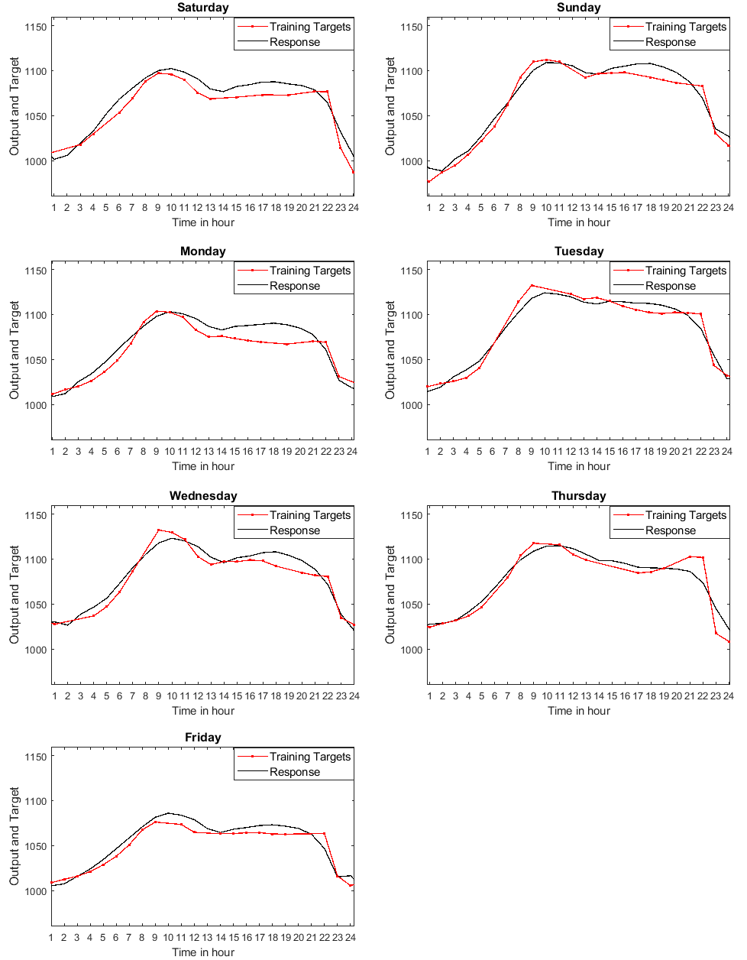

Fig. 7. Errors graph of Day hours versus target and forecast load.

Fig. 8, contain three various plots, the upper is number of epochs against the learning function. Illustrate the gradient direction values with increasing the number of computational epochs, it is essential process to observe the progressive manner during the training. The middle graph given the learning rate (Mu) against epochs number, this figure is necessary for oversight the rate at which network error reduces during all the training progress. The final lower sketch, explain that validation which carried out automatically against epochs number in excellent manner although at the time of 8 epoch we have a sudden jump is attended in the network.

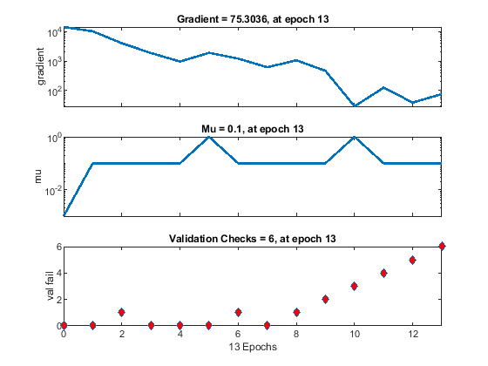

Fig. 8. State graphic for 2 hidden layers each with 4 neurons in forecasting model.

1. **CONCLUSIONS**

A modern Non-Linear method for Short-Term electrical load forecasting was experienced with a Simulink model show the relations feature that exists between the input historical data, and that for training output in the predicting process for the system model, illustrated through a couple of hidden layers each included four neurons. Levenberg- Marquardt algorithm was implemented with a feedback loop. Levenberg method is the most adequate bases for medium scale of short term load forecasted Training Models.

The results obtained in our task from the designed system show the closer values in comparisons between actual load and predicted load that are illustrated well in all figures, such as, the values in the network performance plot, regression picture, hours load presentation and training state sketch, at last the main squared absolute error tested and evaluated all the output results compared with considered target, which presents a high degree of accuracy. However, it must be ensured that the system is not run over-training epochs number by preset the number of iteration to obtaining least error in some epoch.

STLF model with minimum errors could be an important appliance and a main entry for long time load forecasting.

**REFERENCES**

1. Adepoju, G., S. Ogunjuyigbe, and K. Alawode, *Application of neural network to load forecasting in Nigerian electrical power system.* The pacific journal of science and technology, 2007. **8**(1): p. 68-72.
2. Olajuyin, E., et al., *Long Term Load Forecasting Using Artificial Neural Network.* American Journal of Engineering Study (AJER), 2018. **7**: p. 14-17.
3. Singh, A.K., et al., *An overview of electricity demand forecasting techniques.* Network and complex systems, 2013. **3**(3): p. 38-48.
4. Ata, R., *Artificial neural networks applications in wind energy systems*. Renewable and Sustainable Energy Reviews, Elsveier. 2015. 49: p. 534-562.
5. Basavaraj M1, D.S.B.K., SDMCET Dharwad, Karnataka, India, *Load forecasting for HESCOM using Linear Regression and Artificial Neural Network.* International Journal for Science and Advance Research in Technology, 2017. **3**(8).
6. Azadeh, A., et al., *Optimization of short load forecasting in electricity market of Iran using artificial neural networks.* Optimization and Engineering, 2014. **15**(2): p. 485-508.
7. Samsher Kadir Sheikh1, M.G.U., *Short-term load forecasting using ANN technique.* International Journal of Engineering Sciences & Emerging Technologies, 2012. **1**(2): p. 97 - 107.
8. Filik, U.B. and M. Kurban, *A new approach for the short-term load forecasting with autoregressive and artificial neural network models.* International Journal of Computational Intelligence Research, 2007. **3**(1): p. 66-71.
9. Olagoke, M.D., A. Ayeni, and M.A. Hambali, *Short term electric load forecasting using neural network and genetic algorithm.* Int. J. Appl. Inf. Syst, 2016. **10**(4): p. 22-28.
10. Paul, R., *Load Forecasting Using Linear Regression And Artificial Neural Networks*. 2015, Doctoral dissertation, National Institute Of Technology Warangal.
11. Baoyi, W., W. Dongyang, and Z. Shaomin, *Short term distributed power load forecasting algorithm based on Spark and [J].* IPPSO_LSSVM electric power automation equipment, 2016. **36**(1): p. 117-122.
12. Singh, V.V. and A. Srivastava, *An introduction to load forecasting: Conventional and modern technologies.* IRACST Eng Sci Technol Int J, 2014. **4**(2): p. 62-66.
13. Osman, Z.H., M.L. Awad, and T.K. Mahmoud. *Neural network based approach for short-term load forecasting*. in *2009 IEEE/PES Power Systems Conference and Exposition*. 2009. IEEE.
14. Buhari, M. and S.S. Adamu. *Short-term load forecasting using artificial neural network*. in *Proceedings of the international MultiConference of engineers and computer scientists*. 2012.
15. Yang, J. and J. Stenzel, *Short-term load forecasting with increment regression tree.* Electric Power Systems Research, 2006. **76**(9-10): p. 880-888.
16. Senjyu, T., et al., *One-hour-ahead load forecasting using neural network.* IEEE Transactions on power systems, 2002. **17**(1): p. 113-118.
17. Moghram, I. and S. Rahman, *Analysis and evaluation of five short-term load forecasting techniques.* IEEE Transactions on power systems, 1989. **4**(4): p. 1484-1491.
18. Khaparde, S., P. Kale, and S. Agarwal. *Application of artificial neural network in protective relaying of transmission lines*. in *Proceedings of the First International Forum on Applications of Neural Networks to Power Systems*. 1991. IEEE.
19. Huang, S.-J. and K.-R. Shih, *Short-term load forecasting via ARMA model identification including non-Gaussian process considerations.* IEEE Transactions on power systems, 2003. **18**(2): p. 673-679.
20. Ikaraoha, C.O. and A.O. Melodi, *Multifactorial Short-Term Load Forecasting for Enugu Load Center using Artificial Neural Network Concept*. 2015, The Pacific journal of Science and Technology.
21. Shahidehpour, M., H. Yamin, and Z. Li, *Market operations in electric power systems: forecasting, scheduling, and risk management*. 2003: John Wiley & Sons.
22. Robert F. Engle, C.M., and John Rice, *Modelling peak electricity demand.* Journal of forecasting. - Chichester, Wiley, 1992. **11.1992**(3): p. 241-251.
23. Chodakowska, E., J. Nazarko, and Ł. Nazarko, *ARIMA Models in Electrical Load Forecasting and Their Robustness to Noise.* Energies, 2021. **14**(23): p. 7952.
24. López, E., et al., *Wind Power Forecasting Based on Echo State Networks and Long Short-Term Memory.* Energies, 2018. **11**(3): p. 526.
25. Arvanitidis, A.I., et al., *Enhanced Short-Term Load Forecasting Using Artificial Neural Networks.* Energies, 2021. **14**(22): p. 7788.
26. Costa Silva, G., et al., *Advanced fuzzy time series applied to short term load forecasting*. 4th IEEE Latin American Conference on Computational IntelligenceAt: Guadalajara. 2017.
27. Hong, W.-C., *Electric load forecasting by support vector model.* Applied Mathematical Modelling, 2009. **33**(5): p. 2444-2454.
28. Zhang, R., C. Zhang, and M. Yu, *A Similar Day Based Short Term Load Forecasting Method Using Wavelet Transform and LSTM.* IEEJ Transactions on Electrical and Electronic Engineering, 2022. **17**(4): p. 506-513.
29. Li, Xiaolan. and J. Zhou, *An adaptive hybrid fractal model for short-term load forecasting in power systems.* Electric Power Systems Research, 2022. **207**: p. 107858.
30. Liu, T.-Y., et al., Compressive strength prediction of PVA fiber-reinforced cementitious composites containing nano-SiO2 using BP neural network. Materials, 2020. **13**(3): p. 521.