Q₁) For 1-Ph commentator d.c repulsion motor , Explain:
- The different connections for the stator and rotor winding.
- If the rotor possess a single combined winding (G) with angle (ϴ)displaced from d-axis , illustrate the following conditions : 1- ϴ = 0º , 2- ϴ = 90º.
Q₂) A 30 watt , 4 phase stator winding brushless D.C motor:
- Draw a schematic diagram for this motor and the output voltages wave-form.
- Name all components of basic construction .
- Explain the method of operation.
Q₃) Show the deference in Torque slip characteristic of series D.C universal Motor
When the source supply is: 1) A.C electrical power. 2) D.C electrical power.
Q₄) Illustrate operation method, and Rotor position as a function of D.C. Voltage,
For a Two- phase, Two- pole permanent- magnet Stepper motor.
Q₅) According to construction classify the various types of Hysteresis Motor
Q6) Explain what happen to (mutual Inductance, M.M.Fs of Stator and Rotor, E.M.F., current, and Torque), under 3 conditions of the below schematic Diagram for the brush axis position
with respect to d-axis.

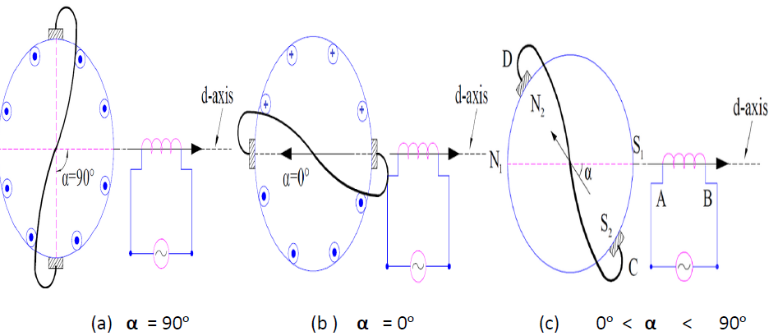

Q7) Sketch to illustrate the torque-speed curve of hysteresis motor.
Q8) For a 2-phase small control (Cervo) motor:
1- Draw the circuit diagram.
2- Describe the method of running
3- Explain the speed-torque characteristic.
Q₉) Illustrate the construction of permanent magnet electrical machines, what is the main advantage of these machines.

Q₁₀) Explain the typical torque speed characteristic for 2-phase control motor, with reference voltage constant , and (0.5 ,0.75, 1.0) p.u. respectively for control voltage (Va).
Q₁₁) For a 2-pole single phase synchronous induction motor , Explain :
- The basic construction , and the method of operation.
- The modification which can be made to moving rotor , and the Torque-Slip curve .

Q₁₂) Explain the speed control method for a series field d.c universal motor.

Q₁₃) Construct a repulsion motor from a d.c commutator motor , draw the machine's diagram to explain the method of operation for this motor with changing the angle between winding .
Q₁₄) Explain the application of synchro transformers , which are used in feed-back control systems , for maintaining synchronism between two or more shafts.
Q₁₅) With the aid of diagrams, illustrate the salient and non-salient construction of permanent magnet
machines, what is the main risk of these machine types .

Q₁₆) Two stepper motors, one with 3-ph, and the second possess 4-ph. Construct a table showing the step size and rotor position per each pulse versus phase voltages.
Q₁₇) For a single phase synchronous reluctance motor. Explain the method of operation and the torque-
speed characteristic. Describe all the modification which can be made to this motor to be self-starting
and also run at synchronous speed.
Q₁₈) By changing the input supply voltage, explain how can you control the speed of the universal Motor.
Q₁₉) Illustrate the construction of three phase Brushless DC Motor, what is the main advantage of these machines.
Q₂₀) Explain the typical torque speed characteristic for 2-phase servo Motor, with reference voltage equal to (1 per unit), and (0.5, 0.75, 1.0) p.u. respectively for control voltage (V_{a}).
Q₂₁) For a 2-pole single phase Reluctance synchronous induction Motor, Explain :
The basic construction, and the method of operation.
Q₂₂) Explain the modification which can be made to moving rotor of single phase Reluctance synchronous induction Motor, and illustrate its Torque-Slip curve.

Q₂₃) Describe the rotor modification and the method of operation for a single phase synchronous Induction motor.
Q₂₄) With the aid of diagrams for a 2-phase servo motor and A.C Tachometers , explain
The main difference between the two machines.
Q₂₅) Illustrate how can you construct a Synchro – drive system from a three phase conventional Wound – Rotor induction motor, all the stators are connected in parallel.
Q₂₆) Draw to explain the compensating winding effect on the Torque – Speed curve in a large type of Universal Motor.
Q₂₇) With the aid of diagram show the complete arrangements of Drag - Cup Servo Motor which used in control system design for a light load response.
Q₂₈) Illustrate how can you construct a Synchro – drive system from a three phase conventional Wound – Rotor induction motor, all the stators are connected in parallel.
Q₂₉) Draw to explain the compensating winding effect on the Torque – Speed curve in a large type of Universal Motor.
Q₃₀) With the aid of diagram show the complete arrangements of Drag - Cup Servo Motor which used in control system design for a light load response.
Q₃₁) For a small A.C Tachometers, draw the machine schematic diagram to describe the method of operation.
Q₃₂) Derive an alternating current Repulsion Motor from a commutator DC Motor

Q₃₃) Explain the equivalent circuit of Saturable – Reactor.
Q₃₄) For a series D.C universal motor, Explain : How can you control it’s speed , and in which way the input voltage polarity can by reversed.
Q₃₅) Explain the construction and design of permanent magnet machines.
Q₃₆) Explain the effect of the reactance variation on saturable reactor.
Q₃₇) With the aid of diagram , show the operation method of A.C tacho-generator.
Q₃₈) Explain the application of synchro transformers , which are used in feed-back control systems , for maintaining synchronism between two or more shafts.
Q₃₉) Explain the modification to a 3 wound-rotor induction motors, with star connection (Y) for 3-ph stators , illustrate the function of the differential shaft.
Q₄₀) A 4-phase stepper motor must be controlling the shaft position of 15º , find :
1) Number of poles.
2) How many pulses / second must be supplied to the control unit of the motor to achieve rotational speed of 1200 r.p.m.
Q₄₁) Explain the speed control method for a series field d.c universal motor.
Q₄₂) Construct a repulsion motor from a d.c commutator motor , draw the machine's diagram to explain the method of operation for this motor with changing the angle between winding .
Q₄₃) Draw equivalent circuit and the simple construction design of D.C series Universal Motor.
Q₄₄) Name the types of Stepper Motor, also show the drawing section of one type only.
Q₄₅) Explain the electrical connection of three phase two pole Permanent Magnet Brushless D.C Motor
Q₄₆) Sketch to Illustrate the Torque Slip characteristic of2- pole Single phase Hysteresis Motor.
Q₄₇) Draw to Explain the Torque speed curves of widely used motors for compare them with universal motor.
Q₄₈) Explain the two schemes for Speed control of Universal Motors typically employs:
1. Phase angle Control (varying the firing angle).
2. PWM Chopper control
Q₄₉) Illustrate the two types which classified Universal motors according to the winding.

Q₅₀) What is the main advantage of Compensated Type of Universal Motor
Q₅₁) Sketch to Illustrate the Torque speed curves of Non – Compensated and Compensated type of Universal Motor.
Q₅₂) Explain the main disadvantage of universal motor
Q₅₃) Illustrate and Sketch the rotor design of (synchronous induction) self starting motor.
Q₅₄) Derive the torque equation of Reluctance Motor which can be expressed in terms of ω and ωm as,
Q₅₅) Name the two main designs of Reluctance Motor and explain one design only.
Q₅₆) Explain the Torque vs. Speed Curve of stepper motor.
Q₅₇) What is The main limitation of stepper motor.
Q₅₈) Name the three main types of stepper motors.
Q₅₉) With the aid of diagram For Brushless D.C motor Illustrate The principal of operation.
Q₆₀) Illustrate and Sketch the electrical connection of 3-phase permanent magnet Brushless dc motor.
Q₆₁) With the aid of A schematic diagram of a 2- phase control motor explain method of operation.
Q₆₂) Sketch the construction diagram of the Drag Cup Servo Motor to show the Rotor - cup
Q₆₃) Explain the motor operation of Drag Cup Servo Motor .
Q₆₄) How can you control The Torque Slip Characteristic of a 2- phase Control motor (Servo Motor
Q₆₅) Draw the cross – section of Hysteresis motor explain a 4- main components of its construction .
Q₆₆) Explain the Method of operation for the hysteresis motor .
Q₆₇) Draw to Illustrate and Explain the Torque speed characteristic of hysteresis motor .
Q₆₈) Derive The Hystersis Torque Equation for Hystersis Motor.
Q₆₉) what is the main advantage of the Hystersis Motor.
Q₇₀) According to construction there are various types of hysteresis motor, name all these types.
Q₇₁) for a 2 – phase A.C TACHOMERTER draw the schematic diagram of the machine.
Q₇₂) Draw the construction diagram of the rotor drag-cup A.C TACHOMERTER .
Q₇₃) Explain the Method of operation for A.C TACHOMERTER.
Q₇₄) Show the main parts of DC tachometer generator.
Q₇₅) Write to explain the emf induces voltage in the dc tachometer generator.
Q₇₆) Explain the electrical connection of a synchro drive system.
Q₇₇) Illustrate the Construction of Repulsion Motor.
Q₇₈) Draw the cross – section of the magnetic – circuit design for permanent magnet motor (PM) .
Q₇₉) Draw and explain the Equivalent CCT of saturable reactor.
Q₈₀) Illustrate the schematic representation of Simple Magnetic Amplifiers .

