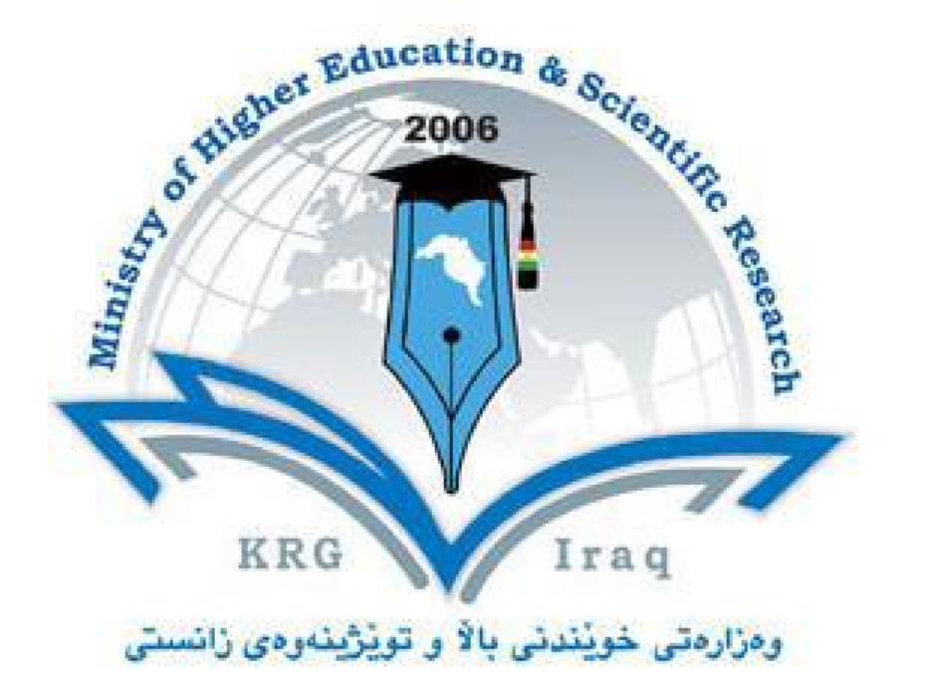

Department of Earth Sciences and Petroleum

College of Science

University of Salahaddin-Erbil

Subject: Mining Geology

Course Book – (Year 4)

Lecturer's name: Dr. Waleed Sulaiman Shingaly

Academic Year: 2023/2022

Course Book

|  |  |  |  |  |  |
| --- | --- | --- | --- | --- | --- |
| 1. Course name | | | Genetics | | |
| 2. Lecturer in charge | | | Assist. Prof. Dr. Waleed Sulaiman Shingaly & Lecturer Sirwa Saed | | |
| 3. Department/College | | | Earth Sciences and Petroleum / Science | | |
| 4. Contact | | | e-mail: waeed.aswad@su.edu.krd, sirwa.saed@su.edu.krd  Tel: (0750 4479241) (0750 4849575) | | |
| 5. Time (in hours) per week | | | For example Theory: 2  Practical: 2 | | |
| 6. Office hours | | | To be Return to the schedule on the office door | | |
| 7. Course code | | | ?????? | | |
| 8. Teacher's academic profile | | | I graduate from Salahaddin University in 2000 (Ranked 1st in Geology Dept., Collage of Science). I accepted in post graduate MSc in 2006 and I finished my MSc degree and start as assistant lecturer for teaching a practical part (Practical Geology, Practical Sedimentology, and Practical mineralogy). I start as an Assistant Lecturer in College of Science in 2006 and as a Lecturer in College of Science from 2013 – 2017. I get my Assistant Professor address in 2017. I worked as a Member of the Examination Committee for College of Science. I worked as a head of Central Examination Committee for Geology Dept. in College of Science in 2013-2014. | | |
| 9. Keywords | | | Geology, Minerals and Rocks, Ore deposits, Principles of Mining, Type of Mining, Environmental impacts related to mining. | | |
| 10. Course overview:  Course description, objectives, and format  Mining geology is an applied science which combines the principles of [economic geology](https://en.wikipedia.org/wiki/Economic_geology) and [mining engineering](https://en.wikipedia.org/wiki/Mining_engineering) to the development of a defined mineral resource. Mining geologists work with engineers to develop an identified [ore deposit](https://en.wikipedia.org/wiki/Ore_deposit) to economically extract the [ore](https://en.wikipedia.org/wiki/Ore).  The process of mining from discovery of an ore body through extraction of minerals and finally to returning the land to its natural state consists of several distinct steps. The first is discovery of the ore body, which is carried out through [prospecting](https://en.wikipedia.org/wiki/Prospecting) or [exploration](https://en.wikipedia.org/wiki/Mineral_exploration) to find and then define the extent, location and value of the ore body. This leads to a mathematical [resource estimation](https://en.wikipedia.org/wiki/Mineral_resource_classification) to estimate the size and [grade](https://en.wikipedia.org/wiki/Ore_grade) of the deposit.  The mining course consists of 12 lectures (annually) and covers topics are integrated with the mineralogy, petrology, ore deposits, geochemistry, economic and industry.  Course learning objectives  By the end of this course, students will be able to apply their basis background in mining to the practice of metal industry, building materials, and in scientific research about type of metal and minerals in our country. Detailed learning objectives are provided for each lecture. | | | | | |
| 11. Course objective:  Each lecture is accompanied by a power point presentation. Information from the presentation and assigned reading is important for mastering the learning objectives which are the primary focus of exam questions. | | | | | |
| 12. Student's obligation  *Exam policy: in addition to present a good report about metals in Kurdistan the student Should take 2 examinations during the course.  *Classroom polices:   1. Attendance: You are strongly encouraged to attend class on a regular basis, as participation is important to your understanding of the material. This is your opportunity to ask questions. You are responsible for obtaining any information you miss due to absence. 2. Lateness: Lateness to class is disruptive. 3. Electronic devices: All cell phones are to be turned off at the beginning of class and put away   during the entire class.   1. Talking: During class please refrain from side conversations. These can be disruptive to your fellow students and your professor. 2. No Disrespectful to both the professor and to your fellow students. | | | | | |
| 13. Forms of teaching  Course book, Power point, Soft and hard copy lectures, white board and black board. | | | | | |
| 14. Assessment scheme Examinations  There will be at least two obligate exams through the course, each exam will contain multiple-choice, true-or-false, short answer questions, long answer questions, give the reasons, solving the problems, make the diagram, etc. .  Quizzes and weekly assignments:  There are a series of 10 minutes quizzes or special take-home assignments totally (5) marks. The lowest grade is dropped.  The exam has (15) marks, the practical exam have (35) marks, so the final grade will be based upon the following criteria:  Mean of two examinations: 15%  Practical examination: 35%  Final examination: 50%  For Students  After each exam (especially the 1st one), evaluate your performance and earning/study strategies. Did your performance reflect the effort you made and your confidence in knowing the material before the exam? Analyse the questions you missed, along with the challenges and responses, and try to figure out why you missed each one, e.g. couldn't remember the information, misunderstood the information, couldn't apply your knowledge to a problem solving question. Once you identify specific problems, you can implement specific solutions. If you want help with this type of evaluation, contact your lecturer. | | | | | |
| 15. Student learning outcome:  At the end of your undergraduate teaching you will be expected to be able to:   * Recognize the rocks and sedimentary strata. * Recognize pattern of distribution minerals within the rocks. * Have a good knowledge about economic minerals and non-economic. * To know the different types of mining. * Learned approaches which can be used for the developed mines | | | | | |
| 16. Course Reading List and References:   * Exploration and mining geology, 2nd edn., Peters W. C., 1987, Wiley, New York, 706p. * Surface and underground excavations: methods, techniques & equipment, byTatiya, R.R., 2005. A.A. Bakema, 579p. * Mine Wastes: Characterization, Treatment and Environmental Impacts, 2nd Edition, by Bernd Lottermoser, 2007. Springer, Berlin Heidelberg. * Mining and the Environment: From Ore to Metal, by KarlheinzSpitz and John Trudinger, 2009. CRC Press, Leiden. * An Introduction to Geology and Hard Rock Mining, ROCKY MOUNTAIN MINERAL LAW FOUNDATION, by Willard Lacy, 2015, Science and Technology Series, 147p. * Applied Mining Geology, Modern Approaches in Solid Earth Sciences, v. 12, Abzalov, M., 2016, Springer, 443p. | | | | | |
| 17. The Topics: | | | | | |
|  | Weeks | Topics | | Lectures |  |
| 1 -7/10 | Introduction | | Course outline, what is mining geology, the role of metals in life, distribution of marks, exams, and final exams |
| 2 -14/10 | The Mining Project | | History of mining, basic terminology, why we do need mine, Mine Planning Cycle, Steps of Mining Project |
| 3 -21/10 | Mineral Exploration | | The principal objective of mineral exploration, The mineral exploration processes, and stages of exploration |
| 4 -28/10 | Mining Sampling | | Methods of Sampling, Surface sampling, Underground sampling, and Errors in Sampling |
| 5 -4/11 | Mineral Resource and Ore Reserve | | What is Mineral resource, Mineral resource classification, what is ore reserve, and Relationship between Mineral Resources and Mineral Reserves |
| 6 -11/11 |  | | Exam |
| 7 -18/11 | Mining Methods: Surface mining – Part 1 | | What is Surface Mining ?, Properties of Surface Mining, and Steps of Surface Mining Operation |
| 8 -25/11 | Mining Methods: Surface mining – Part 2 | | Subdivided surface mining methods, Open-pit Mining, Terrace Mining, Strip Mining, Auger Mining, Glory Holing, Placer mining, and Solution mining |
| 9 -2/12 | Mining Methods: Underground Mining – Part 1 | | Underground mining: Hard rock & Soft rock, Soft rock Mining Methods, Hard rock Mining Methods, What is Stoping in Underground mining ?, and Open-Stope Systems in Underground mining |
| 10 -9/12 | Mining Methods: Underground Mining – Part 2 | | Underground Bulk Mining Methods, A- Steeply dipping ore bodies and B- Gently dipping ore bodies |
|  | 11 -16/12 | Geological Quarry | | Quarrying Explained, What is the difference between a mine and a quarry?, Processes of Quarrying, and Quarry Products |  |
| 12 -23/12 | Impacts of mining projects | | Environmental impacts of mining, Impacts on water resources, Impacts of mining projects on air quality, Impacts of mining projects on wildlife, Impacts of mining projects on soil quality, and Impacts of mining projects on social values |
| 13 -6/01 | Mining Waste | | What is Mining waste, waste rock, tailings, mine water and chemical used. AND FINISH COURSE WITH EXAM |
| 19. Examinations:  *1. Compositional: In this type of exam the questions usually starts with Explain how, What are the reasons for…?, Why…?, How….?*    *2. True or false type of exams:*  *In this type of exam a short sentence about a specific subject will be provided, and then students will comment on the trueness or falseness of this particular sentence.*    *3. Multiple choices:*  *In this type of exam there will be a number of phrases next or below a statement, students will match* the correct *phrase.* | | | | | |
| 20. Extra notes:  In end of this course every student need to prepare a short report about one of the economic metal. | | | | | |
| 21. Peer review  This course about Mining geology is perfect for BSc student. It will make them familiar with mining and economic metals and all the process related to them  Professor Dr. Faraj Habib Tobia | | | | | |