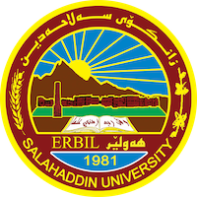
Academic Curriculum Vitae

Personal Information: 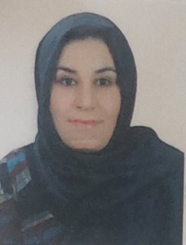
Full Name:khabat hadi jameel
Academic Title:Assitant Lecture
Email: (xabat.jameel@su.edu.krd)
Mobile:07504949782

Education:
- Bachelor:kurdish Language_College of Language”Salahaddin University_Erbil”Kurdistan Region”Iraq 2008
_Master Degre:kurdish _College of arts Salahaddin University_Erbil”Kurdistan Region”Iraq 2015
Employment:
- Department of kurdish”College of Language”Salahaddin University-Erbil”Kurdistan Region”Iraq

Qualifications
- Certificate of Teaching Method Course 1/9/2015_1/11/2015
- IT qualifications
- English Language for academic purpose on 11-4-2021
- Any professional qualification
- You could put any professional courses you have attended

Teaching experience:
- kurdish Studies( teaching undergraduate student at collage of Language

Research and publications
- State all researches, publication you made.

Conferences and courses attended
- پرسی ئینتماو گرفته‌كانی نیشتمان سازی له‌ هه‌رێمی كوردستان له‌ به‌رواری 1-2/3/2023
Funding and academic awards
- List any bursaries, scholarships, travel grants or other sources of funding that you were awarded for research projects or to attend meetings or conferences.

Professional memberships
- Member of Kurdistan teacher union

Professional Social Network Accounts:

- List your profile links of ReserchGate, LinkedIn, etc.

It is also recommended to create an academic cover letter for your CV, for further information about the cover letter, please visit below link:
https://career-advice.jobs.ac.uk/cv-and-cover-letter-advice/academic-cover-letter/

