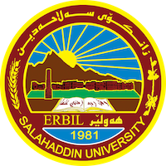
Academic Curriculum Vitae
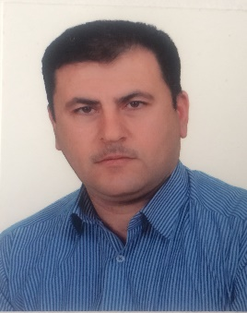
Personal Information:
Full Name: Dr. Abdulilah Saleh Ismaeil
Academic Title: Assistant professor
Email: abdulilah.ismaeil@su.edu.krd
Mobile: 07504733977

Education:
B.Sc. Biology -Salahaddin university -1998
M.Sc. Food Microbiology - Salahaddin university - 2005
Ph.D. Food Microbiology - Salahaddin university - 2020
Employment:
13/1/1999 in Salahaddin university as assistant biology

Qualifications
- Teaching qualifications
- IT qualifications
- Language qualifications such as TOEFL, IELTS or any equivalent
- Any professional qualification
- You could put any professional courses you have attended

Teaching experience:
Food microbiology (Practical & theory )
Toxicology (Theory)

Research and publications
No. | Title of research | Date
1. | Isolation and identification of some gram negative bacteria from some local foods in Erbil city center | 2007
2. | Role of solvent and methods of extraction on the inhibitory effect of black seed extracts on Pseudomonas aeroginosa | 2010
3. | Inhibition of Staphylococcus aureus by Nigella sativa products using different extraction method | 2011
4. | Antifungal Activity of Pomegranate and Oak Galls Extracts against Penicillium spp. and Aspergillus niger | 2011
5. | Inhibitory Effect of Breast Milk Against Pediatric Bacterial Infection | 2011
6. | Effect of Black Seed Alkaloids Against Some Pathogenic Bacteria | 2011
7. | Microbial quality of frozen red meat in some supermarkets in erbil city center | 2012
8. | Sterilization of culture media for microorganisms using a microwave oven instead of autoclave | 2019
9 | Sumac (Rhus cariora) as qorum sensing inhibitor in Staphylococcus aureus | 2019
10 | Synergistic effect of different plant extracts and antibiotics on some pathogenic bacteria | 2020
11 | Attenuation of Staphylococcus aureus By Pomegranate Peel Extracts | 2020

Conferences and courses attended
Funding and academic awards
Professional memberships
1. member of Kurdistan teachers union
2. member of Kurdistan biology syndicate
Professional Social Network Accounts:
- https://scholar.google.com/citations?user=HY1k81EAAAAJ&hl=ar&authuser=1&gmla=AJsN-F6k0eVzewWk35czUyc7SZjf5okA1A3m4YfrfefplMwOE2f9BSVNXv
- https://www.researchgate.net/profile/Abdulilah-Ismaeil/research

